Designing a continuous quality improvement framework for improving electrowinning current efficiency
By T.E. Moongo^{1,2}, and S. Michael¹
Affiliation:
1 Department of Mechanical and Marine Engineering, Namibia University of Science and Technology, Namibia
2 Department of Mining and Process Engineering, Namibia University of Science and Technology, Namibia
Correspondence to: T.E. Moongo
Email: tmoongo@gmail.com

Synopsis
In general, the electrowinning process consumes substantial electrical energy. Considering the ever-increasing unit cost of electrical power there is a need to improve current efficiency so that electrical energy is utilised efficiently. In light of the research/knowledge gap identified, this research aims to design a continuous quality improvement framework for improving electrowinning current efficiency. The objectives of this research are as follow: (i) To explore factors that influence current efficiency; (ii) To evaluate the factor that has the most significant effect on current efficiency, by applying statistical process control; and finally (iii) To design a continuous quality improvement framework for improving electrowinning current efficiency, by applying statistical process control. The scope of work for this research focused on applying statistical process control on an online industrial copper electrowinning process instead of doing laboratory experiments. In this case, a sequential mixed research methodology was applied and Minitab statistical software package was utilized for analysing data by creating control charts. The factors that influence current efficiency were explored and the main factors are as follow: metallurgical short-circuits, impurities, electrode condition, electrode alignment, contacts condition, electrolyte temperature, reagent addition, electrolyte acid concentration, current density, rectifier current, electrode insulators, cathode nodules, electrolyte copper content, and electrolyte flow rate. After analysing constructed control charts and implementing an out of control action plan, it was concluded that metallurgical short-circuits (hotspots) have the most significant effect on current efficiency than all the other factors. Bringing hotspots under statistical control resulted in improved current efficiency by 5.40 % which is equivalent to approximately 74 MT of 99.999 % pure grade A copper cathode production over a period of 1.5 months. Finally, a continuous quality improvement framework for improving electrowinning current efficiency was designed. This was done by considering the following: Anderson Darlington normality test, non-normal data transformation (using Johnson and Box-Cox transformation), constructing control charts, and then analysing control charts which include Pearson correlation analysis, out of control points alignment analysis, root cause analysis, process capability analysis, and implementing an out of control action plan.
Keywords
Quality, continuous improvement, continuous quality improvement, statistical process control, and current efficiency

Introduction
The use of quality control techniques such as Statistical Process Control (SPC) has become essential for any business to thrive in the modern industry. Statistical quality control is one of the reasons why the Japanese had a significant advantage over their competitors. However, many organizations are still not yet applying this powerful quality control technique (Ben & Jiju, 2000; Helm, 2018).
In addition to that, although substantial research has been done to improve electrowinning current efficiency, no evidence of research done to improve current efficiency from a quality perspective by applying statistical process control was found in the reviewed literature (Moongo, 2020). This research/knowledge gap needs to be filled and this research has contributed to the body of knowledge by filling the above-mentioned research/knowledge gap.
In general, the electrowinning process requires substantial electrical energy to electroplate a metal of interest onto a cathode blank (Parada & Asselin, 2009). Unfortunately, the unit cost of electrical energy is ever-increasing (Nampower, 2019; Eskom, 2019). To make things worse, Nampower partly relies on Eskom to meet the electrical energy demand for Namibia.
However, Eskom has been struggling to supply the South African national grid with sufficient electrical power. This resulted in load-shedding (Eskom, 2019). Therefore, it is essential to utilize electrical energy efficiently. Hence, the need to improve current efficiency (CE), and the significance of this research (Moongo, 2020).
Despite the aforementioned facts, the electrical energy utilized in the electrowinning process can be applied more efficiently and cost-effectively by improving electrowinning current efficiency (Hongdan, et al., 2016; Moongo, 2020). A typical electrowinning process consumes approximately 60 % to 80 % of the total electrical energy at a mine (Gonzalez-Dominguez & Dreisinger, 1997). Consequently, there is an opportunity for substantial electrical energy saving and for increasing copper cathode production if electrowinning current efficiency is improved.
Literature Review
Statistical Process Control
Continuous quality improvement via the application of Statistical Process Control (SPC) has been long recognized in the metallurgical industry. Statistical process control assists with monitoring process variability and maintaining process stability, thereby ensuring that the process remains under statistical control (Godina, et al., 2018). The process can get out of statistical control in the presence of process variation, such as controlled process variation and uncontrolled process variation (SCME, 2017).
It was reported that occasionally there are special or assignable causes of process variability which are temporary or not inherently in the process. Unlike common (also called random or chance) causes of process variability (Pavol, 2015; Montgomery, 2009). Normally, all the special causes of process variability should be addressed by developing and implementing an Out of Control Action Plan (OCAP) (Amitava, 2016; Helm, 2018; Moongo, 2020; SCME, 2017).
According to literature, the following tools are utilized in statistical process control namely, histogram, scatter diagram, check sheets, defect-concentration diagrams, cause and effect diagram, control chart, and Pareto chart (Helm, 2018). For this research process control charts, Pareto charts, and the Ishikawa diagram were applied (Moongo, 2020).
Process control charts
Process control charts are used to keep the production process under statistical control. They are frequently employed as diagnostic tools because they can indicate when adjustments should be made in the process. Process control charts monitor process variability and they provide information about the stability of the process (Helm, 2018; Montgomery, 2009; SCME, 2017; Wild & Seber, 2017; Scott & James, 2015).
The construction of process control charts is done by assuming that the quality characteristic data follows a normal/Gaussian distribution. The bell-shaped curve should be reflected. This is because the central limit theorem holds if the sample size has a population distribution which is unimodal and close to symmetric. In general, a process control chart has three horizontal lines namely, the Upper Control Limit (UCL), Lower Control Limit (LCL), and the centreline (process average) (Montgomery, 2009; Anonymous, 2019; Amitava, 2016; SCME, 2017).
It is worth noting that, process control charts work with rules that guide when to say the process is out of statistical process control or it is within statistical process control. Walter Shewhart developed the eight Shewhart rules for process control charts. The first four rules are also referred to as the Western Electric Rules. Typical statistical process control charts include Xbar (mean) and Range ($\overline{X}$ – R) control chart, Individual moving range (I-MR) control chart, proportion control chart (p-chart), Xbar (mean) and Standard Deviation ($\overline{X}$ – S), and many others (SCME, 2017).

Current efficiency
According to literature, current efficiency may be defined as the ratio of direct current which was utilized for electroplating a metal of interest to the total direct current that has been applied onto the electrolytic cells (Joseph, 2017; Moongo, 2020). From the practical viewpoint, current efficiency refers to the actual quantity of the electroplated metal divided by the quantity of the theoretical electroplated metal calculated by applying Faraday’s equation (Beukes & Badenhorst, 2009; Corby Anderson, 2017; Moongo, 2020).
Industrial copper electrowinning current efficiency can range from 90 % to 95 % (Robinson, n.d.). Other authors reported that current efficiency in the copper electrowinning plant should be > 92 %. Nevertheless, lower current efficiency may also be experienced depending on the factors influencing it (Moongo, 2020). The inefficiently used direct current or low current efficiency represents the direct current that was utilized for any unintentional purpose other than electroplating the metal of interest (Michael & Michael, 2007; Ntengwe, et al., 2010).
Research Methodology
Research approach
A sequential mixed research methodology (qualitative and then quantitative research methodology) was applied to achieve all the objectives of the research. A mixed research methodology was chosen because it addressed the current efficiency improvement problem more holistically by complementing either methodology (Moongo, 2020).
On the one hand, for qualitative research methodology, a questionnaire focusing on current efficiency factors and current efficiency improvement best practices was given to 48 people who work as operators, process engineers, academics, and consultants who are experienced/understand the electrowinning process.
On the other hand, a quantitative research methodology concentrated on collecting and analysing electrowinning process data obtained from the Laboratory Information Management System (LIMS) and from the historian or Supervisory Control And Data Acquisition (SCADA) server. A total of 1629 L of electrolyte solution samples comprised of 6516 samples of 250 ml each was analysed by an independent analytical chemistry laboratory. The electrowinning process instrument data was retrieved every 2 hours during the study period.
The data studied was for 6 months from January 2019 to the end of June 2019. The data were analysed using Minitab statistical software package by applying the Anderson Darlington normality test, Pearson correlation analysis, Box-Cox transformation, Johnson transformation, Shewhart control charts, and process capability analysis (Moongo, 2020).
Research Strategy
The research strategy applied comprises of three major steps. Step 1 focused on exploring current efficiency factors, thereby achieving the first objective of the research. Thereafter, step 2 concentrated on analysing historical data and establishing current efficiency improvement best practices. This consequently resulted in accomplishing the second objective of the research. Finally, step 3 was dedicated to designing a continuous quality improvement framework for improving electrowinning current efficiency. Hence, completing the third objective of the research (Moongo, 2020). A detailed roadmap is depicted in Figure 1.
Figure 1: The designed research strategy (Moongo, 2020)
Results and Discussions
Exploring for current efficiency factors
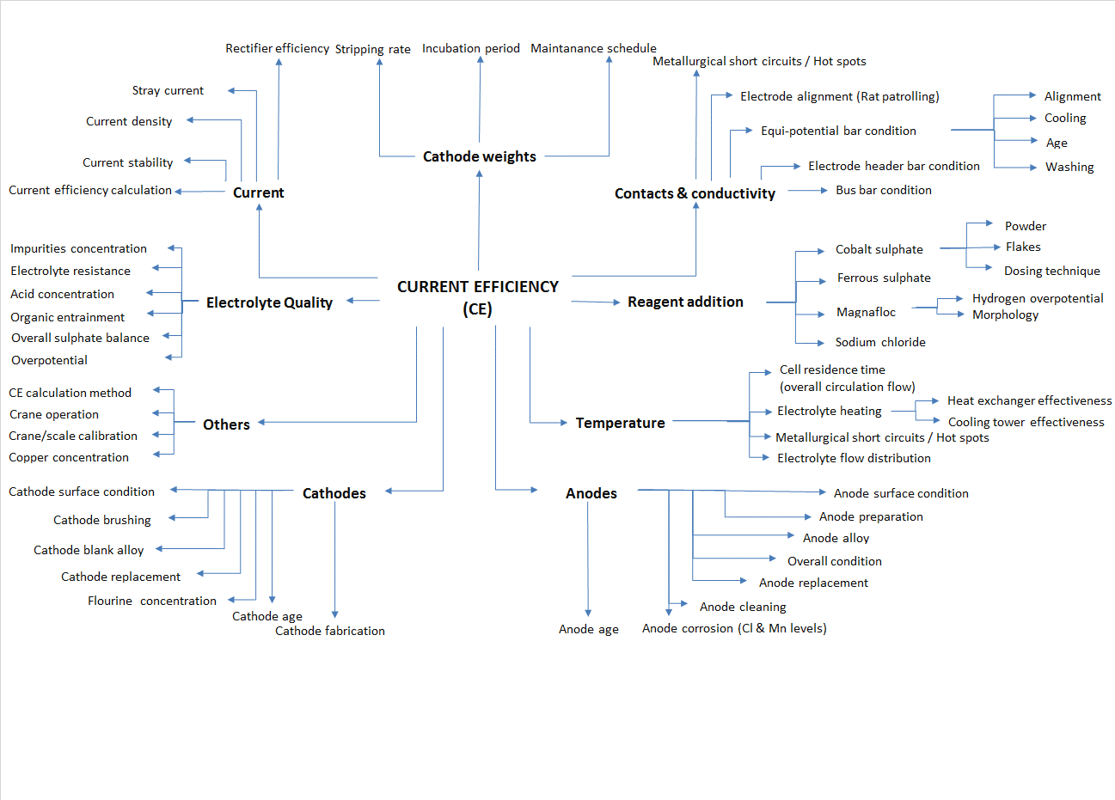
The exploration for factors that influence current efficiency was executed by doing a thorough literature review and also by filling in questionnaires. A lot of factors that influence current efficiency were discovered from an intensive literature review. They are summarized in Figure 2, these factors are mainly divided into the following main categories shown on the mind map, namely: contacts and conductivity, reagent addition, temperature, electrodes (anodes and cathodes), electrolyte quality, current, cathode weight and other factors (Moongo, 2020; Peter, 2017; Ozdag, et al., 2012; Ntengwe, et al., 2010; Beukes & Badenhorst, 2009; Tuaweri, et al., 2013; Arman, et al., 2016; Fereshteh, et al., 2010; Vay, 2011; Joseph, 2017). There are a lot of factors influencing current efficiency. The number of factors was down-sized so that high consideration can be given to the factors that are most likely to have a significant effect on current efficiency.

Figure 2: A mind map of current efficiency factors (Moongo, 2020)

Figure 3 shows a Pareto chart depicting current efficiency factors and their respective frequency of suggestions obtained from the questionnaires. The following factors were suggested: metallurgical short-circuits (hotspots), electrolyte impurities, electrode condition, electrode alignment (rat patrol), contacts, electrolyte temperature, reagent addition, electrolyte acid concentration, current density, rectifier current, rectifier efficiency, electrode insulators, cathode nodules, electrolyte conductivity, electrolyte copper concentration, electrolyte flow rate and others (Moongo, 2020).
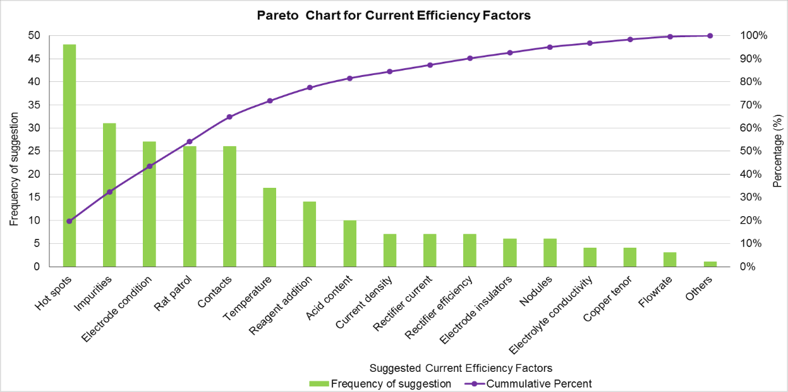
Figure 3: Pareto chart for current efficiency factors from the questionnaires (Moongo, 2020)

Creating process control charts for current efficiency factors
Before control charts were created, an Anderson Darlington normality test was carried out using Minitab (Minitab, 2019). Thereafter, non-normal data was transformed by using Box-Cox transformation and/or Johnson transformation (Minitab, 2020). An Anderson Darlington normality test was repeated by using the transformed data. Last but not least, a statistical summary report was generated for all the factors just to confirm that the data is indeed following a normal distribution and it forms a bell-shaped curve (Moongo, 2020). Finally, the transformed data and/or normally distributed data was then used to create control charts similar to control charts in Figure 4 and Figure 5.

Figure 4: Xbar-R control chart (Moongo, 2020)
Figure 5: Xbar-S control chart (Moongo, 2020)
Analysis of process control charts for continuous data
The analysis of process control charts for continuous data was executed by undertaking an out of control points alignment analysis and Pearson correlation analysis. The out of control points alignment analysis checks if the out of control points for the factors are aligned to the out of control points for current efficiency. The idea is that if the factor has the most significant effect on current efficiency then it’s out of control points should correspond to out of control points of current efficiency (Moongo, 2020). The out of control points alignment and Pearson correlation coefficient results are depicted in Figure 6 and Figure 7 respectively.
The out of control points alignment figure shows that rectifier current and current density both had 87.5 % out of control points aligned to current efficiency out of control points. However, these factors only have 0.053 and 0.179 correlation coefficient respectively. Which means they do not have the most significant effect on current efficiency (Moongo, 2020).
This indicates that the factor that has the most significant effect on current efficiency cannot simply be found by only using one analysis method. A few out of control points can be aligned to the out of control points for current efficiency. But there are many other out of control points which are not aligning and they are not considered. Therefore, all the points should be considered in the analysis (Moongo, 2020).
However, this gap was bridged by considering the correlation coefficient between current efficiency factors and current efficiency itself. From the Pearson correlation coefficient chart in Figure 7, it can be seen that the commercial cells temperature, polishing cells temperature, and advance electrolyte temperature have the highest Pearson correlation coefficient to current efficiency. Their correlation coefficients are 0.295, 0.301 and 0.321 respectively (Moongo, 2020). These factors will have the most significant effect on current efficiency if no other factor has a higher correlation coefficient.
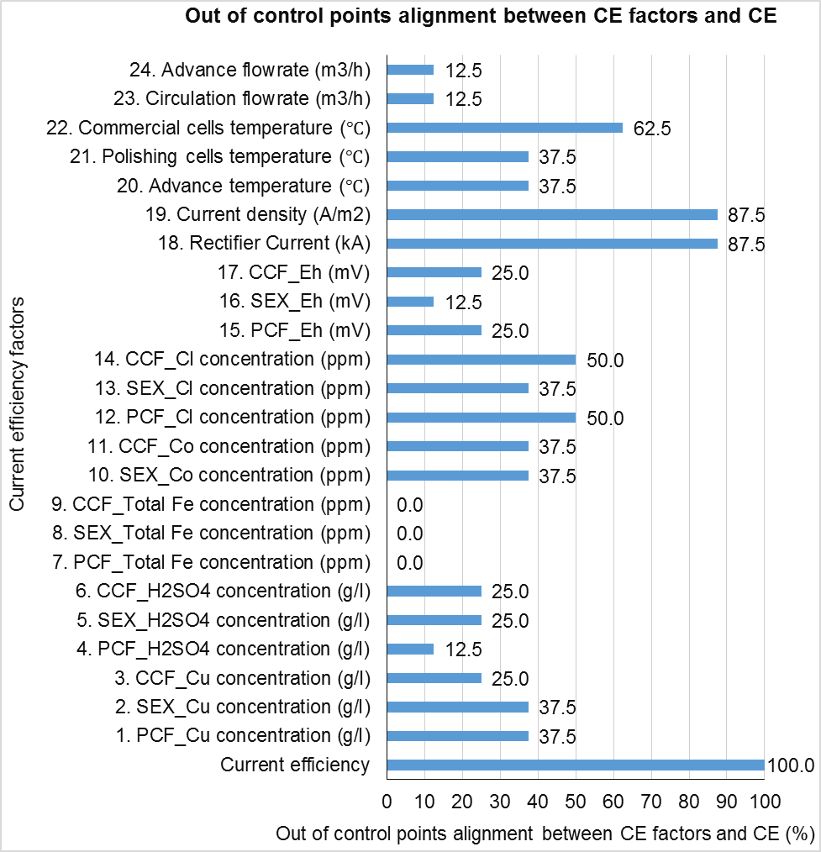
Figure 6: Out of control points alignment analysis (Moongo, 2020)

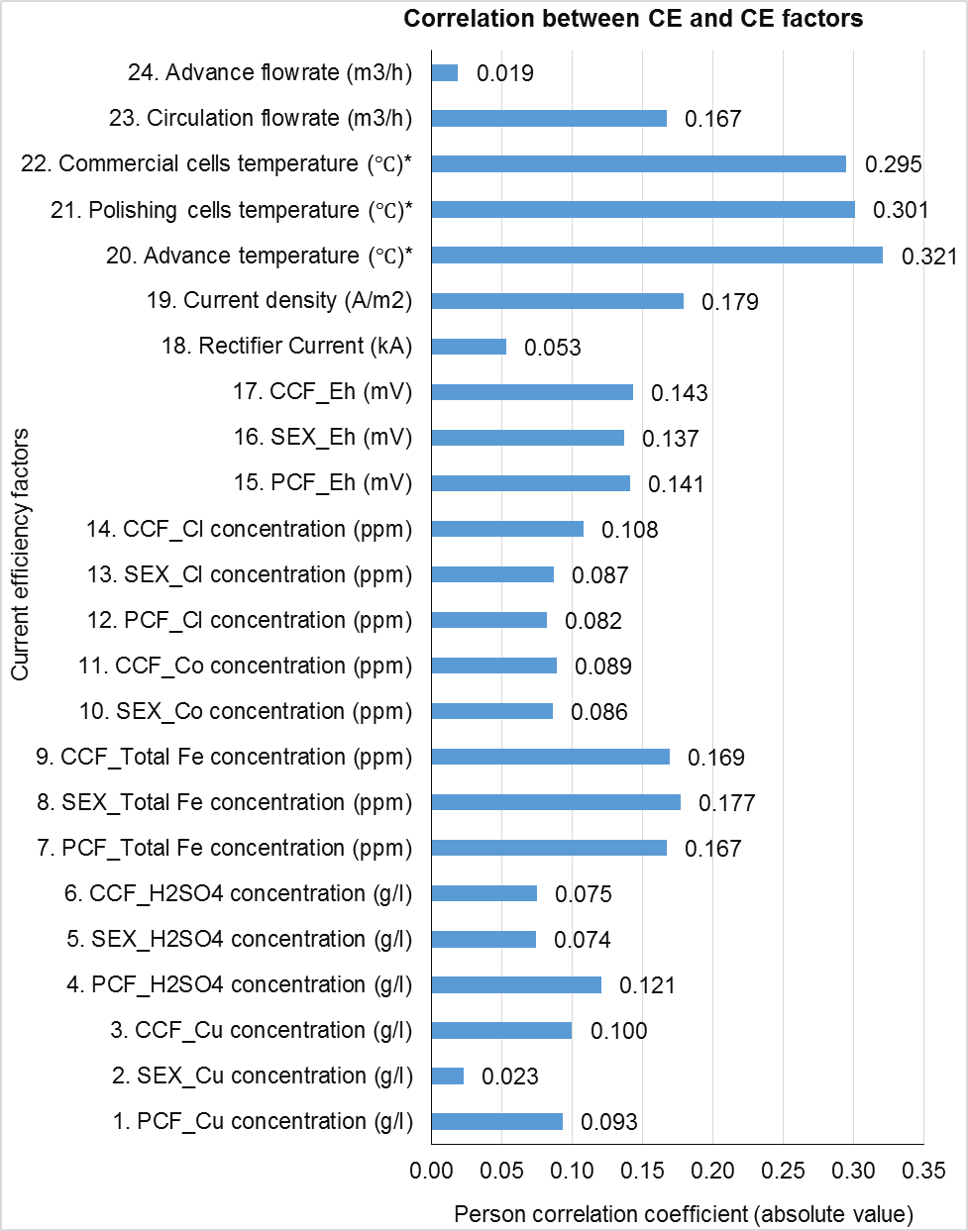
Figure 7: Pearson correlation coefficients (Moongo, 2020)
Analysis of process control charts for attribute data
Attribute data for some current efficiency factors was collected manually in the electrowinning plant. Unlike data collected by analysing samples in the chemistry laboratory and retrieved from the SCADA server database. The main attribute factor whose data was collected manually is metallurgical short-circuits (hotspots). The hotspots were detected by making use of an infrared (IR) camera as depicted in Figure 8. The temperature of the electrode contacts is normally maintained at $≤$ 55$℃$. However, a lot of metallurgical short-circuits (hotspots) which were as high as > 150 $℃$ were detected (see Figure 9).
  Figure 8: Detecting hotspots by using an IR camera (Moongo, 2020) | 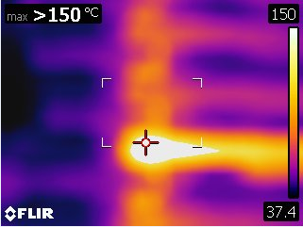  Figure 9: IR camera picture of a detected hotspot (Moongo, 2020)

Implementing an out of control action plan
The presence of metallurgical short-circuits (hotspots) was addressed by developing an out of control action plan and it was implemented because they were deemed to be out of control. The out of control action plan included carrying out an exhaustive hotspot detection and rectification, determining the root cause of hotspots, knocking off cathode nodules, reviewing current efficiency calculations, monitoring and controlling electrolyte impurity content, monitoring and controlling cathode smoothing agent (kemsmooth) addition, improving electrode maintenance, doing proper electrode alignment (rat patrol), straightening bend electrodes, replacement of damaged cathodes, replacement of bend anodes, replacement of electrodes without side insulators, dressing electrodes without side insulators, cleaning equipotential busbars using acetone or steel wire brushes and cleaning of electrode contacts using acetone or steel wire brushes. Some of the action plans implemented are shown in
  Figure 10: Inspecting a cathode (Moongo, 2020) |   Figure 11: Inspecting an anode (Moongo, 2020)
  Figure 12: Knocking off nodules that caused a hotspot (Moongo, 2020) |   Figure 13: Straightening a bend anode (Moongo, 2020)
  Figure 14: Replacing an anode without a side insulator (Moongo, 2020) |   Figure 15: Doing electrode alignment (rat patrol) (Moongo, 2020)
Figure 10 to Figure 19.

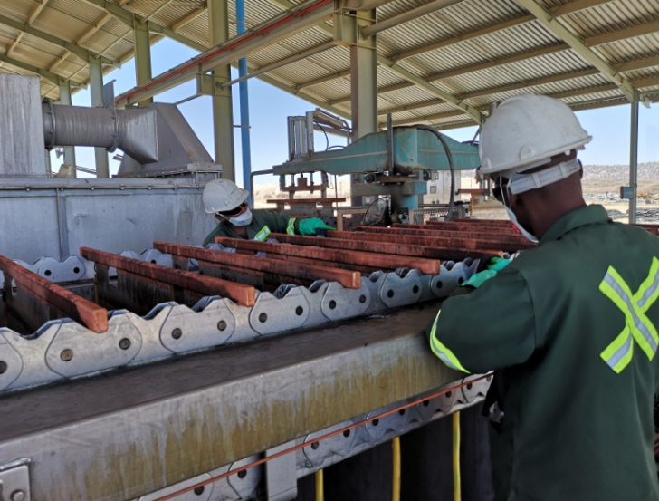  Figure 16: Cleaning cathode contacts (Moongo, 2020) |   Figure 17: Cleaning anode contacts (Moongo, 2020)
  Figure 18: Replacing cathodes (Moongo, 2020) |   Figure 19: Found cathode nodules (Moongo, 2020)

Improvement in current efficiency
The Individual moving range (I-MR) control chart for current efficiency visibly shows that current efficiency improved as metallurgical short-circuits (hotspots) were brought under statistical process control (see Figure 20). The decrease in the number of hotspots after implementing the developed out of control action plan can be seen on the P and U control charts shown in Figure 21 and Figure 22.
Although hotspots have 45.45 % out of control points aligned to current efficiency out of control points, the percentage misalignment for the number of hotspots per cell and percent of cells with hotspots is 54.55 % and 50.00 % respectively. They are the lowest compared to all other factors. A good indication of the significance of the effect of hotspots on current efficiency. Interestingly and in addition to that, hotspots were found to have the highest Pearson correlation coefficient than all the other factors. The number of hotspots per cell and percent of cells with hotspots was found to have a Pearson correlation coefficient of -0.361 and -0.878 respectively.
The negative sign on the correlation coefficients shows that there is an inversely proportional relationship between metallurgical short-circuits (hotspots) and current efficiency. Moreover, the suggestions from the questionnaires regarding best practices for improving current efficiency also shows that rectifying metallurgical short-circuits will certainly result in improved current efficiency (see Figure 23).
Figure 20: I-MR control chart for current efficiency (Moongo, 2020)

Figure 21: P control chart for the percentage of cells with hotspots (Moongo, 2020)

Figure 22: U control chart of the number of hotspots per cell (Moongo, 2020)

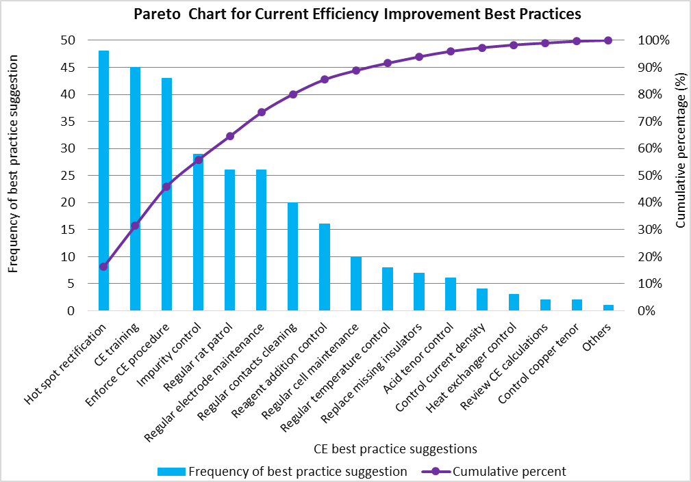
Figure 23: Current efficiency improvement best practices (Moongo, 2020)

After implementing the developed out of control action plan, current efficiency improved from as low as 89.64 % to as high as 95.04 %. This represents an improvement of 5.40 % (see Figure 24). Essentially, this evidently shows that metallurgical short-circuits (hotspots) have the most significant effect on current efficiency than all the other current efficiency factors. Because the presence of metallurgical short-circuits (hotspots) result in the conversion of direct current into heat energy instead of using it for electroplating copper onto the cathode blank sheets (Moongo, 2020). Hence, justifying why current efficiency improved as soon as hotspots where brought back under statistical process control. The 5.40 % improvement in current efficiency translates to approximately 74 MT of 99.999 % pure grade A copper cathode production over a period of 1.5 months (Moongo, 2020).
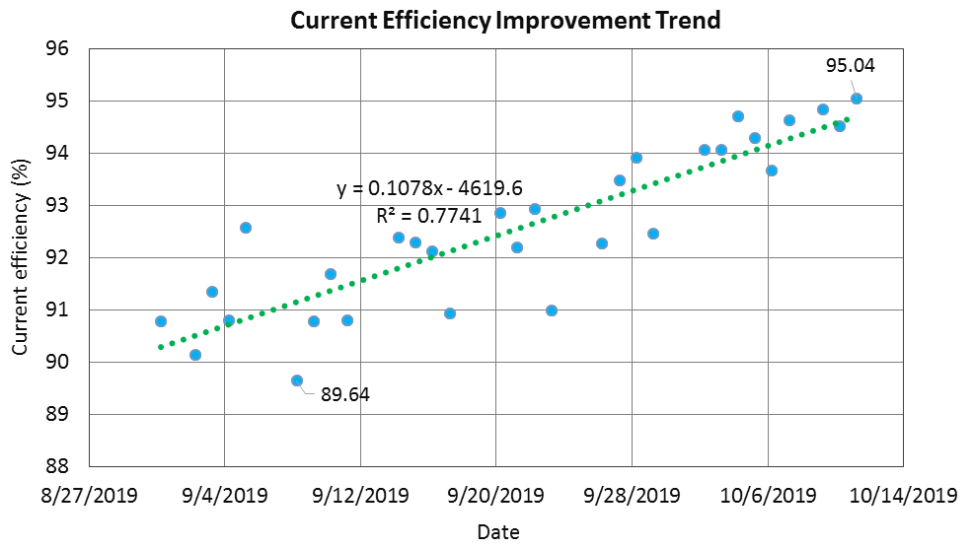
Figure 24: Improvement in current efficiency (Moongo, 2020)

Designing a continuous quality improvement framework
Finally, to accomplish the last objective of this research. The following factors were considered when designing a detailed continuous quality improvement framework for improving electrowinning current efficiency, they are current efficiency factors, Anderson Darlington normality test, transforming non-normal data (Box-Cox & Johnson transformation), classifying data types, selecting a suitable process control chart, Pearson correlation analysis, out of control point alignment analysis, process capability analysis, root cause analysis, developing and implementing an out of control action plan, current efficiency training and developing a current efficiency improvement procedure. A simplified version of the designed continuous quality improvement framework is depicted in Figure 25. The framework serves as a guide to improving current efficiency from a quality perspective, by applying statistical process control.
Figure 25: A simplified continuous quality improvement framework (Moongo, 2020)

Conclusions
In conclusion, the research/knowledge gap identified was successfully filled by this research and all the objectives were accomplished. An exploration of current efficiency factors concluded that the factors that influence current efficiency are metallurgical short-circuits (hotspots), electrolyte impurities, electrode condition, electrode alignment (rat patrol), electrode contacts, electrolyte temperature, reagent addition, electrolyte acid concentration, current density, rectifier current, rectifier efficiency, electrode insulators, cathode nodules, electrolyte conductivity, electrolyte copper concentration, electrolyte flow rate, and others.
After developing and implementing an out of control action plan, upon analysing the constructed statistical process control charts, it was concluded that metallurgical short-circuits (hotspots) have the most significant effect on current efficiency than all the other factors. Consequently, current efficiency improved from as low as 89.64 % to as high as 95.04 % (improvement by 5.40 %) which translates to approximately 74 MT of 99.999 % pure grade A copper cathode production over a period of 1.5 months.
Finally, a continuous quality improvement framework for improving electrowinning current efficiency was designed. The main limitation of this research stems from the fact that the study was done in an industrial copper electrowinning process while it was online (producing copper cathodes). The electrowinning process may not be fully at a stable state during the study. Nonetheless, future research is recommended to focus on improving current efficiency via the application of statistical process control by carrying out laboratory experiments, application of Design of Experiments (DOE), studying the effect of the interactions between current efficiency factors, application of other types of control charts such as multivariate control charts, Cumulative Sum (CUSUM) control charts and Exponentially Weighted Moving Average (EWMA) control charts.

Acknowledgements
The authors would like to thank Mr. Jomo Appolus (Processing Manager) for authorizing the study to be carried out in an online industrial copper refinery (Electrowinning tankhouse). The contributions by the copper refinery technical team, operations team, Mr. Nobert Paradza, and Mr. John Moody is highly appreciated.

References
Amitava, M., 2016. Fundamentals of Quality Control and Improvement. 4th ed. New Jersey: Wiley.
Anonymous, 2019. Anonymous. [Online]
Available at: https://www.researchgate.net/figure/Components-of-Statistical-Control-Charts-CL-UCL-and-LCL-of-mean-control-chart-or-x-chart_fig1_307671037
Arman, E., Ersin, Y. & Hac, D., 2016. The effect of temperature on the electrowinning of copper. UCTEA Chamber of Metallurgical & Materials Engineers, pp. 1-5.
Ben, M. & Jiju, A., 2000. Statistical process control: an essential ingredient for improving service and manufacturing quality. Managing Service Quality: An International Journal, 10(4), pp. 233-238.
Beukes, N. & Badenhorst, J., 2009. Copper electrowinning: theoretical and practical design. The Journal of The Southern African Institute of Mining and Metallurgy, pp. 343-356.
Corby Anderson, C., 2017. Optimization of industrial copper electro winning solutions. Journal of advanced chemical engineering, II(2), p. 156.
Eskom, 2019. Eskom. [Online]
Available at: http://www.eskom.co.za/CustomerCare/TariffsAndCharges/Pages/Tariffs_And_Charges.aspx
Fereshteh, S., Naison, M. & Felix, W., 2010. The dependence of current efficiency on factors affecting the recovery of copper from solutions. Journal of Applied Sciences Research, 6(11), pp. 1862-1870.
Godina, R., Pimentel, C., Silver, F. & Joao, M., 2018. Improvement of the statistical process control certainty in an automotive manufacturing unit. Procedia Manufacturing, Volume 17, pp. 729-736.
Gonzalez-Dominguez, J. & Dreisinger, D., 1997. Identifying research opportunities in zinc electrowinning. Review of extraction & processing, p. 38.
Helm, 2018. Quality Control. Unspecified, I(1), pp. 1-18.
Hongdan, W., Wentang, X., Wenqiang, Y. & Bingzhi, R., 2016. Improving Current Efficiency Through Optimizing Electrolyte Flow in Zinc Electrowinning Cell. CFD Modeling and Simulation in Materials Processing 2016.
Joseph, K., 2017. Design of copper electrowinning circuit using conventional cells, Unspecified: Unspecified.
Michael, M. & Michael, F., 2007. A bright future for copper electrowinning. JOM, p. 34.
Minitab, 2019. Minitab. [Online]
Available at: https://support.minitab.com/en-us/minitab/18/help-and-how-to/statistics/basic-statistics/supporting-topics/normality/the-anderson-darling-statistic/
[Accessed 1 May 2020].
Minitab, 2020. Minitab. [Online]
Available at: https://support.minitab.com/en-us/minitab/19/help-and-how-to/quality-and-process-improvement/control-charts/how-to/box-cox-transformation/before-you-start/overview/
[Accessed 1 May 2020].
Minitab, 2020. Minitab. [Online]
Available at: https://support.minitab.com/en-us/minitab/19/help-and-how-to/quality-and-process-improvement/quality-tools/how-to/johnson-transformation/before-you-start/overview/
[Accessed 1 May 2020].
Montgomery, D., 2009. Introduction to Statistical Quality Control. 6th ed. Arizona: Arizona State University.
Moongo, T., 2020. Designing a continuous quality improvement framework for improving electrowinning current efficiency, Windhoek: Namibia University of Science and Technology.
Nampower, 2019. Nampower. [Online]
Available at: https://www.nampower.com.na/Page.aspx?p=172
Natarajan, S., 1985. Current efficiency and electrochemical equivalent in an electrolytic process. Bulletin of electrochemistry, Mar-Apr, 1(2), pp. 215-216.
Ntengwe, F., Mazana, N. & Samadi, F., 2010. The dependence of current efficiency on factors affecting the recovery of copper from solutions. Journal of applied sciences research, pp. 1862-1870.
Ozdag, H., Bozkurt, K., Ipek, H. & Bilir, K., 2012. The influence of impurity ions on the electrowinning of copper from waste PBCs leaching solutions. Johanesburg, Southern African Institute of Mining and Metallurgy, pp. 112-121.
Parada, T. & Asselin, E., 2009. Reducing power consumption in zinc electrowinning. Sustainable processing, p. 54.
Pavol, G., 2015. Continuous Quality Improvement by Statistical Process Control. Zvolen, Elsevier, pp. 565-572.
Peter, A., 2017. Zinc electrowinning in the presence of iron (II), Western Sydney: ProQuest.
Robinson, T., n.d.. Chapter 19: Electrowinning. In: Extractive metallurgy of copper. Phoenix: Unspecified, pp. 1-13.
SCME, 2017. Control chart basics: primary knowledge unit participant guide. New York: National Science Foundation's Advanced Technological Education.
Scott, L. & James, E., 2015. Variables Control Charts. In: Statistical Process Control. Oregon: Oregon State University, pp. 1-19.
Tuaweri, T., Adigio, E. & Jombo, P., 2013. A Study of Process Parameters for Zinc Electrodeposition from a Sulphate Bath. International Journal of Engineering Science Invention, pp. 17-24.
Vay, L., 2011. Studies of micromorphology and current efficiency of zinc electrodeposited from flowing chloride electrolytes. Lawrence Berkeley National Laboratory, pp. 1-139.
Wild, C. & Seber, G., 2017. Chapter 13: Control Charts. In: Control Charts. New York: Elsevier, pp. 1-32.

