

Designing an Automated e-Readiness Assessment Tool to Assess Local Authorities in Namibia

By

Angelo Cloete
200868179

Submitted in fulfillment of the requirements for the degree
Masters of Informatics
in the

Department of Informatics

at the

NAMIBIA UNIVERSITY OF SCIENCE AND TECHNOLOGY

Supervisor: Prof. A. Peters
Co-Supervisor: Prof. H. Jazri

Date of submission:
31/01/2019

METADATA
TITLE : Designing an Automated e-Readiness Assessment Tool to Assess Local Authorities in Namibia
STUDENT NAME : Angelo Cloete
SUPERVISOR : Prof. Anicia Peters
CO-SUPERVISOR : Prof. Hussin Jazri
DEPARTMENT : Computer Informatics
QUALIFICATION : Masters of Informatics
SPECIALISATION : e-Readiness Assessment
STUDY TITLE : Designing an Automated e-Readiness Assessment Tool to Assess Local Authorities in Namibia
MAIN KNOWLEDGE AREA : e-Government
KEYWORDS : e-Readiness, e-Government
TYPE OF RESEARCH : Applied Research
METHODOLOGY : Quantitative Research
STATUS : Proposal
SITE : Namibia University of Science and Technology (NUST)
DOCUMENT DATE : 31 January 2019

DECLARATION

I, Angelo Cloete, born on 23/08/1979 in Keetmanshoop, Karas Region, Namibia, hereby declare that the work contained in this report for the Degree Masters of Informatics project, entitled: Designing an Automated e-Readiness Assessment Tool to Assess Local Authorities in Namibia, is my own original work and that I have not previously, in its entirety or in part, submitted it at any university or other higher education institution for the award of a degree.

I further declare that I will fully acknowledge any sources of information I will use for the research, in accordance with the rule of the Institution.

Signature: _____________________________ Date: _____________________

Signature of the Supervisor
I, _____________________________, herewith declare that I accept this proposal for my supervision
Signature: _____________________________ Date: _____________________

Designing an Automated e-Readiness Assessment Tool to Assess Local Authorities in Namibia

Abstract
E-Readiness assessments have been identified as a pre-requisite for successful systems implementations and therefore it is a pre-requisite for e-Government as well. It is however difficult to use existing e-Readiness assessment tools as most have been designed to cater for a specific context. In the absence of previous assessments, the level of e-Readiness of local authorities in Namibia is undetermined. The aim of the study is to design an automated assessment tool to assess the level of e-Readiness of Local Authorities, focusing in particular on the Municipality of City of Windhoek. This assessment will be carried out using the newly designed automated assessment tool. Two online surveys were designed and conducted. One was specifically designed for the Information Communication Technology Department and another one was designed for the staff members of all other departments. The surveys measured the e-Readiness of the Local Authority in terms of online service provision, its computer systems, hardware/network infrastructures and the skills set of employees. The findings indicate that the use of Information and Communication Technology (ICT) in research efforts, greatly improves the process, as the automated e-Readiness assessment tool delivered faster assessments and at a lesser cost. The results from the automated assessment tool shows that it can be used to measure e-Readiness at different Local Authorities.

Table of Contents

1. INTRODUCTION 9
1.1 Problem Statement 10
1.2 Research Objectives 12
1.3 Specific Objectives 12
1.4 Research Questions 12
1.5 Importance of the Study 12
1.6 Delineations and Limitations 13
1.7 Risk and Ethical Considerations 13
1.8 Conclusion 14
2. LITERATURE REVIEW 15
2.1 Introduction 15
2.2 Information and Communications Technology (ITC) 15
2.3 E-Government 16
2.4 E-Government in Municipalities 19
2.5 E-Readiness Assessment 21
2.6 E-Readiness Assessment Tools 23
2.7 An analysis of E-Readiness measurement tools 24
2.8 Conclusion 30
3. RESEARCH METHODOLOGY 31
3.1 Introduction 31
3.2 Methodology 31
3.3 Research Philosophy 32
3.4 Research Approach 33
3.5 Research Strategy 34
3.6 Instrument design 34
3.7 Pre-testing of Questionnaires 36
3.8 Data Analysis 38
3.9 Reliability and Validity 38
3.10 The Survey…………………………………………………………………………………………………………………………38

3.11 Ease of use………………………………………………………………………………………………………………………..38

3.12 Conclusion………………………………………………………………………………………………………………………...40

4. DATA COLLECTION AND ANALYSIS………………………………………………………………………………………………41

4.1 The Tool Design...……………………………………………………………………………………………………………..41

4.2 Results obtained from online Questionnaires ..………………………………………………………………..43

4.3 Research Questions..………………………………………………………………………………………………………..74

5. CONCLUSION……………………………..……………………………………………………………………………….………..……79

5.1 Automated calculation of e-Readiness index score by tool……………………………………..……....79

5.2 Future Work………...…………………………………………………………………………….……………….…..………82

REFERENCES………………………………………………………………………………………………………………………………….…84

Table of Figures

Figure 1: Key Elements of e-Government Readiness Assessment Methodology 18
Figure 2: The Basic Elements of Development: Bakry’s STOPE 28

List of Tables

Table 1: Assessing Electronic Government Readiness of Public Organisations, Communications of the IBIMA Volume 8, 2009. 25
Table 2: The Basic Elements of Development: Bakry’s STOPE,
Source: (Bakry, 2004), Development of e-government: A STOPE view 28

List of Appendixes

Appendix A: ICT Stakeholder Questionnaire …………………………………..…………………………………………..87
Appendix B: Academic Staff and Student Questionnaire . 95
Appendix C: An E-Readiness Assessment of the Municipality of City of Windhoek – ICT Department Only. 98
Appendix D: An E-Readiness Assessment of the Municipality of City of Windhoek – All Departments. 107

INTRODUCTION

The purpose of this study is to determine through the design and use of a best-fit online assessment model, which will then be applied to the intended tool, what the level of e-Readiness is of Local Authorities in Namibia and a specific case to assess the Municipality of the City of Windhoek. This assessment tool will be used in a pilot study and will in future be made available nationwide to aggregate and compare e-Readiness assessments across the country’s Local Authorities. E-Readiness assessment tools vary a great deal and although e-Readiness assessments are important, one cannot simply take the first available tool or framework to conduct assessments (Musa, 2010). Most e-Readiness assessments done in developing countries focused on the national level and not on the local authority or organisations. Musa (2010) suggested that since e-Readiness assessments for e-Government implementation are such a tough exercise and each government or entity has its own goals, this might lead people to adopt an existing assessment tool and tweak it to cater for its own goals and which is relevant to their local realities.
There are different e-Readiness assessment tools and they are different because of their own definition of what e-Readiness means. Thus, their research and methodologies are formulated in such a way to answer their definition and as concluded by Dada (2006), this provides different findings by different studies and shows inconsistencies. The need to carry out an e-Readiness assessment for e-Government implementation is still very important as it will provide one with a quantifiable set of indicators, which will show an overview of the Local Authority’s situation and may be used in future as a comparison baseline (Dada, 2006). As stated by Matthew and Monica (2011), e-Readiness assessments will assist leadership at various levels to plan ahead for the integration of ICT, identify areas where further attention is needed and thus focus their efforts. Furthermore, they highlight the fact that the assessment itself is not a goal, but should be the tool used for strategising and the creation of an action plan that will address the issues identified in the e-Readiness assessment, to further the objectives of the country in e-Government planning and subsequent implementation.
Although e-Government and e-Readiness as a pre-condition for successful implementation, the use of e-Government has been widely accepted as the way forward and even described by Barrenechea and Jenkins (2014) as “e-Government or No Government”. It is a very broad subject and it involves many different aspects (Jenkins, 2014). This makes it a particularly difficult task to measure and also to break up into different measurable aspects, as they often depend on other aspects to be classified as ready. This is supported by Bannister (2004) that suggested that e-Readiness assessment indicators are over simplified because more relevant elements that are difficult to measure are simply excluded. The result of such assessments will not reflect authentic levels of e-Readiness of the assessed. This puts more meaning to Jansen’s (2005) recommendation of focusing effort during assessments on only the most specific factors to e-Government, when attempting to measure it (Jansen, 2005).

1.1 Problem Statement

There is limited information published on recent e-Readiness assessed levels of the Municipality of City of Windhoek. The Government of Namibia, as part of their e-Government Strategic Action Plan for the Public Service of Namibia (eGSAP, 2014), conducted an e-Readiness assessment at a national level. The assessment focused on the five main categories of Readiness for e-Government, namely Policy, Access, Content, Capability and Willingness. The 2014 assessment revealed that Namibia scored 2.2 out of a total of 4 on the overall-Readiness Index for the country. As elaborated below, this is essential data for planning, decision making and the successful implementation of e-Government.

However, this score specifically depicts a score at a national level and therefore can only be used as a strategic tool when addressing e-Government requirements for national development. To put this in context, an example would be an assessment of access to internet at a Local Authority, which would not yield the same results as assessing access to the internet nationally. At a Local Authority level, this data does not represent the level of e-Readiness and because of the critical importance of cities and its interaction with citizens, this cannot be compared to a score achieved on a national level. In addition, literature review could not find an e-Readiness assessment model specifically designed for Local Authorities and their citizens in Namibia. The latter was confirmed by the City of Windhoek’s Strategic Executive: ICT. Existing and available assessment models elsewhere might not cater for a Namibian perspective or its needs.

Nonetheless, it is important to measure during the early stages of planned e-Government implementations by Government, to assess various stakeholders and the citizens for whom these services are intended for, in order to establish their e-Readiness in terms of infrastructure, service availability and citizen participation. Since most available assessment tools for e-Readiness have been developed with the national level in mind, little or no assessments have been done on a local level (Musa, 2010). Municipalities are the closest to citizens in decentralized systems and it is their governing body, according to Musa (2010), thus they will play a pivotal role when measuring the E-Readiness of a Local Authority.

It is therefore a risk (possible failure of e-Government implementation) to not study the e-Readiness of such municipalities for their capabilities in delivering services and the citizens making use of such services, by leveraging the power of Information Communication Technologies.

  - Research Objectives

The aim of this proposed study is to design an automated e-Readiness assessment tool with relevant stakeholders and pilot it with the City of Windhoek.

  - Specific Objectives

- To automate e-Readiness assessments of local authorities in Namibia
- To design a prototype e-Readiness assessment tool and pilot it with the Municipality of City of Windhoek.

  - Research Questions

- How can e-Readiness assessments of local authorities in Namibia be improved by the use of automation?
- How can a prototype be developed and tested for Local Authorities in Namibia?
- Will the prototype be accepted by the City of Windhoek and its staff members?

  - Importance of the Study

The importance of regular e-Readiness assessments was emphasised earlier, therefore it will be an invaluable automated assessment tool. The result will be a set of indicators that decision makers can use to improve and monitor on their e-Government efforts and subsequent investments. It will therefore be a significant success if an e-Readiness assessment tool can be designed and developed for Local Authorities in Namibia to measure and review progress made in terms of e-Readiness for successful e-Government implementations.

1.6 Delineations and Limitations

An e-Readiness assessment study of all Local Authorities in Namibia would be for future work, as the sample size is too big to cover in this allotted time frame. Limited secondary data found in literature and the lack of a ready to use e-Readiness assessment tool specifically designed for this purpose, was a limitation of this study. This was only the prototype design phase of the tool and the development of such an application/tool will be for the next stage. Assessment of citizens e-Readiness was excluded during the piloting of the automated e-Readiness assessment tool, as the selected categories excluded them and the focus was primarily on assessing the Local Authority.

1.7 Risk and Ethical Considerations

Data and information collected for this research will be solely used for academic purposes. Results and methods will be reported on in an honest manner. Collected data will be treated with anonymity and confidentiality and will not be used against any person nor institution, especially those who participated in this research. The results and tool used will be shared with any interested party.

1.8 Conclusion

The Chapter discussed the background on e-Readiness assessments and the importance of such assessments. It further elaborated on how assessments of Local Authorities will greatly improve the success rate of Government initiatives to implement e-Government. The problem was highlighted with the limited knowledge of e-Readiness levels at local government and could see the main focus on e-Readiness assessments is on a national level. It concluded with the research objectives which intended to look at methods to address this phenomenon through interventions such as the use of ICTs to automate e-Readiness assessments at Local Authorities, in an effort to increase the latter. The next Chapter will discuss the literature in this field that informed this research.

LITERATURE REVIEW

Introduction

This Chapter discusses literature about e-Government and e-Readiness in the context of this research, focusing on e-Readiness assessments and e-readiness assessment tools. Special consideration will be given to the aims and objectives of the research in compiling and analysing the literature from various authors on e-Government and e-Readiness.

Information and Communications Technology (ICT)

Information and Communications Technology (ICT) has become increasingly a key factor in the drive for production and development across the entire world today (SADC/WEF, 2002). Everywhere in the world, there is a need for a knowledge economy, which plays an important role in wealth creation, especially in developing countries like Namibia. Namibia is classified as an emerging economy and ICT is seen as a viable vehicle or platform for generating wealth and an enabler of change (Bloomberg,2018). Today, in Namibia, the government has put in place so many strategies to fight poverty, overcome other obstacles of development and have a forward outlook to achieving total economic viability. ICT can both be an engine and a weapon for growth, to drive the necessary change to translate Namibia’s vision into reality (Vision 2030 and the NDP5). Empowerment is unarguably one strategy that offers a huge advantage towards overcoming development obstacles. Knowledge through information sharing is key to the development of any economy. Evidence from research done in the past in Namibia, has indicated that there is little or no uniform level of Local Authority e-Readiness or economic and social development within Namibia (eGSAP, 2014). However, prompting the need to have a realistic tool that can assess the readiness to enable economic planners, has a clear basis on which gaps to close and address the when and the how. It is increasingly clear, that for a Local Authority to put ICT to effective use; it must be e-ready in terms of infrastructure and the accessibility of ICT to the residents at large (Rahman, 2007). Therefore, efforts must be made to seek ways to improve Namibia’s e-Readiness. The world has changed because of ICT. ICT constitutes the way businesses now interact with key stakeholders such as suppliers, customers, employees and investors. Moreover, the importance of ICT for economic development in the networked world, rests largely in their potential to facilitate the identification, acquisition, organisation, dissemination and application of information (Mutulaa & Brakel, 2006).

Kling (2000) stated that ICT is considered one of the cornerstone industries of a country’s development strategy. Like many other countries in the world, the Philippines recognises the strategic value of ICT as a tool for economic development and also as a way to improve the governance of public organisations. Over the last few years, the Philippine government has initiated policies and plans to prepare the country for a competitive position in the global marketplace.

E-Government

Internet services have grown tremendously in recent years and this has necessitated the implementation of online provisioning of services by both public and private organisations. Scott (2005) states that there has been a rapid increase in the number of websites, with much content being added daily on the internet. E-Government is the use of Information and Communications Technology (ICT) as a tool to achieve better government (OECD, 2003).

"The strategic and well-conceived use of ICTs in government can result in a more inclusive, effective, efficient, transparent, accountable and people-centered public administration" (UNDESA, 2010). E-Government is an important programme that provides support to the Government’s administrative, social and economic reforms in order to achieve maximum economic benefits. Therefore, the measurement of how the communities are ready to embrace e-Government is significant (Holden, 2003). E-Government assessment measures how ready a country, city, ministry or agency is ready to adopt e-Government (Jiang, 2011). However, the availability of information on electronic government readiness to harness the opportunities of ICT is a critical factor in developing e-Government policies and strategies (Shareef, 2008). E-Readiness is therefore how ready a country is to reap the benefits offered by ICT generally in terms of policy, infrastructure and ground level initiatives. Shareef (2008) proposed the methodology for e-Government Readiness Assessment in their paper, which aimed at addressing the information requirements for strategic planning by assessing e-Government demand and capabilities within national and international contexts, as well as the enabling environment and ICT infrastructure. The importance of the methodology is that it defines the model, scope and process for the survey and instrument design, data collection and analysis to address information requirements for e-Government (Shareef, 2008).

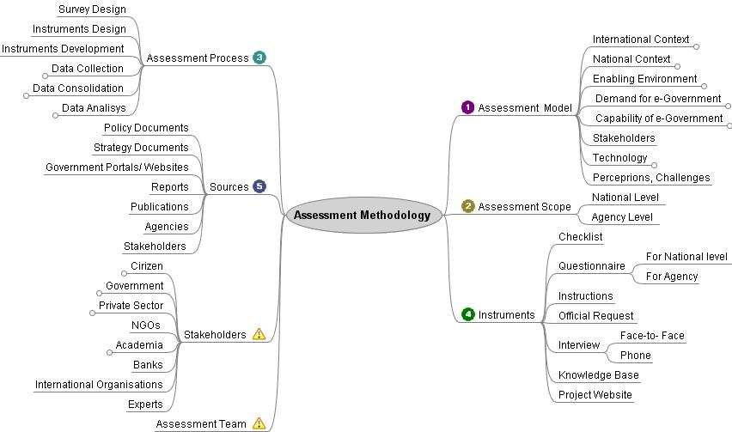

Figure 1: Key Elements of e-Government Readiness Assessment Methodology (Shareef, 2008)

Lastly when looking into common reasons why most e-Government implementations in developing countries fail, it is clear to see where others have faltered. These include approaches for example, by simply adding a computer system at an organisation and expecting “the computer system” to solve the many problems it was sold to overcome in the first place to the customer. Heeks (2002) has identified the gaps below that are common in failed e-Government implementation in developing countries.

- Hard-Soft Gaps: the difference between the actual technology (hard) and the social context (people, culture, politics etc.) in which it operates (soft).
- Private-Public Gaps: the difference between the private and public sectors means that a system that works in one sector often does not work in the other one.
- Country Context Gaps: the gap that exists when trying to use the e-Government systems for both developed and developing countries (Heeks, 2002)

E-Government in Municipalities

Municipal governments are the one on the ground, where they interact closely with the communities. By their nature, local governments facilitate the culture of solutions for local problems to the communities and foster development agendas. Municipalities are the closest governing body to citizens in decentralized systems according to Musa (2010) and therefore they will play a pivotal role when measuring the e-Readiness of a nation. Numerous fundamental and strategic challenges are faced by countries during the implementation of e-Municipality, of which organisational readiness is identified as one of the challenges, according to Bojang and Bwando (2018). As stated by Stevanus (2006), the success of implementing e-Government has a positive correlation with the e-Readiness of that implementation and therefore e-Readiness is a precondition of e-Government implementation. Various factors including information and communication technologies, infrastructure, human resources and culture should be examined and understood to enable governments to better plan and implement. It will also assist with administrating newly implemented systems, to better manage government resources and improve community relationships amongst stakeholders (Musa, 2010). He added that, e-Readiness assessments only provide a snapshot of the current e-Readiness level and therefore have a “brief shelf life in a rapidly changing environment” (Musa, 2010). Conducting of comprehensive e-Readiness assessments in short periods of time will always be challenging and resource intensive. The importance of e-Readiness ranking can be highlighted by the fact that it is easy to use these figures. Having a set of quantifiable indicators can easily provide an overview of a Local Authority’s situation and this can provide the basis of comparison and enable better future planning (Dada, 2006).

Local governments initiate e-Government programs in line with development agendas in their national plans (Koh, 2002). In the study carried out by Mohammad and Yoones (2012), they suggested that e-municipality is the main step of governments in the first decade of the third millennium. He further noted that improving the cultural, social and political infrastructure and gaining the e- Readiness in order to establish the e-municipality is considered as the main municipalities’ mission, (Shahnavazi, 2012). In his study, Shahnavazi (2012) concluded that the e-Readiness of the municipality is remarkable from the organisational, system-services and infrastructural perspective. The setting up of the e-municipality would improve the business environment, strengthen the social participation and increase the public sectors effectiveness and generally the citizen’s quality of life. E-municipality is one of the sub-groups of e-Government that gives electronic services (e-services) to citizens in a smaller scale, within cities. E-municipality is part of the ICT and facilitates the implementation of government daily life (Toots, 2007). It is the transparency and accountability in the e-municipality that provides opportunities for citizens to participate in political, social activities and decision-making processes in their communities (Norris, 2005). E-municipality strengthens good governance and broadens public participation. However, Norris (2005) stated that the implementation of the e-municipality requires the readiness of the organisation, the infrastructure and the citizens’; and this will provide for the reduction of redundancy regulations in the municipality and surrounding organisations, including the private sector (Scott, 2005). Therefore, an e-Readiness assessment is necessary.

E-Readiness Assessment

The rapid rate of internet penetration all around the world compounded by the dramatic advancement in the adoption of the ICT, has seen the rise in demand for the e-Readiness of communities. E-Readiness has been defined in many varying ways. Harvard’s readiness guide (www.readinessguide.org) has defined e-Readiness as “the degree to which a community is prepared to participate in the Networked World”. The Centre for International Development (CID) (2000), defines an e-ready society as, “one that has the necessary physical infrastructure, integrated ICTs throughout businesses, communities (local content, many organizations online, ICTs used in everyday life, ICTs taught in schools) and the government (e-Government); strong telecommunications competition; independent regulation with a commitment to universal access”. However, the ability of the community to absorb ICT and use it for economic and social benefit is further strengthened by e-Readiness. According to Bridge (2005), e-Readiness measures the access and use of ICT by the community, which is the status or quality of readiness for a society or an economy to use electronic technology. Nevertheless, e-Readiness assessment involves assessing e-Readiness from different perspectives looking at a long-term vision, formulating strategies, goals and objectives, defining priorities and aligning organisational goals and objectives with national development strategies. E-Government readiness assessment evaluates how ready a country, a city or a government agency is to develop e-Government (Jiang, 2011). According to Ojo (2007), the notion of e-Readiness covers political, regulatory, organisational, cultural, communication and technological factors (Ojo, 2007). The underlying understanding is that the digital economy can assist in building a better society. E-Readiness assessment examines the network society, network access, network education, network economy and network government. A recent study by Manoharan and Ingrams (2018) have indicated ICT skills are closely related to the success of e-Government. Through e-Readiness assessments, the shortage of such skills can be determined, which according to these studies could assist academia on assessing programs offered versus what employees need at their work places.

As a country, e-Readiness is a measure of the country’s business environment and how the market is acquiescent to ICT opportunities. In many parts of the world e-Readiness of governments has become an important policy, which has been adopted through principles of good governance. According to Holdern and Millert, (2005), e-Readiness for government offers a way for citizens to interact with the government and enhances trust, which fuels economic efficiency and business.

The need to carry out e-Readiness for communities and Local Authorities still remains very important (Dada, 2006). It is with e-Readiness assessments that leadership at various levels is assisted to plan ahead for integration of ICTs. It will also provide one with a quantifiable set of indicators, which will show an overview of the local authority’s situation and may be used in future as a comparison baseline (Dada, 2006). As stated by Matthew and Monica (2011) e-Readiness assessments assist to plan ahead for integration of ICT, identify areas where further attention is needed and thus focusing their efforts (Monica, 2011). Decision makers can be held accountable for failed/slow or non-existing e-Government adoptions in Local Authorities according to (Lourenco, Pedro, Piotrowski and Ingrams, 2017). Furthermore, they highlighted the fact that the assessment itself is not a goal but should be the tool used for strategising and the creation of an action plan that will address the issues identified in the e-Readiness assessment to further the objectives of the country in e-Government planning and subsequent implementation. The development of any country sits on e-Readiness, which represents the transformation of the society from traditional relations and methods to more entrepreneurial thinking (Bacook, 2005). Ingrams (2017) believe that by looking holistically at Government institutional models and their important characteristics, it can assist in determining how they shape the growth of e-Government. Globally, e-Readiness facilitates the sources of competitive advantage and opportunities for economic and social development (EIU, 2003).

E-Readiness Assessment Tools

Redep (2016) stated that, “E-readiness assessment tools are meant to provide the best possible indication about measurable variables affecting e-government so as to help decision makers in deciding what to focus on and to what extent improvements should be made to the different aspects measured to enhance the overall e-Readiness of the country or part of it or just an organization” (Ređep, 2016). There are numerous e-Readiness assessment tools that have been used over the years in many countries including Namibia, at a national level. None of them focused on the e-Readiness for Local Authorities and the citizens. Bridges (2001) states that each tool measures how ready a society or economy is to benefit from Information Technology (IT). E-Readiness assessment tools vary a great deal and although e-Readiness assessments are of utmost importance, one cannot simply take the first available tool or framework to conduct assessments (Musa, 2010). Most e-Readiness assessments done in developing countries focused on the national level and not on the Local Authority or organisations. Musa (2010) suggested that since e-Readiness assessments for e-Government implementation are such a tough exercise and each government or entity has its own goals, this might lead people to adopt an existing assessment tool and tweak it to cater for its own objectives and that which is relevant to their local realities (Musa, 2010).

These tools are different in their definitions and at the same time differ in methods for measurement. According to the Computer System Policy Project (1998) “An e-ready community is defined as one that has high-speed internet access in a competitive market; with constant access and application of ICTs in schools, government offices, businesses, healthcare facilities and homes; user privacy and online security and government policies which are favorable to promoting connectedness and use of the Network.” There are five categories of measurement for e-Readiness and these are access, infrastructure, application and services, economy and enablers, which are policies, privacy, security and ambiguity (Gupta, 2005). To measure these requires assessment tools and models. So many e-Readiness tools have been developed to measure the level of e-Readiness of various governments and nations (Abhijit. G, 2015).

An analysis of E-Readiness measurement tools

Table 1 below shows a comparative analysis between selected e-Readiness assessment models, which have been adopted in various environments. Presented in a table format, each model is presented along with the entity that developed it, its focus, and the main components it measures, based on the classification presented above.

 | Focus | IT Infrastructure | HR | Policies and Regulations | Environment | e-Government Transformation
1- Center for International Development – Harvard University and IBM (CID) | e-society | √ | √ | √ | √ | Government effectiveness in promoting the use of ICT  Availability of online government services  Extent of government Websites  Business Internet interactions with government
2- Center for International Development and Conflict Management (CIDCM) | e-society | √ | √ | √ | √
3- International Telecommunication Union (ITU) | e-society | √
4- World Bank (Knowledge Assessment Methodology - KAM) | e-economy | √ | √ |  | √ | Availability of e-Government services
5- World Economic Forum, Infodev & INSEAD (Network Readiness Index - NRI) | e-economy | √ | √ | √ | √ | Government use of ICT for its own services & processes  Volume of transactions that businesses have with governments  Presence of government services online
6- U.S. Agency for International Development (USAID) | e-society | √ | √ | √ | √ | ICT usage in government (hardware, software, and networks in each ministry)
7- The World Information Technology and Services Alliance (WITSA) | e-economy | √ | √ | √ | √
Table 1: Source: Nahed A. Azab, Assessing Electronic Government Readiness of Public Organizations, Communications of the IBIMA Volume 8, 2009. (Nahed A. Azab, 2009)

The above analysis shows that e-Readiness tools, such as CIDCM, ITU, and WITSA do not include e-Government in their assessments. CID, KAM, NRI, and USAID do not consider all internal factors. They assess the availability and number of e-Services, promotion and usage of ICT by the public sector.

One of the tools was developed by Bakry (2000 and 2002), in his model STOPE.
Strategy
Technology
Environment
People
Organisation
Development

Figure 2: The Basic Elements of Development: Bakry’s STOPE,
Source: (Bakry, 2004), Development of e-government: A STOPE view

The STOPE framework is used to assess the integration of five e-Readiness factors which are strategy, technology, organisation, people and environment. The STOPE is used to evaluate different ICT problems which includes among other things e-business and e-Government planning, information security management (Bakry, 2004) and enterprise resource planning, Bakry (2005 and 2006). It is a holistic evaluation model to e-Readiness.

Strategy
Strategy is the means to reaching the intended goals or objectives. In order to adopt an e-Government, a robust strategy must be set up as the first step (Raffat, 2003). Since the development of the strategy is most crucial, it should be aligned with the organisation’s business strategy (Beaumaster, 2002). The strategy is there to set an action plan, clearly outlining accountability, organisation structure, resource allocation, systems, policies, procedures and leadership (Zahra and Covin, 1993).

Processes
The two processes involved here are business processes and e-Government evaluations (Scholl, 2003). Business processes should be integrated internally and e-Government evaluations should be considered as a systematic approach which should be performed periodically (Accenture, 2005). The processes include motives, vertical and horizontal integration, usage, feedback mechanisms and stakeholder engagements.

Technology
It is technology that constitutes the important factor influencing e-Government success. According to Woodroof and Burg (2003), technological dimension should also consider the quality of the hardware, and the technical support and development provided by the IT department to the entire organisation referred to as service quality. It encompasses information quality, systems quality, web presence quality, security measures, hardware and technical support and development.

People
The main success factors of the e-Government are the people. This includes user satisfaction, employee skills, knowledge, and proficiency in using IT (Bailey and Pearson, 1983).

All three factors: processes, technology, and people, are affected by e-Government strategy since this strategy comprises a number of aspects that cause major changes in the mentioned three factors. An efficient e-Government strategy, if followed, should have a direct impact on them (Azab, 2009).

2.8 Conclusion

In this Chapter, the literature on e-Government and e-Readiness assessments from different authors was reviewed with particular emphasis on e-Readiness assessments and the tools available. Comparative analyses were done on different e-Readiness assessments and their focus areas. Finally, e-Readiness assessment methodologies used at Municipalities were examined. The next Chapter will elaborate on the methodology for this research.

RESEARCH METHODOLOGY

Introduction

The purpose of the proposed tool is designed to support the management of the Municipality of City of Windhoek to measure their e-Readiness. Those measured include human, technological, regulatory and organisational factors that have been identified and which will impact e-Readiness; this will inform them on how e-ready they are to implement ICT services. It is supposed to highlight any weaknesses for organisations to improve on and thereby increase the success of launching e-Government services.

Methodology

The e-Readiness assessment proposed in this study aims at addressing information requirements for local authorities to enhance strategic planning by assessing demand and capabilities within the local context, as well as the enabling environment and ICT infrastructure. As most e-Readiness assessments done in Namibia in the past mainly focused on the national level and not on the local authority level. This tool will enable easier and faster gathering of e-Readiness data for local strategic development planning. However, the design strategy requires a clear method in order to come up with an effective, attractive and user-friendly tool.

The methodology defines the research philosophy, approach and strategy. It also defines the model, scope and process for the instrument design, as well as data collection and data analysis to address information requirements for e-Readiness strategic planning.

Research Philosophy

Research philosophy is distinct by the type of knowledge in the research project that is being investigated (May, 2011). It also examines belief on how data should be collected and analysed about a phenomenon (Levin, 1988). Two main ontological frameworks can advise the research process namely positivism and constructionism (Monette et al. 2005).

Pragmatism
This philosophy argues that the most important factor of the epistemology, ontology and axiology is derived from the research question and the use of mixed methods, i.e. qualitative and quantitative methods, which are used in this philosophy to address real life challenges (Ihuah and Eaton 2013).

Positivism
This research approach makes use of experimental methods to gather data and mostly uses quantitative methods to analyse (Urus 2013). It uses rational means to answer concepts and theories (Saunders, 2009).

Interpretivism
The researcher is involved when analysing elements of the study and therefore stresses qualitative analysis over quantitative analysis (Saunders, Lewis & Thornhill, 2012).

Realism
This research philosophy is based on the idea that what we witness as humans using our senses is the truth. The latter is also defined as direct realism while critical realism argues that the same senses can be deceived in the real world as explained by Saunders et al (2012).

The research will adopt a positivism approach as “Positivist e-government studies hold a realist, objective ontology, where ontology refers to a set of assumptions about the nature of reality”, (Heeks and Bailur, 2007; Tan et al, 2007).

3.4 Research Approach

Two types of approaches are listed below;

Deductive approach
The deductive approach develops the hypothesis upon an existing concept and then formulates this approach to test it (Silverman, 2013).

Inductive approach
The inductive approach uses observations as the starting point for the researcher, and then patterns are analysed in the data (Beiske, 2007).

The deductive approach is considered best suited to the positivist philosophy and thus also for this research. This approach allows for the formulation of hypotheses and the numerical testing of expected outcomes to an accepted level of probability (Snieder & Larner, 2009).

3.5 Research Strategy

Research strategy is how the researcher intends to conduct the research (Saunders et al., 2007). Different strategy approaches exist, such as experimental research, action research, case study research, interviews, surveys and systematic literature review. Experimental research is a research process that examines the results of an experiment against the expected results (Saunders et al., 2007). According to Bryman (2012) Action Research is defined as a practical approach to an identified problem within a community of practice. Bryman (2012) stated that case study research is the assessment of a single entity in order to determine its key features and identify generalisations. “It can offer an insight into the specific nature of any example, and can establish the importance of culture and context in differences between cases” according to Silverman (2013).

Case study research strategy has been selected as it is deemed suitable where research is being piloted in an organization, where few or no previous studies have been conducted (Benbasat, 1984; Yin, 1984). The case study was conducted at the Municipality of City of Windhoek.

3.6 Instrument design

Scope
The scope of the project design was the initial stage prepared as a guide to the design and stakeholder engagement in the process.

Design method
The output of this project was an automated online e-Readiness assessment tool which is an online questionnaire with automated analysis capabilities. Both local and national e-Readiness assessments require various types of instruments for specific purposes at different assessment stages. The proposed assessment model was adopted from literature review as it covers the most critical areas when assessing e-Readiness, namely Infrastructure, Human Resources, ICT Deployment, Policy and Regulatory frameworks. Questionnaires used for the prototype tool were adapted to suit the needs for the piloting of this tool from Wole and Opesade (2008). This study included two questionnaires, in Appendix A ICT Stakeholder Questionnaire and Appendix B Academic Staff and Students Questionnaire.

The questionnaire titled ‘ICT Stakeholder Questionnaire’ was incorporated into ‘An E-Readiness Assessment of the Municipality of City of Windhoek – ICT Department Only’ (see Appendix C). The original questionnaire consisted of 30 questions and the adapted questionnaire contained 38 questions (see Appendix A). A total of 24 questions were derived from the original questionnaire and were mainly rephrased to suit the audience. Questions 20, 21 and 24 were not used from the original questionnaire as it was a repetition for the intended audience, while question 24 would have been only for ICT management’s knowledge. Furthermore, a total of four questions were added to illicit more information on the training and human resource area. Lastly, a total of eight demographic questions were added to assist report reviewers in better understanding the origin of certain information.

The second questionnaire titled Academic Staff and Student questionnaire, was incorporated into ‘An E-Readiness Assessment of the Municipality of City of Windhoek – All Departments’ see Appendix D. The original questionnaire consisted of 21 questions and the adapted questionnaire contained 20 questions. A total of 14 questions were derived from the original questionnaire and were mainly rephrased to suit the audience. Questions five, seven, eight and nine were not used as it was irrelevant for the intended audience. Lastly a total of six demographic questions were added to assist report reviewers in better understanding the origin of certain information.

Online questionnaires were created using Microsoft Forms™ and were authorised for distribution by the Strategic Executive: ICT at the Municipality of City of Windhoek. The electronic version also enabled the gathering of information about the respondents, their roles and development of City of Windhoek’s 5-year Strategic Plan (2017-2022). No face-to-face interviews were conducted as the questionnaire is an online tool that people access through a link and complete using internet at any point using either a computer or mobile device. The tool design ensured that the questionnaire is answered online and an information database was available where all information would be centrally collected, categorised and analysed automatically. The collective responses all by itself producing informative results ready for decision making and strategic planning through a detailed report found online, as results get depicted herein.

3.7 Pre-testing of Questionnaires

Both questionnaires were piloted with five respondents who consisted of two males and three females. It showed that the questions were clear and the subjects would understand how each question should be answered as all questions in both questionnaires were answered. The questionnaire completed by all departments took on average 30 minutes and the questionnaire completed by the ICT department took 12 minutes on average. Following the pre-testing, the questionnaires remained unchanged.

Pilot case study

The last step in the preparation stage involved performing a pilot case study to test the instrument developed for gathering quantitative data. The two adapted questionnaires discussed earlier were distributed as follows, one for all staff in the ICT department and the second questionnaire for all other staff members from Finance and Customer Services, City Police, Urban and Transport Planning, Economic Development and Community Services, Office of the CEO, Electricity, Human Capital and Corporate Services, Infrastructure, Water and Technical Services, Housing Property Management and Human Settlements departments. The ICT Department was selected to provide information on e-Readiness Objectives, Policy and Regulation Framework, ICT deployment in the Municipality and all other departments within the Municipality were selected to provide information on ICT Infrastructure Access Level, Training and Human Resources. The sample selected and used in this pilot study ensured that the tool addressed the needs and answered the objectives of this research. The research purpose was to design an automated tool that would simplify e-Readiness data collection and analysis to address information requirements, for realistic and effective local e-Government strategic planning. It will further satisfy the information requirements for demand and supply components of e-Government at local levels of government, and to assess technology, resources, online services, local contexts, and perceptions and challenges for local e-Government development.

3.8 Data Analysis

The survey data collected during the pilot study enters directly into a Knowledge Base Data Base developed for data consolidation and analysis within the tool. It was automatically sorted and analysed. The statistical variables collected and social network analysis were analysed automatically by the system providing quality information for strategic decision-making. At the same time, the process included concrete measures to ensure quality, integrity and confidentiality of information gathered. Results were publicised to check for any variabilities and do corrective measures. The results were tested against the objectives of the tool design and the intended purpose.

3.9 Reliability and Validity

3.9.1 Reliability
The reliability of data collected through the use of the online tool was ensured as the respondents were the only ones who administered it. The completed questionnaires showed a level of consistency in the way in which questions were answered. It can be assumed that the data provided was suitable to fulfil the aim of the questionnaires as respondents had enough time and in their own comfort to work through the questions. The instrument was adopted from an existing questionnaire; therefore, all items were tested beforehand for reliability.

3.9.2 Validity
The questions in the online questionnaires were adopted from Wole and Opesade (2008) and the original questionnaire was formulated and tested for validity to ensure applicable data is mined upon completion in order to answer the research questions. Both questionnaires were piloted with five respondents which consisted of two males and three females. It showed that the questions were clear and the subjects would understand how each question should be answered as all questions in both questionnaires were answered. Hyperlinks were electronically sent to respondents to ensure that it was received in a timeous manner.

3.10 The Survey

The Online tool explores information on the use of IT services which includes factors such as human, technological, regulatory and organisational factors. The tool comprised of:

- General personal information (e.g. age, gender, education level)
- Skills of computer software usage
- Speed and reliability of internet connection
- Connectivity and access
- Types of services used on the internet

3.11 Ease of use

The tool should be user friendly and not difficult to use, it will not include all factors as with the case of high-level tools. This is more in line with the environments of the Municipality of City of Windhoek and Namibia in general where availability of infrastructure and other characteristics required by high-level tools are not available.

3.12 Conclusion

The Chapter outlined the research methodology of the study, which condensed the research method, research design, research instrument design, testing of the tool, data collection, data presentation, and analysis using the designed tool to assess its effectiveness. It revealed and justified the research methodology used to obtain answers to the research questions in Chapter one, equally, as it justified the survey research method as the most contingent to the designing of an Automated e-Readiness Assessment tool to assess Local Authorities in Namibia.

4. DATA COLLECTION AND ANALYSIS

The following chapter outlines the data presentation and analysis of the research findings

4.1 The tool design

The tool was designed in a five-dimension strategy:

1. e-Readiness Objectives
2. Policy and Regulation Framework
3. ICT Deployment
4. ICT Infrastructure Access Level
5. Training and Human Resources

These five categories would then be measured with data collected using the predefined scale in Table 2 below:

Rating | Interpretation (%) | Used Value
Very High | 0 -24 | 1
High | 25 – 49 | 2
Low | 50 – 74 | 3
Very Low | 75 – 100 | 4
Table 2: Predefined rating scale

Computing of e-Readiness Indices

e-Readiness index formula as presented by Wole and Ospenade (2008) is as follows:

e-Readiness index = Σj=1,n wij eij /n

Where:
e-Readiness: the overall e-Readiness value j: each of the five (5) indicators wij: relative weights assigned to the five (5) indicators (j) eij: individual index score for each indicator on a scale of 1 to 4 n: total number of measures (5)

Data collected with the questionnaire were computed and converted to scales using the predefined scale in Table 2.

Calculated Value (%) | Converted value (scale)
0 – 24 | 1
25 – 49 | 2
50- 74 | 3
75 – 100 | 4
Table 3: The predefined scale for questionnaire analysis

Based on this, the overall e-Readiness index of the Municipality of City of Windhoek = (4+3+3+2+1)/5 while the overall e-Readiness index of the Municipality = 2.6 (See Table 4).

e-Readiness Indicator | Contributory Parameters | Calculated value | Parameter Index | Indicator Index
ICT Infrastructural Availability | Computers | 88% | 4 | 4
Access to ICT Infrastructure | Access in Department | 32% | 2 | 3
Access to ICT Infrastructure | Access in Office | 63% | 3 | 3
Training and Human Resources | Trained Users | 48% | 2 | 3
Training and Human Resources | Users possessing enough skill | 95% | 4 | 3
Training and Human Resources | Users needing more training | 56% | 3 | 3
Training and Human Resources | Measures in place to train users | 50% | 3 | 3
Enabling Policy and Regulatory Framework | Effectiveness of staff enabling policies | 48% | 2 | 2
Enabling Policy and Regulatory Framework | Effectiveness of controlling regulations | 5% | 1 | 2
ICT Deployment | Deployment in staff based activities | 7% | 1 | 1
Table 4: Municipality of City of Windhoek’s e-Readiness Indicators and Indices

4.2 Results obtained from online Questionnaires

4.2.1 Table 5: below are the results collected from the online questionnaire sent to all departments at the Municipality of City of Windhoek. The questionnaire was separated into four sections, namely Employee Data, Internet Access, Manpower and Demographic Data each will be discussed individually.
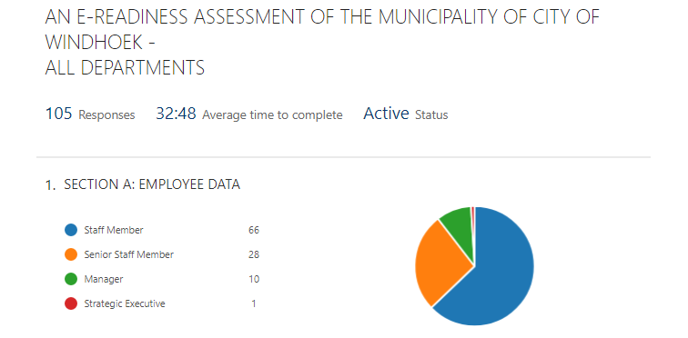
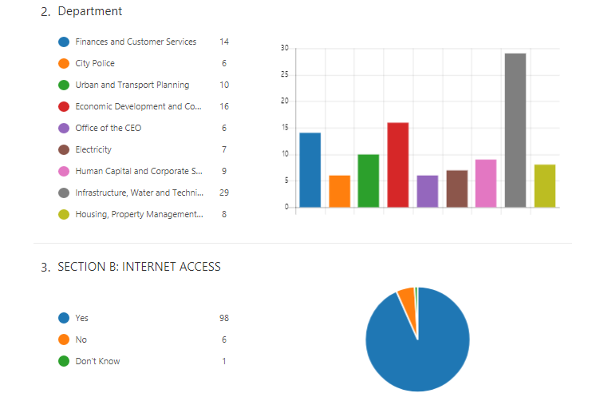
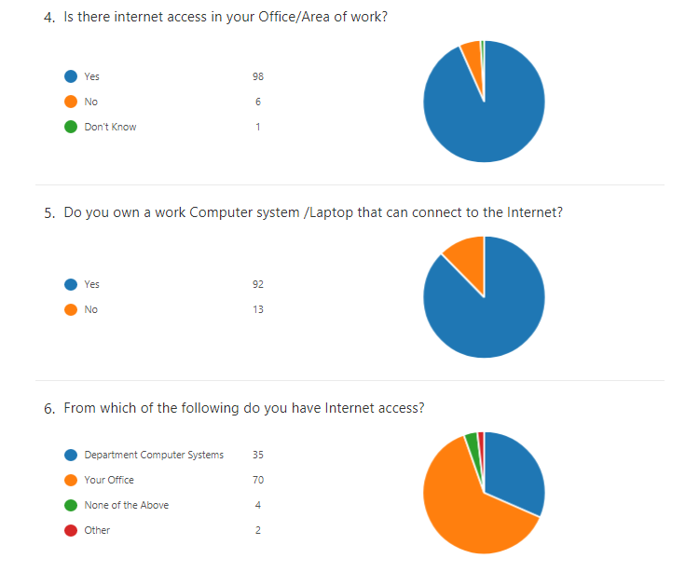
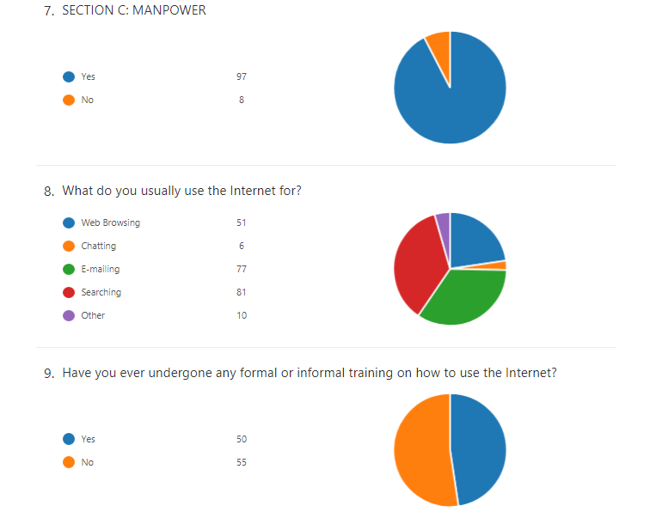
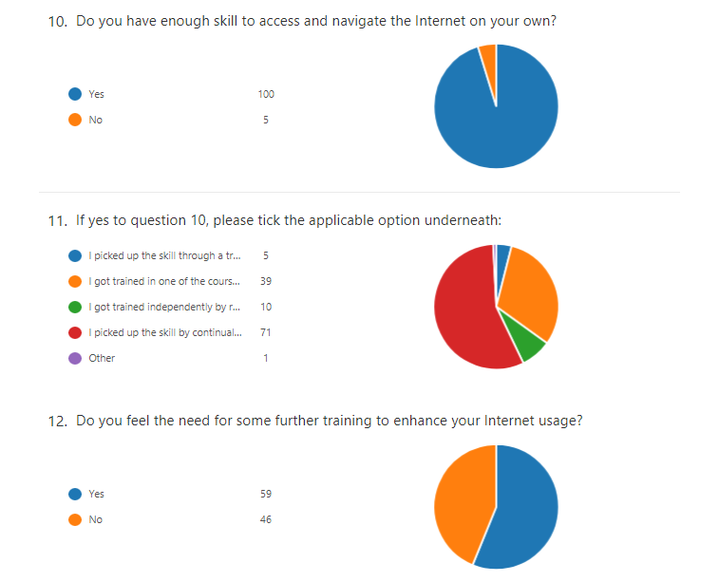
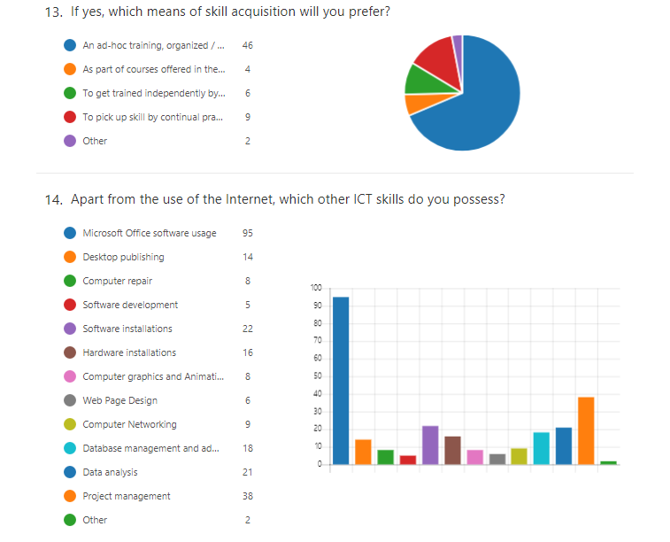
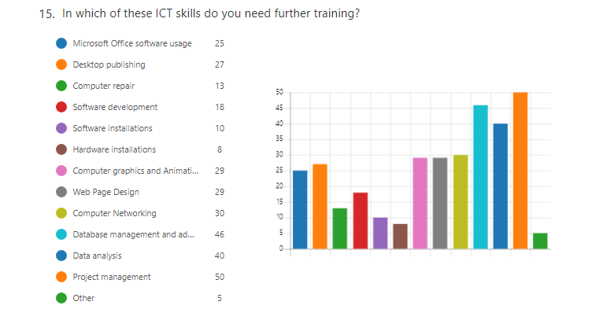
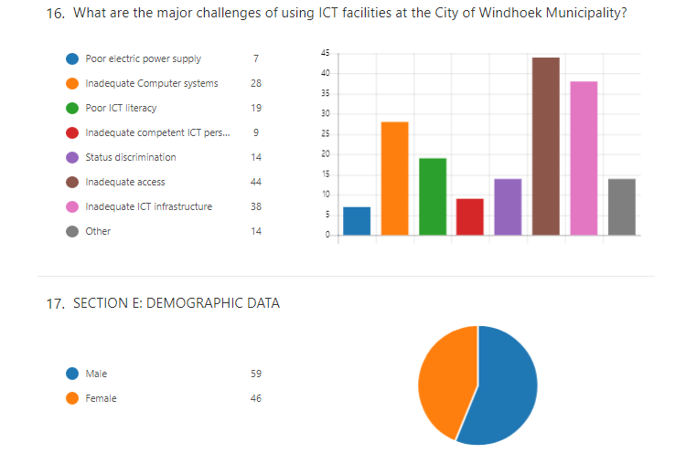
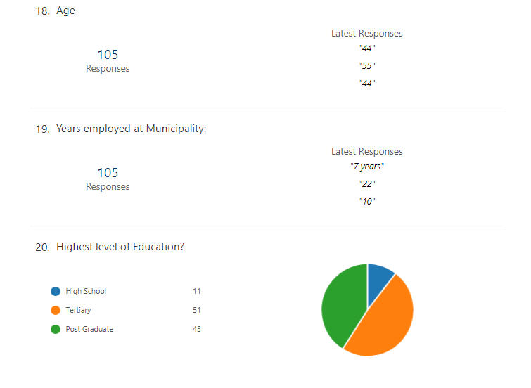
Table 5: Results: E-Readiness Assessment of the Municipality of City of Windhoek – All Departments

A total of 105 respondents completed the online questionnaire and it took them on average 32 minutes to complete the 20 questions in the said questionnaire.

Employee and Demographic Data:

Overall feedback received consisted of 63% staff members, 27% senior staff members, 10% managers and 1% strategic executive. Department representation was noted as follows from the highest to lowest participation:
- Infrastructure, Water and Technical Services (28%),
- Economic Development and Community Services (15%),
- Finance and Customer Services (13%),
- Human Capital and Corporate Services (9%),
- Housing, Property Management and Human Settlements (8%),
- Electricity (7%),
- Office of the CEO (6%) and
- City Police (6%).

The number of male (59) respondents was more than the number of females (46) who responded. Their ages vary from youngest of 23 years old up to 57 years of age. Years employed ranged from less than a year of employment and up to 29 years of employment at the City of Windhoek. On the question on highest qualification obtained, 10% indicated that they completed high school while 49% stated that they had completed a tertiary qualification and of note a total of 41% had successfully completed a post graduate degree.

Internet Access:

The purpose of this section was to determine ICT Infrastructural Availability and Access to the internet across all departments. 93% indicated that there is access to the internet from either their office or area of work, while 6% confirmed that they do not have such access. 88% of staff members indicated that they do have a working computer system that can connect to the internet while the rest do not have. According to the data received the majority (63%) have access in their offices, 32% from a department shared computer system while only a small number of respondents (4%) indicated that they do not have access from any location stipulated.

Manpower:

The data showed that 92% of respondents make use of internet facilities at work, despite the fact that only 48% have received training on how to use internet facilities. They indicated that they mainly use the internet facilities for searching (36%), e-mailing (34%), web browsing (23%), others included research and chatting.

On their ability to access and navigate the internet on their own, almost all (95%) specified that they do possess the skill. The follow up question tried to reveal how they came about the ability and the data showed that 56% of users picked up the skill through continuous practice, second highest (31%) rating indication revealed that this skill was taught in one of the courses offered in their academic curriculum. 8% of respondents registered independently at a Computer School while only 4% received training by means of a workshop or training sponsored by the employer. With the bulk of staff member’s ability to access and navigate the internet on their own, the result indicates that 56% of them feel that there is a need for further training to enhance their internet usage skills. The latter indicated that the best way to receive such training would be through ad-hoc trainings sponsored by their respective departments. Respondents were also asked on other ICT skills they possessed apart from the ability to use the internet and 95% indicated they are conversant with Microsoft Office software packages and 38 stated that they have Project Management skills. Software installations and data analysis received over 20 responses while the rest, which includes desktop publishing, computer repairs, software development, hardware installations, computer graphics and animation, webpage design, computer networking and database management and administration, all received less than 20 responses in terms of possession of such skills. On the same list of ICT skills presented, 48% of respondents indicated that they would like further training on Project Management. Database Management and Administration were selected by 44% and 38% of staff members indicated that they need further training on data analysis. The remainder of the ICT skills received 29% or less responses. Lastly the study wanted to identify what the major challenges are at the City of Windhoek that would limit the use of ICT facilities. Inadequate access (42%) was listed as the most limiting factor, followed by inadequate ICT infrastructure (36%). These were followed by poor ICT literature (18%), status discrimination (13%), inadequate competent ICT personnel (9%) and poor electric power supply (7%).

4.2.2 Table 6: below are the results collected from the online questionnaire sent to only the ICT department at the Municipality of City of Windhoek. The questionnaire was separated into five sections, namely Employee Data, Municipality E-Readiness Objective, ICT Policy and Regulatory Framework, ICT Deployment in Municipality Activities and Demographic Data. Each section will be discussed individually.

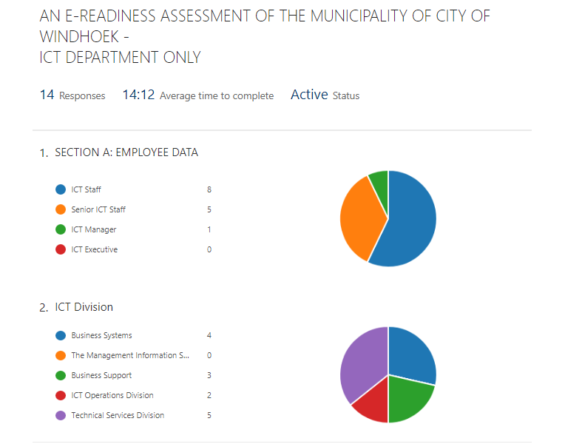
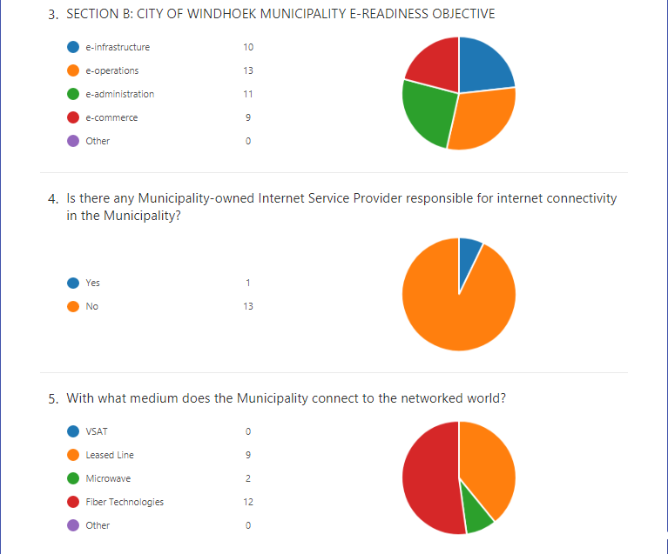
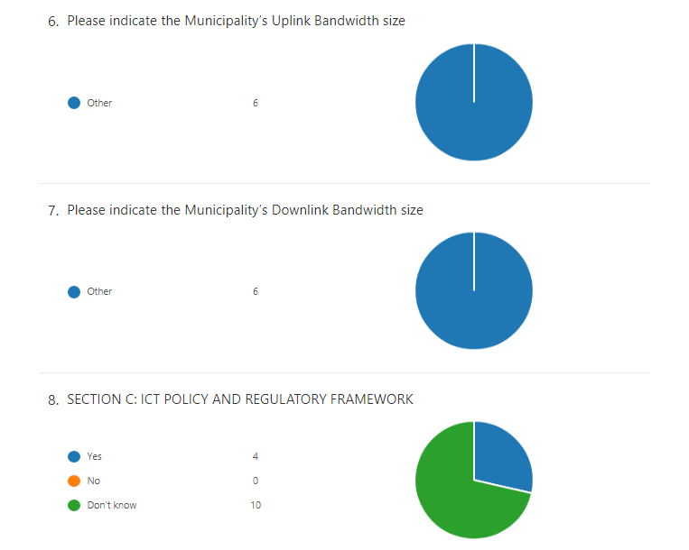
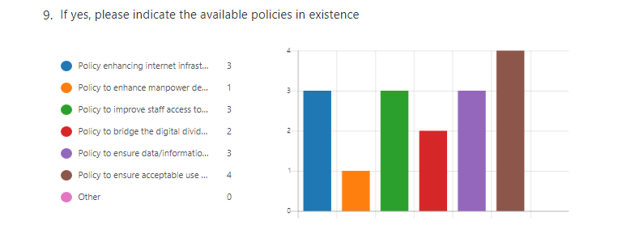
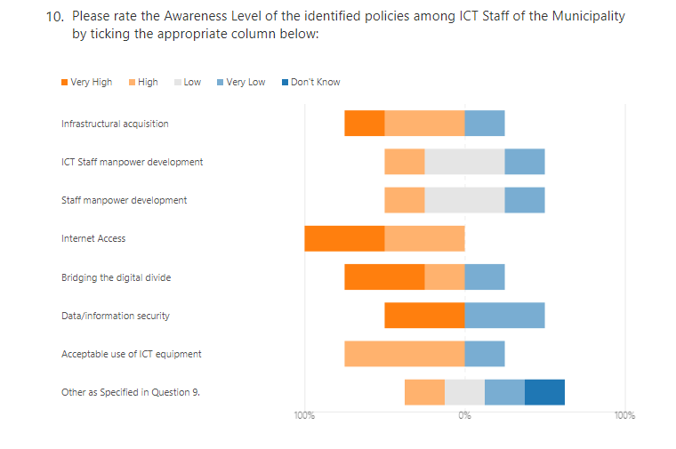
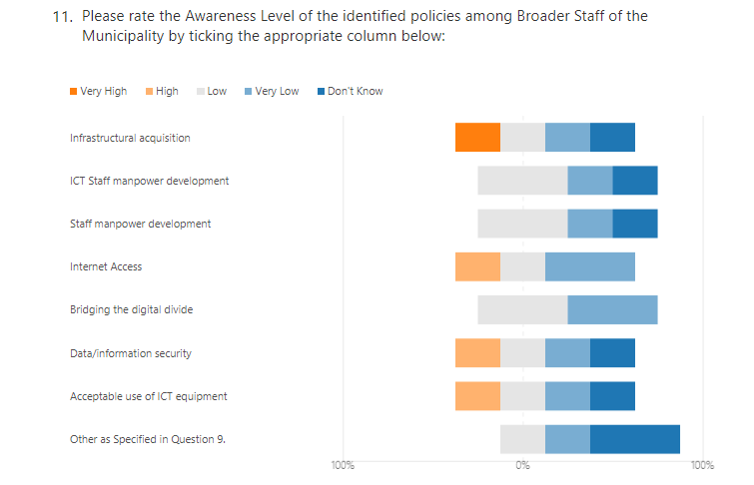
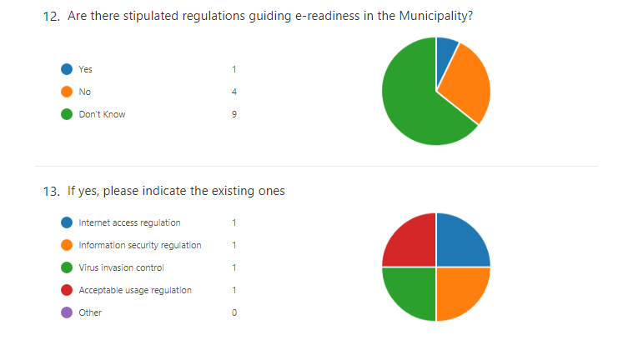
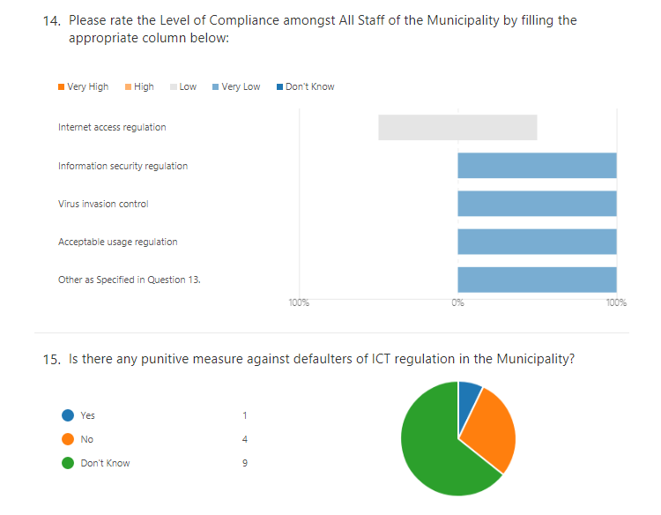
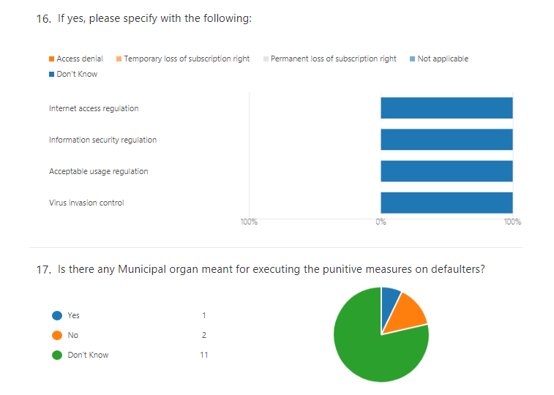
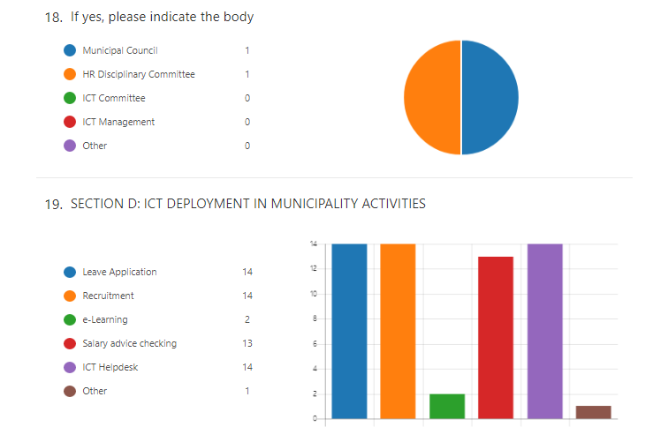
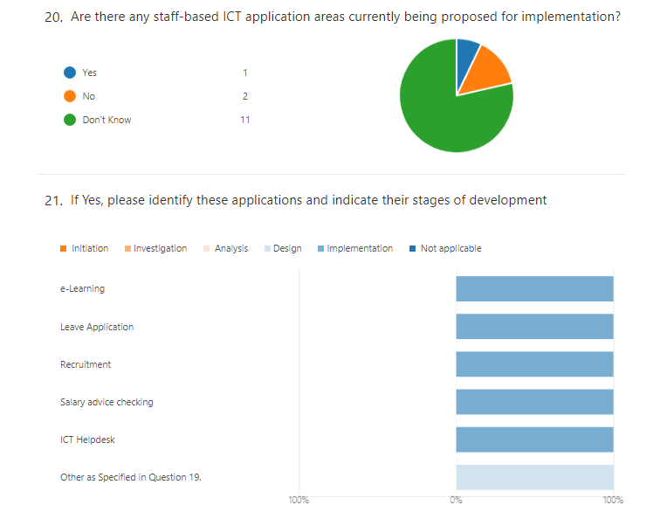
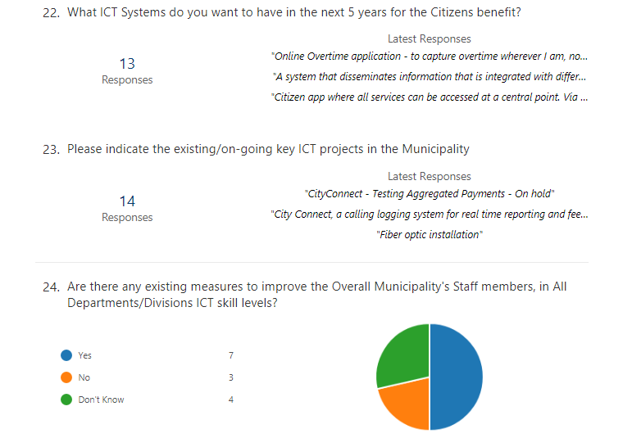
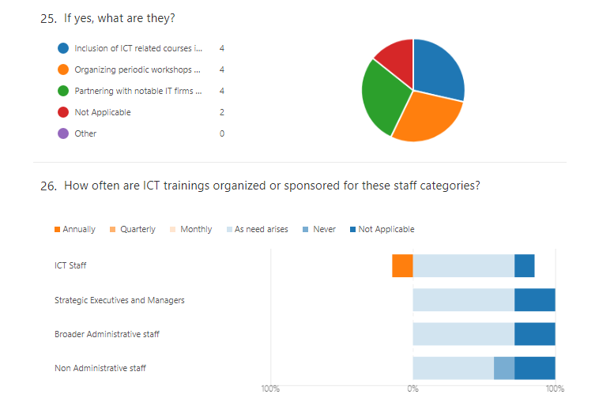
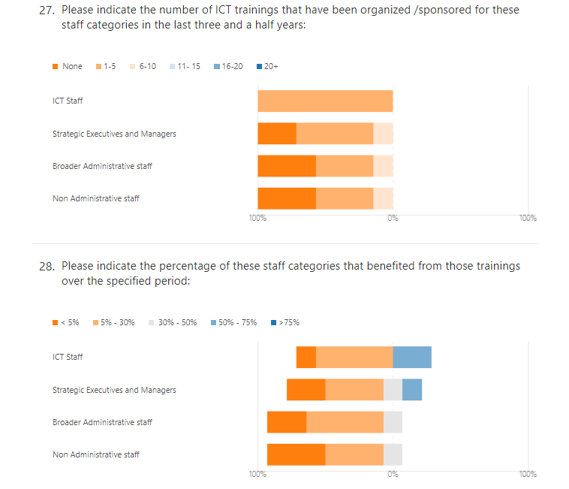
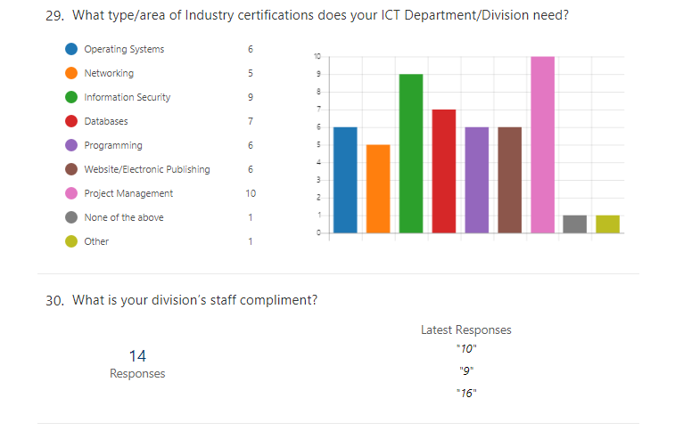
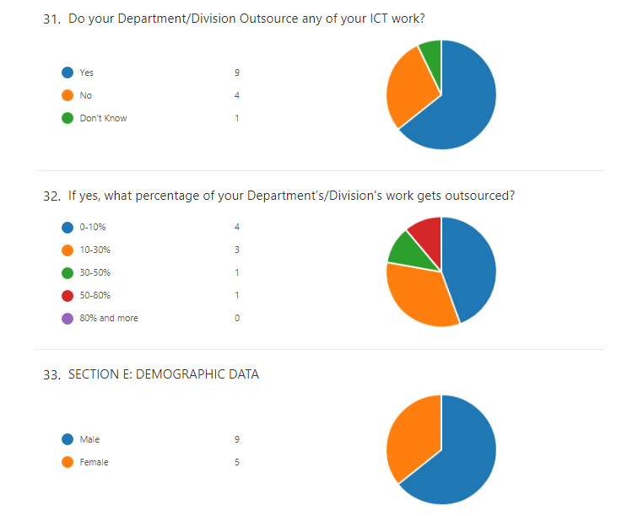
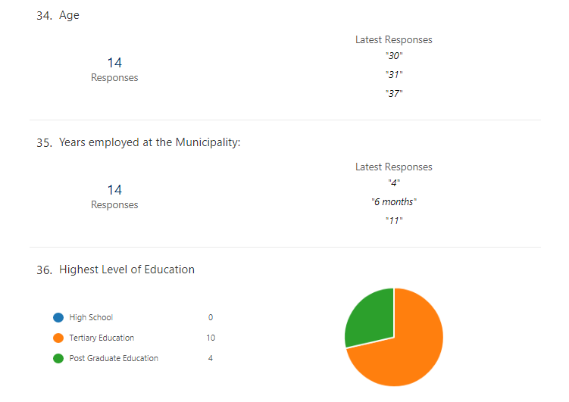
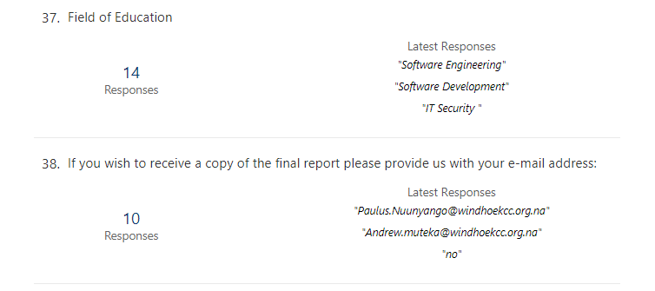
Table 6: Results obtained from an e-Readiness assessment from the Municipality of City of Windhoek – ICT Department only

As per Table 6 above a total of 14 respondents completed the online questionnaire and it took them on average 14 minutes to complete the 38 questions in the said questionnaire.

Employee and Demographic Data:

Overall feedback received included 57% ICT staff members, 36% senior ICT staff members, 7% ICT managers and no ICT Strategic Executive took part. Department representation was noted as follows from highest to lowest participation. The department of Management Information Systems was not available during the data collection period, hence the zero participation.

- Technical Services Division (36%),
- Business Systems (29%),
- Business Support (21%),
- ICT Operations Division (14%),
- Management Information Systems (0%)

The number of male (nine) respondents was more than the number of females (five) who responded. Their ages vary from the youngest of 30 years old up to 47 years of age. Years employed ranged from less than a year of employment and up to 23 years of employment at the City of Windhoek. On the question asked on the highest qualification obtained, 71% stated that they had completed a tertiary qualification and the remaining 29% had successfully completed a post-graduate degree.

Municipality E-Readiness Objective:

The purpose of this section was to establish what the ICT objective of the Municipality is and to gather information on their internet infrastructure. All objectives presented to respondents were selected and these included e-infrastructure, e-operations, e-administration and e-commerce. The results indicate that there is no uniform or agreed objective within the ICT Department.

On internet infrastructure, the municipality makes use of ISPs to provide internet services to them and mediums used include fiber technologies, leased lines and microwave as revealed by the data. Internet capacities could not be concluded from insufficient data provided by the ICT department staff members, as different speeds were given for 10MB, 20MB and 1GB.

ICT Policy and Regulatory Framework:

Most respondents indicated that they were not aware of any policies that are in existence for enabling e-Readiness within the Municipality, while only 30% said they are aware of such policies. The latter selected the following policies: enhancing internet infrastructural acquisition, enhance manpower development among staff, improve staff access to the internet, bridge the digital divide in the Municipality, ensure data/information security and ensure acceptable use of ICT equipment. It is clear from the results that the majority of ICT staff members (70%) were not aware of the identified policies. This could be that the existing policies are not advocated as often as needed.

The same scenario is seen with the awareness level of policies in the rest of the organisation, where the data revealed that the majority of staff member’s awareness of such policies is low to very low. The same is true for awareness of regulations guiding e-Readiness where (93%) indicated that they are either not aware or do not know of such regulations. The remaining 7% however indicated that they are aware of the following regulations: Internet access regulation, Information security regulation, Virus invasion control and Acceptable usage regulation. On these regulations, the results indicate that compliance among staff members is low to very low.

In conclusion, the survey attempted to examine whether there were any existing punitive measures in place to assist in enforcing the mentioned ICT regulation, but the results revealed the same trend where the majority stated that they do not know. The minority however did mention the following punitive measures that are in place: access denial, temporary loss of subscription rights and permanent loss of subscription right. However, the results did not indicate which measures will be exercised during which events. The respondents could also not identify with certainty which organ is responsible for executing such punitive measures among the options given: Municipal Council, Human Resources (HR) Disciplinary Committee, ICT Committee and ICT Management. Only the Municipal Council and the HR Disciplinary committee were selected and this was also by the minority.

ICT Deployment in Municipal activities and Training:

In this section the results of the investigation, as to what extent different systems for internal (staff based) and external (citizens) are being developed. The respondents were asked if any applications are being on boarded for staff members at the Municipality of City of Windhoek and to indicate at which stage of development the specified application currently is.

Developmental stages;

Initiation – Identify problems and suggest improvements.
Investigation – Defining the problems, the objectives and the resources such as
personnel and costs.
Analysis – The end-user’s requirements should be determined and documented, what their expectations are for the system, and how it will perform.
Design – this phase defines the elements of a system, the components, the security level, modules, architecture and the different interfaces and type of data that goes through the system.
Implementation – The final phase which the system is built and tested.

The following staff-based systems have been identified and are in the implementation stage: e-Learning, Leave Application, Recruitment, Salary advice checking and ICT Helpdesk.

The following external systems were envisioned for the next five years for the benefit of the citizens:
Smart City, single view customer portal - be able to identify all related services applicable to a customer by use of a single click. e-City Concept, Citizen app where all services can be accessed at a central point via mobile and web access. Free Wi-Fi, wireless access to citizens for free. Queue Management System, to enhance the customer experience when visiting municipal offices. Online account management, ability for customers to manage their municipal accounts online. Online traffic fine management, ability for customers to manage their traffic fines online. Mobile app, to view statements and make payments, Citizen app, where all services can be accessed at a central point via mobile and web access and a system that disseminates information that is integrated with different government entities.

Finally, respondents’ answers advised on the existing and key ICT projects currently underway at the City of Windhoek: these include an Online Business registration portal, e-Payment and SMS gateways, migration to Microsoft Office 365 and continuous fiber optic installations city wide.

Half of the respondents (50%) stated that there were measures in place to improve ICT skills of all staff members while the other half either said they were not aware or don’t know of such measures. The respondents who attested to the measures highlighted the following as means to this: Inclusion of ICT related courses in the staff member’s career development plan, organising periodic workshops and trainings for staff members and partnering with notable ICT firms for certification training.

The same respondents indicated that these measures are mostly only implemented as the actual need arises and not on a regular basis. This also shows in the analysis of data provided on ICT training provided for different staff categories over the past three and a half years, where the majority indicated number of trainings to be between 1-10 with the exception of the ICT staff, where it is recorded at 1-5 trainings over the same period. Further analysis showed that the percentage of these staff categories who received training were mostly less than 30%. Training needs specifically for the ICT Department were identified as follows: Operating Systems (43%), Networking (36%), Information Security (64%), Databases (50%), Programming (43%), Website/Electronic Publishing (43%) and Project Management (71%) which showed the highest need.

Lastly the study wanted to acquire more information on the outsourcing of ICT related services by the City of Windhoek and the data reveals the following: 64% of ICT work is still being outsourced and the majority stated that they only outsourced up to 10%. The second and third highest reported outsourcing up to 30% and 50% respectively. While only one respondent stated that their department outsources up to 80%.

4.3 Research Questions

The objective of this study was to design an automated e-Readiness assessment tool with relevant stakeholders and pilot it with the City of Windhoek. Sub objectives were to design a prototype e-Readiness assessment tool and to automate e-Readiness assessments of local authorities in Namibia.

The research questions were answered in the following way:

4.3.1 How can e-Readiness assessments of Local Authorities in Namibia be improved by the use of automation?

The study looked at available e-Readiness assessments and the manner in which they are conducted. The literature review indicated there is in existence various e-Readiness assessment instruments and models that have been used at various levels of government. An e-Readiness assessment in itself is a time consuming and costly exercise, while the result of the said assessment will only give you the assessed e-Readiness level at that specific point in time; in essence a snapshot of your e-Readiness. It would also be difficult to carry out regular e-Readiness assessments for the same reasons mentioned above and perhaps an indication as to why such assessments are absent. The automation of such a cumbersome exercise would greatly increase in the adoption and use of e-Readiness assessments as it will prove to be less costly, less administration overheads, more efficient and could be concluded in much less time. When the process is automated regular assessments can be carried out thus keeping a closer eye on progress made since last assessment. More value could be derived in future from the central database that the tool utilises when government wants to assess all Local Authorities nationally and use the aggregated data to better understand e-Readiness levels across the country. The analysis of such data could assist decision makers in identifying areas that need more attention in realising e-Government nationally.

4.3.2 How can a prototype be developed and tested for Local Authorities in Namibia?

The focus of the study was to design a prototype of an automated e-Readiness assessment tool and pilot it at the Municipality of City of Windhoek. The use of Information and Communication Technologies (ICT) would be used to develop this tool. This allows data to be collected electronically, results are stored centrally and can be shared across networks. When the tool is used to gather information through the use of questionnaires benefits include instant submission of completed questionnaire, ability to pause and complete questionnaire at a later time and branching (branching refers to skipping of irrelevant questions for the respondent based on his answers) of questions. Various previous assessment methods to gather quantitative data made use of paper based questionnaires. Comparison on existing e-Readiness assessment tools showed that they do not automate the process but rather differ on their approach on what to measure. The first step was to design a prototype that would ultimately deliver the same results but require less effort, to this extent, existing e-Readiness assessments were analysed and adapted to meet local requirements. In addition, the tool should have the capability to automatically compute an e-Readiness score based on the input it generates from respondents. The below e-Readiness formulae were adopted from Wole and Ospenade (2008).

Computing of e-Readiness Indices
e-Readiness index formula as presented by Wole and Ospenade (2008) is as follows:

e-Readiness index = Σj=1,n wij eij /n

Where:
e-Readiness: the overall e-Readiness value

j: each of the five (5) indicators
ICT Infrastructural Availability
Access to ICT Infrastructure
Training and Human Resources
Enabling Policy and Regulatory Framework
ICT Deployment

wij: relative weights assigned to the five (5) indicators (j)
Relative weights are calculated from data provided by respondents on specific questions related to the indicators (j). Weights were calculated in percentages and converted into scale values as follows; 0-24% value is 1, 25-49% value is 2, 50-74% value is 3 and 75-100% value is 4.

eij: individual index score for each indicator on a scale of 1 to 4
Index score is calculated by averaging contributory parameters indexes

n: total number of measures (5)
Total number of measures refer to the number of indicators being assessed

Based on this, the overall e-Readiness index of the Municipality of City of Windhoek = (4+3+3+2+1)/5 while the overall e-Readiness index of the Municipality = 2.6

An appropriate online survey tool was then sourced based on cost and functionality, to fulfil this purpose. Microsoft Forms were selected and questionnaires were created in an online system. Permission was obtained from the organisation to distribute to its staff members for piloting of the tool. The testing of the tool involved a pilot phase where data was collected and analysed. The computation of the e-Readiness score was then calculated using only the before mentioned formulae’s.

4.3.3 Will the prototype be accepted by the City of Windhoek and its staff members?

The overall acceptance level for the pilot phase (completing of online questionnaires) was satisfactory as participation showed that co-operation was received from all departments and all ranks of staff members. The pre-testing of the online questionnaires confirmed from participants that questions presented were clear and easy to answer. Online completion of questionnaires was opened, completed and submitted. The positive results could also have been influenced by the fact that the organisation is advocating on becoming a smart city. Further efforts in awareness and education on the purpose of such assessments will increase participation levels.

5. CONCLUSION

The main objective of this study was to investigate and design a prototype tool that can be used to automate e-Readiness assessments at Local Authorities in Namibia. As established from the literature review, the importance of e-Readiness assessments is crucial to successfully achieving e-Government initiatives.

The existing available options in terms of conducting such assessments was investigated and it was established that there were limited, readily made available, automated tools for this purpose and those that exist were not suitable for the Namibian context. A review of available tools showed a vast array of manual tools and methods that have been used in previous assessments and need to be adapted in order to suit our local requirements. The sheer amount of resources needed, is already deterring the prospect of starting an e-Readiness assessment project and the responsible party may not even have the necessary resources at their disposal. It is against these reasons that it was opted to improve and look at alternative ways to achieve the same outcome, but that will require less resources.

Computerising the process of e-Readiness assessments by making use of ICTs addresses the need for improvement in this area. With web based technological capabilities, collecting of information from people got easier with a range of added benefits which is not normally included or provisioned for when using manual paper based methods. These include faster delivery of questionnaires, rich content, easier completion of questionnaires, database of results stored and many more. While the input part greatly enhanced the user experience, the output part is also providing more benefits. These benefits include features like automatic sorting and analysis, computing an e-Readiness score by applying predefined ratings per section/question. The automatic sorting of results as they become available, will save any organisation time. Such sorted data may then be used for other projects as it can be extracted from the tool. Equally so, automatic analysis of data received is benefiting the tool as decision makers get immediate insight into what the state of e-Readiness is at their organisations. The detailed analysis per question allows the reader to understand more of the information compared to only the assessed score at the end of the project. In this particular study, the results that are available will be analysed for easier interpretation by the reader and can be shared with the relevant stakeholders with a click of a button. The designed and piloted prototype showed that it can enhance existing methods as it is a more efficient and affordable solution.

5.1 Automated calculation of e-Readiness index score by tool

A total of five e-Readiness indicators were used in the calculation below, namely:
- ICT Infrastructural Availability
- Access to ICT Infrastructure
- Training and Human Resources
- Enabling Policy and Regulatory Framework
- ICT Deployment
Calculated values for contributory parameters were derived from data and scored on a predefined scale to determine the parameter indexes. The actual result in this particular pilot study yielded the scores below. The total for indicator index was calculated at 13. This was to be divided by the number of e-Readiness indicators used, in this case five, and the e-Readiness level was thus computed at 2.6 as per below.

e-Readiness Indicator | Contributory Parameters | Calculated value | Parameter Index | Indicator Index
ICT Infrastructural Availability | Computers | 88% | 4 | 4
Access to ICT Infrastructure | Access in Department | 32% | 2 | 3
Access to ICT Infrastructure | Access in Office | 63% | 3 | 3
Training and Human Resources | Trained Users | 48% | 2 | 3
Training and Human Resources | Users possessing enough skill | 95% | 4 | 3
Training and Human Resources | Users needing more training | 56% | 3 | 3
Training and Human Resources | Measures in place to train users | 50% | 3 | 3
Enabling Policy and Regulatory Framework | Effectiveness of staff enabling policies | 48% | 2 | 2
Enabling Policy and Regulatory Framework | Effectiveness of controlling regulations | 5% | 1 | 2
ICT Deployment | Deployment in staff based activities | 7% | 1 | 1

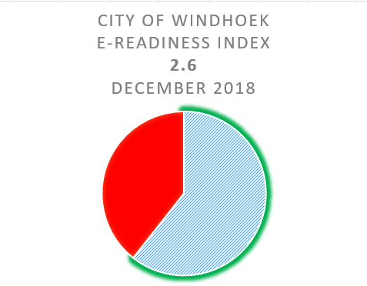
Scale:
0-1: Not ready, only use basic ICT tools
1-2: Started the use of ICTs in Services, not ready
2-3: Use of ICTs in Delivering some Services
3-4: Ready to deliver ICT Services

5.2 Future work

The research is about the design and testing of an automated e-Readiness assessment tool that can aid Local Authorities in Namibia to carry our regular e-Readiness assessments. The piloted tool with its results, should be analysed with various stakeholders and improved where needed. It should be developed into a fully-fledged web application and user tested in order to increase usability and adoption. The elements measured with the piloting of the tool should be extended to include other key categories such as the citizens and business communities, as this approach will give a more holistic view of e-Readiness for the Local Authority as a whole.

Conclusion

This research revealed more information on the benefits of using the automated e-Readiness assessment tool which showed enhanced capabilities and more efficiencies. These advantages will allow more assessments to be conducted and therefore increase availability of data which in turn will aid decision makers better. The tool was demonstrated to be able to compute the data automatically using the various criteria and context-specific questions.

References

Abhijit. G, S. S. (2015). E-Readiness Assessment for Ministries of Nepal for Implementation of e-government. 2015 International Conference on Data Mining, Electronics and Information Technology (DMEIT'15). Pattaya, Thailand: Department of Computer Science and Engineering, Singhania University, Rajasthan, India.
Accenture. (2002, July 31). e-Government Leadership: Realizing the Vision. Retrieved from http://www.golged.gc.calpub/pub_e.asp
Accenture. (2005, July 31). Leadership in Customer Service: New Expectations, New Experiences. Retrieved from http://www.accenture.com/xdoc/ca/locations/canada/insights/studies/leadership_cust.pdf
Aroon, P., Manoharan., Ingrams, A. (2018). State and Local Government Review 2018, Vol. 50(1) 56-66 sagepub.com/journalsPermissions.nav DOI: 10.1177/0160323X18763964 journals.sagepub.com/home/slg
Azab, N. A. (2009). A Suggested Framework for Assessing Electronic Government Readiness in Egypt. Electronic Journal of e-Government, 7(1), 11-28.
Bakry, S. (2004). Development of e-government: A STOPE view. International Journal of Network Management, 14(5), 339-350.
Bojang, M. and Bwando, M. (2018). E-Municipality applications in Local Government: Propects and Challenges. A paper presented at 3600 with youth 4th International Student Conference, April 3rd-4th 2018, Manisa, Turkey.
Dada, D. (2006). E-Readiness for developing countries. Moving the focus from the environment to the users, Department of Information Systems, 27(6), 1-14.
Dada, D. (2006). E-Readiness For Developing Countries: Moving the Focus From the Environment to the Users. The Electronic Journal on Information Systems in Developing Countries, 27(6), 1-14.
DeVans, D. (2001). Research Design in Social Research. London: SAGE.
Greener, S. (2008). Business Research Methods. Ventus Publishing ApS .
Gupta, M. P. (2005). Government Online-Opportunities and Challenges. Tata: McGraw-Hill Publishing Company Ltd.
Hartley, F. (2005). Business Research Methods. New York : AVI Publishers.
Holden, S. H. (2003). Electronic government at the local level: Progress to date and future issues. Public performance and management review, 26(4), 325-344.
Ingrams, Alex. (2017). The legal-normative conditions of police transparency: A configurational approach to open data adoption using qualitative comparative analysis. Public Administration 95: 527–45.
Jansen, A. (2005). Assessing E-government progress– why and what. In D. o.-g. studies (Ed.), NOKOBIT (pp. 21-23). Bergen: University of Oslo.
Jenkins, M. B. (2014). E-Government or out of Government, . ISBN 978- 09936047-2-0.
Jiang, L. Z. (2011). Assessing E-Government Readiness of Local Governments in China: Developing a Bottom-up Approach . E-government Research Center, National Academy of Governance.
Lourenco, Pedro, R., Piotrowski, S., Ingrams, S. (2017). Open data driven public accountability. Transforming Government: People, Process and Policy 11:42-57
Mohamed Shareef, T. J. (2008). A readiness assessment framework for e-government planning: design and application. Conference Paper .
Monica, C. O. (2011). E-Readiness Assessment of Enugu State, Nigeria. (D. o. Science, Ed.) Asian Journal of Information Management, 5(1), 25-34.
Musa, M. R. (2010). An e-readiness Assessment Tool for Local Authorities: A Pilot Application to Iraq. Department of Public Policy and Administration, The American University in Cairo.
Nahed A. Azab. (2009). Assessing Electronic Government Readiness of Public Organizations. Communications of the IBIMA, Volume 8.
Norris, D. (2005). Electronic Democracy at the American Grassroots. International Journal of Electronic Government Research, 1(3), 1-14.
OECD. (2003). e-Government Studies: The E-Government Imperative. OECD Publishing.
Ojo, A. J. (2007). Determining Progress Towards e-Government – What Are the Core Indicators?” . United Nation University – International Institute for Software Technology Report, No. 360.
Ređep, V. Đ. (2016). Review on e-readiness assessment tools . Central European Conference on Information and Intelligent Systems, 161-168.
Saunders, M. (2007). Research Methods for Business Students (4th ed.). Harlow, England: Pearson Education Limited.
Scholl, H. J. (2003). e-Government: A Special Case of ICT-Enabled Business Process Change. 36th Hawaii International Conference on System Sciences. Hawaii.
Scott, J. K. (2005). E- Services: Assessing the Quality of Municipal Government Web Sites. E- Services: Assessing the Quality of Municipal, 37(2), 151-165.
Sekaran, U. (2003). Research Methods for Business: A Skill Building Approach. John Wiley.
Shahnavazi, M. I. (2012). E-Municipality; New Step in Providing Electronic Services in Iran. International Journal of Business and Social Science, 3(15).
Toots, A. (2007, August 04). Take-up of municipality e-services: Some findings from citizens' survey in Tallinn. Retrieved from http://www.nispa.sk/_portal/files/conferences/2007/papers/200704231034430.Toots_fulltext_Kyiv_WG_egovmnt.pdf
UNDESA. (2010). United Nations E-Government Survey 2010; Leveraging e-government at a time of financial and economic crisis. UN Department of Economic and Social Affairs, 1.

Appendix A

ICT STAKEHOLDER QUESTIONNAIRE

AFRICA REGIONAL CENTRE FOR INFORMATION SCIENCE UNIVERSITY OF IBADAN
AN E-READINESS ASSESSMENT OF THE UNIVERSITY OF IBADAN.
Dear Respondent,
This questionnaire is designed to gather information with which to assess University of Ibadan’s preparedness to benefit from the networked world. All information provided shall be handled with utmost confidentiality and it shall be used strictly for the purpose of this research only. Thanks for your anticipated cooperation.
Dr. Olatokun Wole & Opesade, A.O.

SECTION A: UNIVERSITY OF IBADAN E-READINESS OBJECTIVE
1. What is /are the University’s main objective(s) of connecting to the networked world? [ ] e-infrastructure [ ] e-learning [ ] e-administration [ ] e-campus [ ] Other Pls. specify--------------------------------------------------------------------------------------------------------
2. Is there any University-owned Internet Service Provider responsible for internet connectivity in the university? [ ] Yes [ ] No
3. With what medium does the University connect to the networked world? [ ] VSAT [ ] Microwave [ ] Leased line [ ] Other pls. specify -------------------------------------------------------------------------------------------------------
4. Please indicate the university’s uplink bandwidth size [ ] 256KByte- 512kByte [ ] 512KByte – 1024KByte [ ] 1MByte- 2MByte [ ] >2MByte
5. Please indicate the university’s downlink bandwidth size [ ] 256KByte- 512kByte [ ] 512KByte – 1024KByte [ ] 1MByte- 2MByte [ ] >2MByte

SECTION B: ICT POLICY AND REGULATORY FRAMEWORK

6. Are there any policies enabling e-readiness in the university? [ ] Yes [ ] No
7. If yes, please indicate the available policies on ground
[ ] Policy enhancing internet infrastructural acquisition
[ ] Policy to enhance manpower development among staff
[ ] Policy to enhance manpower development among students
[ ] Policy to improve students / staff access to the internet
[ ] Policy to bridge the digital divide in the University
[ ] Policy to ensure data/information security
[ ] Policy to ensure acceptable use of ICT equipment
[ ] Other, (please specify) ------------------------------------------------------------------------------------------------

8. Please rate the awareness level of the identified policies among academic staff of the University by ticking the appropriate column below: Note: 4 = Very high 3=High 2=Low 1= Very low 0= Don’t know

 | Very high | High | Low | Very low | Don’t know
Policy | 4 | 3 | 2 | 1 | 0
Infrastructural acquisition
Staff manpower development
Student manpower development
Internet Access
Bridging the digital divide
Data/information security
Acceptable use of ICT equipment
Other (please specify)

9. Please rate the awareness level of the identified policies among students of the University by ticking the appropriate column below: Note: 4 = Very high 3=High 2=Low 1= Very low 0= Don’t know

 | Very high | High | Low | Very low | Don’t know
Policy | 4 | 3 | 2 | 1 | 0
Infrastructural acquisition
Staff manpower development
Student manpower development
Internet Access
Bridging the digital divide
Data/information security
Acceptable use of ICT equipment
Other (please specify)

10. Are there stipulated regulations guiding e-readiness in the University? [ ] Yes [ ] No

11. If yes, please indicate the existing ones
[ ] Internet access regulation [ ] Information security regulation [ ] Virus invasion control [ ] Acceptable usage regulation [ ] Others (pls. specify) ------------------------------------------------------------------------------------

12. Please rate the level of compliance among academic staff /Students of the university by filling the appropriate column below: Note: 4 = Very high 3=High 2=Low 1= Very low 0= Don’t know
 | Very high | High | Low | Very low | Don’t know
Regulation | 4 | 3 | 2 | 1 | 0
Internet access regulation
Information security regulation
Virus invasion control
Acceptable usage regulation
Other (please specify)

13. Is there any punitive measure against defaulters of ICT regulation in the University?
[ ] Yes [ ] No

14. If yes, please specify with the following:
Regulation Punitive measure | Regulation Punitive measure
Internet access regulation | Internet access regulation [ ] Access denial [ ] Temporary loss of subscription right [ ] Permanent loss of subscription right [ ] Not applicable  Other(s), pls. specify --------------------------------------
Information security regulation | Internet access regulation [ ] Access denial [ ] Temporary loss of subscription right [ ] Permanent loss of subscription right [ ] Not applicable  Other(s), pls. specify --------------------------------------
Virus invasion control | Internet access regulation [ ] Access denial [ ] Temporary loss of subscription right [ ] Permanent loss of subscription right [ ] Not applicable  Other(s), pls. specify --------------------------------------
Acceptable usage regulation | Internet access regulation [ ] Access denial [ ] Temporary loss of subscription right [ ] Permanent loss of subscription right [ ] Not applicable  Other(s), pls. specify --------------------------------------
Other (please specify) | Internet access regulation [ ] Access denial [ ] Temporary loss of subscription right [ ] Permanent loss of subscription right [ ] Not applicable  Other(s), pls. specify --------------------------------------

15. Is there any University organ meant for executing the punitive measures on defaulters?
[ ] Yes [ ] No

16. If yes, please indicate the body [ ] Senate [ ] Student’s disciplinary Committee [ ] ICT Committee [ ] University council Other, pls. specify-----------------------------------------------------------------------------------------

SECTION B: ICT DEPLOYMENT IN UNIVERSITY ACTIVITIES

17. Please identify which of the following services are available to students online [ ] Students admission processing [ ] students registration [ ] Result checking [ ] Transcripts preparation [ ] Student accommodation processing Others, pls. specify ---------------------------------------------------------------------------

18. Are there any student-based ICT application areas currently being proposed for implementation?
[ ] Yes [ ] No

19. If Yes, please identify these applications and indicate their stages of development Service Stage of development
Service | Stage of development
e-learning | [ ] Initiation [ ] Investigation [ ] Analysis [ ]Design [ ] Implementation [ ] Not applicable  Other pls. specify ------------------------------------------
Students admission processing | [ ] Initiation [ ] Investigation [ ] Analysis [ ]Design [ ] Implementation [ ] Not applicable  Other pls. specify ------------------------------------------
Students registration | [ ] Initiation [ ] Investigation [ ] Analysis [ ]Design [ ] Implementation [ ] Not applicable  Other pls. specify ------------------------------------------
Result checking | [ ] Initiation [ ] Investigation [ ] Analysis [ ]Design [ ] Implementation [ ] Not applicable  Other pls. specify ------------------------------------------
Transcripts preparation | [ ] Initiation [ ] Investigation [ ] Analysis [ ]Design [ ] Implementation [ ] Not applicable  Other pls. specify ------------------------------------------
Student accommodation processing | [ ] Initiation [ ] Investigation [ ] Analysis [ ]Design [ ] Implementation [ ] Not applicable  Other pls. specify ------------------------------------------
Other (please specify)

20. Which of the following are the staff-based ICT application areas in the University?
[ ] Research collaboration [ ] Staff administration [ ] Staff publicity to the global world [ ] Intra-campus communications [ ] Electronic publishing [ ] Other(s), pls. specify ---------------------------------------

21. Are there any staff-based ICT applications currently being proposed for implementation?
[ ] Yes [ ] No

22. If Yes, please identify these applications and indicate their levels of development
ICT Application Area | Stage of development
Research collaboration | [ ] Initiation [ ] Investigation [ ] Analysis [ ] Design [ ] Implementation [ ] Not applicable  Other pls. specify ------------------------------------------
Staff administration
Staff publicity to the global world | [ ] Initiation [ ] Investigation [ ] Analysis [ ] Design [ ] Implementation [ ] Not applicable  Other pls. specify ------------------------------------------
Intra-campus communications | [ ] Initiation [ ] Investigation [ ] Analysis [ ] Design [ ] Implementation [ ] Not applicable  Other pls. specify ------------------------------------------
Electronic publishing | [ ] Initiation [ ] Investigation [ ] Analysis [ ] Design [ ] Implementation [ ] Not applicable  Other pls. specify ------------------------------------------
Other (please specify) | [ ] Initiation [ ] Investigation [ ] Analysis [ ] Design [ ] Implementation [ ] Not applicable  Other pls. specify ------------------------------------------

23. Please indicate the existing/on-going key ICT projects in the University
Project | Status
VSAT acquisition | [ ] Existing [ ] On-going
Bandwidth Increment | [ ] Existing [ ] On-going
Increased computer density | [ ] Existing [ ] On-going
Increased internet access | [ ] Existing [ ] On-going
Implementation of campus wide network | [ ] Existing [ ] On-going
Other(s), (please specify)  (i)  (ii)  (iii) | [ ] Existing [ ] On-going  [ ] Existing [ ] On-going  [ ] Existing [ ] On-going

24. Kindly specify the purpose, benefits/ perceived benefits and sponsor(s) of each of the projects indicated above:
Project | Purpose | Benefit(s) | Sponsor(s) | Not Applicable
VSAT acquisition
Bandwidth Increment
Increased computer density
Increased internet access
Implementation of campus wide network
Other(s), (please specify)
(i)
(ii)
(iii)

25. Are there any existing measures to improve the University staff ICT skills?
[ ] Yes [ ] No
26. How often are ICT trainings organized or sponsored for these staff categories?
Staff Category | Training frequency
ICT Staff | [ ] Annually [ ] Quarterly [ ] Monthly [ ] As need arises [ ] Never [ ] Other, pls. specify ----------------
Deans of Faculties & Heads of Departments | [ ] Annually [ ] Quarterly [ ] Monthly [ ] As need arises [ ] Never [ ] Other, pls. specify ----------------
Academic staff | [ ] Annually [ ] Quarterly [ ] Monthly [ ] As need arises [ ] Never [ ] Other, pls. specify ----------------
Administrative staff | [ ] Annually [ ] Quarterly [ ] Monthly [ ] As need arises [ ] Never [ ] Other, pls. specify ----------------
Senior non academic staff | [ ] Annually [ ] Quarterly [ ] Monthly [ ] As need arises [ ] Never [ ] Other, pls. specify ----------------
Junior non academic staff | [ ] Annually [ ] Quarterly [ ] Monthly [ ] As need arises [ ] Never [ ] Other, pls. specify ----------------

27. Please indicate the number of ICT trainings that have been organized /sponsored for these staff categories in the last three and a half years:
Staff Category | Number of trainings
ICT Staff | [ ] None [ ] 1-5 [ ] 6-10 [ ]11- 15 [ ]16-20  [ ] above 20
Deans of Faculties & Heads of Departments | [ ] None [ ] 1-5 [ ] 6-10 [ ]11- 15 [ ]16-20  [ ] above 20
Academic staff | [ ] None [ ] 1-5 [ ] 6-10 [ ]11- 15 [ ]16-20  [ ] above 20
Administrative staff | [ ] None [ ] 1-5 [ ] 6-10 [ ]11- 15 [ ]16-20  [ ] above 20
Senior non academic staff | [ ] None [ ] 1-5 [ ] 6-10 [ ]11- 15 [ ]16-20  [ ] above 20
Junior non academic staff | [ ] None [ ] 1-5 [ ] 6-10 [ ]11- 15 [ ]16-20  [ ] above 20

28. Please indicate the percentage of these staff categories that benefited from those trainings over the specified period:
Staff Category | Percentage
ICT Staff | [ ] < 5% [ ] 5% - 30% [ ] 30% - 50% [ ] 50% - 75%  [ ] >75%
Deans of Faculties & Heads of Departments | [ ] < 5% [ ] 5% - 30% [ ] 30% - 50% [ ] 50% - 75%  [ ] >75%
Academic staff | [ ] < 5% [ ] 5% - 30% [ ] 30% - 50% [ ] 50% - 75%  [ ] >75%
Administrative staff | [ ] < 5% [ ] 5% - 30% [ ] 30% - 50% [ ] 50% - 75%  [ ] >75%
Senior non academic staff | [ ] < 5% [ ] 5% - 30% [ ] 30% - 50% [ ] 50% - 75%  [ ] >75%
Junior non academic staff | [ ] < 5% [ ] 5% - 30% [ ] 30% - 50% [ ] 50% - 75%  [ ] >75%

29. Are there any existing measures to improve the University students’ ICT skills?
[ ] Yes [ ] No

30. If yes, what are they?
[ ] Inclusion of ICT related courses in the student’s academic curriculum [ ] Organizing periodic workshops and trainings for students [ ] Partnering with notable IT firms for certification trainings
[ ] Other (Please specify) ---------------------------------------------------------------------------------------------

Appendix B

ACADEMIC STAFF AND STUDENTS QUESTIONNAIRE
AFRICA REGIONAL CENTRE FOR INFORMATION SCIENCE UNIVERSITY OF IBADAN
AN E-READINESS ASSESSMENT OF THE UNIVERSITY OF IBADAN.

Dear Respondent, this questionnaire is designed to gather information with which to assess University of Ibadan’s preparedness to benefit from the networked world. All information provided shall be handled with utmost confidentiality and it shall be used strictly for the purpose of this research only. Thanks for your anticipated cooperation. Dr. Olatokun Wole & Opesade, A.O.

SECTION A: DEMOGRAPHIC DATA

Please, tick or fill the appropriate answer as it applies to you. 1. Category: [ ] Student: [ ] Post graduate [ ] Undergraduate [ ] Teaching staff: [ ] Professor [ ] Reader [ ] Senior lecturer [ ] Lecturer I [ ] Lecturer II [ ] Assistant Lecturer

2. Faculty -----------------------------------------------------------------------------------------------------------------

3. Department -----------------------------------------------------------------------------------------------------------

4. Sex: [ ] Male [ ] Female

SECTION B: INTERNET ACCESS

5. Is there internet access in your faculty?
[ ] Yes [ ] No [ ] I don’t know

6. Is there internet access in your department?
[ ] Yes [ ] No [ ] I don’t know

7. Is there internet access in your Office / Classroom?
[ ] Yes [ ] No [ ] I don’t know

8. Is there any available computer laboratory for staff /students’ internet access in your faculty?
[ ] Yes [ ] No [ ] I don’t know

9. Is there any available computer laboratory for staff /students’ internet access in your department?
[ ] Yes [ ] No [ ] I don’t know

10. From which of the following do you have internet access?
[ ] Faculty laboratory [ ] Departmental laboratory [ ] Your office/ classroom [ ] University owned cybercafé [ ] Business Centre Cyber café [ ] None of the above Other (please specify) ----------------------

11. Do you own a computer system /laptop that can connect to the internet?
[ ] Yes [ ] No

SECTION C: MANPOWER

12. Do you make use of the internet facility?
[ ] Yes [ ] No If ‘No’, please go to question 14, but if ‘Yes’ kindly continue.

13. What do you usually use the Internet for?
[ ] Chatting [ ] Searching [ ] Web browsing [ ] E-mailing [ ] Other(s) pls. specify----------------------------------

14. Have you ever undergone any formal or informal training on how to use the internet?
[ ] Yes [ ] No

15. Do you have enough skill to access and navigate the internet on your own?
[ ] Yes [ ] No

16. If yes to question 15, please tick the applicable option underneath
[ ] I picked the skill through a training/workshop organized / sponsored by my department / faculty
[ ] I got trained in one of the courses offered in the academic curriculum
[ ] I got trained independently by registering in a computer school
[ ] I picked up the skill by continual practice
[ ] Other (Please specify) ------------------------------------------------------------------------------------------

17. Do you feel the need for some further training to enhance your internet usage?
[ ] Yes [ ] No

18. If yes, which means of skill acquisition will you prefer?
[ ] An ad-hoc training, organized / sponsored by my department / faculty
[ ] As part of courses offered in the academic curriculum
[ ] To get trained independently by registering in a computer school
[ ] To pick up skill by continual practice on my own.
[ ] Other (Please specify) -------------------------------------------------------------------------------------------

19. Apart from the use of the internet, which other ICT skills{s} do you possess?
[ ] Microsoft Office software usage [ ] Desktop publishing [ ] Computer repair [ ] Software development [ ] Software installations [ ] Hardware installations [ ] Computer graphics and Animation [ ] Web Page Design [ ] Networking [ ] Database management and administration [ ] Data analysis [ ] Project management [ ] Other(s) (please specify) ------------------------------------------------------------------------------------

20. In which of these ICT skills do you need further training? [ ] Microsoft Office software usage [ ] Desktop publishing [ ] Computer repair [ ] Software development [ ] Software installations [ ] Hardware installations [ ] Computer graphics and Animation [ ] Web Page Design [ ] Networking [ ] Database management and administration [ ] Data analysis [ ] Project management [ ] Other(s) (please specify) ------------------------------------------------------------------------------------------

21. What are the major challenges of using ICT facilities in the University? [ ] Poor electric power supply [ ] Inadequate Computer systems [ ] Poor ICT literacy [ ] Inadequate competent ICT personnel [ ] Gender discrimination [ ] Status discrimination [ ] Inadequate ICT infrastructure [ ] Inadequate access
[ ] Other(s) (please specify) ---------------------------------------------------------------------------------------

Appendix C

AN E-READINESS ASSESSMENT OF THE MUNICIPALITY OF CITY OF WINDHOEK - ICT DEPARTMENT ONLY

Dear Respondent, this questionnaire is designed to gather information with which to assess the Municipality of City of Windhoek’s preparedness to benefit from the networked world. All information provided shall be handled with utmost confidentiality and it shall be used strictly for the purpose of this research only. Thank you for your anticipated cooperation.
Dr. Anicia Peters & Angelo Cloete

1.SECTION A: EMPLOYEE DATA
Please, tick or fill the appropriate answer as it applies to you below
ICT Staff
Senior ICT Staff
ICT Manager
ICT Executive
2.ICT Division
Business Systems
The Management Information Systems
Business Support
ICT Operations Division
Technical Services Division
3.SECTION B: CITY OF WINDHOEK MUNICIPALITY E-READINESS OBJECTIVE
What is /are the Municipality’s main objective(s) of connecting to the networked world? Select all that apply.
e-infrastructure
e-operations
e-administration
e-commerce
4.Is there any Municipality-owned Internet Service Provider responsible for internet connectivity in the Municipality?
Yes
No
5. With what medium does the Municipality connect to the networked world?
VSAT
Leased Line
Microwave
Fiber Technologies
6.Please indicate the Municipality’s Uplink Bandwidth size
7.Please indicate the Municipality’s Downlink Bandwidth size
8.SECTION C: ICT POLICY AND REGULATORY FRAMEWORK
Are there any policies enabling e-readiness in the Municipality?
Yes
No
Don't know
9.If yes, please indicate the available policies in existence
Policy enhancing internet infrastructural acquisition
Policy to enhance manpower development among staff
Policy to improve staff access to the internet
Policy to bridge the digital divide in the Municipality
Policy to ensure data/information security
Policy to ensure acceptable use of ICT equipment
10.Please rate the Awareness Level of the identified policies among ICT Staff of the Municipality by ticking the appropriate column below:
 | Very High | High | Low | Very Low | Don't Know
Infrastructural acquisition
ICT Staff manpower development
Staff manpower development
Internet Access
Bridging the digital divide
Data/information security
Acceptable use of ICT equipment
Other as Specified in Question 9.
11.Please rate the Awareness Level of the identified policies among Broader Staff of the Municipality by ticking the appropriate column below:
 | Very High | High | Low | Very Low | Don't Know
Infrastructural acquisition
ICT Staff manpower development
Staff manpower development
Internet Access
Bridging the digital divide
Data/information security
Acceptable use of ICT equipment
Other as Specified in Question 9.
12. Are there stipulated regulations guiding e-readiness in the Municipality?
Yes
No
Don't Know
13. If yes, please indicate the existing ones
Internet access regulation
Information security regulation
Virus invasion control
Acceptable usage regulation
14.Please rate the Level of Compliance amongst All Staff of the Municipality by filling the appropriate column below:
 | Very High | High | Low | Very Low | Don't Know
Internet access regulation
Information security regulation
Virus invasion control
Acceptable usage regulation
Other as Specified in Question 13.
15.Is there any punitive measure against defaulters of ICT regulation in the Municipality?
Yes
No
Don't Know
16.If yes, please specify with the following:
Regulation and possible punitive measure
 | Access denial | Temporary loss of subscription right | Permanent loss of subscription right | Not applicable | Don't Know
Internet access regulation
Information security regulation
Acceptable usage regulation
Virus invasion control
17.Is there any Municipal organ meant for executing the punitive measures on defaulters?
Yes
No
Don't Know
18. If yes, please indicate the body
Municipal Council
HR Disciplinary Committee
ICT Committee
ICT Management
19.SECTION D: ICT DEPLOYMENT IN MUNICIPALITY ACTIVITIES
Please identify which of the following services are available to staff online
Leave Application
Recruitment
e-Learning
Salary advice checking
ICT Helpdesk
20.Are there any staff-based ICT application areas currently being proposed for implementation?
Yes
No
Don't Know
21. If Yes, please identify these applications and indicate their stages of development
Service and Stage of Development
 | Initiation | Investigation | Analysis | Design | Implementation | Not applicable
e-Learning
Leave Application
Recruitment
Salary advice checking
ICT Helpdesk
Other as Specified in Question 19.
22.What ICT Systems do you want to have in the next 5 years for the Citizens benefit?
Please identify these ICT Systems and their main purpose.
23.Please indicate the existing/on-going key ICT projects in the Municipality
Project Title and Project Status
24.Are there any existing measures to improve the Overall Municipality's Staff members, in All Departments/Divisions ICT skill levels?
Yes
No
Don't Know
25. If yes, what are they?
Inclusion of ICT related courses in the staff member’s career development plan
Organizing periodic workshops and trainings for staff members
Partnering with notable IT firms for certification trainings
Not Applicable
26.How often are ICT trainings organized or sponsored for these staff categories?
Staff Category and Training frequency
 | Annually | Quarterly | Monthly | As need arises | Never | Not Applicable
ICT Staff
Strategic Executives and Managers
Broader Administrative staff
Non Administrative staff
27. Please indicate the number of ICT trainings that have been organized /sponsored for these staff categories in the last three and a half years:
Staff Category and Number of Trainings
 | None | 1-5 | 6-10 | 11- 15 | 16-20 | 20+
ICT Staff
Strategic Executives and Managers
Broader Administrative staff
Non Administrative staff
28. Please indicate the percentage of these staff categories that benefited from those trainings over the specified period:
Staff Category and Precentage
 | < 5% | 5% - 30% | 30% - 50% | 50% - 75% | >75%
ICT Staff
Strategic Executives and Managers
Broader Administrative staff
Non Administrative staff
29. What type/area of Industry certifications does your ICT Department/Division need?
Operating Systems
Networking
Information Security
Databases
Programming
Website/Electronic Publishing
Project Management
None of the above
30.What is your division’s staff compliment?
31.Do your Department/Division Outsource any of your ICT work?
Yes
No
Don't Know
32.If yes, what percentage of your Department’s/Division's work gets outsourced?
0-10%
10-30%
30-50%
50-80%
80% and more
33.SECTION E: DEMOGRAPHIC DATA
Gender:
Male
Female
34.Age
35.Years employed at the Municipality:
36.Highest Level of Education
High School
Tertiary Education
Post Graduate Education
37.Field of Education
38.If you wish to receive a copy of the final report please provide us with your e-mail address:

Appendix D

AN E-READINESS ASSESSMENT OF THE MUNICIPALITY OF CITY OF WINDHOEK - ALL DEPARTMENTS

Dear Respondent, this questionnaire is designed to gather information with which to assess the Municipality of City of Windhoek’s preparedness to benefit from the networked world. All information provided shall be handled with utmost confidentiality and it shall be used strictly for the purpose of this research only. Thank you for your anticipated cooperation.
Dr. Anicia Peters & Angelo Cloete

1.SECTION A: EMPLOYEE DATA
Please, tick or fill the appropriate answer as it applies to you below
Staff Member
Senior Staff Member
Manager
Strategic Executive
2.Department
Finances and Customer Services
City Police
Urban and Transport Planning
Economic Development and Community Services
Office of the CEO
Electricity
Human Capital and Corporate Services
Infrastructure, Water and Technical Services
Housing, Property Management and Human Settlements
3.SECTION B: INTERNET ACCESS
Is there Internet access in your Department?
Yes
No
Don't Know
4.Is there internet access in your Office/Area of work?
Yes
No
Don't Know
5.Do you own a work Computer system /Laptop that can connect to the Internet?
Yes
No
6.From which of the following do you have Internet access?
Department Computer Systems
Your Office
None of the Above
7.SECTION C: MANPOWER
Do you make use of the Internet facility?
Yes
No
8.What do you usually use the Internet for?
Web Browsing
Chatting
E-mailing
Searching
9.Have you ever undergone any formal or informal training on how to use the Internet?
Yes
No
10.Do you have enough skill to access and navigate the Internet on your own?
Yes
No
11.If yes to question 10, please tick the applicable option underneath:
I picked up the skill through a training/workshop organized / sponsored by my department
I got trained in one of the courses offered in the academic curriculum
I got trained independently by registering in a computer school
I picked up the skill by continual practice
12.Do you feel the need for some further training to enhance your Internet usage?
Yes
No
13.If yes, which means of skill acquisition will you prefer?
An ad-hoc training, organized / sponsored by my department
As part of courses offered in the academic curriculum
To get trained independently by registering in a computer school
To pick up skill by continual practice on my own
14.Apart from the use of the Internet, which other ICT skills do you possess?
Microsoft Office software usage
Desktop publishing
Computer repair
Software development
Software installations
Hardware installations
Computer graphics and Animation
Web Page Design
Computer Networking
Database management and administration
Data analysis
Project management
15.In which of these ICT skills do you need further training?
Microsoft Office software usage
Desktop publishing
Computer repair
Software development
Software installations
Hardware installations
Computer graphics and Animation
Web Page Design
Computer Networking
Database management and administration
Data analysis
Project management
16.What are the major challenges of using ICT facilities at the City of Windhoek Municipality?
Poor electric power supply
Inadequate Computer systems
Poor ICT literacy
Inadequate competent ICT personnel
Status discrimination
Inadequate access
Inadequate ICT infrastructure
17.SECTION E: DEMOGRAPHIC DATA
Gender:
Male
Female
18.Age
19.Years employed at Municipality:
20.Highest level of Education?
High School
Tertiary
Post Graduate

