
FACULTY OF COMPUTING AND INFORMATICS
DEPARTMENT OF COMPUTER SCIENCE

A hierarchical Cooperative Intrusion Detection METHOD in Ad-hoc Wireless Networks

BY

TERESIA ANKOME

STUDENT NUMBER: 211009199

A THESIS SUBMITTED IN PARTIAL FULFILMENT OF THE REQUIREMENTS FOR THE AWARD OF MASTER OF COMPUTER SCIENCE

AT THE
NAMIBIA UNIVERSITY OF SCIENCE AND TECHNOLOGY

Supervisor: Prof. GUY-ALAIN LUSILAO ZODI

January 2020

DEDICATION

This thesis is dedicated to my parents, Veronika Ankome and Desiderius Ankome. Without them, I would not be this far in journey.

ACKNOWLEDGEMENT

Firstly, I would like to thank the Almighty for granting me the opportunity of life, strength, wisdom and knowledge.
Secondly, I would like to express my sincere gratitude to Prof Guy-Alain Lusilao Zodi, for his unwavering support and guidance, encouraging me to learn more every day. His valuable suggestions, comments and his deep insights from his expertise towards my studies, contributed immensely. I am forever indebted by his selfless support, generosity and for the patience he has provided over the years. My biggest gratitude, as without him, this work will not have seen the light of today.
I would also like to thank my colleagues for all their advice, support, time and guidance.
Lastly, I would like to thank my parents for their continuous guidance, support and love.

ABSTRACT

In recent years, ad-hoc wireless networks have experienced an increase in popularity and usage due to their flexibility and the ability to provide connectivity from anywhere, at any time. Ad-hoc wireless network provides mobile communications to nodes in situations where the participating nodes are not in need of existing network infrastructure. The detection of malicious nodes is hard to achieve due to its dynamic nature of nodes mobility, lack of infrastructure and the nature of the wireless channel. Most traditional Intrusion Detection Systems (IDS) are designed to operate in a centralized manner, and do not operate properly in MANET as data in mobile ad-hoc networks are distributed in different network devices.
Hierarchical Cooperative Intrusion Detection Method (HCIDM) is a distributed intrusion detection mechanism that uses collaboration between nodes to detect active attacks against the routing table of a mobile ad-hoc wireless network. HCIDM operation reduces the effectiveness of the attack by informing other nodes about the existence of the malicious nodes, its operating mode and keeps the performance of the network within an acceptable level. The novelty of the mechanism lies in the way the responsibility to protect the network is distributed among nodes, the trust level is computed and the information about the presence of a malicious activity is communicated to potential victims, that is, nodes within the radio range of the attacker. HCIDM operates as a middle box between the network traffic and the routing protocol. HCIDM is tested using the Network Simulator (NS-2) in an AODV-enabled mobile ad hoc wireless network. The accuracy and the efficiency of HCIDM are tested during a black hole attack in a network with mobile nodes, starting with a small network topology and increasing the number of nodes to test its performance in a large network. The throughput, delay and packet loss are used as metrics for evaluating the performance of HCIDM.

Table of Contents
DEDICATION 2
ACKNOWLEDGEMENT 3
ABSTRACT 4
LIST OF FIGURES 8
LIST OF TABLES 9
Chapter 1 Introduction and Background of the Study 10
1.0 Overview 10
1.1 Background of the Study 10
1.2 Statement of the Problem 13
1.3 Research Objectives 13
1.4 Research Questions 14
1.5 Methodology 14
1.6 Significance of the Study 15
1.7 Limitations of the Study 16
1.8 Document Overview 16
Chapter 2 Ad-hoc Network 17
2.1 Introduction to Ad-hoc Wireless Networks 17
2.2 Challenges of Ad-hoc Wireless Networks 19
2.4 Routing in Ad-hoc Wireless Networks 20
2.4.1 Proactive Routing Protocol 21
2.4.1.1 Optimized Link State Routing (OLSR) 22
2.4.1.2 Temporally Ordered Routing Algorithm (TORA) 22
2.4.1.3 DSDV (Destination-Sequence Distance-Vector) 23
2.4.2 Reactive Routing Protocol 23
2.4.2.1 Ad-hoc On-Demand Distance Vector 24
2.4.3 Hybrid Routing Protocol 24
2.4.4 Cluster Based Routing 25
2.5 Security in Ad-hoc Wireless Networks 26
2.5.1 Vulnerability Nature 26
2.5.2 Security Needs 27
2.5.3 Attacks in Ad-hoc Wireless Networks 28
2.5.4 Security Schemes 33
Conclusion 33
Chapter 3 Intrusion Detection 34
3.1 Introduction 34
3.2 Intrusion Detection Systems (IDSs) 34
3.2.1 Type of Intruder 35
3.2.2 Type of Intrusion 36
3.2.3 Detection Methods 36
3.2.3.1 Anomaly-based Detection 36
3.2.3.2 Misuse Detection 37
3.2.3.3 Specification Detection 37
3.2.4 Audit Data Source 37
3.2.4.1 Network Intrusion Detection System (NIDS) 38
3.2.4.2 Host Intrusion Detection System (HIDS) 38
3.2.4.3 Hybrid Intrusion Detection System 38
3.2.5 Data location 38
3.2.6. IDS Infrastructure 39
3.3 Secure Routing Protocols 40
3.3.1 Secure Efficient Ad-hoc Distance Routing Protocols 41
3.3.2 Secure DSR routing protocols 41
3.3.3 Secure On Demand Distance Vector 42
3.3.4 Authenticated Routing for Ad-hoc Networks 42
3.3.5 Security-aware Ad-hoc Routing 42
3.3.6 Security Routing Protocol 43
3.4 Secure Clustering Routing Protocols 43
Conclusion 46
Chapter 4 Design and Implementation 47
4.1 Introduction 47
4.2 System Design 47
4.2.1 Secure Cluster Formation 49
4.2.2 Calculation of the trust level of nodes 50
4.2.3 Determination of a Secure Cluster Head 51
4.2.3.1 Initial Phase 51
4.2.3.2 Election of Secure Cluster Head 51
4.3. System Requirements 52
4.4 Simulation Model 53
4.4.1 Introduction 53
4.4.2 Architecture of NS2 53
4.4.3 Data Collection and Analysis in NS2 54
4.4.4 Extending NS2 to support malicious node 55
Conclusion 55
Chapter 5 Simulation and Analysis 56
5.1 Introduction 56
5.2 Metrics Definition 56
5.2.1 Throughput 56
5.2.2. Packet Delivery Ratio 57
5.2.3 Packet Delay 57
5.3 Simulation Setup 57
5.4 Confidence Intervals 58
5.5 Performance of HCIDM in Static Ad-Hoc Wireless Network 60
5.5.1 Impact of black hole attack in a static nodes network 60
5.5.2 Impact of HCIDM in Static Ad-Hoc Wireless Networks 62
5.6 Performance of HCIDM in MANETs 65
5.6.1 Effect of black hole attack in MANET 66
5.5.2 Effect of HCIDM in MANET 69
5.6 Performance of HCIDM in large network 72
5.7 Dynamic black hole node in a fixed 150 legitimate nodes MANET network 74
5.8 Comparison between CCIDM and HCIDM 77
5.9 Summary 79
Chapter 6 Conclusion 81
6.1 Conclusion 81
6.2 Future Research Direction 82
Reference 83

LIST OF FIGURES
Figure 2. 1 Ad-hoc network 18
Figure 2. 2 Routing protocols 21
Figure 2. 3 Wormhole attack 30
Figure 2. 4 Black hole attack 32

Figure 4. 1 HCIDM Design 48
Figure 4. 2 C++ and Tcl/Otcl interaction 54

Figure 5. 1 Confidence Interval For Lost Packets 58
Figure 5. 2 Throughput 59
Figure 5. 3 Packet Delay 60
Figure 5. 4 Packet Lost 60
Figure 5. 5 Packet Throughput 61
Figure 5. 6 Packet Delay 62
Figure 5. 7 Packet Lost 62
Figure 5. 8 MANET Throughput 64
Figure 5. 9 MANET Delay 65
Figure 5. 10 Packet Lost 66
Figure 5. 11 HCIDM Throughput 67
Figure 5. 12 HCIDM Packet Delay 68
Figure 5. 13 HCIDM Packet Lost 70
Figure 5. 14 Static and Dynamic Throughput 71
Figure 5. 15 Static and Dynamic Delay 72
Figure 5. 16 MANET with HCIDM Throughput 73
Figure 5. 17 MANET with HCIDM Delay 74

LIST OF TABLES
Table 4. 1 Configuration of the Simulated Ad-hoc wireless network 55

Table 5. 1 Configuration of the Simulated Ad-hoc wireless networks 57
Table 5. 2 Average throughput per connection 67
Table 5. 3 Average packet delay per connection 68
Table 5. 4 Average packets lost per connection 69
Table 5. 5 Average throughput per connection 70
Table 5. 6 Average packet delay per connection 71
Table 5. 7 Average packet lost per connection 72

Chapter 1 Introduction and Background of the Study

Overview

In this chapter, a brief background on ad-hoc network is reviewed and challenges that has occurred since its existence with the purpose of introducing the readers to the area of ad-hoc network. We also stated the objective of the research and the problem statement, including the questions that the research is based on. A summarized methodology paragraph also appears with the expected outcome at the end of the research and an overview outlining the structure of the thesis.

Background of the Study

An ad-hoc wireless network is a type of network where wireless nodes communicate directly with each other without the use of a middle device or central point of control. There is a high increase in the usage of ad-hoc wireless network mainly due to the easy setup of devices, with no cables connection required and is also easily dismantled, giving it an advantage over existing traditional wired network that requires dismantling of cables on devices (Dahiya, 2017). A node is referred to any mobile device with the ability to communicate with other devices and in ad-hoc, a node can act as a host , as well as router. The networks topology is forever changing over time as nodes move around, from one position into another leaving one network and joining new networks, with some disconnecting from the network (Marchang, Datta, & Das, 2017). However, ad-hoc wireless networks present many issues starting with security that require further work due to mobility nature, lack of central point of control and wireless communication links. Ad-hoc wireless networks are vulnerable to various kinds of attacks that include passive eavesdropping, active interfering, impersonation and denial of service, Siddiqui & Farooqui (2014). Securing mobile ad hoc networks from attacks performed by a legitimate node that has been captured, for example, is a challenging task due to the absence of a point of control that deprives the network of an administrative point that could facilitate detection or prevention of the attack. The detection system deployed to detect unauthorised access to the networks sometimes fails to detect intruders and as a result, important data are lost to hackers.
The conventional approach of positioning a relatively small number of intrusion detection systems (IDS) and firewalls at traffic concentration or “choke” points to inspect all network traffic, will not work because traffic is normally dispersed over many routes that change dynamically, which means that, persistent choke points will not exist (Sterne et al., 2005). Intrusion detection in mobile ad-hoc networking must be carried out in a distributed fashion because of the absence of infrastructure and fixed topology, stated Huang & Lee (2004). It is therefore important for IDS to detect and block doubtful traffics (B. S. Kumar et al., 2013)
An Intrusion Detection System refers to a software application system that monitors a network or system for malicious activity. The IDS is based primarily on identifying potential security threats, logging information related to events observed and notifying security administrators about suspected events for the attack to be contained in order to reduce the damaged system and to identify attackers, Huang L & Lee W. (2003). Intrusion Detection Systems are classified into different categories; mainly Active and Passive IDS, Network Intrusion Detection Systems and Host Intrusion Detection System.
An active IDS refers to an Intrusion Detection and Prevention System (IDPS) which is configured to automatically block suspected attacks without involvement of an operator and offers an advantage of real-time corrective action in an attack response. A passive IDS is a system configured to monitor and analyse network traffic activity and alerts the operator when it detects potential vulnerabilities and attacks. This system however, is not capable of performing any protective or corrective functions on its own. IDSs are also classified into centralised and decentralised IDS. A centralized IDS consists of a central point of control that analyses data on all nodes in a network while in a decentralised IDS, each node works independently and act as an IDS agent spread across the network. A Network Intrusion Detection System (NIDS) is an intrusion detection system made up of a network appliance or sensor with a Network Interface Card (NIC) operating in promiscuous mode and a separate management interface. In NIDS, an IDS is placed along a network segment or boundary and monitors all traffic on that segment. A Host Intrusion Detection System (HIDS) is installed on workstations that are to be monitored. The agents are responsible for monitoring the operating system and write data to log files and trigger alarms. A HIDS can only monitor individual workstations on which the agent is installed on and do not monitor the entire network (Surana, Sharma, Saraf, Puri, & Navin, 2017). Intrusion detection systems have emerged in the computer security area because of the difficulty of ensuring that an information system will be free of security flaws, stated Debar (2002). Anomaly detection is useful for finding attacks like misuse of protocol and service ports, Denial of Service (DoS) based on crafted payloads, DoS based on volume (DDoS), buffer overflow and other application payload anomaly as stated Vijayaram & Sylviaa (2015).

Most traditional Intrusion Detection System (IDS) were designed to operate in a centralized manner; however, they rely on data that are distributed in different network devices, which makes data protection very difficult. Over the past few years new generation of decentralized IDS has emerged that includes various mechanisms to prevent intruders from accessing important information. Decentralized intrusion systems enable cooperation between network devices or nodes to prevent attacks over decentralized computer networks. Decentralised IDS are seen as a good approach to prevent malware for infecting worldwide computers, as they can reduce the effect of attacks such as phishing of emails or vulnerability within the network defences known as “WannaCry”. WannaCry is a malware in a form of ransomware, whereby an organization affected has to pay money in order for their hard drives to be decrypted. One of the infection causes in WannaCry is described as a module that exploits vulnerability in Windows and uses a worm component to spread within a network through NetBIOS. Once it has breached a network, the virus easily spreads by seeking out and infecting other Windows servers with the vulnerability (Malik, 2017).

Previous similar work by Huang & Lee (2004), states that each node should have an Intrusion Detection System (IDSs) to monitor its behaviour, routing table as well as the behaviour of bordering nodes. It is a very useful approach since a centralised point of concentration for traffic is not needed in the ad-hoc wireless network, they proposed to organise the network into clusters. Clustering approach is very useful in improving the management of a large-scale ad-hoc wireless network as it involves dividing the network nodes into small groups instead of managing a large network of nodes. Monitoring a large network that lacks central control is as difficult as a having to offer a class to more than 150 student in one venue. One will not really observe who is paying attention and who does not understand the lesson. To maintain communications efficiency, the hierarchy is automatically reconfigured as needed using clustering techniques in which cluster heads are selected in each cluster based on topology and other criteria (Sterne et al., 2005). Clustering is essential in solving network scalability in large ad-hoc networks, though it requires an exchange of messages among the nodes from time to time in order to maintain the clustering structure. The approach is also useful improving the network performance in reference to the routing delay, bandwidth consumption among the nodes and the throughput. In our work, we focused on improving the existing clustering approaches by running a comparative study between an existing clustering approach by Saurabh, Sharma, & Itare (2017) that was based on Collaborative Clustering Intrusion Detection Mechanism (CCIDM) with our design on Hierarchical Cooperative Intrusion Detection Method (HCIDM). We evaluated the performances of the two by using ns-2 simulator to run different tests and used metrics such as packet delivery ratio, end-to-end delay, packet lost and throughput.

In this research, we propose a Hierarchical Cooperative Intrusion Detection Method (HCIDM) for efficient and effective detection of attacks in ad-hoc wireless networks. HCIDM is a passive, distributive and network IDS that organises the network into clusters and focus on selecting the best nodes to participate in the dependable exchange of information about active cooperation and network events to be cluster heads. The cluster head will manage the clusters and every node in the cluster will register with their cluster head on occasion. The cluster head will share information about anomaly intrusion with other neighbouring cluster heads in different clusters. Each cluster will have to elect a new cluster head that will take over in case a cluster head has been compromised or in case of power failure.

Statement of the Problem

The lack of infrastructure in ad-hoc wireless networks makes it easy for access by unauthorized devices within the range of the network. Distinguishing between intrusion and legitimate operations or condition in ad-hoc wireless networks is very hard due to the open wireless channel and the dynamic topology changes. This research proposes a hierarchical cooperative intrusion detection to prevent unauthorised access to the ad-hoc wireless network.

Research Objectives

The main objective of this study is to develop an intrusion detection mechanism to protect ad-hoc wireless networks from access by unauthorised devices. This research will consider a Hierarchical Intrusion Detection Method approach, whereby wireless nodes in ad-hoc wireless networks organise themselves into clusters and cooperate to protect the network against active attacks from malicious nodes.
To meet the main objective, we consider the following sub-objectives.
- Analyse the impact of black hole attack on ad-hoc wireless networks.
- Organise the network into clusters in which cluster heads are selected based on the network topology, trust values and energy level.
- Select the devices that will participate best in the collaboration towards protecting the network.
- Identify the type of information that nodes need to share amongst themselves in protecting the network.

1.4 Research Questions

To fulfil the objectives, the research aims to answer the following questions:
- What effects does a black hole attack have on ad-hoc wireless network?
- How should nodes in ad-hoc wireless network be organised into clusters?
- Which devices should participate best in the collaboration of the network protection?
- Which type of information should devices share amongst themselves to protect the network?

1.5 Methodology

The research is based on experimental approach using a comparative analysis, where the proposed intrusion detection mechanism is implemented using the Network Simulator version 2 (NS2). Although various network simulator tools such as Nessi2 or Riverbed Academic are available, we chose to simulate our model in NS2, which is an open-source that offers support for ad-hoc network features, several routing algorithms and communication networks’ protocols.
We run NS2 in Linux operating system, which requires the following packages to run: Tcl release 8.3.2, Tk release 8.3.2, OTcl release 1.0a7 and TclCL release 1.0b11. A simple scenario can run on any machine, but a very large scenario should make use of large amount of memory. The installation is easy but requires many configurations. It is recommended that one use “all-in-one” package as it includes the source code. NS2 support the use of SCTP (which is a requirement for us), for our graphical representations, multiple protocols. We have made use of gnuplot for graphical presentations, to illustrate clear graphs.
We have extended the standard NS2 to support the black hole attacks that are common to ad-hoc wireless networks. A black hole attack occurs when a malicious node intrudes the network by making use of the vulnerabilities of the route discovery packets protocol, to redirect the traffic destined to another node to itself. We then conduct various experiments to test the efficiency of our proposed solution and compare the performance of our model against CCIDM.
Metrics such as throughput, delivery ratio, delay and packet lost were used to study the performance of our proposed model.

1.6 Significance of the Study

This work is important to every organization connected to ad-hoc wireless networks, as it addresses in solving routing attacks in ad-hoc wireless networks. I furthers enhance its capability into ensuring an improvement into the network performance based on reducing routing delay, high bandwidth consumption among the nodes and achieving a high throughput. This type of network needs more attention due to its vulnerability to attacks. The success of this project will benefit all new and old users that connect to ad-hoc wireless networks. It will also be assisting in cyber security world that focuses on improving the security implementation in organizations or industries, by finding a protocol that would prevent important information from being accessed.

Furthermore, the study also gives a clear understanding of Intrusion Detection in wireless networks, with a strong emphasis towards other researchers studying towards similar research topic/field, to broaden their knowledge on the importance of Intrusion Detection in their networking environment.

1.7 Limitations of the Study

The study will however only focus on ad-hoc wireless networks, which is highly susceptible to intruders due to a lack of a centralized point of coordination above unlike other types of networks. With many attacks on ad-hoc wireless networks, we only performed tests using black hole attack which the results is expected to me similar if tested on attacks such as sink hole and worm hole attacks as they work similarly. The project testing will be done using a simulation tool instead of a test bed, as it saves our budget costs as malfunctioning of expensive hardware resources.

1.8 Document Overview

The rest of this document is organized as follows.
Chapter 2 introduces mobile ad-hoc networks in general and differentiating them from other communication networks. The chapter also highlights some challenges encountered in ad-hoc environments, the security issues and goals, and describes various routing protocols used in ad-hoc networks.
Chapter 3 outlines the security schemes implemented in ad-hoc networks and highlights the difference from traditional intrusion detection mechanisms used in wired network. An important aspect of this study is to design a Hierarchical Cooperative Intrusion Detection Method (HCIDM) and simulate active attacks among wireless nodes, which will be resolved using the proposed HCIDM.
The simulation details of the attacks, the design and implementation of the proposed HCIDM are discussed in Chapter 4.
In Chapter 5, we discussed the evaluation of the HCIDM system. The metrics that were used to measure the performance of the HCIDM system are presented along with graphs that illustrate the performance of HCIDM system in MANET under a black hole attack.
Finally, Chapter 6 concludes the research and discusses some future works.

Chapter 2 Ad-hoc Network

2.1 Introduction to Ad-hoc Wireless Networks

This chapter focuses on ad-hoc wireless networks and the challenges that it experiences. An ad-hoc network is well characterised by the lack of underlying fixed infrastructure and nodes that join this network on the fly to create a network of their own (Kumar Sarkar, Puttamadappa, & Basavaraju, 2007).

Technology has evolved from the use of only wired network towards the use of wireless networks (Dahiya, 2017). An introduction of temporary network connection among devices called ad-hoc network made life easier. We describe ad-hoc wireless networks as a temporary peer-to-peer network connection between devices/nodes within the same communication range that makes use of the wireless network to share resources in a decentralized fashion (Jitendra, Anusha, & Pachipala 2016). Mobile nodes that are within the same radio range and those within another radio range can communicate using wireless links, with this forming up a dynamic network. Wireless devices make use of multi-hop communication, whereby devices use intermediate devices to relay the messages to the destined devices (Kumar Sarkar et al., 2007). The nature of this network is due to the visible absence of a fixed infrastructure support of base stations, access points and other centralised traditional devices. The network topology experiences constant changes due to the nodes joining in and moving out in the network. Forwarding packets, routing and various network operations are carried out by individual nodes themselves (Dahiya, 2017).

Figure 2.1 illustrates how an ad-hoc wireless network is formed by mobile nodes not necessarily within the radio range of each other, with some nodes are positioned far from others. In this configuration, nodes within the radio range of each other can communicate directly, while nodes further apart use other nodes to relay their data to the destination node.
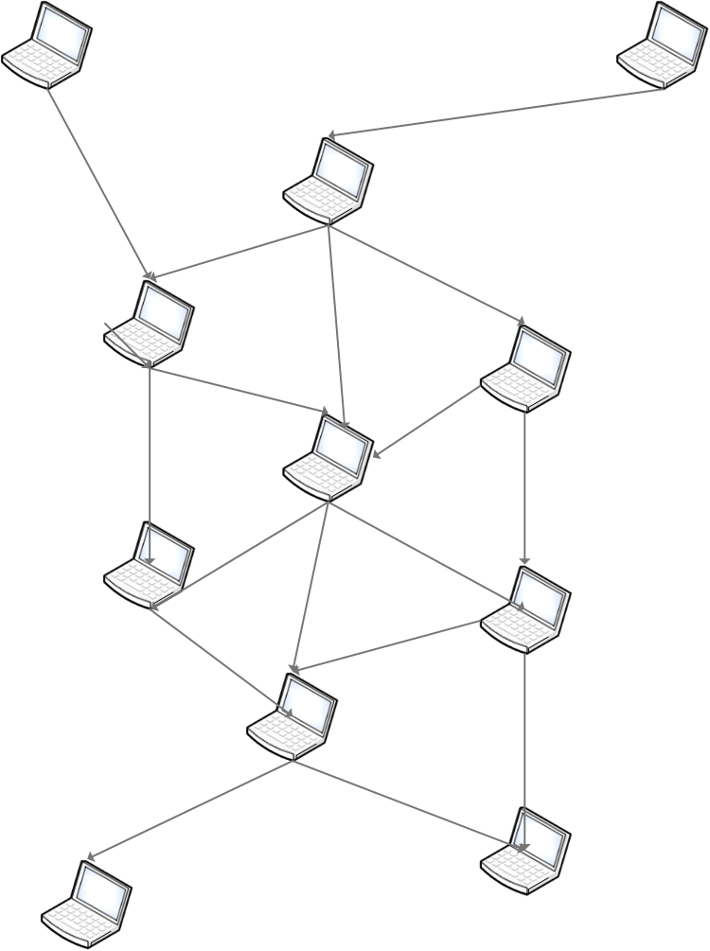
Figure 2.1 Ad-hoc network
An Ad-hoc wireless network is ideal for environment that lacks infrastructure or in a situation with a low finance budget, as they do not require a lot of setting up and extra infrastructures (Vegda & Modi, 2018). With is type of network, connectivity is setup within hours if it is a lot unlike with wired network that requires weeks or month to be fully functioning. (Kumar Sarkar et al., 2007). The connection easily setup, as is easily disconnected and the number of nodes connected at a time is not defined, as it accommodate limitless number of nodes. The network is useful for sharing resources without the use of cables and is especially suitable in circumstances where the need for a network is immediate, such as workshops, schools, boardroom sessions, field operations, as well as military command post offices or any commercial applications (Kaurav & Joshi, 2017; Mapenduka, 2018).

The network does not depend on existing infrastructure for its operations; it only needs nodes to be close to each other for communication to occur (Sarma & Devi, 2012; Tyagi, 2014). The nodes in the network may not maintain a fixed position as mobile nodes can move around freely while organising themselves randomly. Each node acts as a router and forwards packets to each other for communication purposes among the mobile nodes (Bharati & Kumar, 2015). The path between each pair of nodes may have radio among them that are heterogeneous and have various asymmetric links. The ad-hoc network connection can operate in a stand-alone manner.

Nodes in an ad-hoc wireless network communicate with each other while roaming around freely, and for this reason, the network topology changes over time. With the lack of central control, participating nodes in the network work with each other, relaying the traffic to other nodes that are not in close range to their destination nodes (Kaushal & Aggarwal, 2015; Vijayalakshmi & Sweatha, 2016). This can sometimes bring a loss in connectivity if the nodes in close range to the destination node decline to take part in the routing process, leading onto a segmented network. The nodes have limited processing and memory capacity, powered with batteries that have a limited life line and the network suffers from eavesdropping due to its open communication medium (Sarma & Devi, 2012).

Another important characteristic of an ad-hoc network that was mentioned above is the dynamic topology changes of nodes. The nodes move all around, some are joining networks while some move out and others disconnecting themselves leading to the network dynamic change (Marchang et al., 2017).This characteristic makes routing protocols hard to implement in an ad-hoc network. The constant changing topology due to the movement of nodes out and in the network. This together with unreliable wireless link among the nodes and the lack of incorporation of security features in statically configured wireless routing protocols not meant for ad-hoc environments, leads to increased vulnerability and exposure to attacks (Vegda & Modi, 2018; Kaushal & Aggarwal, 2015). The vulnerability of the links, limited physical protection of the nodes, infrequent nature of connectivity, the lack of a centralised monitoring point and the dynamic changes in topology all contribute towards the difficult achievement of securing the wireless ad-hoc network (Kaushal & Aggarwal, 2015). The challenges prompt the serious need for intrusion detection, prevention and other related counter measures to be implemented in the network. Ad-hoc wireless networks face many attacks and attempts have been made to try to secure this network. The network also has various concepts of routing protocols and the security concepts available; however, attackers keep on developing new techniques on finding the networks vulnerability (Dahiya, 2017). Thus, ensuring the security in wireless, ad-hoc networks are the focus of this chapter.

2.2 Challenges of Ad-hoc Wireless Networks

The ad-hoc wireless networks have distinct advantages over traditional wired networks in the way the network is set. It does not require any long cable to be pulled nor plugged into any device (Mello, Patil, Shaikh, Shaikh, & Malik, 2015; Fazeldehkordi, Amiri, & Akanbi, 2016). Nodes organise themselves to enable communication with other nodes without the assistance of a fixed infrastructure or central network authority control. The topology of the network dynamically changes over time for various reasons such as mobility of nodes, new nodes joining the network, or other nodes disengaging from the network (A. Kumar, K.Katiyar, & Kumar, 2016). The change in the network’s configuration requires routing protocols that adapt to the lively topology changes (Vegda & Modi, 2018). A node intending to communicate with another node that is not within its communication range takes the help of intermediate nodes to relay its traffic to far away nodes. The relaying of traffic in ad-hoc wireless networks, although it plays a major role in the routing process, it also causes a routing overhead in the network (Vegda & Modi, 2018). In a situation where a node declines to take part in the routing process, connection among the nodes is lost which may segment the network.

Other reported challenges that an ad-hoc wireless network may experience include limited hardware resources, lack of clear line of defence, battery power consumptions and constrained CPUs and security threats (Mapenduka, 2018; Visalakshi & Anjugam, 2015). Nodes use chargeable batteries that have a limited life cycle, when the battery runs out of energy, the communication with other nodes gets disconnected, causing the loss of packets (Ketshabetswe, Zungeru, Mangwala, . Chuma, & Sigweni, 2019). Security will be discussed in detail later at the end of this chapter.

2.4 Routing in Ad-hoc Wireless Networks

A smooth distribution of information within the network among the different routes is highly needed. Routing protocols were introduced to create routes between various nodes in ad-hoc wireless networks that enable the selection of routes between any nodes. Each route contains information of the node attached to it directly. Due to the limited energy of nodes and the dynamic change of the network topology, routing protocol needs to take into consideration the following characteristics (Corson & Macker, 1999):
- Security: The protocol should protect the network against malicious node that alter information and mislead other legitimate nodes in the network. This protocol should work in accordance to the network medium and will differ from current used protocols.
- Energy consumption: The nodes in the ad-hoc network have limited battery life and sleep or become inactive occasionally to conserve energy. Therefore, routing protocols should adapt to the rest time of the nodes without risking the smooth operation of the network.
- Unidirectional link support: The use if unidirectional link in both directions is needed to replace the bidirectional link.
- Distributed operation: Is highly needed due to the decentralized nature of ad-hoc wireless network.
- Loop freedom: Contributes to better performance, although not strictly imposed.
- On-demand operation: The routing protocol should find routes when needed instead of maintaining routing table entries for all the possible destinations in order to conserve both energy and bandwidth.
- Proactive operation: It is the opposite of the “on-demand” operation. When the reactive, on-demand behaviour produces unacceptable overhead in searching for routes.

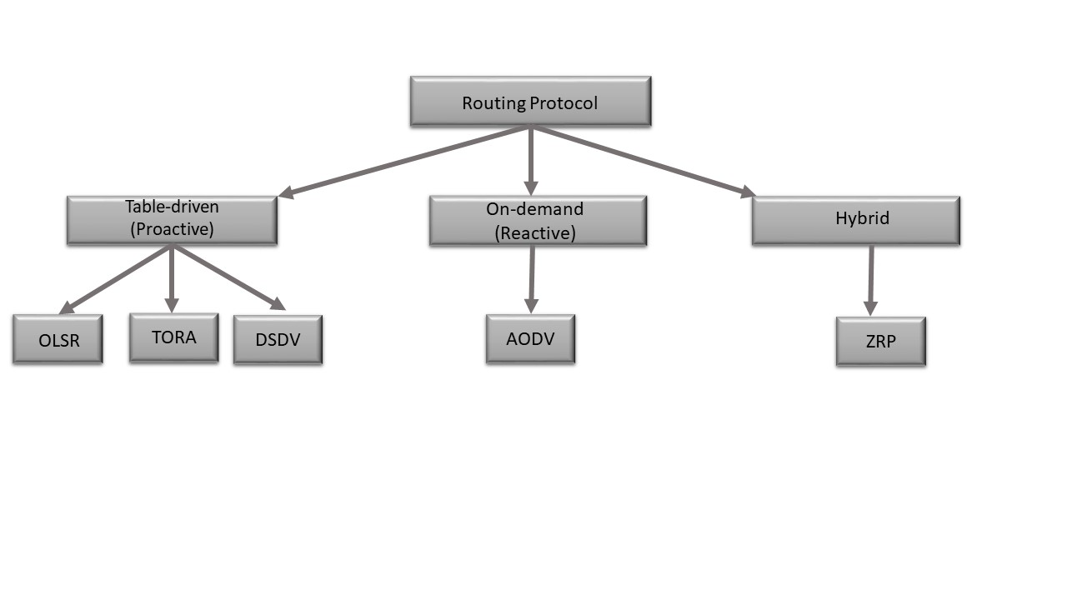
In general, routing protocols in ad-hoc networks are categorised into proactive (Table-driven), reactive (On-demand) and hybrid routing protocols, as illustrated in Figure 2.2.
Figure 2. 2 Routing protocols

2.4.1 Proactive Routing Protocol

Proactive routing protocol stores information on reliable and updated routing information for all nodes in every node. It determines routes of the nodes in a specific network beforehand and ensures that the route is always available whenever it is needed (Yerneni & Sarje, 2012). The scheme experiences large route discovery overheads as all routes in the network need to be discovered. This protocol can also be called Table-Driven routing protocol. OLSR (Optimized Link State Routing), TORA (Temporally Ordered Routing Algorithm) and DSDV (Destination-Sequence Distance-Vector) are examples of proactive of Table-Driven Routing Protocols.

2.4.1.1 Optimized Link State Routing (OLSR)

OLSR always have routes available when needed, due to its proactive nature and offers stable link state algorithm. The protocol uses selected nodes known as Multi-Point Relays (MPR) to reduce the overhead caused by control traffic flooding, to retransmit control messages (Santhamurthy, 2012). With this, the number of retransmission of messages to all nodes is reduced in the network. When the node receives message updates, it then determines the routes towards known nodes. The nodes keep its neighbours MPRs list by selecting sets saved by their neighbours. Whenever the nodes broadcast messages, the nodes included in its MPR set are responsible for broadcasting the messages and the sets consist of nodes with a two hops distance. OLSR offers few advantages on its operation, starting with how it does not need a central administrative system to handle its routing process as all nodes update themselves (Amraoui, Habbani & Hajami, 2018). The messages are sent periodically and this does not have to be sequential, making the link reliable for messages control. The protocol also works well on high density networks and does not allow long delays when transmitting. OLSR however periodically sends updated information throughout the whole network and allowing high protocol bandwidth usage. This also causes transmission duplication, increase in the number of topology control messages and causing a network overhead (Amraoui et al., 2018).

2.4.1.2 Temporally Ordered Routing Algorithm (TORA)

TORA protocol is based on link reversal concept that offers efficient, highly adaptive and scalable distributed routing algorithm (Honey & Sachdeva, 2015; Santhamurthy, 2012). Unlike OLSR, TORA’s control messages are localized to a small set of nodes that are near the topological change. The protocol supports multiple routes between the source and destination and quickly resolves issues of node failure or removal without the involvement of the source, by switching to another route to improve congestion in the network (Bharati & Kumar, 2015). The nodes maintain routing information of the adjacent nodes. The protocol basic functions are; Route creation, Route maintenance and Route erasure. The protocol maintains multiple routes to the destination by reacting only when all the routes to the destination are lost. Thus, it does not require periodic updates, minimising communication overhead and bandwidth utilisation. The challenge with this protocol is that, it depends on synchronised clocks among the nodes in the network (Santhamurthy, 2012).

2.4.1.3 DSDV (Destination-Sequence Distance-Vector)

DSDV routing protocol has each node maintaining a routing table containing all listed destinations along with information of the next hop and the number of required hops between each destination node. The protocol uses full dump and incremental update packets types to update the routing table information. The full dump stores all routing information that is available at a node, with packets being transmitted only when nodes sometimes experience movement as they produce considerable routing overhead. This incremental packet updates only hold changes that occurred since the last full dump packet transmission. Thus, this protocol works better in an ad-hoc network that has low to moderate node movement as stated by Singh, Yadav, Rani, & Sharma (2013).

2.4.2 Reactive Routing Protocol

Reactive Routing protocol provides the route only when it is needed, and this makes it experience small Route Discovery overheads (Ishengoma, 2016). The protocol consists of Ad-Hoc On-Demand Distance Vector (AODV) routing protocol. The protocol provides the route in demand by flooding the network with Route Request packets (Fazeldehkordi et al., 2016). The AODV routing protocol uses the next hop mechanism as DSDV, though DSDV is a proactive protocol and AODV is a reactive protocol.

2.4.2.1 Ad-hoc On-Demand Distance Vector

AODV combines the on-demand with distance vector routing protocol and only maintains route information of the nodes that it is in communication with. The protocol uses Route Request (RREQ) messages when handling route discovery. It broadcasts a RREQ message to neighbouring nodes through the network until it reaches the destination node or a node that know the new route is reached. When the request reaches the destination, it creates a Route Reply (RREP) message that contains information such as the number of hops that are required to reach the destination. A forward route is then created by all nodes participating in the forwarding of the route reply packet to the source. When the node forwards the packets, it enters the ID in its routing table in order to compile a route from the destination node towards the node of the source. When the source node moves, the route discovery is activated again and if the next neighbouring node moves, the link will be invalid, and the node will send this message to the source node. After this, the source node will start with the route discovery again. Each node creates a route from the source to destination by hop-to-hop methodology. This protocol provides a loop free routing and it reduces the control and broadcasting overhead. The protocol comes with the delay caused by the route discovery process (Ishengoma, 2016; Sandhu & Sharma, 2013).

2.4.3 Hybrid Routing Protocol

Hybrid routing protocol is a combination of both reactive and proactive routing protocols’ good factors. The Hybrid protocol has the Zone Routing Protocol (ZRP) in which every network node maintains the routing information proactively about its routing zone, while acquiring routes to destination beyond the routing zone reactively. By doing this, the protocol maintains a balance between the contrasting proactive and reactive routing approaches. The protocol works well on a large-scale network. The term “Zone” is derived from use of zones that defines the transmission radius for every participating node (Ajirioghene, 2009). Due to the fact that communication nodes in ad-hoc networks are mostly distributed due to shifts in the location of nodes, ZRP uses this to describe the basis for communication nodes with other existing protocols (Kaurav & Joshi, 2017; Ravilla, Sumalatha, & Putta, 2011).

2.4.4 Cluster Based Routing

Contrary to the routing protocols discussed above, cluster-based routing protocols organise the network into small groups each managed by a cluster head for routing of data within a cluster and between clusters.

Acharjee, Rajkonwar, & Roy (2016) proposed another clustering routing approach that works by varying cluster head. The cluster head is selected by electing the node that has the highest signal strength, which is observed when nodes exchange hello messages with other nodes in the network and the second highest node is chosen as an assistant cluster head. The hello messages contain node id, node’s signal strength, the state as well as the number of neighbours. The authors present a modified hierarchical cluster-based routing approach for wireless mesh networks. Their approach reduces the load on cluster heads in a network as they have an assistant cluster head, but it however creates an extra load on the mesh point portal and group heads by introducing assistant cluster head. Each node in the network contains neighbour table that consist of neighbouring nodes information plus a cluster adjacency table that stores cluster head and assistant cluster head information.

Tamizarasu & Rajaram (2012) developed a cluster-based weighted algorithm, which took into consideration the degree, broadcast power, battery power of mobile nodes and mobility. Every node in a cluster acquires the weight values of all other nodes and rebroadcast them in order to gather information of other cluster heads. The algorithm uses the AODV routing approach to reduce the routing overhead. Routing is performed in two ways; within a class (intra-class routing) and outside a class (inter-class routing). An intra-cluster routing works with nodes within a cluster, by ensuring that each node obtains routing information in its own cluster. On the other hand, Inter-cluster routing is implemented when routing among clusters of Cluster and involves only Cluster Heads (CH). If a cluster head fails to locate a certain destination, it makes use of neighbouring CHs that are 2-hops away to help finding the destination.
Huang, Fan, Xiang, Wan, Zhou & Yang (2016) designed a clustering algorithm based on a hierarchical routing protocol meant for a large ad-hoc network. The network consists of a cluster head, some cluster gateway nodes, some guest cluster nodes as well as other members. They use proactive protocol by absorbing the quintessence of ZRP among nodes found in individual clusters with reactive protocol placed between clusters.

2.5 Security in Ad-hoc Wireless Networks

Although ad-hoc wireless networks have features such as low-cost installation, they pose serious security issues especially for applications that require confidentiality. This is due to the lack of point of control and frequent changes in the network topology. Therefore, for ad-hoc wireless networks to operate appropriately, attackers need to be detected before they can harm the operation of the network. The security approaches of traditional network vary from the ad-hoc wireless networks. Some of the valid security aspects applied in the wired networks may not be fully applicable to ad-hoc wireless networks. Although basic security requirements such as authentication and confidentiality are the same, the security level plus the performance approach of wireless ad-hoc network limits the set of applicable security mechanisms that are related to another. In this section, the security challenges that the field of wireless ad-hoc networking experiences are explored in more detail. The section deals with the security needs in wireless ad-hoc network plus the concern on attacks performed against the routing fabric. Additionally, important security schemes are presented to illustrate common approaches mostly used to ensure security in networks with fewer infrastructures.

2.5.1 Vulnerability Nature

The wireless ad-hoc network is at risk because of various reasons, from a security point of view. What exactly do we mean when we mention security and how does security play a role in wireless ad-hoc network? The limited physical protection among the nodes makes it difficult to provide tight security in ad-hoc wireless networks. The wireless medium is open, fully exposed, insecure and prone to attacks by malicious nodes. Protection of company or organisational data is very important as once in the wrong hands, it can damage an organisation’s reputation including its personal information being used for wrong reasons, and for this, security is highly needed.

The wireless ad-hoc network experiences unreliable communication among the nodes due to physical security threats. The dynamic changes of the network topology affect the security in the network, making the trust among nodes very hard to derive. One moment a certain node is part of the network and the next it has moved out of the network. A node with a small memory capacity may not be able to perform security task due to memory limitation. The lack of clear line of defence due to open medium increases destruction among nodes as they pass on important information to compromised nodes without knowing. Apart from undetected compromised nodes, the network suffers from eavesdropping, whereby malicious nodes obtain information that can be used unethically to destroy an organisation without knowing how it was leaked (Tanwar, 2013).

2.5.2 Security Needs

The ad-hoc wireless networks are made up of an open medium whereby nodes move freely around as they want with no control among the nodes. This character makes the network highly exposed to attacks. For ad-hoc wireless networks to be secured, it has to have attributes such as: confidentiality, integrity, availability, authentication, access and usage control.
- Authentication: Ensures that nodes verify the identity of their peer that they communicate with. The nodes will need to prove their identities and without authentication, an adversary could masquerade as one of the nodes. This leads to gaining access to sensitive and classified information and likely causing interference with the normal and secure network operation (Aldabbas, Alwada, Janicke, & Al-bayatti, 2012).
- Confidentiality: This is ensuring that unauthorised users do not get hold of sensitive information as the network is used for sensitive operation such as military fieldwork, mobile hospitals and other sensitive uses. In case of secret location operations, information such as routing information should be protected from most users and only be known by those authorised to know. Therefore, there is a high need of preventing nodes that are not trusted from understanding information being transmitted in the network (Aluvala, Sekhar, & Vodnala, 2015).
- Integrity: Ensures that the message sent from the source is delivered to its destination without being altered or corrupted along the route (Aluvala et al., 2015).
- Availability: The network should be able to offer all the services despite when attacks such denial of service occurs (Aluvala et al., 2015).
5) Access and usage control: It ensures that the access to information in ad-hoc network is controlled (Aldabbas et al., 2012).
6) Non-repudiation: When the sender cannot later deny sending a message and the recipient cannot deny receiving it. With this, detecting and isolating compromised nodes has been made easier. When a node receives an error message, it accuses the sender with the proof and informs other nodes about the compromised node (Aldabbas et al., 2012).

In the next section, we discuss attack types such as internal and external attacks including other type of attacks experienced in ad-hoc wireless networks.

2.5.3 Attacks in Ad-hoc Wireless Networks

While challenges such as limited battery life occur among nodes in the network, the ad-hoc wireless networks face attacks that expose higher security-sensitive information. Attacks in ad-hoc wireless networks can be categorised mainly as active and passive attacks.
With passive attacks, an intruder is interested in listening or viewing information without altering it. The main aim is to obtain information being transmitted and to use it later for active attacks. An example of a passive attack is eavesdropping where the attacker listens to secret information to break the confidentiality of a secured communication.

On the other hand, an active attack is an attack where an intruder enters the network and disrupts its operations. The attacker may replicate, modify and delete the information being routed by altering information falsely, which is then forwarded to the receiver without both communication ends noticing that the information has been tempered with. There are also adversaries (whereby) that results from attempts to change the behaviour of the protocol in active attacks.

Active attacks are further categorised into external and internal attacks. External attacks occur when the node performing the attack does not belong to the network and intrudes the network to form part of it. Such an attack can happen very close to the place where the network is configured. External attacks can cause congestion, propagate incorrect routing information, stop system service from working and may shut down the system. In contrast, an internal attack can come from a legitimate node that is part of the network but that has been compromised by a malicious operation (Bharati & Kumar, 2015). Nodes in internal attacks are hard to remove as they belong to the network and are protected by any security mechanism that the system might have and even worse if this malicious node is working as part of a group.

Most existing routing protocols in ad-hoc wireless networks are built on the assumption that all nodes are “good citizens”, that is, they will behave correctly and not compromise the operation of the network. However, the past few years has seen an increase in the number of Layer3 attacks against ad-hoc wireless networks (Wang, Attebury, & Ramamurthy, 2006). Some of the attacks experienced are as follows:
Eavesdropping: Is a passive attack type that operates by finding secret information that should be kept in privacy when communicating. Such information can be private or public keys of senders/receivers or any password (Aluvala et al., 2015).

Traffic Analysis: The attacker senses the communication path between the sender and the receiver. The attacker does this in order to know exactly the amount of data that travels between the nodes without changing anything (Aluvala et al., 2015).
Monitoring: Here the attacker views only confidential information, without changing nor modifying it.

Sniffing: This method attempts to find out the type of data information transferred by sender by sniffing without the sender’s permission (Aluvala et al., 2015).

Sinkhole attack: A compromised node among legitimate nodes attempts to charm the data towards it from neighbouring nodes. The compromised node eavesdrops all the data that the neighbouring nodes are communicating between each other. This attack can be applied on an ad-hoc wireless network such as AODV by minimising the hop count in order for the presented path through the malicious node to look as the suitable route for efficient communication (Aluvala et al., 2015).

Sybil: Is another type of active attack where malicious nodes affect more nodes in a network through impersonation. With one malicious node capable of impersonating several nodes, this significantly degrades the effective measures with the attacker getting access to almost all data available. This attacker may also alter packets before reaching their destination, and the recipients will not be able to detect if the packets were altered along the way. The multiple representation identities in a trust-based routing environment are used to deliver fake recommendations about the trustworthiness and attract more traffic towards it, leading to continuous attacks (Faisal, Abbas, & Ur Rahman, 2018).

The Jellyfish attack: Operates at the routing layer of the network protocol stack and it is similar to black hole attack. In jellyfish, an attacker intrudes the network by making itself part of the forwarding group and intentionally delays data packets for certain period of time before forwarding them out. By doing this, packets suffer a high end-to-end delay and a high delay jitter. Jellyfish attack causes also the degrading of the network performance in real-time applications (Nguyen & Nguyen, 2012).

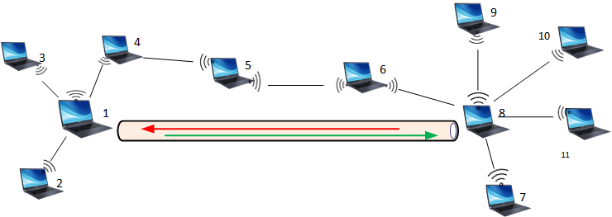
Figure 2. 3 Wormhole attack
Wormhole attack: Is a routing attack that occurs when two far away nodes (node 1 and node 8) use a tunnel to communicate with each other, giving an impression that they are only one hop away from each other as illustrated in Figure 2.3. Each of these nodes will accept a route request and topology control messages from the source and forwards it further to the other half (colluding peer) through the tunnel. With this tunnel, the peer is able to advertise that they have the shortest distance to the destination. Upon link establishment these two nodes choose each other as multipoint relays (MPRs), leading to incorrect topology information throughout the network. This incorrect information further gets forwarded to other nodes in the network, gaining trust of other nodes which will send out packets through the peer path. This prevents legitimate nearby nodes from establishing real shortest delivery links in the network (Kaurav & Joshi, 2017). This attack is very dangerous as it either drops incoming packets or can select which packets to forward in order to avoid detection (Mehta & Sharma, 2013).

Black Hole Attacks: Are a highly sophisticated type of DoS attack, where a malicious node advertise itself having the shortest path to the destination node. After that, the malicious node drops all packets that passed through it. The node does all this with the knowledge of the vulnerabilities of the route discovery packets of an on-demand protocol such as AODV protocol (Mehta & Sharma, 2013). In route discovery of AODV, a malicious node responds to source filling it with false information instead of finding a fresh route to the destination for the packet delivery.

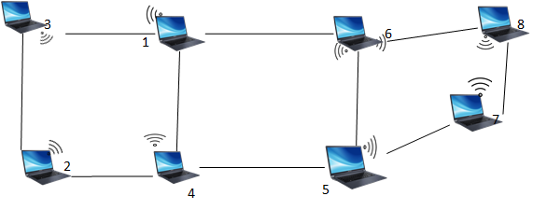
Figure 2. 4 Black Hole Attack
Figure 2.4 illustrates a black hole attack. The source node (node 3) wants to send a packet to the destination node (node 7) as shown in the figure. Node 3 sends out a RREQ (Route Request) broadcast packet into the network. Node 2 is a malicious node in our case, which receives the RREQ packet together with Node 1. Node 1 checks its routing table and finds a route to the receiver. It then generates a RREP (Route Reply) packet and send to the source node. However, if Node 1 could not find a clear route for the packet to reach the destination, Node 1 will forward the RREQ packet further to neighbouring nodes. With the malicious Node 2, after receiving the RREQ packet from the source node, it does not check its routing table nor does it forward the packet further instead it responds immediately with a false RREP to the source Node 3 claiming to have a suitable route for the packet to reach the destination. Node 3 will accept the first reply from the malicious Node 2, forwards the data packet without knowing if it will be dropped and never reach its destination. Once Node 2 receives the data packets, it will drop them and further preventing the establishment of routes plus saving its battery consumption with fewer tasks in the network. A black hole attack is very dangerous. All traffic redirected towards a malicious node never get to reach their intended destination. Thus, for this research we will be focusing on black hole attacks in ad-hoc wireless networks.

The vulnerability of ad-hoc wireless networks towards attacks that occur both within and outside the network, which can be active or passive attacks.
In the next section, we focus on security schemes implemented to detect and prevent attacks in ad-hoc wireless networks.

2.5.4 Security Schemes

In this section, two security schemes are used to secure ad-hoc wireless network: intrusion detection and secure routing.
- In Intrusion detection, wireless nodes detect and avoid malicious behaviour in the network without affecting the routing protocol infrastructure. Implementing intrusion detection system in wireless ad-hoc networks can be quite a challenge due to the nature of the network. Many researchers prefer an alternative solution that consists of modifying the Layer 3 protocols of the networks which is the most vulnerable to attacks (Alrajeh, Khan, & Shams, 2013).
- Secure routing is designed to include security features on existing ad-hoc routing protocols such as DSR and AODV to enhance the operation of the ad-hoc wireless networks (Belgaum, Musa, Su'du, Alam, Soomro & Alansari, 2019).

Conclusion

The characteristics of ad-hoc wireless networks pose many challenges, with secure routing being at the top of the list. The selection of the right routing protocol to use in a certain type of network plays a major role, as it affects the behaviour of your network and most existing protocols were designed to support wired network that operates differently to ad-hoc wireless networks. Our work is primarily based on addressing routing attacks in ad-hoc wireless networks and we will use black hole attack to test the performance of our designed algorithm.

Chapter 3 Intrusion Detection

3.1 Introduction

In this chapter, we discuss intrusion detection, the types of intrusion detection and the infrastructure that comes with IDS, detection methods as well as various secure routing protocols that are performed in ad-hoc wireless network.
In a network or a system, any access or activity that is achieved by obtaining information without the owner’s authorisation are known as intrusions (Valeur, Vigna, & Kruegel, 2004). It is further defined as a sequence of related actions performed by a malicious adversary that results in the system being compromised (Valeur et al., 2004). IDSs are only one part of the overall security of system of an ad-hoc wireless network which generally involves three main components:
- Prevention is the first line of defence in the security system of ad-hoc wireless networks. However, this does not always guarantee a complete system protection as attackers are daily developing more sophisticated attacks. When the system identifies an intruder at the prevention step, it gets ejected from the system before any harm can occur. However, if the attacker manages to escape the prevention step, the system is at risk and switches to its second line of defence, which is the Intrusion Detection (Butun, Morgera, & Sankar, 2014).

- Detection is the second line of defence. It uses software that reduces unauthorised malicious activities by detecting and dealing with intrusion in real-time. Its goal is to detect activities that can harm the system from occurring (Butun et al., 2014; Mishra, Nadkarni & Patcha, 2004). IDS role includes detection of intruders that operate within the network (internal intruder) as well as those that operates from outside the network (external intruder).

- Mitigation is the final step of the security of a system and deals with nullifying the threat by removing the nodes that have been affected from the network routing tables (Butun et al., 2014).

3.2 Intrusion Detection Systems (IDSs)

Intrusion Detection Systems (IDSs) are very important to the network as they provide the mitigation system with information on the identity of the intruder, the location of the intruder, the time the intruder accessed the network and the type of activities that the attacker performs against the network (Butun et al., 2014). IDSs are designed to identify hostile activities in the network, observe any logging information related to past observations, and notify security administrator for any suspected events in order to get them contained on time before damaging the system. The systems achieve detection by continuously being on a look out for any new types of attacks and document old type of attacks that may try to repeat themselves in the network.

IDSs are made up of various tools, methods and resources that are used to assist in identifying, assessing and reporting intrusion in the network and respond to malicious activities by issuing alerts to the mitigation system which in turn blocks the suspicious connection or remove the compromised node from the routing table (Mishra, Nadkarni & Patcha, 2004). IDSs include features such as little usage of the network resources, reliability and minimum false alarms in the detection phase, and little degradation of the overall performance of the system for optimal operation. Their performance is very challenging due to the lack of concentration points in ad-hoc wireless network where aggregated traffic can be analysed (Shavali & Siddiqa, 2013). The conventional approach of positioning a relatively small number of intrusion detection systems (IDSs) and firewalls at traffic concentration or “choke” points to inspect all network traffic, does not work because traffic is normally dispersed over many routes that change dynamically, that is, persistent choke points will not exist (Sterne et al., 2005).

3.2.1 Type of Intruder

Intruders in the network occur in two types, internal intruder and external intruder. An Internal intruder is usually a compromised node that is part of the network but compromised by a malicious person to harm the operation of the network. Internal intrusion is very hard to detect as the compromised node was once marked as a legitimate node that has been participating in the routing process and has a record of the network security information. Since the compromised nodes have been part of the normal operation of the network, they erase any suspicion of them being an intruder. Insider intruders are mostly targeting two types of nodes, according to Michiardi and Molva (2002): selfish nodes and malicious nodes. Selfish nodes are devices that use the network resources, save their battery life for own communication to take place and do not cause harm to other nodes. Malicious nodes, on the other hand, are nodes that are responsible for causing damage to other legitimate nodes by performing attacks such as DoS or by partitioning the network. Saving the battery life is not a priority for malicious nodes. External intruders invade the network with the intention to cause an overload, spread false routing information and disrupt the operation of the network (Kumar & Dutta, 2016).

3.2.2 Type of Intrusion

There are various types of intrusions in the network, with the most common being DoS (Denial of Service), malicious use, leakage and attempted break-in (Butun et al., 2014). A DoS attack blocks the network resources to prevent communication among nodes. A malicious use occurs when a malicious node intentionally damages the network resources. Leakage intrusion attempts to distribute undesirable information to the network while attempted break-ins occur when one gains access to the network without authorisation.

3.2.3 Detection Methods

Different approaches are used to detect intrusion based on specific list of behaviours. The approaches are categorised into three groups: Anomaly-based detection (also known as behaviour-based intrusion detection), Misuse-based detection (also known as knowledge-based intrusion detection) and Specification-based detection (also known as Hybrid-based intrusion detection).

3.2.3.1 Anomaly-based Detection

Anomaly-based detection uses a statistical behaviour modelling approach. The system monitors and captures the network traffic behaviour and builds a profile based on the behaviour of the system (D. A. Kumar & Venugoplan, 2017). The profile is done with the assumption that the network is operating smoothly, free from attack. The network periodically continues to monitor and generates profiles that are compared with the system initial reference profile. Any new behaviour that occurs in the network acting differently from the profile is flagged as an anomalous intrusion attempt (Manusankar, Karthik, & Rajendran, 2010). The technique suffers from weak profiles accuracy due to observation of events that constantly change and has difficulty of setting trigger alerts at the accurate time.

3.2.3.2 Misuse Detection

The misuse detection is a detection system that uses patterns of well-known attacks to identify known intrusions. This technique accurately and effectively detects instances of known attacks and vulnerabilities. However, this technique is unable to detect newly invented attacks. It is a technique that is difficult to implement in ad-hoc networking due to its dynamic nature in terms of the network and lack of point of control. The nature of ad-hoc wireless networks makes it very difficult to define traffic patterns that indicate an attack.

3.2.3.3 Specification Detection

The specification-based detection consists of a set of constraints and specifications that describe the right operation of a protocol or program. Then, it monitors the execution of the program considering the defined constraints and specifications. The method provides the capability of detecting previously unknown attacks, while exhibiting a low false positive alarm rate. By doing this, it combines the benefits of misuse and anomaly based detection techniques by manually using the developed specifications and constraints to characterise legitimate system behaviour (Butun et al., 2014).

3.2.4 Audit Data Source

IDS can also be categorised into three groups depending on the origin of the data being analysed: Network based Intrusion Detection System (NIDS), Host based Intrusion Detection System (HIDS) and Hybrid based Intrusion Detection System.

3.2.4.1 Network Intrusion Detection System (NIDS)

NIDS is made up of a network appliance or sensor with a Network Interface Card (NIC) operating in promiscuous mode with a separate management interface. In NIDS, an IDS is placed along a network segment. NIDS actively or passively listens to the network transmission, captures, and monitors the packets being transmitted on the network segment. An entire packet, payload in the packet and IP address or ports can be analysed by NIDS (Surana et al., 2017).

3.2.4.2 Host Intrusion Detection System (HIDS)

HIDS are installed on workstations that are to be monitored. The agents attached are responsible for monitoring the operating system and write data to log files and trigger alarms. A HIDS can only monitor individual workstation where it is installed on and does not monitor the entire network (Surana et al., 2017). HIDS monitors the real-time system usage of the hosts and examines the log files on the host machines. It is capable of (but not limited to) detecting changes to critical system files on the host, repeated failure access attempts to the host, unusual process memory allocations and unusual CPU activity or I/O activity (Butun et al., 2014).

3.2.4.3 Hybrid Intrusion Detection System

Hybrid IDS combines the advantages of NIDS and HIDS by making use of mobile agents. Mobile agents travel to each host machines and perform system log files check and forward the information to a central agent that checks the overall network traffic for any anomalies (Butun et al., 2014; D. A. Kumar & Venugoplan, 2017).

3.2.5 Data location

Most traditional Intrusion Detection Systems (IDS) are designed to operate in a centralized manner and do not work properly in mobile Ad-hoc networks because data in mobile ad-hoc networks are distributed in different network devices. IDSs are categorised into four categories according to the computing location of the data collected (Butun et al., 2014).
- Centralized IDS
A central computer monitors all activities occurring in the entire network and detects intrusion by analysing the monitored network data activities.
- Stand-alone IDS
Each node runs IDS independently and each decision is made separately based on information collected at a specific node. There is no cooperation among the nodes in this network and no information is shared among the nodes. Each node only knows information about itself.
- Distributed and Cooperative IDS
Each node runs an IDS agent, with nodes sharing information with their neighbours about intrusion detection decisions and actions. When a node detects an intrusion with weak or uncertain evidence, it initiates a cooperative global intrusion detection procedure. When a node detects sufficient evidence of an intrusion, it independently alerts the network regarding the attack.
- Hierarchical IDS
This method works on a multi-layer network infrastructure, where nodes are organised into clusters. Each node in the cluster has different priority, ranging from normal nodes with less privilege to cluster heads (CH) with more privileges. The cluster head monitors their member nodes and participates in the global intrusion detection decisions.
- Mobile Agent based IDS
A mobile agent get assigned with a specific task of the IDS on selected nodes. The mobile agent and the group of selected nodes collaborate among themselves to detect intrusion. Once detection is performed, the mobile agent can relocate to other pre-defined nodes in order to increase the lifetime of the network and the efficiency of the IDS. The specifications of the mobile agents are mobility, autonomy and adaptability.

3.2.6. IDS Infrastructure

Network infrastructure in ad-hoc wireless network can be flat or clustered. In a flat infrastructure, all nodes have equal capabilities and participate in the routing functions. Since the network lacks a centralized control point, it is difficult to manage alerts from different nodes concerning an intrusion in the system. This infrastructure is not desirable when managing alerts, since scalability may become a serious issue especially when the network size increases (Sun, Wu, & Pooch, 2003).

In a clustered infrastructure, nodes do not have equal capabilities. Huang et al.,( 2016) define a cluster as a dynamic grouping of nodes into logical separation or non-overlapping entities. Nodes within a certain transmission range are grouped together to form a cluster and elect a Cluster Head (CH) that has more rights than the rest of the nodes. CH centralizes all routing information for the cluster and is made up of powerful devices with backup batteries for a longer transmission range. The CHs form the backbone of the network and in some cases intermediate gateways may relay packets between CHs. Clustering of nodes offers an efficient technique of establishing a hierarchical structure in ad-hoc wireless networks and solve the complication of addressing and routing for ad-hoc wireless networks that do not scale up well (Chen, Liestman, & Liu, 2004; Huang et al., 2016). With a structured network, it is easy to implement a distributed and collaborative approach to intrusion detection.

3.3 Secure Routing Protocols

Most attacks in ad-hoc wireless network target the link layer or the routing table of nodes. In case an ad-hoc wireless network offers strong encryption and authentication solutions, the security requirements are implemented at the upper layers network, essentially at the network layer. This is because many ad-hoc wireless networks apply IP-based routing protocols. In this section, we take a look at how routing protocols can be secured.

In ad-hoc wireless networks, the absence of a point of control means that all nodes participate in the routing process either as originators of data or as relays. This makes every single node of the network a target for routing attacks. This necessitates the incorporation of measures to secure routing of data and reliability of nodes. In general, the schemes used to secure the routing process involve encryption, authentication and trust relationship to be defined before routing can occur. The guidance requirements to construct a secure routing protocol involves confidentiality of the network topology so as the bottleneck nodes in the routing process are not revealed to the attackers, stability against attacks which ensures that the routing protocol revert back to its usual state after experiencing an attack and detection and exclusion of malicious nodes. Generally, secure routing protocols operate in two modes, stand-alone mode where the routing protocol comes with all the security features and incorporation mode where the security mechanisms are added into an existing routing protocol like AODV. Another approach is to detect intrusions from existing information and respond promptly.

3.3.1 Secure Efficient Ad-hoc Distance Routing Protocols

The Secure Efficient Ad-hoc Distance vector routing protocol (SEAD) is a secure ad-hoc network routing protocol that uses hash chains to authenticate hop counts and sequence numbers. SEAD is designed based on proactive ad-hoc routing protocol DSDV (Moudni, Er-Rouidi, Mouncif, & Hadadi, 2016). The protocol has a minimum requirement of the utilisation of a clock synchronisation mechanism or the establishment of a shared secret between each pair of nodes. It provides loop freedom and protects the nodes from impersonation and several other attacks. The protocol make use of efficient one-way hash functions, that guards against Denial-of-service attacks caused by attackers with an attempt to cause other nodes to consume excessive network bandwidth is made possible (Hu, Johnson, & Perrig, 2002). The protocol handles attackers trying to modify the network routing information if they update the DSDVSQ protocol, disrupting the routing by modifying the sequence number and the metric field of a routing table update message. The protocol does not function with wormhole attack (Kumar, Kulkarni & Gupta, 2010).

3.3.2 Secure DSR routing protocols

Ariadne is a secure ad-hoc routing protocol that is based on a reactive protocol DSR and follows an end-to-end approach for building its security mechanism (Wu, Liu, Zhu, Zhao, & Chen, 2012). Ariadne authenticates routing messages using any of the following three schemes: shared secret key between two nodes, shared secrets between communicating nodes combined with broadcast authentication and digital signatures. Ariadne guarantees that the target node of a route discovering process can authenticate the initiator. The initiator can authenticate each intermediate node on the path to the destination present in the RREP message and no intermediate node can remove a previous node in the node list in the RREQ or RREP messages.

3.3.3 Secure On Demand Distance Vector

Another routing protocol that utilises hash chains to provide security features is the Secure Ad-hoc On-demand Distance Vector (SAODV). SAODV proposes a set of extensions which can be used by providing security features such as integrity, non-repudiation and authentication to protect the route discovery mechanism. It uses cryptographic signatures to authenticate non-mutable fields, while one-way hash chains are used to encrypt all different route discovery processes (Von Mulert, Welch, & Seah, 2012). The protocol suggests that each node in an ad-hoc wireless network is capable of checking the relation between the address of the ad-hoc node in a secure manner. In order to perform asymmetric cryptography, the presence of a key management system is necessary. Two methods used to protect AODV messages are: electronic signatures to authenticate non-mutable message fields and hash chains to encrypt hop count data (the only mutable information in messages). This is because, in the case of non-mutable data, encryption could be carried out in a point-to-point way, but the same kind of procedure cannot be extended to mutable information, which cannot, however, be used for mutable information. This is mostly because some path vulnerabilities contain a huge amount of mutable data that requires a different kind of defence. This stops neighbouring nodes from sending messages to certain destination nodes (Zapata, 2002).

3.3.4 Authenticated Routing for Ad-hoc Networks

The Authenticated Routing for Ad-hoc Networks (ARAN) protocol is a reactive routing protocol that requires a predefined trust relationship. ARAN is based on a type of query-reply dialog that means that the network does not keep up-to-date topology information up to date. ARAN protocol is a stand-alone protocol that uses public-key cryptographic certificates to achieve authentication and non-repudiation security objectives (Moudni et al., 2016).

3.3.5 Security-aware Ad-hoc Routing

Security-aware Ad-hoc Routing (SAR) introduces a new security criterion in the route discovery and maintenance process, treating protected routing as a quality of service (QoS) problem. The SAR protocol incorporates ad-hoc routing protocols such as AODV and DSR on-demand. SAR allows security to be used as a negotiable metric to improve the relevance of discovered routes and uses attributes such as trust values and trust relationships to define the metric (Moudni et al., 2016). SAR's discovered routes come with guaranteed "value of protection" This routing protocol operates with integrated security features to capture and implement specific cooperative confidence relationships (Shcherba & Nikonov, 2016).

3.3.6 Security Routing Protocol

Secure Routing Protocol (SRP) introduces a set of security extensions that is used in any protocol using broadcasting and route queuing methods. The extension is compatible with the existing reactive routing protocols. The SRP requires the existence of a security association between the source node that engages the route discovery process and the destination node for its operation. Upon the establishment of the security association, the nodes share a secret key that is further used by the protocol. SRP guarantees the acquisition of correct topology information by allowing the initiator of the route discovery to detect and drop bogus replies. The protocol is based on the availability of a security association (SA) between the source node (S) and the destination node (T). The SA can be established using a hybrid key distribution based on the public keys of the communicating parties. S and T can exchange a secret symmetric key (KS, T), using the public keys of one another to establish a secure channel. S and T can then further proceed to mutual authentication of one another and the authentication of routing messages. SRP however suffers from the lack of validation mechanism for route maintenance messages, it is not immune to the wormhole attack as two malicious nodes working together can easily misroute the routing packets on a private network connection and alter the perception of the legitimate nodes about the network topology (Moudni et al., 2016).

3.4 Secure Clustering Routing Protocols

The secure routing protocols discussed so far secures the network from the viewpoints of authentication, integrity, nonrepudiation, and privacy. These requirements can be partially met, for instance, by using strong encryption mechanisms and digital signatures. We look at current efforts focusing on secure clustering protocols for wireless ad-hoc networks. Clustering approach provides solutions for problem in the network ranging from network scalability, fault tolerance and communication overhead reduction (Tamizarasu & Rajaram, 2012). These schemes include one or more of the concepts already discussed to ensure secure routing, however, they organise the network into small groups with every single group managed by a group leader. The decision on how a group leader is appointed and the security mechanism implemented within a group vary from one algorithm to another.

Huang & Lee (2004) proposed a mechanism in which each node has its own IDS that monitors the behaviour of the routing and the behaviour of neighbouring nodes. Nodes are organised into clusters, with every cluster managed by a cluster head that is randomly elected. However, their work did not state whether the cluster heads are permanent or not, and if not for how long they remain cluster heads before another random node is selected. The model proves useful in a network without a centralized point of concentration of traffic but equipping each node with an IDS can drain the energy of nodes especially in ad-hoc wireless networks with limited resources such as wireless sensor networks.

Bharati and Kumar(2015) used a clustering approach with a cluster leader in each cluster network using a public-key cryptosystem. Every node has a public key that is known to everyone in the network and a private key that is secret to a specific node in the network. The cluster leader has all the public keys information of all nodes in their network and has its private key portions that it keeps to itself, which is used to decrypt and uses the public keys to encrypt messages for transmission.

Wang & Gao (2010) proposed a secure clustering scheme for MANET that offers forward secrecy and backward secrecy. The scheme organises the network into several clusters and uses the trust values of nodes to judge whether the connection between two nodes is to be trusted or not. Nodes within a cluster are organised into three groups, cluster head, core nodes and cluster members. Cluster head is the node with the highest trusted connections within cluster members, and the nodes that have trust relationships with the cluster head are selected as sub nodes. The cluster head and core nodes join together to form a service group that provides service for requests to cluster members. Each node distributes a secret share key which is part of the secret key for itself and used as an authentication parameter for ongoing investigations. The secret share is also used as a form of authentication by the node for itself. Once a node is identified as a malicious node, the cluster head will broadcast the news to all the cluster members and refuse to provide updating service for the malicious node. The keys of nodes and key of cluster are generated after consultation among the service group members. At the same time, the cluster may achieve the periodic update, the cluster head will be reselected, and the service group reformed, with the updating in cluster key and nodes key. The method seems secure; however, it experiences a problem of the battery life of the nodes that is limited. Nodes tend to use up most battery life within a short span.

Yu, Zhang & Yang (2012) built a secure clustering algorithm on reputation evaluation mechanism based on the behaviours of nodes. The algorithm evaluates the experience of the nodes in the routing process in order to achieve accurate definition and precise quantisation of reputation of nodes, in defending the threat in the network’s cluster. The algorithm also looked at the degree and relative mobility in the clustering to guarantee the stability of clusters.

Gomathi & Parvathavarthini (2015) concentrated on a secure Trust based Clustering Algorithm (TBCA) for MANETs. Their work is based on trust evaluation technique to find the trust value of each node. The trust value is calculated as fuzzy value that ranges between zero and one and is compared with a pre-defined threshold value to decide which node should act as the cluster head. The cluster security is ensured by selecting trustworthy node as the cluster head. The technique is evaluated based on jitter, Packet Delivery Ratio ( PDR ) and Packet drop.

Saurabh, Sharma, & Itare (2017) proposed a collaborative clustering intrusion detection mechanism (CCIDM), using a Modified AODV to detect and prevent black-hole attacks. All nodes in a cluster have to ping once to the elected cluster head, for the detection of exclusive difference between the received data packets and the forwarded data packets by specific nodes. The number of data packets received should be equivalent to the number of forwarded data packets. Once a fault is discovered, all the member nodes will obscure the contagious nodes from the network. The system performance readings are recorded using ns-2 simulator with the metrics being packet delivery ratio (PDR), end-to-end delay (ETD), throughput and energy simulation interference. Their work elected the cluster head using random selection, which can lead to a malicious node being elected as a cluster head. This is a risky method.

Conclusion

Intrusion detection was discussed in depth, by outlining its functions and how it operates, the types of IDS available and its detection methods. On protecting the routing paths in ad-hoc wireless networks, various secure routing approaches were presented as well as existing literature work. The next chapter focuses on our proposed algorithm design.

Chapter 4 Design and Implementation

4.1 Introduction

This chapter introduces our proposed algorithm, by capturing the system design layout, listing all the requirements needed plus the approach needed into testing the functionality of the algorithm and including all the necessary features needed to achieve the operation of HCIDM.
Hierarchical Cooperative Intrusion Detection Method (HCIDM) is a distributed intrusion detection mechanism that uses collaboration between nodes to detect active attacks against the routing table of a mobile ad-hoc wireless network. HCIDM operation reduces the effectiveness of the attack by informing other nodes about the existence of malicious nodes and its operating mode and keeps the performance of the network within an acceptable level. The novelty of the mechanism lies in the way the responsibility to protect the network, which is distributed among nodes. The way the network is clustered using the proximity degree between nodes and finally the way trust level is computed and the information about the presence of a malicious node is communicated to potential victims, that is, nodes within the radio range of the attacker.
HCIDM operates as a middleman between the network traffic and the routing protocol; and is tested using the Network Simulator (NS-2) in an AODV-enabled mobile ad-hoc wireless network. The accuracy and the efficiency of HCIDM are measured during a black hole attack. The packet delivery ratio, throughput, delay and packet loss are used as the main metrics for the evaluation of the performance of HCIDM.

4.2 System Design

The proposed HCIDM is designed to prevent unauthorised access to the routing table of nodes in ad-hoc wireless networks. HCIDM organises the network into clusters, with each cluster having two types of nodes, normal nodes which can be referred to as Member Nodes (MNs) and Cluster Heads (CHs). A cluster head manages its cluster and every member node in the cluster and shares information about anomaly intrusion with other neighbouring cluster heads while MNs control the behaviour of their respective CHs in case they get compromised. A member node in a cluster will register with its cluster’s head periodically to update information regarding its trust level and energy level.
A small number of MNs in a specific cluster affects the detection accuracy, while having too many MNs in a single cluster can bring network overhead and exhaustion of energy among the network’s nodes. It is therefore important to determine the right number of nodes each cluster head should manage. However, in MANET, nodes do not maintain a fixed position, they often move around from one cluster to another which makes it hard to detect compromised nodes. To improve the accuracy of HCIDM, we set the number of MNs in each cluster to a fixed value based on the trade-off between detection effectiveness and energy saving and configure the cluster head such that it alerts its neighbouring cluster heads every time that it is full and cannot accommodate new moving nodes.
During mobility, the security is maintained since the CH to which the moving nodes is currently associated with, will communicate with the new CH the trust level of the incoming node. The functions of the HCIDM is described in three steps: (1) secure cluster formation, (2) secure Cluster Head selection and (3) secure routing protocols.
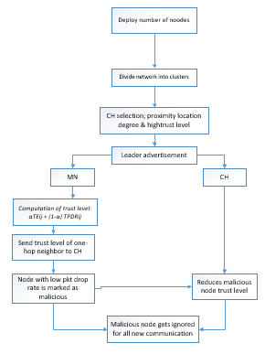
Figure 4. 1 HCIDM Design
The Figure 4.1 above, illustrate an outline of the operation on our HCIDM design that is explained in the sections below.

4.2.1 Secure Cluster Formation

Our secured clustering mechanism chooses clusters consistency and security efficiency. We divided the ad-hoc wireless network into several one-hop clusters where in each cluster, a node is either a cluster head or a member node. The cluster head is a node that communicates directly with other clusters.

A cluster head (CH) is elected in every cluster and it is responsible for maintenance, inter-cluster routing and intra-cluster routing. The cluster formation is based on the geography location of nodes, energy level and the trust level. We introduced the proximity location degree to compute how close nodes are within each other, before the cluster heads are elected. The proximity location degree factor is computed as described below.
Consider a node $i$ with wireless connectivity with a number of neighbouring nodes$j$, $i$ uses the signal strength to estimate its distance $d_{ij}$ to each of its neighbor node$j$. The value of $d_{ij}$ is then compared with the minimum distance value $d_{min}$and the maximum distance value $d_{max}$ to determine how close the node is to its neighbour (see equation 4.1).

$$δ_{ij}=\frac{d_{max}-d_{ij}}{d_{max}-d_{min}}$$ | (4.1)

Node $i$ then computes its proximity degree${ γ}_{i}$ to all its neighbours as follows.

$$γ_{i}=\frac{\sum_{j=1}^{n}{δ_{ij}}}{n}$$ | (4.2)
Where n represents the number of neighbouring nodes.

The values of the proximity degree are then exchanged between neighbouring nodes, and cluster formation is done around nodes with the lowest proximity degree.

For node j to elect node i with the lowest proximity degree as its cluster head, node i needs to exchange additional information about its residual energy and trust levels. The trust level is introduced to ensure security efficiency while the residual energy level ensures that node $i$ can perform the function such as management of the cluster, inter-routing and intra-routing of data. The determination of the trust level is discussed in the next subsection.

It is worth to mention before concluding this section that when$d_{max}=d_{min}$, this means that all neighbouring nodes are within the equal distance of each other, in this case the cluster’s formation is only based on the residual energy and the trust level of nodes.

4.2.2 Calculation of the trust level of nodes

We have adopted the traditional weighing approach of computing the trust level of nodes using parameters such as packet drop rate, packet sent and energy level of nodes. Each member node stores a trust table for all the one-hop neighbouring nodes and these values are periodically forwarded to the cluster head or transmitted to cluster head upon request (Hur et al., 2005).

Since the target attacks is the black hole attacks, we will focus more on the computation of the trust level using the packet drop and energy level. If a node has received some packets while it is not the destination node, it needs to forward the packets according to the routing table stored in its memory. However, if it is a compromised node, it will not forward them but drop them. We implement a packet drop ratio (PDR) at the sending node to monitor its one-hop neighbouring node using the following formula:

$${PDR}_{ij}=\frac{{pktD}_{ij}}{{pktR}_{ij}}$$ | (4.3)
were ${pktR}_{ij}$ indicates the number of packets node j has received from node i and forwarded to the next-hop node according to the routing table and ${pktD}_{ij}$is the total number of packets from packets node i dropped by node j. Every node computes the packet drop ratio of its one-hop neighbouring nodes as indicated in Equation (4.3) and periodically communicate the drop ratio to the cluster head. A node with a high packet drop ratio is considered malicious upon detection. The cluster head upon reception of the packet drop ratio compute a new trust value ${TPDR}_{ij}$of the node as follows.
$${TPDR}_{ij}=1-{PDR}_{ij}$$ | (4.4)

The packet drop ratio is communicated to the cluster head periodically or on request. The cluster head then sends a control packet to every node to communicate the new trust values. All new communications will exclude the node(s) with the lowest trust level, this way clusters prevent any attacks from taking place.
We also compute the trust level ${TE}_{iJ}$based on the energy consumption. All nodes need to consume energy either for transmission, reception or storage of data and a malicious node will consume energy more quickly due to more other actions than normal nodes, including transmitting, processing or dropping, and receiving. Thus, we can know the energy consumption information of a node by comparing its average energy consumption to the normal level. If node i makes assessment of node j, the calculation formula is defined as

$${TE}_{iJ}=\frac{E_{i}}{E_{j}}$$  . | (4.5)
The total trust $T_{ij}$ of node $i$on node$j$ is given a combination of both trust values.
$$T_{ij}={TPDR}_{ij}+{TE}_{ij}$$ | (4.6)

4.2.3 Determination of a Secure Cluster Head

4.2.3.1 Initial Phase

Every node in the network elects itself as the cluster head and advertises its geographical location to its direct neighbouring nodes to compute the proximity degree.

4.2.3.2 Election of Secure Cluster Head

Unlike other schemes whereby the cluster head is selected randomly which may affect the lifetime of the network, in our design we selected the cluster head candidates based on the lowest proximity degree to the neighbouring nodes and next use two criteria: the residual energy and the trust level to adaptively determine the secure cluster head.
We used the following formula to adaptively select the secure cluster head depending on the behaviour of the network

$$αTE_{ij}+\left(1-α\right){TPDR}_{ij}$$ | (4.7)

Where $(0<α<1)$ is a factor we introduce to determine the risk level of the network. If the network is not under threat then the value of alpha is close to 1 and if the network is at risk then the value of alpha is switched to a number close to zero, to give more importance to the trust level based on packet dropped. In our implementation with set the value of $α$ to 0.8 to indicate that the network is in high risk of attack.

4.3. System Requirements

HCIDM main requirements are summarised in the following points:
- Create an intrusion detection model for ad-hoc wireless networks that operate for AODV routing protocol.
- Prevent a black hole attack from intruding ad-hoc wireless networks.
- Upon detection of malicious activity, the CH should be able to send out an alert in real time and should be able to take countermeasures to hold the network performance to acceptable levels.
- Detected malicious nodes are penalised for a finite period of time rather than being isolated forever in order to avoid the impact of possible false positive alarms.
- If a CH gets compromised, the next node with the highest trust level and/or energy level will take position as a new CH.

Simulation Model

4.4.1 Introduction
The simulation model presented in this thesis is based on the Network Simulator 2 (NS2). NS2 is an object-oriented, free, discrete event-driven and open-source network simulator that offers support for wired and wireless networks, several routing algorithms, and networks’ protocols. Some of the network protocols that are built into NS2 include TCP/IP suite and various other protocols to perform experiments in both wired and wireless mediums. In recent years, its functionality has grown to include ad-hoc networks as well (Issariyakul & Hossain, 2012).
NS2 grew out of the REAL simulator developed by Srinivasan Keshav in 1989. Later, the Network Research Group at the Lawrence Berkeley National Laboratory by Floyd and McCanne in 1995 extended it. The VINT project (Virtual InterNetwork Testbed) at the Lawrence Berkeley National Laboratory later extended NS2 to support many telecommunication protocols. The core of the NS2 simulation engine is implemented using C++. However, to set up a simulation experiment, the topology needs to be described using oTCL scripting language (Naguib, 2017). NS2 comes with extended packages such as NAM (Network Animator), a Tcl-based animation system that produces a visual representation of the specified network.

4.4.2 Architecture of NS2

NS2 is very helpful when cutting very high cost in verifying viability of new algorithms, test architectures, check topologies, check data transmission etc., which instead is first tested in a simulation environment before a real-life implementation. The NS2 network simulator offers simplicity and modularity that has made it very popular among network research participants community. NS2 implements transport layer protocols such as TCP or UDP, interfaces queue and simulates mobility in wireless networks. The network simulation allows simulation scenarios, to be easily written in the Tcl/OTcl programming language. More complex functionality relies on C++ code that either comes with NS2 or is supplied by the user. The combination of the two programming languages increases the flexibility of NS2. C++ handles algorithm, headers and per-packet processing tasks for which if performed in Tcl/oTcl would take too long to produce output. The usage of Tcl/oTcl for simulation scenario scripts allows the user to change parameters of a simulation without having to recompile any source code. The usage of two different programming languages is better summarised, that OTcl is suitable for the programs and configurations that demand frequent and fast change while C++ is suitable for the programs that have high demand in speed. Both C++ and OTcl programs consist of two different class hierarchies, the linked hierarchy and the standalone hierarchy. The classes of the linked hierarchy of both the domains are linked together using TclCL as shown in figure 4.2 below.

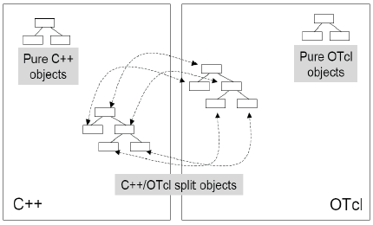
Figure 4. 2 C++ and Tcl/Otcl interaction
Figure 4.2 illustrates an example of how C++ interacts with Tcl/Otcl language. Tcl language is used in this work in designing the ad-hoc wireless network in setting up the parameters of the nodes, configuration of the nodes, laying out the topology, setting up connections and traffic between the network nodes.

We have modified the aodv protocol to enhance our design method by accessing the aodv.cc file found under the directory: /ns-allinone-2.35/ns-35/aodv. The following picture illustrate the path plus the changes added to the aodv.cc file as compared to the aodv-draft file which was the original aodv.cc file.

4.4.3 Data Collection and Analysis in NS2
The simulation runs using a network scenario in a Tcl Simulation script that is fed as an input to an executable ns file. During the simulation, the packet flow information can be collected through text based or NAM tracing files.

We then extract relevant subset of text-based data and transform it to a more conceivable presentation in order to analyse the particular behaviour of the network. This can be achieved using text processing tools such as AWK program, PERL or Python.

4.4.4 Extending NS2 to support malicious node

As explained in Chapter 2, a black hole attack occurs when a malicious node advertises itself as having a valid route to the destination to mislead the sender into using its path and later drops the packets instead of forwarding it. In order to add the malicious routing node that performs the black hole attack in NS2, some internal NS2 files had to be modified.

In our implementation, a malicious node intrudes the network using a false identification and then tries to attract all the traffic by claiming a fresh route to the destination and then drops them without forwarding to the destination which disrupts the performance of the network almost completely.

Conclusion

The chapter introduced the proposed HCIDM, which focuses on a clustering approach to managing and securing a corporation among the nodes in the network. The algorithm focused on the arrangement of nodes and trust level values to nodes to ensure better detection against malicious nodes as well an incorporated secure routing protocol into the network. The algorithm uses ns-2 simulator as a testbed environment.

Chapter 5 Simulation and Analysis

5.1 Introduction

In this chapter, we evaluate the performance of the proposed Hierarchical Clustering Intrusion Detection Mechanism to improve routing security in mobile ad-hoc wireless networks. The mechanism, which will be referred to as HCIDM, organizes the network into clusters and removes black hole node from the routing table when the node has be identified as the one dropping most packets in the routing path. We perform various simulation to analyse the effectiveness of the proposed mechanism, looking at metrics such as throughput, packet loss, average end-to-end delay and delivery ratio. From the simulation, we observe that the mechanism reduces packets loss, reduces the end-to-end delay experienced by packets in transit to the destination and, improves the overall networks throughout.

5.2 Metrics Definition

The metrics used in all our experiments are computed using the formulas below as defined in (Yasin & Zant, 2018).

5.2.1 Throughput

Throughput (T) specifies the amount of data received at destination node from the source node during the entire transmission time and is computed using Equation 5.1.

$T=\frac{Pr}{Ct}×\frac{8}{1024}$ (5.1)
Where Pr is the number of received packets and Ct is the connection between the source node and destination node. The unit for measurement is Megabits per second (Mbps)

5.2.2. Packet Delivery Ratio

Packet delivery ratio (PDR) indicates the ratio of successfully received packets at the destination node to the packets sent from the source node. Packet delivery ratio is computed using Equation 5.2:
$PDR=\frac{Pr}{Ps}$ (5.2)
Where Pr is the number of received packets received by the destination node and Ps the number of packet sent from the source node.

5.2.3 Packet Delay

Average end-to-end delay refers to the amount of time that the source node takes to transfer packets to the destination node.
$Delay=\sum_{i=1}^{n}{{Rt}_{i}}-\frac{{St}_{i}}{n}$ (5.3)
Where ${Rt}_{i}$ is the receive time recorded on packets at nodes i, with the total number of nodes in the network represented by n. The delay is measured using millisecond (ms).

5.3 Simulation Setup

We simulated various ad-hoc wireless networks, the number of mobile nodes and black hole nodes differed for most simulation. The configuration of the networks is summarised in Table 5.1 below.
Table 5. 1 Configuration of the Simulated Ad-hoc wireless networks
Simulator | ns-2
Duration of the simulation | 20.0 min
Simulation area (m²) | 1000 * 1000
Number of mobile nodes | changes according to the 5 different simulations
Interface queue type | Queue/DropTail/PriQueue
Mac type | Mac/802.11
Network interface type | Phy/Wirelessphy
Propagation model | Two-way ground radio
Number of malicious nodes | changes according to the 5 different simulations
Routing protocol | idsAODV
Packets size(bytes) | 500
Thresholds | 4
Maxcwnd /maximum contention window size | 7
Energy level | 10

Table 5.1 gives a detailed description of the simulated network topology in an ad-hoc wireless network.
The ad-hoc wireless network environment of this project is as follows: a wireless channel, two ray ground radio propagation model, MAC 802.11 protocol, physical wireless network interface, Queue/DropTail/PriQueue, and idsAODV protocol.
The network is configured with a network size of 1000 m x 1000 m. The number of clusters is specified in each simulation. We had insured the worthiness of our test results by making use of confidence interval. The confidence interval was measured by using packet lost. However, metrics such as throughput, packet lost, delivery ratio and packet delay were considered in the performance evaluation of the proposed HCIDM mechanism.

5.4 Confidence Intervals

In our first simulation, we computed the confidence interval for the expected number of lost packets during a black hole attack. Each replication started from the same initial conditions and terminated at the end of the simulation time. The independence of the replication is achieved by varying randomly the number of mobile nodes in each replication. The number of black hole nodes was 10% of the number normal mobile nodes.
The simulation consisted of 50 normal mobile nodes and of 5 black hole nodes that moved randomly in a grid of 2000 m square. During the simulation the black hole nodes movement were located in the shortest path between the destination nodes and the source nodes. The source nodes relayed packets through malicious nodes that stored and dropped many packets instead of forwarding them to their destination nodes.
Fig. 5.1 (a) shows the confidence intervals and the relative errors for the expected number of packet lost in a 16 times replication simulation. After 16 replications of the simulation capturing, the average number of packet lost at around x (17) =18906.5 and a relative error y=12%. We found that the relative error was too high after 16 replications and proposed to increase the number of replications to 50 to reduce the relative error.
Fig. 5.1 (b) shows the confidence intervals and the relative errors for the expected number of packet lost in a 50 times replication simulation. After 50 replications, the average number of packet lost was at around x (50 =19082.5 and the relative error y at 5%. Looking at the two above figure 5.1(a) and 5.1(b), the relative error in (b) had better results of 5% relative error as compared to the higher relative error in figure 5.1 (a) that has 12% due the low number of replications. The more replications of the simulation reduced the relative error from 12% to 5%. Thus, in the rest of this chapter all the results presented are replicated 50 times to reduce the relative error to less than 5%.

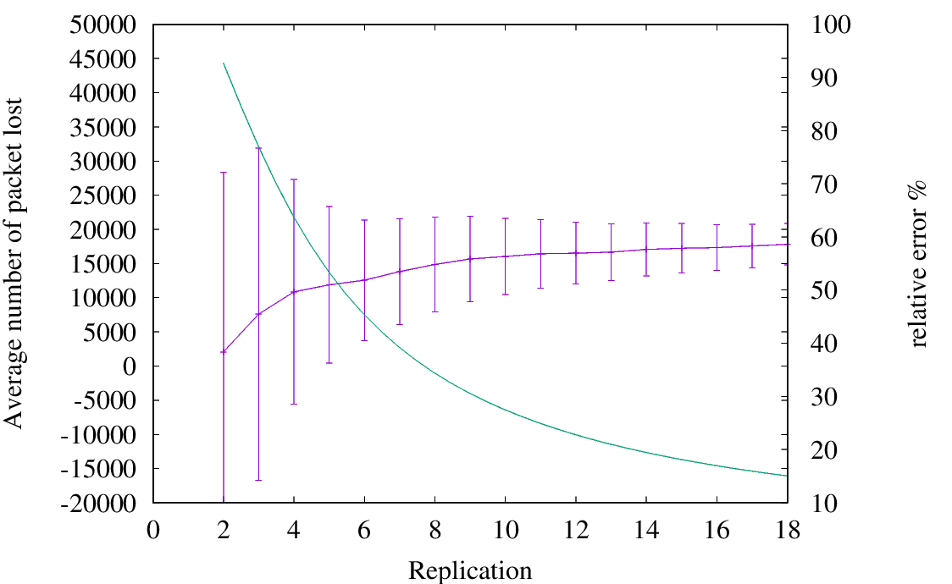  (a) After 16 Replications | 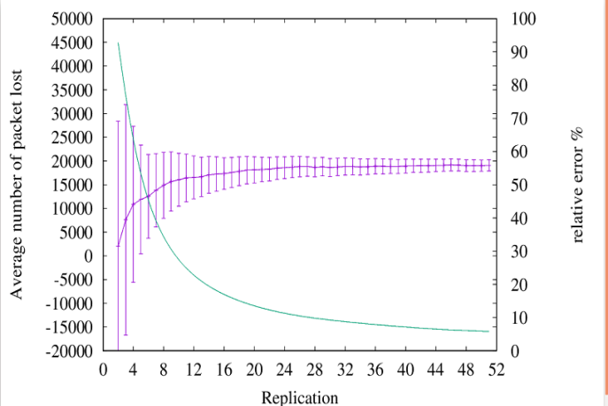  (b) After 50 Replications
Figure 5. 1 Confidence Interval for Lost Packets

5.5 Performance of HCIDM in Static Ad-Hoc Wireless Network
In our second experiment, we test the impact of a black hole attack in a static wireless ad-hoc network and the performance of the proposed HCIDM in the same network. A static ad-hoc wireless network is a network where wireless nodes are not moving. The simulation consists of 7 legitimate wireless nodes being attacked by 1 compromised black hole node.

Impact of black hole attack in a static nodes network

The following three graphs illustrate the throughput, packet lost and delay experienced during a black hole attack.

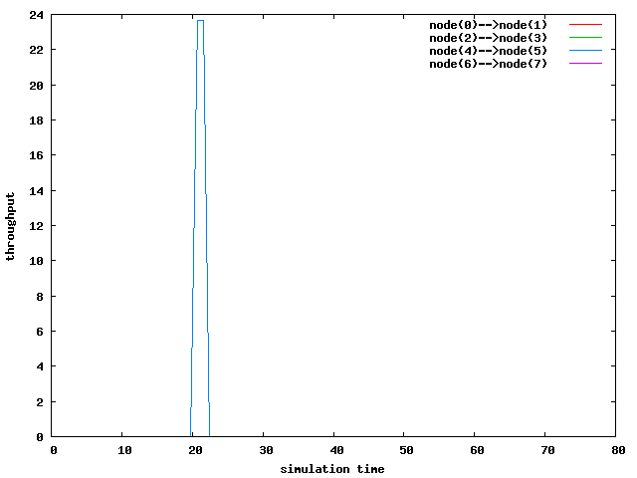
Figure 5. 2 Throughput
Figure 5.2 shows that only the connection between node 4 and node 5 was able to transmit data for a short period. The other transmissions were completely blocked by the black hole node that managed to compromise their routing tables at beginning of the simulation; and due to the fixed position of nodes, once a node routing table has been compromised by a black hole node due to its proximity to it, it remains blocked throughout the whole simulation.
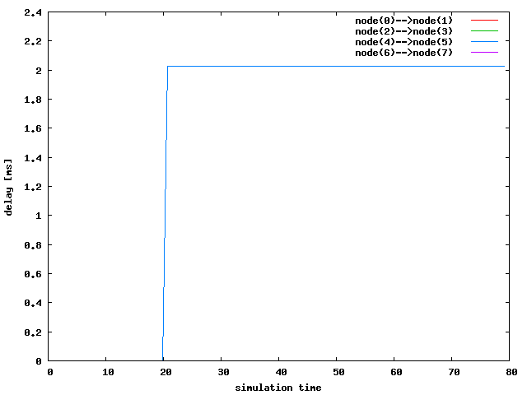
Figure 5. 3 Average Packet delay
Figure 5.3 shows that packets transmitted by node 4 to node 5 experienced an average delay of 2ms in the transmission of the data packets, the rest of the nodes could not send out any packet as they were compromised immediately at the beginning of the simulation (see Figure 5.2).

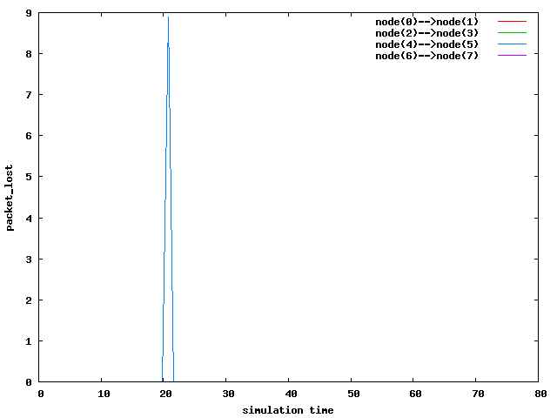
Figure 5. 4 Packet lost
Figure 5.4 shows that only 9 packets were lost from the connection between node 4 and node 5 while packets for all other transmissions were blocked, thus lost. Thus achieving 48% of delivery ratio.

Impact of HCIDM in Static Ad-Hoc Wireless Networks

We then, replicate the same experiment and the enhanced the network with the proposed HCIDM protocol. However, since the network is very small with only 8 nodes with 1 compromised black hole attack node. We only used one single cluster and allocated to all legitimate nodes the same trust level. The following three graphs illustrate the throughput, packet lost and delay experienced under one black hole node attack.
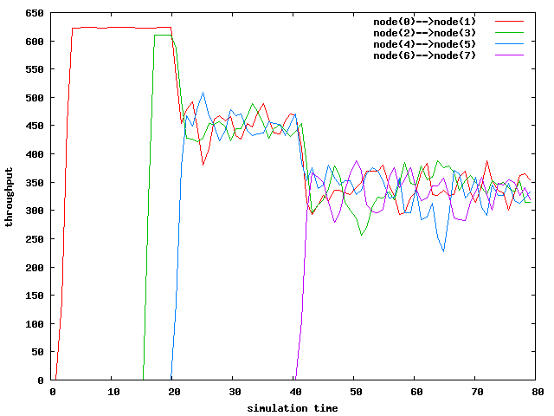
Figure 5. 5 Packet throughput

Figure 5.5 shows that with the proposed HCIDM, all connections were able to transmit data packets despite the presence of the black hole node. High throughput is observed during the first 20ms of the simulation time, which only started reducing slightly after 20ms. Few packets got dropped by the malicious node before HCIDM detected its presence and blocked further attacks in the network.

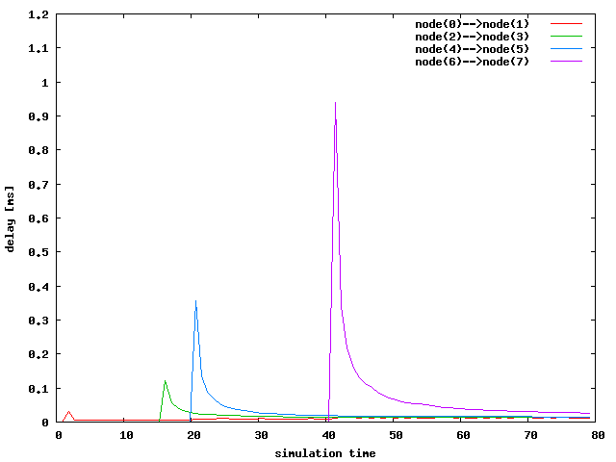
Figure 5. 6 Packet delay
Figure 5.6 above illustrate the highest packet delay experienced between the connection of node 6 and node 7 during 40ms of the simulation running time for about 4ms before it reduced rapidly from 0.9ms delay to below 0.1ms delay. This rise in the delay can occur due to the presence of a malicious black hole node misleading nodes in the network about it having a shortest routing path to the destination node. When this occurs, packets that arrive at this malicious node gets dropped instead of being relayed to the destination node.

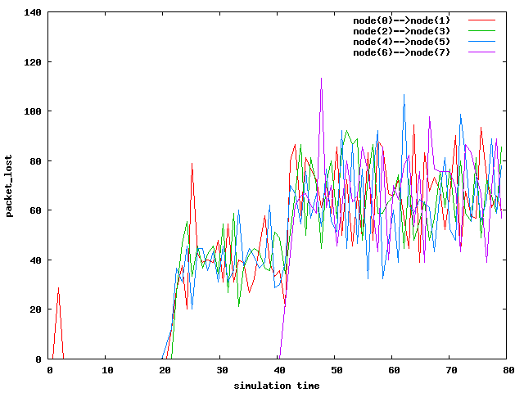
Figure 5. 7 Packet lost
Figure 5.7 shows packet lost experienced in the network occurring in most transmitting nodes in the network with HCIDM working under a network with black hole attack. An example of transmission connection between node 6 and node 7 experiencing a number of packet lost from 40ms of the simulation time could be that the nodes were under attack before HCIDM detected the attack in the network. By default, the routing protocol drops few routing packets when there is high resource consumption in the network that the attack takes advantage of this and floods the network with unnecessary routing traffic. The flooding in the network could affect genuine routing packets to be dropped as it will not be able to detect the unnecessary ones in time. The overall delivery ratio for the wireless ad-hoc network with the HCIDM protocol was 73%.

5.6 Performance of HCIDM in MANETs

In this experiment, we investigate the performance of HCIDM when mobility is introduced in the network. The simulation consists of 50 mobile nodes being attacked by five black hole nodes. We set up 10 UDP connections between node $i$ and node node $i+1$ ($\left(i=1,…10\right)$) and implemented a UDP loss monitoring agent at the receiver end to facilitate computation of the throughput, delay and packet lost. We first look at how black hole attack impacts on the performance of MANETs and then analyse the same scenario when the network is enhanced with our proposed HCIDM. The simulation consists of 50 nodes scattered in an area of 1000 m square. We have increased the number of nodes to ensure that communication between nodes is still possible as they are moving. However, we organise the networks into three clusters. The nodes that are in close range proximity form up a cluster and within the cluster the node that has the highest trust level and the lower proximity degree in the cluster gets elected as a cluster head.

5.6.1 Effect of black hole attack in MANET

We analyse the effect of black hole attacks in MANET using the throughput, packet delay and packet lost.
Figure 5.8 and Table 5.1 below shows the throughput readings during simulation run time and the average throughput per connection respectively.
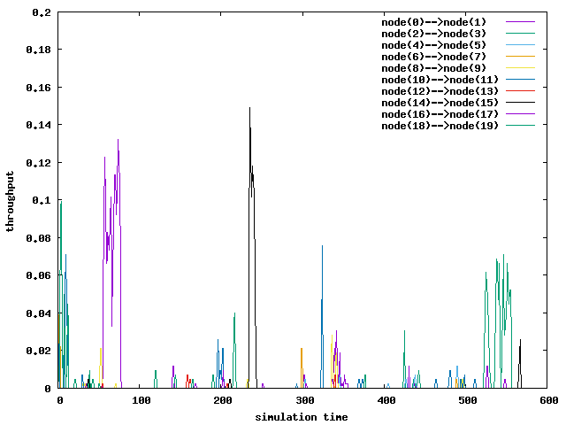
Figure 5. 8 MANET Throughput

Table 5. 2 Average throughput per connection
Connection ID | 1 | 2 | 3 | 4 | 5 | 6 | 7 | 8 | 9 | 10
Nodes connection | 0-1 | 2-3 | 4-5 | 6-7 | 8-9 | 10-11 | 12-13 | 14-15 | 16-17 | 18-19 | Total Average
Average throughput  (Mbps) | 2.389 | 3.93 | 0.09 | 3.23 | 1.03 | 0.63 | 0.141 | 1.06 | 1.06 | 0.65 | 1.42

Figure 5.8 and table 5.2 illustrate the throughput decreasing as mobility occurs compared to a static wireless ad-hoc network. Nodes that move in proximity of black hole nodes experiences attack that reduces their throughput as most packets will be dropped when relayed by a black hole node. The nodes that are transmitting far from black hole nodes manages to successfully transmit their packets This can however change if there is a black hole node in the routing path towards the destination nodes. Once the packet reaches the black hole node it will get dropped immediately. For example, if we consider the connections 2 and 4 from table, we observe that they had an average throughput above 3 Mbps as compared to the connections 6 and 7 that had below zero Mbps, meaning packets relayed from nodes with a high average throughput escaped the attack. This explains the low throughput observed in the Figure 5.8 and Table 5.2.
Figure 5.9 and table 5.3 below illustrate respectively the instant packet delay and average packet delay for the same scenario.

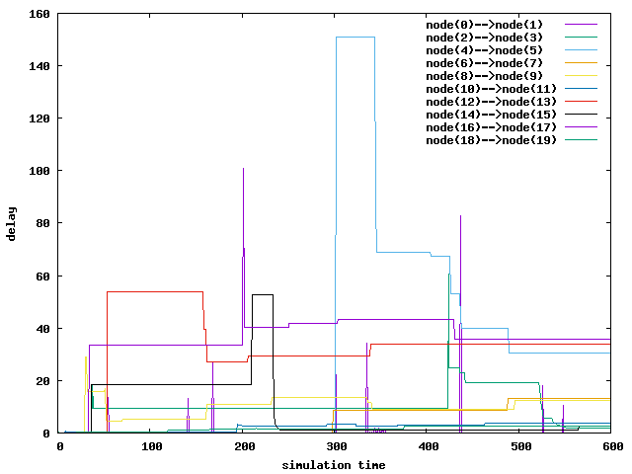
Figure 5. 9 MANET delay
Table 5. 3 Average packet delay per connection
Connection ID | 1 | 2 | 3 | 4 | 5 | 6 | 7 | 8 | 9 | 10
Nodes connection | 0-1 | 2-3 | 4-5 | 6-7 | 8-9 | 10-11 | 12-13 | 14-15 | 16-17 | 18-19 | Total Average
Average packet delay  (ms) | 0.25 | 6.99 | 31.30 | 7.79 | 8.89 | 2.83 | 33.55 | 6.52 | 35.76 | 2.61 | 13.65

From figure 5.9 and table 5.3, shows the presence of black hole attack, the network experienced a high end-to-end delay as compared to a static ad hoc wireless networks. This is because most of nodes relayed their packets through the black hole nodes. For example, the connection between 4 and 5 has an increase in the delay during 300ms to 400ms of the simulation time. The two nodes kept relaying their packet through a black hole node and retransmitting the packet dropped cause a high packet delay. This also leads to a high average delay in the two nodes of 8.89ms.

Table 5. 4 Average packets lost per connection
Connection ID | 1 | 2 | 3 | 4 | 5 | 6 | 7 | 8 | 9 | 10
Nodes connection | 0-1 | 2-3 | 4-5 | 6-7 | 8-9 | 10-11 | 12-13 | 14-15 | 16-17 | 18-19 | Total Average
Average packet lost | 14.32 | 21.45 | 22.35 | 24.04 | 22.33 | 13.55 | 23.43 | 21.54 | 11.50 | 18.32 | 19.28

Finally, the graph of the number of packet lost was difficult to read, we therefore, we summarised the average packet lost results in table 5.4. The connection between 18 and 19 shows an increase in packet loss throughout the network. This is due to the fact the five black hole attacking nodes are in proximity with the source nodes, causing many packets to be dropped. When the mobility increases among the nodes, the malicious nodes targets the source nodes by manipulating the source nodes pretending to have the shortest path to the packet destination. Once the source nodes relay packets to the malicious nodes, the black hole nodes drop all the packets that they received causing a high packet loss the network.

5.5.2 Effect of HCIDM in MANET

In this section, we included HCIDM in a MANET and evaluated the effect of black hole attack when HCIDM is implemented in the network.

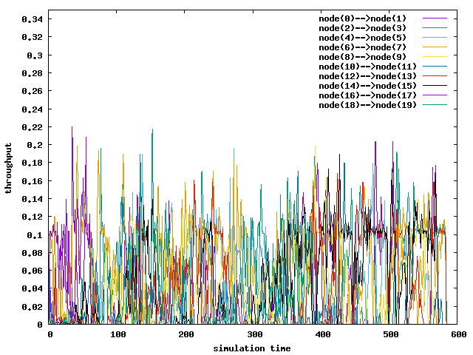
Figure 5. 10 HCIDM throughput

Table 5. 5 Average throughput per connection
Connection ID | 1 | 2 | 3 | 4 | 5 | 6 | 7 | 8 | 9 | 10
Nodes connection | 0-1 | 2-3 | 4-5 | 6-7 | 8-9 | 10-11 | 12-13 | 14-15 | 16-17 | 18-19 | Total Average
Average throughput (Mbps) | 24.58 | 29.28 | 25.89 | 44.59 | 21.68 | 14.11 | 23.83 | 29.11 | 5.82 | 13.42 | 23.23

From Figure 5.10 and table 5.5, it was observed an increase in the network throughput after implementing HCIDM during a black hole attack. The total average of the network with black hole attack is at 1.42 Mbps while the network with HCIDM during a black hole attack has a total average throughput of 23.23 Mbps which represents an improvement of 94% of the overall throughput.
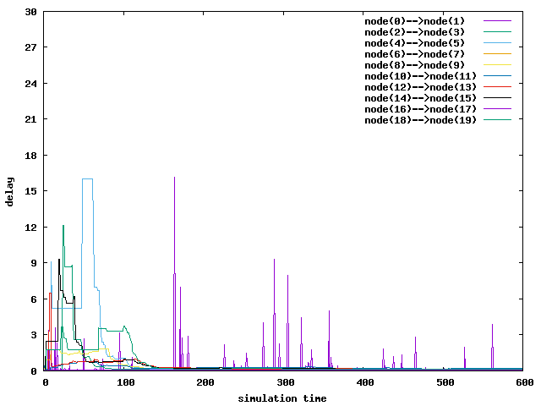
Figure 5. 11 HCIDM packet delay

Table 5. 6 Average packet delay per connection
Connection ID | 1 | 2 | 3 | 4 | 5 | 6 | 7 | 8 | 9 | 10
Nodes connection | 0-1 | 2-3 | 4-5 | 6-7 | 8-9 | 10-11 | 12-13 | 14-15 | 16-17 | 18-19 | Total Average
Average packet delay(ms) | 0.13 | 0.28 | 0.70 | 0.06 | 0.29 | 0.25 | 0.24 | 0.40 | 0.49 | 0.44 | 0.33

Figure 5.11 and table 5.6 above show the results of the reduction in packet delay when compared with the readings from figure 5.9 were the network was under a black hole attack without a HCIDM. Table 5.4 had a total average delay of 13.65ms when the network was under attack while with the network with HCIDM with black hole attack had a total average delay of 0.33ms, giving a huge throughput increase in the network. The presence of HCIDM reduces the delay of the network as it eliminates retransmission of packets caused by black hole attacks. When a network experiences a high throughput as recorded in the previous table 5.5, the delay is low as most packets were transmitted successfully.

Table 5. 7 Average packet lost per connection
Connection ID | 1 | 2 | 3 | 4 | 5 | 6 | 7 | 8 | 9 | 10
Nodes connection | 0-1 | 2-3 | 4-5 | 6-7 | 8-9 | 10-11 | 12-13 | 14-15 | 16-17 | 18-19 | Total Average
Average packet lost | 17.69 | 16.38 | 12.10 | 14.23 | 13.93 | 16.51 | 14.85 | 11.75 | 0.28 | 10.47 | 12.82

For better presentation of the packet lost we summarised the results using table 5.7 that shows the packet lost readings. The network experienced an average packet lost of 12.82 with HCIDM compared to an average packet lost of 19.28 without HCIDM.HCIDM has improved transmission of packets in the network by achieving a lower average packet lost.

Performance of HCIDM in large network

In this section, we study the robustness of the HCIDM when the network size and number of black hole nodes increases. Firstly, we focus on the effect an increase in the network size has on the HCIDM and then we look at both the effect an increase in the network size (number of legitimate nodes) as well as the increase in the number of black hole nodes as on the HCIDM. In this second case, the number of black hole nodes is obtained as 10% of the number of legitimate nodes.
Figures 5.12 and 5.13 illustrate the throughput and delay recorded in a MANET with static and dynamic number of black hole nodes. In the static case the number of black hole nodes is fixed to five, while in a dynamic case, as stated above the number of black hole node is set to 10% of the number of normal nodes. For example if the network consists of 50 normal nodes, the number of black hole nodes will be five.

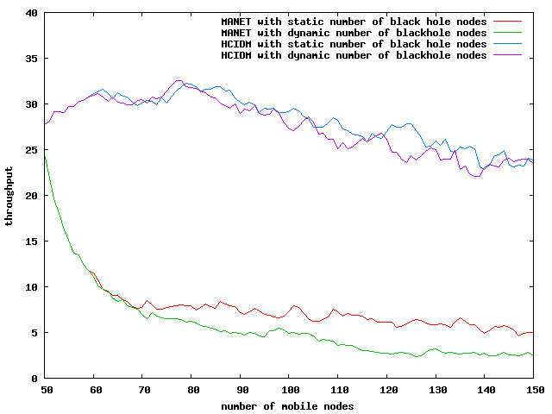

Figure 5. 12 Static and dynamic throughput
Figure 5.12 shows a very high throughput in the network with HCIDM in comparison to the network without HCIDM and the drop in the network throughput for HCIDM is steady as the network size grows. The network with static number of black hole has, however, the highest throughput compare to the varying number of black hole nodes. The average throughput for the static case is 34 Mbps and for the dynamic case is 31 Mbps, which highlight how well HCIDM copes with an increase in the number black hole nodes.
The network without HCIDM experienced a very low average throughput of around 8 Mbps, and the throughput decreases very fast with the increase of the network size. As for the network with HCIDM, the static case had a slight high throughput than the dynamic environment network. However, here the difference in the achieved average throughput between the two scenarios is noticeable from 8 Mbps to 3 Mbps.
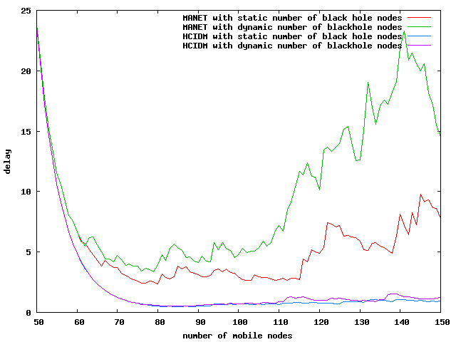

Figure 5. 13 Static and dynamic delay
Figure 5.13 shows a low delay for a network with HCIDM running in both static and dynamic modes in comparison to the network without HCIDM. The network without HCIDM experienced a very high delay especially in the dynamic case where the size of the network and the number of black hole nodes both increased. This is due to the increased number of black hole nodes dynamic compared to the static environment that leads to more attacks and retransmissions of packets. The HCIDM with dynamic number of black hole nodes has a slight high delay compared to the HCIDM with static number of black hole nodes. In a dynamic environment, the number of black hole node was more than in static environment. However, as in figure 5.14 the difference in delay between the two scenarios is not noticeable which demonstrates that the proposed HCIDM is coping well with the change in the network conditions.

Dynamic black hole node in a fixed 150 legitimate nodes MANET network

In this section, we study how the proposed HCIDM resist to black hole attack when the network size has a fixed number of normal nodes and an increase in the number of black hole nodes in a MANET network with HCIDM and another without HCIDM, to get more on how the proposed HCIDM resist to black hole attack.
Figures 5.14 and 5.15 illustrate the throughput and delay in a MANET with HCIDM and another without HCIDM both under a black hole attack. Both networks consist of fixed 150 normal nodes and a varied number of black hole nodes from 5 to 30 nodes.

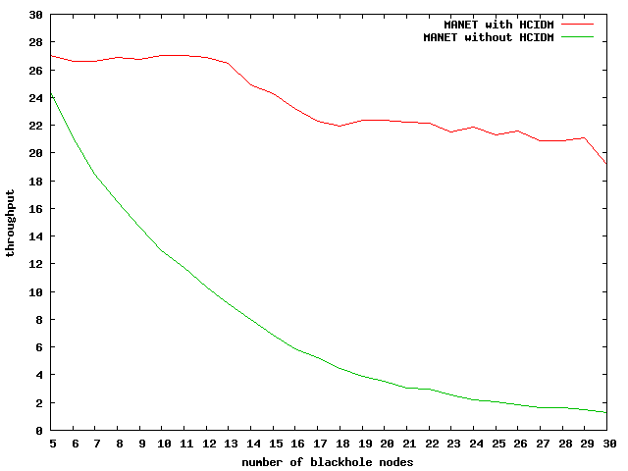
Figure 5. 14 Dynamic black hole throughput
Figure 5.14 shows the comparison of the throughput in a MANET with HCIDM versus MANET without HCIDM. HCIDM proved to handle the increase in the number of black hole nodes in the MANET network very well. When the number of black hole nodes started increasing, the throughput just reduced slightly but still maintained a throughput above 20 unlike in the network without HCIDM that the throughput kept on decreasing as the number of black hole nodes increased in the network. When the number of black hole nodes was 30 the MANET network with HCIDM had a throughput of 21 while the MANET without HCIDM had a throughput around 1. HCIDM showed exceptional performance while under greater attack.
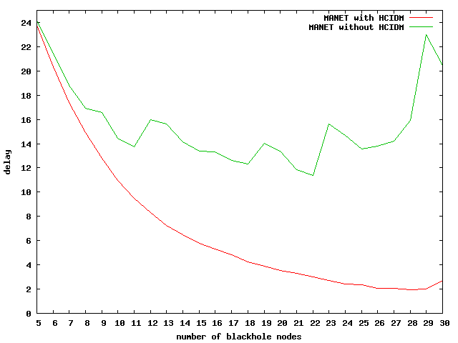
Figure 5. 15 MANET with HCIDM delay
Figure 5.15 illustrates the delay in the network with HCIDM started reducing as the number of black hole nodes started increasing while the network without HCIDM increased its delay as the number of black hole nodes kept on increasing. HCIDM had a delay of around 5 when the network had 30 black hole nodes while the network without HCIDM had a delay around 23. With reference to figure 5.14 and 5.15 HCIDM shows a great performance towards handling black hole attacks in MANET.

5.8 Comparison between CCIDM and HCIDM

This section gives a comparison study of the performance of our proposed HCIDM with CCIDM (see Chapter 3) in MANET under black hole attack. We simulated two network’s with 30 black hole nodes with 150 normal nodes, one network with HCIDM and another with CCIDM algorithm, the networks were further divided into three clusters with equal number of nodes using the close proximity degree allocation. With this comparison, we were able to verify the improvement on our designed HCIDM over the existing CCIDM.
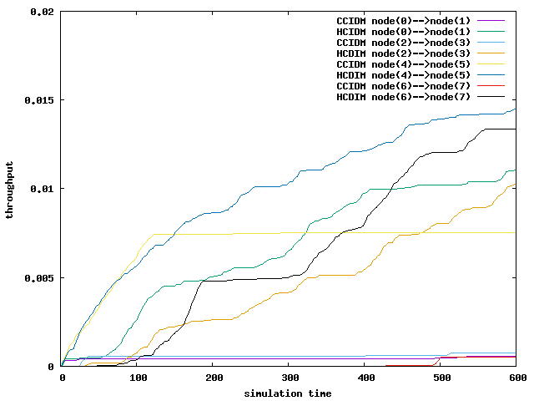

Figure 5. 16 CCIDM vs HCIDM throughput
Figure 5.16 illustrates that the network with HCIDM achieves a high throughput compared to a network with CCIDM. HCIDM proved to be outperforming CCIDM approach in throughput, with the highest throughput of around 0.014 in HCIDM node 4 and node 5. HCIDM can handle more black hole attacks than CCIDM, as CCIDM struggles to isolate black hole nodes from participating in the routing decision. Once the black hole nodes manage to mislead others during the route path selection, they drop all received packets instead of relaying them to reach their appropriate destination reducing the number of throughput when using CCIDM.

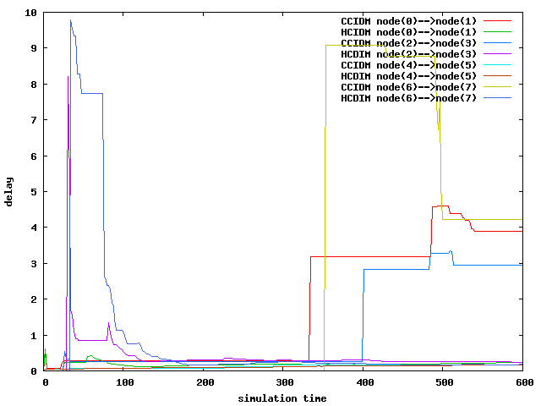
Figure 5. 17 CCIDM vs HCIDM delay
Figure 5.17 illustrates delay experienced in the two networks, with the HCIDM network experiencing a high delay at the start-up and which decreases at around 100 of simulation time. This can be attributed to HCIDM which is attempting to eliminate the effects of the black hole nodes at the very beginning of the simulation. CCIDM in contrary start with a low packet delay which then increases towards 300ms of the simulation time. This can be explained by the challenges by CCIDM method to isolate black hole nodes for participating in the routing decision.

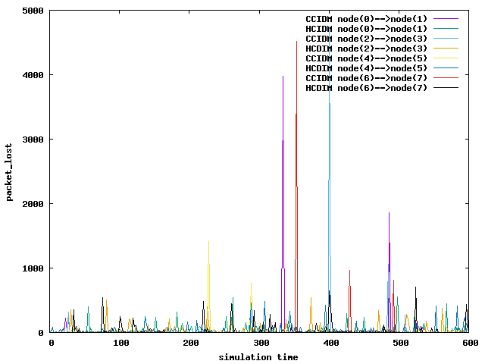
Figure 5. 18 CCIDM vs HCIDM packet lost
Figure 5.18 illustrate the packet lost recorded during a network with CCIDM and another with HCIDM. The results showed that a network with CCIDM has a high spikes in the packet lost which can be damaging for real-time application such as streaming video. The network with HCIDM has achieved an average packet lost of 26.92 while CCIDM had an average of 19.85, this can be the result of a high throughput in HCIDM in figure 5.16.

5.9 Summary

This research discussed the issue of black hole attacks in ad-hoc wireless networks. Ad-hoc wireless networks suffers from black hole attacks that drops all packets relayed to its route, this gives a high risk on routing security. The dynamic changes in the network makes it vulnerable to such attacks and without a secure routing protocol in place the network suffers greatly. To alleviate the attack and improve the performance of the network a HCIDM secure routing protocol is implemented.
HCIDM is tested in a network with static nodes and in MANET. We compared the results by running a network under black hole attack without HCIDM versus a network with HCIDM running along black hole attack. With this test, we observed a high number of packets lost, high delay and a low throughput in networks under black hole attack without HCIDM in both static network and in MANET. While the networks that had HCIDM running experienced a low packet lost, low delay and a high throughput, indication a strong elimination of black hole attack in the network.
The comparison between existing CCIDM and our proposed HCIDM showed a low throughput, high packet lost and high delay experienced with the CCIDM while HCIDM showed better performance of high throughput, low packet lost and a low delay in the similar network setup under black hole attack.

Chapter 6 Conclusion

6.1 Conclusion

In this thesis, a HCIDM algorithm that uses collaboration between nodes to detect and eliminate active black hole attacks against the routing table in ad-hoc wireless network has been designed and implemented.
The flexibility and the ability to provide connectivity from anywhere at any time has made ad-hoc wireless networks popular, with an increased number of users. Ad-hoc wireless networks provide mobile communication to nodes in situations where the participating nodes are not in need of existing network infrastructure. However, the constant movement of nodes mobility, lack of infrastructure and the wireless channel nature of ad-hoc wireless networks makes the detection of malicious nodes hard to achieve. Most traditional IDSs are designed to operate in a centralized manner, and do not function properly in MANETs, as data are distributed in different network devices.
For optimum performance and security, we designed a HCIDM algorithm that provides distributed intrusion detection mechanism where nodes collaborated among themselves to detect active attacks against the routing table of a mobile ad-hoc wireless networks. HCIDM operation reduces the effectiveness of the attack by informing other nodes about the existence of the malicious nodes and keep the performance of the network within an acceptable level. The algorithm further protects the network in a distributed manner by computing the trust level and the information about the presence of a malicious behavior which is communicated to potential victims, that is, nodes within the radio range of the attacker.
The algorithm organize nodes into clusters, with each cluster having a cluster head. The cluster head is elected based on the proximity location degree with surrounding nodes and it should have a higher trust level than other nodes. The trust level is computed using the weighing method that uses parameters such as packet drop rate, packet sent and the energy level of nodes. Each node then stores a trust table for all one-hop neighboring nodes, which are periodically forwarded to the cluster head and when requested for. A node with a high packet drop rate is considered malicious and upon detection, the cluster head reduces the nodes trust level. The cluster head further communicates the new trust values to all nodes. Therefore, for all new communications, the node(s) with the lowest trust level get ignored. This way, clusters are protected from accepting malicious node. Similarly, HCIDM monitors the movement of nodes by ensuring that a communication between cluster head occurs. The current cluster head of a node transmits its trust level information to the new cluster head for consideration before handover occurs.
Using the ns-2 simulator, the effectiveness and accuracy of HCIDM was tested in an wireless ad-hoc and mobile ad-hoc networks, starting with a small network topology and increased the number of nodes as the testing went on in order to test the performance in a larger network. We ran a series of simulations depicting a network under a black hole attack to check the impact of black hole attack and the efficiency of the proposed HCIDM algorithm. We also compared the performance of the proposed algorithm with CCIDM (Saurabh et al., 2017).
The results of the comparison between CCIDM with HCIDM indicates that, HCIDM achieved an improved delay and a better throughput than that of CCIDM. The study reviled that the existing CCIDM has difficulty in isolating black hole nodes from participating in the network routing decision, which leads to malicious nodes being included in the routing selection, thus preventing a number of packets from a successful delivery. However, a better performance was observed with HCIDM. Overall, the study proved that HCIDMs’ performance in dealing with black hole attacks outperforms CCIDM and had a better delivery ratio.

6.2 Future Research Direction
Future work in this area should focus on testing energy efficiency of the proposed HCIDM in MANETs. In our implementation with set manually the risk level of the nodes to 0.8, it will be better to find a mechanism to determine this factor automatically. This is also left for future work.

Reference
Acharjee, T., Rajkonwar, S., & Roy, S. (2016). An improved Hierarchical Cluster based routing approach for Wireless Mesh Network. 2016 International Conference on Computer Communication and Informatics (ICCCI), 1–6. https://doi.org/10.1109/ICCCI.2016.7480013
Ajirioghene, O. R. (2009). THE PERFORMANCE OF DYNAMIC SOURCE ROUTING PROTOCOL FOR MOBILE AD HOC NETWORKS Aspect of Cache Size and Cache Expiry Time Blekinge Institute of Technology September 2009, (September).
Aldabbas, H., Alwada, T., Janicke, H., & Al-bayatti, A. (2012). Data Confidentiality in Mobile Ad hoc Networks Data Confidentiality in Mobile Ad hoc Networks, (March). https://doi.org/10.5121/ijwmn.2012.4117
Alrajeh, N. A., Khan, S., & Shams, B. (2013). Intrusion Detection Systems in Wireless Sensor Networks : A Review, 2013. https://doi.org/10.1155/2013/167575
Aluvala, S., Sekhar, K. R., & Vodnala, D. (2015). Analysis of Security Threats and Issues in MANETs. Internation Journal on Advanced Computer Theory and Engineering (IJACTE), 4(5), 23–28.
Amraoui, H., Habbani, A., & Hajami, A. (2018). A Forwarding Game Approach for Reducing Topology Control Traffic in MANETs. Arab J Sci Eng, 6945–6946. https://doi.org/org/10.1007/s13369-017-2910-7 RESEARCH
Belgaum, M. R., Musa, S., Su, M., Alam, M., Soomro, S., & Alansari, Z. (2019). Secured Approach towards Reactive Routing Protocols Using Triple Factor in Mobile Ad Hoc Networks. Annals of Emerging Technologies in Computing (AETiC), 3(2), 32–40. https://doi.org/10.33166/AETiC.2019.02.004
Bharati, T. S., & Kumar, R. (2015). Secure Intrusion Detection System for Mobile Adhoc Networks. 2nd International Conference on Computingfor Sustainable Global Development (INDIACom), 1257–1261.
Butun, I., Morgera, S. D., & Sankar, R. (2014). 002 - A Survey of Intrusion Detection Systems in Wireless Sensor Networks. IEEE Sensors Journal, 14(5), 1370–1379. https://doi.org/10.1109/ITW.1998.706478
Chen, Y. P., Liestman, A. L., & Liu, J. (2004). Clustering algorithms for ad hoc wireless networks. Ad Hoc and Sensor Networks. Nova Science Publishers, 1–16.
Dasilva, L. A., Midkiff, S. F., Park, J. S., Hadjichristofi, G. C., & Davis, N. J. (2004). Network Mobility and Protocol Interoperability in Ad Hoc Networks, (November), 2–10.
Debar, H. (2002). An Introduction to Intrusion-Detection Systems. Proceedings of Connect 2000, (January 2009).
Faisal, M., Abbas, S., & Ur Rahman, H. (2018). Identity attack detection system for 802.11-based ad hoc networks. Eurasip Journal on Wireless Communications and Networking, 2018(1). https://doi.org/10.1186/s13638-018-1143-0
Fazeldehkordi, E., Amiri, I. S., & Akanbi, O. A. (2016). A Study of Black Hole Attack Solutions A Study of Black Hole Attack Solutions On AODV Routing Protocol in MANET. Elsevier.
Gomathi, K., & Parvathavarthini, B. (2015). An Enhanced Distributed Weighted Clustering Routing Protocol for Key Management. Indian Journal of Science and Technology, 8(4)(February), 342–348.
Honey, & Sachdeva, S. (2015). A Comparative Study of Mobile Ad-Hoc Network Protocols. International Journal of Engineering and Management Research, 5(1), 198–202.
Hu, Y. C., Johnson, D. B., & Perrig, A. (2002). SEAD: Secure efficient distance vector routing for mobile wireless ad hoc networks. Proceedings - 4th IEEE Workshop on Mobile Computing Systems and Applications, WMCSA 2002, 1, 3–13. https://doi.org/10.1109/MCSA.2002.1017480
Huang, J., Fan, X., Xiang, X., Wan, M., Zhuo, Z., & Yang, Y. (2016). A Clustering Routing Protocol for Mobile Ad Hoc Networks. Mathematical Problems in Engineering, 2016. https://doi.org/10.1155/2016/5395894
Huang, Y., & Lee, W. (2004). Attack Analysis and Detection for Ad Hoc Routing Protocols, 1–21.
Ishengoma, F. R. (2016). Routing Protocols under Mobility Models. Journal of Informatics and Virtual Education, 4(01), 13–18. Retrieved from https://www.researchgate.net/publication/312021427_Performance_Comparison_of_AODV_and_AntHocNet_MANET_Routing_Protocols_under_Mobility_Models
Issariyakul, T., & Hossain, E. (2012). Introduction to Network Simulator NS2 (Second Edi). New York: Springer Science+Business Media. https://doi.org/10.1007/978-1-4614-1406-3
Jaspal, Kumar; M, Kulkarni; Gupta, D. (2010). Secure routing protocols in ad hoc networks: a review, 2(2), 157–165.
Jitendra, A., Anusha, N., & Pachipala, Y. (2016). Data Sharing Scheme for Mobile Ad Hoc Network Data Sharing Scheme for Mobile Ad Hoc Network.
Kaurav, H., & Joshi, K. K. (2017). Improved Routing Security using Intrusion Detection System in Mobile Ad Hoc Network, 172–176.
Kaushal, S., & Aggarwal, R. (2015). A study of Different types of attacks in MANET and performance analysis of AODV protocol against Wormhole attack. Ijarcet, 4(2), 301–305.
Kumar, A., K.Katiyar, V., & Kumar, K. (2016). Secure Routing Proposals in Manets: A Review. International Journal in Foundations of Computer Science & Technology, 6(1), 21–35. https://doi.org/10.5121/ijfcst.2016.6102
Kumar, B. S., Sekhara, T. C., Raju, P., Ratnakar, M., Baba, S. D., & Sudhakar, N. (2013). Intrusion Detection System- Types and Prevention, 4(1), 77–82.
Kumar, D. A., & Venugoplan, S. R. (2017). Available Online at www.ijarcs.info INTRUSION DETECTION SYSTEMS : A REVIEW. International Journal of Advanced Research in Computer Science, 8(0976).
Kumar, S., & Dutta, K. (2016). Itrusion detection in mobile ad hoc networks techniques, systems, and future challenges. Security and Communication Networks, 9(5 May 2016), 2484–2556. https://doi.org/10.1002/sec. 1484
Mahmoud, A., Sameh, A., & El-Kassas, S. (2005). Reputed Authenticated Routing for Ad hoc Networks protocol (Reputed-ARAN). 2nd IEEE International Conference on Mobile Ad-Hoc and Sensor Systems, MASS 2005, 2005, 787–794. https://doi.org/10.1109/MAHSS.2005.1542872
Manusankar, C., Karthik, S., & Rajendran, T. (2010). Intrusion Detection System with packet filtering for IP Spoofing. 2010 International Conference on Communication and Computational Intelligence (INCOCCI), 563–567.
Mapenduka, W. (2018). Methods For Detecting Attacks In Mobile / Wireless Ad - Hoc Networks : A Survey. International Journal of Scientific and Technology Research, 7(7), 168–174.
Mehta, S., & Sharma, M. (2013). Analysis of Black Hole and Wormhole Attack using AODV Protocol, 1(1), 44–48.
Mello, S. D., Patil, P. B., Shaikh, T. P. S., Shaikh, H. S., & Malik, S. M. (2015). A Survey on Wireless Routing Protocols ( AODV , DSR , DSDV ). Internation Journal of Computer Techniques, 2(1), 3–8.
Michiardi, P., & Molva, R. (2002). Communications and Multimedia Security, 8735. https://doi.org/10.1007/978-3-662-44885-4
Moudni, H., Er-Rouidi, M., Mouncif, H., & Hadadi, B. El. (2016). Secure routing protocols for mobile ad hoc networks. 2016 International Conference on Information Technology for Organizations Development, IT4OD 2016, 1–7. https://doi.org/10.1109/IT4OD.2016.7479295
Naguib, A. M. (2017). How to Extend NS-2 for Wireless Sensor Networks Localization. International Journal of Scientific and Engineering Research, 8(1), 1501–1509.
Nguyen, H. L., & Nguyen, U. T. (2012). A STUDY OF DIFFERENT TYPES OF ATTACKS IN MOBILE AD HOC NETWORKS. 25th IEEE Canadian Conference on Electrical and Computer Engineering (CCECE).
Ravilla, D., Sumalatha, V., & Putta, C. S. R. (2011). HYBRID ROUTING PROTOCOLS FOR. International Journal of Ad Hoc, Sensor & Ubiquitous (IJASUC), 2(4), 79–96.
Sandhu, D. S., & Sharma, S. (2013). Performance evaluation of DSDV, DSR, OLSR, TORA routing protocols - A review. Communications in Computer and Information Science, 296 CCIS, 502–507. https://doi.org/10.1007/978-3-642-35864-7_77
Santhamurthy, T. (2012). A Quantitative Study and Comparison of AODV , OLSR and TORA Routing Protocols in MANET. Journal of Computer Science, 9(1), 364–369.
Saurabh, V. K., Sharma, R., & Itare, R. (2017). Cluster-based technique for detection and prevention of black-hole attack in MANETs. Proceedings of the International Conference on Electronics, Communication and Aerospace Technology, ICECA 2017, January, 489–494. https://doi.org/10.1109/ICECA.2017.8212712
Shcherba, E. V., & Nikonov, V. I. (2016). A role-based approach to secure routing in wireless ad-hoc networks. 2016 International Siberian Conference on Control and Communications, SIBCON 2016 - Proceedings, 1–5. https://doi.org/10.1109/SIBCON.2016.7491816
Siddiqui, T., & Farooqui, T. (2014). A Survey on Malicious Node Detection in MANET. International Journal of Advanced Research in Computer Science and Software Engineering, 4(12), 156–162.
Singh, K., Yadav, P. K. P., Rani, D., & Sharma, A. (2013). Routing Protocols in Mobile Networks, (1), 40–47.
Sterne, D., Balasubramanyam, P., Carman, D., Wilson, B., Talpade, R., Ko, C., … Rowe, J. (2005). A general cooperative intrusion detection architecture for MANETs. Information …. https://doi.org/10.1109/IWIA.2005.1
Sun, B., Wu, K., & Pooch, U. (2003). Alert aggregation in mobile ad hoc networks. Proceedings of the 2nd ACM Workshop on …, (January 2003), 69–78. https://doi.org/10.1016/j.tripleo.2008.02.011
Surana, J., Sharma, J., Saraf, I., Puri, N., & Navin, B. (2017). A Survey On Intrusion Detection System 1. International Journal of Engineering Development and Research, 5(2), 960–965.
Tamizarasu, K., & Rajaram, M. (2012). An AODV-based Clustering Approach for Efficient Routing in MANET. International Journal of Computer Applications, 51(15), 42–46. https://doi.org/10.5120/8122-1751
Tanwar, S. (2013). Threats & Security Issues in Ad hoc network: A Survey Report. International Journal of Soft Computing and Engineering, (26), 2231–2307.
Valeur, F., Vigna, G., & Kruegel, C. (2004). A Comprehensive Approach to Intrusion Detection Alert Correlation.
Vegda, H., & Modi, N. (2018). Review Paper on Mobile Ad-hoc Networks. International Journal of Computer Applications, 179(37), 975–8887. Retrieved from www.ijcaonline.org
Vijayalakshmi, S., & Sweatha, M. (2016). A Survey on History and Types of Manet. International Journal of Emerging Trends in Science and Technology, 3(7), 4310–4315. https://doi.org/: http://dx.doi.org/10.18535/ijetst/v3i07.07
Vijayaram, S., & Sylviaa, M. s. (2015). INTRUSION DETECTION SYSTEM – A. International Journal of Security, Privacy and Trust Management (IJSPTM), 4(1), 31–44. https://doi.org/10.5121/ijsptm.2015.4104
Visalakshi, P., & Anjugam, S. (2015). Security issues and vulnerabilities in Mobile Ad hoc Networks ( MANET ) -A Survey. Nternational Journal of Computational Engineering Research, 189–194.
Von Mulert, J., Welch, I., & Seah, W. K. G. (2012). Security threats and solutions in MANETs: A case study using AODV and SAODV. Journal of Network and Computer Applications, 35(4), 1249–1259. https://doi.org/10.1016/j.jnca.2012.01.019
Wang, Y., Attebury, G., & Ramamurthy, B. (2006). Security Issues and Remidies in Wireless Sensor Networks- A Survey. CSE Journal Articles. 84., 8(2), 1–23. https://doi.org/10.5120/13731-1528
Wu, X., Liu, S., Zhu, H., Zhao, Y., & Chen, L. (2012). Modeling and verifying the ariadne protocol using CSP. Proceedings - 2012 IEEE 19th International Conference and Workshops on Engineering of Computer-Based Systems, ECBS 2012, 24–32. https://doi.org/10.1109/ECBS.2012.31
Yasin, A., & Zant, M. A. (2018). Detecting and Isolating Black-Hole Attacks in MANET Using Timer Based Baited Technique. Hindawi, Wireless Communications and Mobile Computing, 2018, 1–10. https://doi.org/10.1155/2018/9812135
Yerneni, N. R., & Sarje, A. K. (2012). Secure AODV protocol to mitigate Black hole attack in Mobile Ad hoc. 2012 3rd International Conference on Computing, Communication and Networking Technologies, ICCCNT 2012, (July). https://doi.org/10.1109/ICCCNT.2012.6396040
Yu, H., Zhang, X., & Yang, Y. (2012). An Extended ISOMAP by Enhancing Similarity, 808–809.
Zapata, M. G. (2002). Secure ad hoc on-demand distance vector routing. ACM SIGMOBILE Mobile Computing and Communications Review, 6(3), 106. https://doi.org/10.1145/581291.581312

