FACULTY OF ENGINEERING AND THE BUILT ENVIRONMENT
SCHOOL OF ENGINEERING
DEPARTMENT OF CIVIL, MINING AND PROCESS ENGINEERING

A WEAP MODEL ANALYSIS OF THE IMPACT OF INDUSTRIAL EFFLUENTS ON THE WATER QUALITY OF KLEIN WINDHOEK RIVER, NAMIBIA.

BY

TATENDA MARTHA MASIYA (219131791)

Thesis presented in partial fulfilment of the requirements for the degree Master of Integrated Water Resources Management at the Namibia University of Science and Technology

Supervisor: Mr A Vushe
Co-Supervisor: Mr W Gumindoga

October 2022

DECLARATION

I, Tatenda Martha Masiya hereby declare that the work contained in the thesis, entitled A WEAP model analysis of the impact of industrial effluents on the water quality of Klein Windhoek River, Namibia, is my own original work and that I have not previously in its entirety or in part submitted it at any university or other higher education institution for the award of a degree.

Signature:……………………… Date: ......................

RETENTION AND USE OF THESIS

I, Tatenda Martha Masiya being a candidate for the degree of Master of Integrated Water Resources Management, accept the requirements of the Namibia University of Science and Technology relating to the retention and use of thesis deposited in the Library and Information Services.

In terms of these conditions, I agree that the original of my thesis deposited in the Library and Information Services will be accessible for purposes of study and research, in accordance with the normal conditions established by the Librarian for the care, loan or reproduction of theses.

Signature: .. ...... ... ... ...... ... ............. Date: ..... ....................

ACKNOWLEGEMENTS

My appreciation goes to my supervisor Mr. Vushe and my co-supervisor Mr. Gumindoga for guiding me throughout this research project. I am so grateful, thank you! I want to express my gratitude to the NamWater laboratory staff for helping me with handling and testing of the water samples I collected for my research.

I also want to thank my close friends and family for the support and encouragement. Finally, a special mention to my fellow classmates who made this learning process endurable.

ABSTRACT

In Namibia, there have been problems of water scarcity, water pollution and water shortages. Despite Swakoppoort reservoir being one of the important sources of surface water in central Namibia, water quality in the reservoir has continued to deteriorate due to urban wastewater pollution. In this research, Klein Windhoek River one of the rivers flowing into the reservoir was studied with the aim of evaluating if a water quality change trend forecast can be a useful tool for water quality management. Water samples were collected from Klein Windhoek River with a focus on industries sited along the river including Ujams Wastewater Treatment Plant, a biological nutrient remover which discharges effluent into Klein Windhoek River. Water quality samples were collected downstream and upstream of Ujams WWTP from Klein Windhoek River to analyse the impact of industrial effluents discharged into the river after treatment at Ujams WWTP. The samples were tested for physical and chemical parameters pH, chemical oxygen demand(COD), dissolved oxygen(DO), total dissolved solids(TDS), conductivity, total phosphate(TP) and chromium. Water quality concentrations in tested samples at times exceeding standards stipulated in Act No.11 of 2013 for COD, DO, TDS, TP and electrical conductivity. WEAP21 modelling software was used to analyse the impact of industrial effluents on Klein Windhoek River by modelling a wastewater treatment plant for four parameters (COD, DO, TDS, TP) for years 2015 to 2021. Results showed unsatisfactory Nash-Sutcliffe efficiency results of below 0.7 with a value of 0.62 for COD, 0.62 for TDS and 0.29 for TP. WEAP21 model showed deficiency in forecasting the ephemeral river’s water quality.

Keywords: Water quality, Water quality sampling, WEAP21, Modelling, Klein Windhoek River

TABLE OF CONTENTS

ABSTRACT ii
LIST OF FIGURES vi
LIST OF TABLES v
LIST OF ABBREVIATIONS viii
CHAPTER 1: INTRODUCTION 1
1.1 Introduction 1
1.2 Background of the study 2
1.3 Statement of the Problem 4
1.4 Research Objectives 4
1.5 Research Questions 5
1.6 Significance of the Study 5
1.7 Ethical considerations 5
1.8 Limitations of the Study 6
CHAPTER 2: LITERATURE REVIEW 7
2.1 Introduction 7
2.2 Water Quality Management 8
2.3 Industrial and domestic effluent discharge and legislation in Namibia 19
2.4 Summary 20
CHAPTER 3: METHODOLOGY 21
3.1 Introduction 21
3.2.Research Design 21
3.3 Study Area description 21
3.4 Research Approach 23
3.5 Data collection and methods 24
3.6 Modelling approach 27
3.7 Model calibration 28
3.8.Scenarios for water quality analyses 29
3.9 Data processing and analysis 29
3.10 Conclusion 30
CHAPTER 4: RESEARCH RESULTS 31
4.1 Introduction 31
4.2 Assessment of water quality along the Klein Windhoek River 31
4.3 WEAP21 Water Quality modelling 41
4.3.1 Water Quality Verification…………………………………………………………………….. 47
4.3.2 Scenarios for Water Quality analysis in WEAP 49
4.4 Conclusion 52
CHAPTER 5: DISCUSSION, CONCLUSIONS AND RECOMMENDATIONS 53
5.1 Introduction 53
5.2 Summary 53
5.3 Discussion 53
5.4 Conclusions 55
5.5 Recommendations 56
APPENDICES 57
Appendix A : Effluent Standards- Water Act No.11 of 2013 57
Appendix B: Standard of Effluent Discharges from the US Environmental Protection Agency(EPA) 59
Appendix C: General Standards for Waste/Effluent Water Discharge into the Environment. 60
Appendix D: Oanob River flow data 61
References 62

LIST OF FIGURES
Figure 1: Study Area location 22
Figure 2: Study Area 23
Figure 3: Research approach diagram 24
Figure 4: Sampling Site shown on Upper Swakop Basin map 26
Figure 5: Sampling sites on google maps 27
Figure 6: COD concentration values at sampling points 35
Figure 7: TDS concentration values at sampling points 36
Figure 8: Conductivity concentration values at sampling points 36
Figure 9: DO concentrations at sampling sites 37
Figure 10: TP concentration values at sampling points 38
Figure 11: Effluent from Ujams WWTP (27/05/2021) 38
Figure 12: Effluent from Ujams WWTP (10/06/2021) 39
Figure 13: Klein Windhoek River flow towards Brakewater 40
Figure 14: Study area schematic diagram 42
Figure 15: Conceptual model of the study area 43
Figure 16: Comparative COD before and after Ujams WWTP was added 44
Figure 17: Comparative TDS values before and after Ujams WWTP was added. 45
Figure 18: Comparative results for DO before and after Ujams WWTP 46
Figure 19: Comparative results for TP before and after Ujams WWTP 46
Figure 20: Comparison of simulated and observed data 47
Figure 21: Correlation diagram showing NSE value for COD 48
Figure 22: Correlation diagram showing NSE value for TDS 48
Figure 23: Correlation diagram showing NSE value for TP 49
Figure 24: Bar chart for change in trend for COD concentration (scenario analysis) 50
Figure 25: Line chart for change in COD trend (scenario analysis) 51
Figure 26: Bar chart for change in trend for TDS concentration (scenario analysis) 51
Figure 27: Line chart for change in trend for TDS (Scenario analysis) 52

LIST OF TABLES
Table 1: Advantages and Limitations of different models (U.S Environmental Protection Agency, 2001) 15
Table 2: Water sampling sites coordinates 26
Table 3: Klein Windhoek River water quality sampling results for May 2021 31
Table 4: Klein Windhoek River water quality sampling results for May 2021 32
Table 5: Klein Windhoek River water quality sampling results for June 2021 32
Table 6: Klein Windhoek River water quality sampling results for June 2021 33
Table 7: Klein Windhoek River water quality sampling results for July 2021 33
Table 8: Klein Windhoek River water quality sampling results for July 2021 34
Table 9: Klein Windhoek River water quality sampling results for August 2021 34
Table 10: Ujams WWTP Effluent water quality data (2015) 40
Table 11: Water quality of typical wastewater discharge from industrial sites 41
Table 12: Average monthly temperatures in Windhoek 41

LIST OF ABBREVIATIONS

WEAP21 Water Evaluation and Planning System software
BOD Biological Oxygen Demand
COD Chemical Oxygen Demand
DO Dissolved Oxygen
TP Total Phosphate
TDS Total Dissolved Solids
TSS Total Suspended Solids
WWTP Wastewater Treatment Plant
CAN Central Area of Namibia
CoW City of Windhoek
NamWater Namibia Water Corporation Ltd
USB Upper Swakop Basin
WQM Water Quality Management
SS1 Sampling Site
SS2 Sampling Site 2
SS3 Sampling Site 3
SS4 Sampling Site 4

CHAPTER 1: INTRODUCTION

Introduction

Water pollution has become a subject of growing concern in the industrial world. The environmental problems caused by the increase of pollutant loads discharged into natural water systems have led the scientific community into pursuing studies capable of relating the pollutant discharge with changes in the water quality (Brebbia & Wrobel, 2012).

The expansion and growth of industrial areas has socio-economic and economic advantages in any society. However, there is also generation of waste during production which at times end up being discharged into water bodies when proper effluent discharging channels are not followed (Edokpayi et al. 2017). Wastewater management or the lack of it has impact to society as it can interrupt the fundamentals of life’s support systems. It is important for wastewater management to be given a priority (Corcoran et al. 2010).

Lowrance (2012) explains how river systems are used as the principal disposal pathways for industrial, agricultural, and domestic effluents. As demand for water increases, water quality deteriorates and there is a requirement for effective decision-making techniques that can be applied to solve water quality management problems (Lowrance, 2012). Contaminated water destroys aquatic life and is a hazard to human health. It can also leads to destruction of aesthetic quality of lakes and rivers (Bashir et al. 2020).

In Windhoek, domestic sewage is treated at Gammams wastewater treatment plant while wastewater from recycling and heavy industries is treated at Ujams wastewater treatment plant and the effluent from the wastewater treatment facility is discharged into Klein Windhoek River (Moyo et al. 2015).

The ephemeral river system is the main source of water supply to the inland settlements of Namibia, like in the capital city Windhoek. In the Upper Swakop Basin, it has become difficult to meet water demand from water resources within the basin (NamWater, 2012). Swakoppoort reservoir, one of the reservoirs providing water in the Central Area of Namibia (CAN) has been facing high pollution problems, emanating from the upstream polluted and decommissioned Goreangab reservoir and effluent coming through ephemeral streams. The ephemeral streams flowing towards the reservoir include Klein Windhoek River, Dobra River, Otjiseva River and Otjihavera River (Pazvakawambwa, 2018).

This study focuses on the use of WEAP21 model a computer software to analyse the impact of industrial effluents on the water quality of Klein Windhoek River which one of the ephemeral rivers that originates upstream of the Avis dam and flows towards Okapuka and Dobra River and meeting with Otjiseru River to feed into the Swakoppoort reservoir. Contamination of the Klein Windhoek River has adverse effects not only to the Swakopport reservoir but also to groundwater and it is also a health risk to anyone who might use water from the river during rain seasons including informal settlers along the way, for instance mix settlements sited on the river bank.

1.2 Background of the study

Von Bach is the main source of portable water in Windhoek but its water being later mixed with recycled and borehole water to meet the demand. Low rainfall patterns and high rates of evaporation due to high temperatures experienced in Namibia brings the challenge to meet water demand. There is constant water transfer between Von Bach and Swakoppoort reservoir. Water from Swakoppoort reservoir is therefore important, because when water is pumped if its polluted it could also compromise the quality of water going to downstream reservoirs and also put pressure on the water treatment processes (Kalumbu et al. 2017).

According to Lehmann (2010) there is a high possibility of industrial effluents being carried downstream through Klein Windhoek River into the Swakoppoort reservoir especially during rainy seasons when Klein Windhoek River temporarily flows contributing to the Swakoppoort reservoir water quality deterioration. In another report high chromium concentration levels, TDS and COD exceeding minimum permissible standards were found. Pollution was also believed not to be caused by only Ujams ponds linked to the Ujams Wastewater Treatment plant but illegal effluent discharge from other industries (Kalumbu et al. 2017).

Klein Windhoek River is one of the ephemeral rivers that has a high potential of transporting contaminants to other tributaries. These contaminants end up in the Swakopppoort reservoir. Klein Windhoek River flows from Avis Dam passing through the Lafrenz and Northern Industrial area north of the city centre. Most of the industries that use huge amounts of water in their production process are found in the area. Their waste water is treated and discharged into the Klein Windhoek River (Kalumbu et al. 2017). The industries in the Northern Industrial area include an abattoir, brewery and beverage companies, metal plating and tanneries as shown in Figure 2.

A biological nutrient remover wastewater treatment plant was commissioned in 2014, Ujams Wastewater Treatment plant to replace Ujams waste stabilisation ponds which were previously used to treat effluent from the industries. The ponds were no longer able to adequately treat the loads from the industries and partially treated effluent was being discharged into the Klein Windhoek River. The new Ujams Wastewater Treatment plant however also discharges the treated effluent into the Klein Windhoek River which means if effluent is not adequately treated it will also pollute the Klein Windhoek River (Kalumbu, Kgabi, & Reynders, 2017).

Although Klein Windhoek River does not flow continuously because it is an ephemeral river, it flows after intense rainfall events (Kalumbu et al. 2017). When it flows all the contaminants that were once disposed into the river are carried downstream by the runoff into the Swakoppoort reservoir as illustrated in Figure 2.

According to Kalumbu et al (2017) high levels of physical parameters such as copper, zinc, and chromium were observed downstream of the Ujams waste stabilisation ponds. DO levels and COD levels also did not meet the effluent discharge standards. There was also suspicion of illegal dumping of solid waste by other industries. A pollution risk assessment done also indicated deterioration of soil quality at several sampling points along the river. In addition to adverse effects of serious human health, there are also negative effects to the ecosystem and biodiversity in rivers transporting contaminants.

The continuous reduction in water quality levels in many regions has forced a shift from quantity-based water resources management to a greater emphasis on water quality management. Water quality models can act as invaluable tools that facilitate a conceptual understanding of processes affecting water quality and can be used to investigate the water quality consequences of management scenarios (Slaughter & Mantel, 2018). Water quality models can be effective tools to simulate and predict pollutant transport in water, identify water environmental pollution and the final fate and behaviours of pollutants in water environments (Wang et al. 2013).

The Water Evaluation and Planning (WEAP) model of the Stockholm Environment Institute is one such model that has been extensively used for managing water resources in drought prone, rain fed areas, for water quality issues and conjunctive use management (Agarwal et al. 2019). As water quality challenges continue to arise, water quality change trend forecasting now has an important role in supporting water resource management and planning. Use of WEAP models can help support managers and planners by suggesting optimised solutions to scenarios for sustainable water resources management, for instance for water quality by trend forecasting water quality parameters like BOD, COD, DO, TSS and other parameters (Yates et al. 2005).

Although several studies have been done on the impact of industries effluents and water quality in Namibia before the biological nutrient removal treatment plant, Ujams was commissioned in November 2014. The researcher sees the need to analyse and assess changes in water quality trends and apply WEAP21 software as a tool for water quality assessment of Klein Windhoek River after the commissioning of the new Ujams Wastewater Treatment plant in 2014.

1.3 Statement of the Problem
The continued reduction in water quality of water resources found in Central Area of Namibia (CAN) has become a major drawback. This is a serious issue of concern considering that there is already scarcity of water and major climate variation challenges of frequent droughts that has led to continued water availability challenges. The impact of effluents from the new Ujams Wastewater Treatment Plant and other industries discharging effluents into receiving Klein Windhoek River are not well documented. In addition to the Central Area of Namibia (CAN) receiving low rainfall like many parts of the country, population growth and rapid urbanisation have put pressure on water resources in central Namibia. Some water resources like the Goreangab reservoir have been abandoned due to high volumes of contaminants. Water pollution management is therefore a huge matter of concern, especially that Klein Windhoek River’s pollutants are eventually discharged into an urban water resource, the Swakoppoort reservoir (Pazvakawambwa, 2018).

1.4 Research Objectives

1.4.1 Main Objective
To analyse the impact of industrial effluents on water quality of Klein Windhoek River, using WEAP21 model.

1.4.2 Specific objectives
- To assess the various potential water pollutant sources and contributory elements to water pollution in Klein Windhoek River.
- To analyse the impact of industrial effluents on water quality of Klein Windhoek River using the WEAP model.
- To evaluate various possible water quality scenarios using WEAP on pollution loads modification.

1.5 Research Questions
- What are the contributory elements and main sources of water pollution in Klein Windhoek River?
- What is the impact of industrial effluents on water quality of Klein Windhoek River?
- What could be the impact of various possible scenarios with increase in pollution loads.

1.6 Significance of the Study
The results of this research can help in mapping and highlighting the water quality threats in the Klein Windhoek River system. This may help in decision making for river system management, reducing contamination of the Klein Windhoek River and pollution of downstream water resources like Swakoppoort reservoir. This can also contribute in bringing solutions to the continued reduction in water quality level of the Swakoppoort reservoir. This research will also add relevant information on the usefulness of WEAP21 as a Decision Support System (DSS) tool for analysis of impact of effluent discharges and effectiveness of strategies for river basin management especially on water quality management.

1.7 Ethical considerations
As per ethical considerations, the research is for academic purposes therefore secondary data sourced was used only for the purpose of learning and ethical integrity was maintained by the researcher at all times.

1.8 Limitations of the Study
Limitations to the study included; limited time, some gaps in data and that the research data gathering was done at end of rainy season and hence flow downstream of Ujams WWTP in river was mainly because of Ujams WWTP discharging effluent into the river. Limited financial resources also reduced the number of water quality parameters that could be analysed during the research.

CHAPTER 2: LITERATURE REVIEW

2.1 Introduction

Water is one of the important natural resources crucial for the survival of all living organisms. For humans, vital purposes which include daily domestic use, food production, and use in many economic activities. A wide variety of industrial processes depends on water and its availability yet many daily human activities associated with rise of urbanization, population growth and industrial production are causing water quality to decline. Water pollution has become a serious threat to the well-being of both the earth and its population (Halder & Islam, 2015).

Good water quality is important to sustainable socio-economic development. Aquatic ecosystems are threatened daily by various pollutants from destructive land use or water-management practices. Organic pollution has led to disturbances in oxygen balance and an increase in eutrophication. Direct contamination of surface waters with metals in effluent from mining, melting and industrial manufacturing has always been a serious problem (Bartram & Pedley, 1996).

Industrialization has led to both the growth of industries as well as the associated waste they generate. Despite green technologies like pretreatment of industrial effluents and wastewater reuse being a solution to some of these industrial effluents, it is clear that industries will continue to produce these effluents at least into the foreseeable future (Doble & Kumar, 2005).These effluents end up contaminating water resources like rivers.

Halder & Islam (2015) prove through their study how river water pollution in urban Dhaka, the capital city of Bangladesh led to a variety of health problems including skin, diarrhea, dysentery, respiratory illnesses, anemia and complications in childbirth. Yellow fever, cholera, dengue, malaria and other epidemic diseases were also in this area. These diseases are either waterborne or water-washed. It is therefore vital for rivers and other water resources to be protected from pollution. In addition to human health, it is also important to conserve the balance in the ecosystem and the environment.

2.1.1 Klein Windhoek River pollution

In Windhoek, industries have led to pollution of the Klein Windhoek River. The challenge is to strike a balance between sustainable management of water bodies and increase in production for the growing population remains (Kalumbu et al. 2017). The main industrial activities along Klein Windhoek River include an abattoir, brewery, beverage companies, metal plating, and tanneries. These activities use considerable amounts of water and wastewater discharged usually contains heavy metals ions, high levels of COD and high levels of BOD (Pazvakawambwa, 2018).

A research by Lehmann (2010) highlighted that Klein Windhoek River was intermittently polluted by the Ujams waste water treatment works which is mainly treating industrial waste waters. In the dry season the stream dries up before reaching the Swakoppoort reservoir but in the rainy season the river flow reaches the reservoir with a washout of accumulated contaminants. This is a matter of concern as it is important for priorities to be put in place that preserves sanitation of water bodies for human health reasons and also for protection of the environment and balance in the ecosystem.

A research by Kalumbu et al (2017) indicated how the effluent discharged from the Ujams waste stabilization ponds had TDS and COD levels exceeding the standards for both the Ujams Ponds inlet and outlet, as well as downstream from the discharge point. DO and COD levels also did not meet the standard. For metal composition, high values of chromium concentrations were recorded, whereas the rest of the metals were within the allowable limits. There was an indication of poor water quality at all sampling stations based on bio monitoring and soil analyses results downstream of Ujams waste stabilization ponds.

They report on how high levels of chromium could be as a result of chromate salts used in the tanner and maybe also from some effluent from the metal plating industry. They also illustrated pollution risk assessment using the pollution load index for the soil samples and the biodiversity of aquatic invertebrates. They suspected illegal effluent discharges by some industries into the river. Although Ujams stabilization ponds were replaced with the biological nutrient removal wastewater treatment plant in 2014 there is still a huge concern since it also discharges effluent into the river (Kalumbu et al. 2017). It is important to make sure that continued pollution of Klein Windhoek River is prevented as it has diverse effects and subsequently leads to pollution of the Swakoppoort reservoir which is an important resource for urban water supply.

2.2 Water Quality Management

Water quality management is a very important aspect of water resources management. Water quality management should deal with all water quality problems that relates to the beneficial use of water including water pollution control, proper treatment and disposal of wastewater. Therefore water quality should be managed so that no use of water at any location should be detrimental to the use of water at another location (Krenkel & Novotny, 1980).

Biswas & Tortajada (2019) explain how water quality management is neglected in many parts of the world although it is very important. They also reiterate how water quality management is a far more complex process than water quantity management and how it is politically ignored despite other countries currently having the knowledge, expertise, technology or investment funds to manage water quality problems properly.

It is vital to prioritize water quality management considering imminent water shortages and existing water quality problems of Goreangab and Swakoppoort reservoir caused by discharging of industrial effluents into upstream streams. Some key strategies in water quality management and analysis of industrial effluents impacts on river water quality are water quality sampling and monitoring programs, biomonitoring and computer modelling (Nguyen, 2005).

2.2.1 Water quality monitoring

Water quality monitoring (WQM) is important when managing and protecting riverine ecosystems. The most popular being water sampling with many methods for selecting the monitoring sites, water quality parameters (WQPs), and monitoring frequencies (Nguyen, 2005). Water managers however face difficulties on adopting appropriate WQM design methods, difficulties on planning local boundary conditions, monitoring objectives, monitoring costs, and legal regulations. Taking into consideration cost and time consumption of monitoring approaches it is crucial for water managers to evaluate and redesign monitoring networks based on monitoring goal achievements (Nguyen, 2005). This might be the case for Windhoek where despite industrial growth, poor management strategies for some of the water bodies has led to contamination of rivers and hence proper design of water quality management strategies have become a great necessity.

Water quality monitoring is vital in assessing compliance with legislation, regulations and policies. It also controls the treatment process to ensure achievability of the desired water quality results. It defines cause and effect relationships, determine ongoing trends and identify changes in water quality. It is important because it can provide early warnings and any necessary modifications in frequency of monitoring (UNESCO, 2009). Therefore, it is very important for water managers to priorities, design and plan water quality monitoring systems that produce results.

Water quality monitoring methods include community-based surveillance systems, rapid assessment and surveys, sanitary inspections and these depend on water quality sampling (U.S EPA, 2016). In Windhoek Namibia, Kalumbu et al (2017) and Pazvakavambwa (2018) sampled water quality close to Klein Windhoek River area before the commissioning of a new biological nutrient removal plant, Ujams WWTP. However, designing of consistent water quality monitoring programs has always been a problem and very little has been done to implement researchers’ recommendations. It is important to design consistent water quality monitoring programs that can be implemented by water quality managers to try and curb water pollution and continued contamination of water bodies not only in Windhoek but also in other towns in Namibia (Lewis et al. 2019).

2.2.1.1 Water quality sampling

Water quality sampling is a method used to assess the physical, chemical and biological characteristic of water in any water body (Clark, 2015). Biswas & Tortajada (2019) explained how managing water quality is becoming more challenging and complex in recent years compared to water quantity management. This is because even in situations where water demand is met, increasing levels of pollution in water resources are often an underlying challenge. They also explain how water managers struggle in making evidence-based decisions as to how many water quality parameters should be measured regularly so that a cost-effective management system can be formulated and strictly implemented.

The impact of industrial effluents on river water quality have been widely studied because of adverse effects industrial effluents have on the environment. Many researchers have used water quality sampling methods to analyze the impact of industrial effluents on nearby river water quality. Nosheen et al (2012) studied wastewater characteristics from some major industrial units in the surrounding area of River Kabul, in Pakistan by doing water quality sampling to highlight the impact of industrial effluents. The main industries in the studied area included paper, textile, tanneries, sugar, ghee (butter) mills which is a case almost similar to Klein Windhoek River area. They recommended treatment of water at the various industries before being discharged into the river.

In India a study was also done on the impact of industrial on Behgul River at Bareilly by selecting sampling points along the river. The physio-chemical parameters studied were temperature, pH, total solids, total suspended solids, dissolved oxygen (D.O), biological oxygen demand (B.O.D), chemical oxygen demand (C.O.D), calcium, hardness, alkalinity and chlorides. Results showed variations and fluctuations in the parameters and how the industries were contaminating the Kabul River(Kumara, Kumar & Agarwal, 2010). The research highlighted the importance of sampling, site selection and choosing the right sampling parameters in relation to the industries available which is important for water managers.

Kalumbu et al (2017) also did a study on the impacts of industrial effluents on Klein Windhoek River by sampling the wastewater entering and effluent exiting the Ujams Oxidation Treatment System. The physical and chemical parameters measured also included temperature, total dissolved solids (T.D.S), pH, conductivity, dissolved oxygen (D.O), chemical oxygen demand (C.O.D), lead, chromium, zinc, cadmium and copper. There was an indication of poor water quality at all sampling stations based on bio monitoring and soil analyses results.

Pazvakavambwa (2018), also researched on water governance in the Upper Swakop Basin. Highlights were on how water pollution was a major challenge in the Central Area of Namibia (CAN). The study included sampling water quality in water resources on different tributaries and dams in the basin. The water quality parameters included pH, turbidity, total suspended solids (TSS), conductivity, dissolved oxygen (DO), chemical oxygen demand (COD), nitrates, total phosphates and sulphates. In the report there were extreme concentrations of sodium in river reaches close to the industries Okapuka Meatco Tannery and Nakara Tannery. Extreme levels of DO, conductivity, TSS, TDS, COD and BOD were also recorded close to Nakara Tannery, Okapuka Tannery and Namib Poultry.

2.2.1.2 Bio-monitoring

Biomonitoring involves studying ecological conditions of rivers, lakes, streams, and wetlands by examining its aquatic living organisms to determine changes in water quality. Changes to note may vary depending on the health of the river body. The extend of water pollution can be concluded from mortality, growth inhibition, cancers and tumors, genetic alteration, reproductive failure and diversity in species (Dimitriadou, 1995).

Chapman, Jackson & Kreb (1996), explain how biomonitoring should be used only if it suits the objectives of the program. They also explain how biomonitoring should always be accompanied by physical and chemical measurements for proper interpretation of results as biological monitoring should not be seen as an alternative to physical and chemical monitoring but should complement to indicate overall effects of contaminants in a water body.

The first very crucial stage of biomonitoring is the identification of organisms or macroinvertebrates or bioindicators to work with. Many studies have been done with presentation of results being helped by the use of biotic indices. For macroinvertebrates the indices include Biological Monitoring Working Party Score System (BMWP), ASPT (Average Score per Taxon), Hilsenhoff’s Biotic Index (HBI) Trent Biotic Index (TBI), Extended Biotic Index (EBI) and Chandler’s Score System. However, the BMWP is recommended by the Water Framework Directive and it is widely used in the European Union (Li, Zheng & Liu 2010).

In South Africa, a South Africa Scoring System (SASS) was developed for rapid bioassessment of rivers by Chutter in 1994 and has ever since been modified. Just like other systems it uses the component of riverine biotas and benthic macroinvertebrates but with specifics to what is found in South Africa (Dickens & Graham, 2002). Kalumbu et al (2017) used this scoring system for Klein Windhoek River downstream of Ujams stabilization ponds outlet and results confirmed moderately modified health conditions for aquatic living organisms.

The disadvantages of biological monitoring is that at times it can be a challenge to relate observed effects to a specific aspect of environmental disturbance and it requires experienced biologists (Chapman et al. 1996). Although studies have been done for Klein Windhoek River there hasn’t been a continuous program to monitor and assess effluent discharged from Ujams Wastewater treatment plant and the other industries despite suspicions of illegal dumping and discharges of effluent by nearby industries (Pazvakawambwa, 2018).

2.2.2 Computer modelling

In these recent years Decision Support System (DSS) tools have become very important in planning and managing of water resources. Decision Support System tools are computerised programs used visualize scenarios to help in decision making (Whyte, 1986). An example of such is model-based DSS systems. Wurbs (1994) explains how computer models play important roles in essentially all aspects of water management from development, control, protection, regulation, and beneficial use of surface and ground water resources. With the continued evolution technology computer-based models have become more useful in the modern-day society.

In integrated water resources management, models now help water managers and water management community to make better decisions and models strengthen the knowledge base which supports decision-making processes (Giupponi & Sgobbi, 2013). According to Slaughter & Mantel (2018), water quality models can act as very important tools as they facilitate a conceptual understanding of processes affecting water quality and can be used to investigate the water quality consequences of management scenarios.

Water quality modeling helps by providing evidence for policy makers to make proper decisions. Water quality modeling has become more relevant as it helps to understand and predict the changes over time in water resources from issues of water scarcity, climate change and also financial issues. Water quality models consists of a collection of formulations that represent physical mechanisms used to determine position also momentum of pollutants in a water body (Hahn & Schreiner, 1978).

Models can simulate both non-point source and point source pollutant loads by developing different scenarios. Scenarios are “what if” questions that can be used to assess the impacts of alternative management activities (Munir & Gunderson, 2003). Models can be used to forecast changes in water quality due to changes in discharges of wastewater. They can be useful when establishing priorities for reduction of existing wastewater discharges also on predicting the impacts of a proposed new discharge (World Bank Group, 1998).

Slaughter & Mantel (2018) explain how in South Africa, the Water Quality Systems Assessment Model (WQSAM) was developed as a management-focussed water quality model that is relatively simple to use as it is able to utilise the small amount of available observed data. They explain how the model can be of great use in developing countries where integrated water resources management is important and should be prioritised. The different computer models used in water quality management include water quality assessment model (WQAM), enhanced stream water quality model (QUAL2E), water quality analysis simulation program (WASP), one dimensional water quality for streams (CE-QUAL-W2), environmental fluid dynamic code (EFDC) and water evaluation and planning system model (WEAP21).

Engel et al (2007) explains how in model selection criterion an appropriate model should be selected based on the project goals and objectives, how the model results will be used, appropriate level of detail required, calibration requirements, data requirements and availability, previous applications of the model and its acceptance, ease of use, sensitivity of the model to process of interest, availability of resources and time.

2.2.2.1 WQAM
This is a set of methods used for analysis of changes in water quality due to changes in loadings. It uses a collection of equations and incorporates non-linear regression in developing the model (World Bank Group, 1998).

2.2.2.2 QUAL2E
It is a steady-state model used for simulation of well-mixed rivers. It is especially used for assessing the effect of changes in point-source discharges on water quality. It is very useful when analyzing the impacts of nutrients on algal concentration and dissolved oxygen. It is widely used in the United States (World Bank Group, 1998).

2.2.2.3 WASP5
It is flexible model for analyzing a variety of pollutants in any type of water body. However, it is very complex when comparing models. It requires a lot of data and also expertise in order to use it successfully (World Bank Group, 1998).

2.2.2.4 CE-QUAL-W2
A model used for simulation of dynamics of highly unsteady stream flows, for example during flood events. It consists of a module for water quantity linked to water quality. The water quantity module is however used more compared to the quality module which is less widely applied compared to WQAM, QUAL2E, or WASP (World Bank Group, 1998).

2.2.2.5 EFDC
A model which was developed primarily for open-source surface water quality modeling. It includes hydrodynamic, sediment and contaminant integrated in a single code implementation (World Bank Group, 1998).

2.2.2.6 Water Evaluation and Planning System (WEAP)
A model which incorporates natural hydrology and reservoir storage, return flows and abstractions but within which water quality modelling facilities are unsophisticated (Slaughter & Mantel, 2018).

Table 1: Advantages and Limitations of different models (U.S Environmental Protection Agency, 2001).

Model | Advantages | Limitations
WQAM | Few data requirements, can be used easily with a hand calculator or a computer spreadsheet. | Limited to screening for toxic and conventional pollutants in surface and ground waters.
QUAL2E | User-friendly windows interface, widely used and accepted. It is able to simulate most conventional pollutants and can be linked to WEAP. | Limited to simulation of time periods during which stream flow and input loads are essentially constant.
WASP | Can be applied to estuarine situations because it includes comprehensive DO and algal processes. It can be used in 3-d simulations by linking with hydrodynamic models. | Linking with other different multi-dimensional hydrodynamic models require complicated site-specific linkage efforts.
CE-QUAL-W2 | Can simulate the onset and breakdown of vertical stratification. Useful when vertical variations are an important water quality consideration. | Requires extensive modelling experience.
EFDC | It can give 3-d description of water quality parameters. Wide range analysis as sediment, eutrophication and toxic chemical constituents can be included. | Requires extensive data for calibration and verification. It also requires high level of expertise to be able to use it.
WEAP | User-friendly interface and easy to use. It can track pollution generation at demand sites, waste removal at wastewater treatment plants, effluent flows to surface and groundwater sources, and model water quality in rivers. Can be linked to QUAL2K. | Cannot model reservoir water quality. No ability to perform flow routing.
These models have different advantages and limitations. They can be selected in different situations according to their applicability. Table 1 shows some advantages and limitations of different models.

In this research the WEAP21 model was used because it is an easy-to-use model, available and easily accessible in developing countries. It is very applicable in this situation as it can be successfully used in water quality management including scenario analysis and forecasting. The model was developed by the Stockholm Environmental Institute (SEI) centre in the United States in 1990 and has been improved over the years.WEAP21 model is a very useful tool to use in less complex river basin scenarios (Slaughter & Mantel, 2018).

WEAP is a digital hydrological model that can support water resource assessment and planning. WEAP relies on the basic principle of water balance which makes it applicable to even single basin or transboundary river systems. Key features of the model include simulation of hydrological processes in the basin and simulation of human activities on water resources thereby assessing the impact of domestic demand on water resources as well as influence from human activities on water quality (Sieber et al. 2005).

In WEAP water users can be divided into groups called demand sites. A person using the model can define number of user groups depending on available data. The supply sources and users are connected by the links provided and regressed. Priorities of use can also be set. WEAP allows the creation of regression points at demand nodes with different ratios allowing regression to evaluate the effects of waste source to water quality. WEAP also allows one to develop a variety of forecasting scenarios which can act as a base for the researchers and the planers to develop optimal methods for achieving water quality goals. This means it can help water planners to solve water quality problems and also to develop plans for quality control in wastewater management (Nguyen et al. 2013).

WEAP model has been applied successful in different parts of the world for water quality management. Mishra et al (2017) applied a WEAP model to analyze sustainability of water resources of Kathmandu Valley, Nepal. WEAP was used in this case to simulate year 2014 and also 2020 and 2030 as future years for water quality conditions of Bagmati river. BOD and COD were used in order to explore alternate wastewater treatment options. The study had three major components hydrologic, water quality and scenario modelling. In the study WEAP successfully used after it was calibrated using monthly discharge with effective rainfall and runoff on infiltration ratio as the parameters. This validates the significance of WEAP as a water quality modelling tool that can be used even to forecast future outcomes depending on scenarios.

Lakshmi & Madhu (2014) also used WEAP integrated with QUAL2K to model dissolved oxygen and temperature of Periyar river, South India. Periyar river flows through highest industrial belt and needed strategic water quality assessment. In the study surface water temperature and dissolved oxygen were modelled using QUAL2K with 2007 to 2008 monthly data. WEAP was then successfully used to forecast QUAL2K model for temperature and DO for 2009 to 2030. Variation of DO and temperature were analyzed for a 28year period with trend analysis. Model was prepared with monthly DO data of river from April 2007 to May 2008. The data was calibrated with DO from April to May 2008 and 2013. The most recent version of WEAP software has the option of using it together with the QUAL2K which can be very useful if there is need to use them together.

WEAP model was also used for water quality forecasting of Day River as a pilot study in Vietnam where water quality issues had risen. Water quality change trend forecasting was used to see how it could support water resource managers in planning. Four basic parameters DO, COD, BOD, TSS were chosen based on the scenarios of discharging waste water into watercourse. Modelling calculation diagram in WEAP was used and calibration and verification of flows at nodes was done. Water quality change trend forecasting was then done with changing scenarios of waste source. Forecasting of water quality trend was done based on the scenarios of discharging wastewater into water sources. Results of this study indicated that the model was perfectly suitable to help in water quality management (Nguyen et al. 2013).

Klein Windhoek River has had water quality issues due to industrial effluents being disposed into the river. Water quality change trend forecasting can have a crucial role in supporting water resource managing and planning as it has been likely that it is carrying contaminants during rain and flooding seasons into the Swakoppoort reservoir which is a very important water source for Windhoek. During the last few years, water quality sampling studies have been done for Klein Windhoek River which makes some data available. Data availability is one of the requirements when using WEAP as a water quality forecasting and management tool. Application of WEAP in water quality analyses of the Klein Windhoek River is crucial as it is one of the first of many more applications in modelling water quality management of the ephemeral Klein Windhoek River.

2.2.3 Industrial wastewater and water quality parameters

Industrial effluents are usually a potential water pollution problem as they are characterized by their abnormal turbidity, conductivity, chemical oxygen demand (COD), total suspended solids (TSS), biological oxygen demand (BOD), and total hardness. Waste waters from textile, brewery, food and beverages, paper, pulp and palm oil industries are believed to give a broad outline of industrial wastes as well as disposal problems(Kanu & Achie, 2011). Heavy metals contaminations could exist in wastes of many industries, such as metal plating, mining operations, tanneries, radiator manufacturing, smelting and alloy industries as well as storage battery industries. Some of the heavy metals include cadmium (Cd), chromium(Cr), copper(Cu) , nickel(Ni), lead(Pb), and zinc (Arbabi, Hemati & Amiri 2015).

Water quality is a measure of suitability of water for a particular use based on its physical, chemical and biological composition (Chapelle et al. 2019). The following water quality parameters are usually monitored in water quality monitoring as they give a measure of how the water is suitable for a certain use. The parameters include, temperature, pH, electrical conductivity (EC), dissolved oxygen (DO), chemical oxygen demand (COD), Total Phosphate (TP), chromium and other heavy metals.

Temperature
It is a very important parameter linked to reactions in water. Since aquatic biochemical rate of reaction increase with temperature, chemical and biological reactions increase as water temperature increases. Temperature influences the amount of oxygen that is to be dissolved in water, rate of photosynthesis by algae also sensitivity of organisms to toxic waste (Arroyo Seco Foundation, 2010).

pH
It is a level of measurement of the acidity or the alkalinity of water. pH level can indicate chemical changes in water and therefore also solubility of metals. A pH range between 6.5 and 8.5 is considered acceptable.

Electrical Conductivity (EC)
It is the measure of the ability of water to conduct an electric current. The concentration of total dissolved solids (TDS) and conductivity are correlated. They describe the salinity level of water. The analysis of TDS concentration from EC can be used to give an overview of water quality and potential water quality problems (Rusydi, 2018).

Dissolved Oxygen (DO)
It refers to the amount of oxygen gas dissolved in water. It is a key parameter in determining the quality of water since in organisms in the aquatic system all need oxygen for respiration. DO concentration indicate the quality of freshwater also the health of streams and rivers. Amount of DO also depicts odor, taste , color and potential corrosion in water (Bartram & Pedley, 1996).

Chemical Oxygen Demand (COD)
It is an indirect method of measuring amount of organic matter in a sample. it determines the amount of oxygen to be consumed during chemical oxidation of organic matter under controlled conditions. COD is used as a measurement of pollutants in wastewater (Abdulla et al. 2012).

Total Phosphate (TP)
It is a measure of all the forms of phosphorus in the water which includes dissolved and particulate phosphorus that are found in a sample while soluble reactive phosphorus is a measure of orthophosphate, the filterable fraction of phosphorus directly taken up by plant cells (Murphy, 2007).

Chromium
Chromium has been used for many industrial applications in various industrial processes such as electroplating, printing, dyeing, tanning and metallurgy. It causes a huge problem on the environment for plants and animals as it exerts carcinogenic, mutagenic and teratogenic effects and causes tissue damage (Mitra, Sarkar & Sen, 2017).

2.3 Industrial and domestic effluent discharge and legislation in Namibia

Namibia has policies and laws made to reduce pollution of water resources. For instance, the water Act (Act No.54 of 1956) has section 23 that speaks against pollution of both public and private water. The Act gives water quality standards that are to be complied with when discharging effluent (Department of Water Affairs, 1991). Another Act (Act No 11 of 2013) forbids industries from discharging effluent that is not up to a certain standard into the sewage system as it could have adverse effects at waste water treatment facilities. It also prohibits discharging effluents without a license(Government of Republic of Namibia, 2013). For effluent discharge limits set for different parameters refer to Appendix A. For sewage treatment in Windhoek, sewage from domestic sources is treated at Gammams WWTP while wastewater from recycling and heavy industries is treated at Ujams WWTP and the effluent from Ujams is discharged into Klein Windhoek River.
However, despite the policies and laws pollution has continued to be a problem as there is a loophole in implementation, monitoring and inspection from the responsible ministry (Kalumbu et al. 2017). A WEAP model analysis of the impact of industrial effluents including forecasting on the water quality of Klein Windhoek River would be an initiative into giving an insight on the effects of industrial effluents and if successfully applied may help the responsible stakeholders in decision making as it may help in mapping and highlighting the water quality threats in the Klein Windhoek River system.

2.4 Summary

In this chapter the researcher describes Klein Windhoek River, water pollution and potential sources of pollution as stated by other researchers. The researcher also discusses the lack of consistent water quality monitoring strategies in Upper Swakop Basin and Klein Windhoek River being a potential source of pollution for Swakoppoort reservoir as it is upstream of the reservoir. The link between water quality management, water quality monitoring and water quality modelling was discussed in detail. There was also a discussion on water quality modelling software. Details were also given on WEAP as a modelling software and how it’s the most applicable for this research study. Existing related studies were also discussed and the probable knowledge gap looking at researches done in Namibia and in other countries. The next chapter will focus on the research methodology.

CHAPTER 3: METHODOLOGY

3.1 Introduction

This chapter outlines the research methods used to answer the research questions. First the study area was described. Then the researcher also described the research design, research approach, method of data collection, the input data, scenarios and data analysis methods.

3.2 Research Design

A quantitative research approach was used as numerical data was used to quantify the problem into usable statistics. Quantitative research is concerned with consistent measurement of a phenomenon over time and by different researchers, usually by means of a measurement device (Cresswell, 2009). Research results for this study are presented in form of tables, graphs and charts.

3.3 Study Area description

The Klein Windhoek River is located in Namibia’s Upper Swakop Basin (USB). The USB receives annual rainfall between 300mm to 500mm (Namibia Meteorological Services, 2015). The river flows from Avis Dam passing through the Lafrenz and Northern Industrial area north of the city centre in Windhoek (22⁰57’74’’S, 17⁰12’14’’E to 22⁰29’57’’S, 16⁰95’44’’E). Most industries in Windhoek that use water in their production processes are found along the river. The industries in the Northern Industrial area include an abattoir, brewery, beverage company, metal plating and tanneries. The study area location is shown in Figure 1.
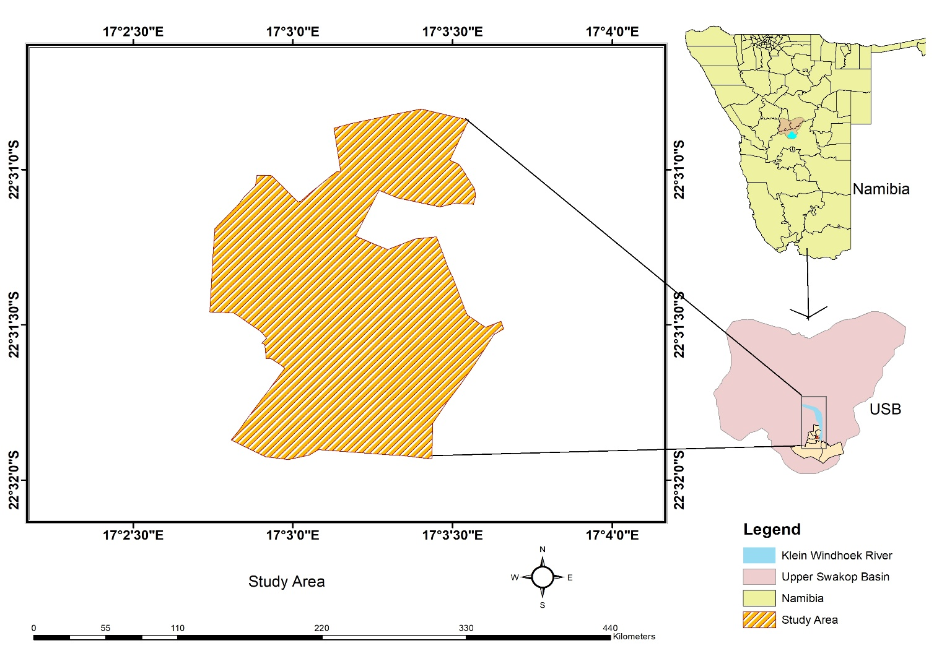
Figure 1: Study Area location

A new water treatment plant was constructed in the area, Ujams Wastewater Treatment Plant (UWTP) to cater for the treatment load that kept on increasing and overwhelming Ujams ponds. Treated effluent from the plant is discharged into the Klein Windhoek River. The Klein Windhoek River also passes close to the Ujams Oxidation Pond System which is now used for disposing sludge from the new treatment plant.

Figure 2 shows where industries are sited close to the Klein Windhoek River. It also shows how Klein Windhoek River flows into Otjiseru River, a river that flows towards Swakoppoort reservoir. Swakoppoort reservoir, one of the reservoirs providing water in the Central Area of Namibia (CAN) has been facing high pollution problems, emanating from the upstream polluted and decommissioned Goreangab reservoir and effluent in ephemeral streams (NamWater, 2015).

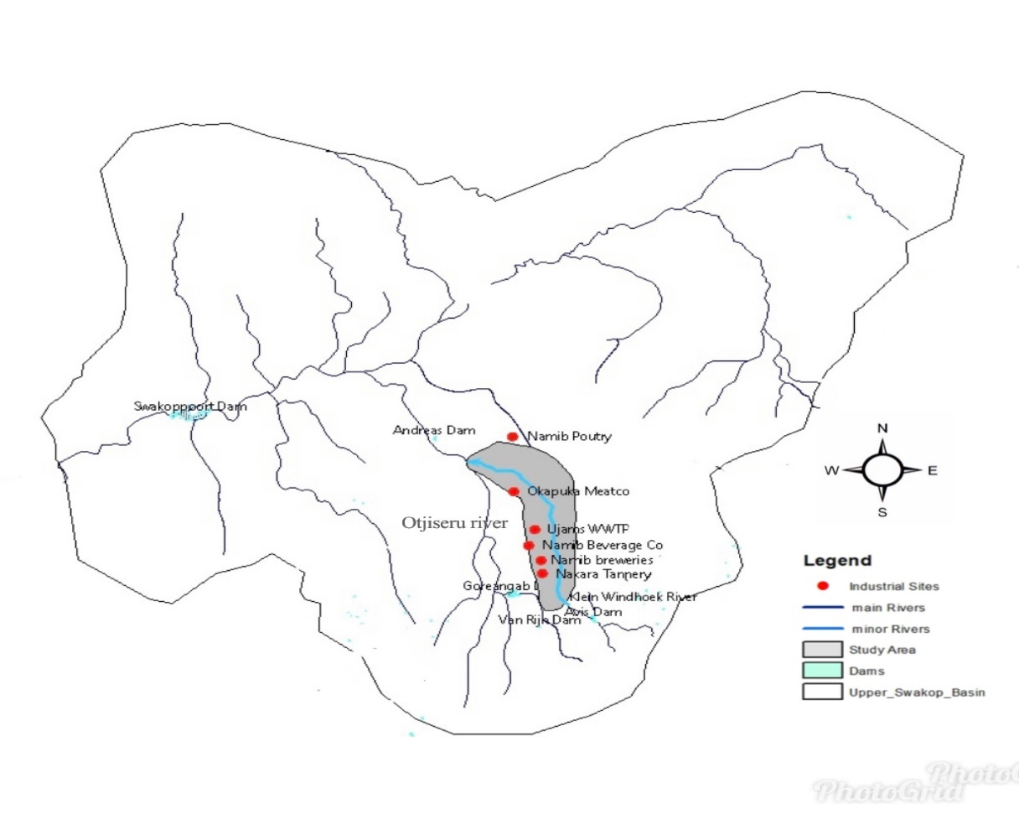
Figure 2: Study Area

3.4 Research Approach

In this study, the researcher analysed the impact of industrial effluents on water quality of Klein Windhoek River, using WEAP21 model. A diagram of the research approach is illustrated in Figure 3:

Figure 3: Research approach diagram
Data collection

Data processing, organization &verification
Data collection
- Water quality sampling data
- Climatic data
- Industrial discharge water quality data
- Water treatment plant effluents data
- data
Data organization
Data processing, organization &verification
WEAP model
Calibration
Model Simulation
Scenarios development
Simulation results
Analysis &Interpretation of results

After entering data on the modelling calculation diagram in WEAP to determine the parameters of the model which included reach length, head flow and tail flow distance, river stage width and monthly flows. The forecasting of water quality trend based on the scenarios of discharging wastewater into the water sources is conducted in steps as follows:

Calibration of flows at the nodes

Calibration and verification of water quality data

Water quality change trend forecasting with scenarios

(Nguyen et al. 2013).

3.5 Data collection and methods

The quality of a river at any point reflects several major influences including atmospheric inputs, climatic conditions and anthropogenic inputs (Bricker & Jones, 1995).

3.5.1 Data collection methods
The following methods of data collection were used for this research:

3.5.1.1 Water quality Sampling
Water quality sampling was done using grab sample method. This is a method usually used for smaller streams where water is well mixed. It is important for this method to take samples at numerous sections at regular intervals in order for a sample to give a true representation of water quality (Water Science School, 2018).

3.5.1.2 Secondary data collection
Secondary data for water quality modelling was collected from City of Windhoek (CoW). which included water quality of wastewater discharge from Meatco, Namib Breweries, Namib Beverage draining to Ujams WWTP and Ujams wastewater treatment plant inlet and outlet data from January 2015 to 2021. The data collected was received in Excel spreadsheets format.

3.5.2 Klein Windhoek River water quality

Water quality sampling was done to obtain current Klein Windhoek River water quality data. Water samples were collected in 1litre plastic bottles and transported to Namwater laboratory where water quality testing and analyses was done. Sampling bottles and onsite pH testing kit were provided by NamWater laboratory. Sampling bottles were transported to NamWater laboratory in a cooler box with ice packs for quality insurance purposes. Grab samples were taken from four different sites in Northern industrial area every two weeks twice a day for the months May, June, July and August.

The sampling sites chosen were upstream and downstream of Ujams wastewater treatment plant as shown in Figure 5, this was to compare the water quality before the point of discharge of effluents from Ujams wastewater treatment plant and water quality after the effluent discharge point.

3.5.3 Sampling sites

The sampling sites chosen were downstream and upstream of Ujams WWTP effluent discharge point to analyse the change in water quality upstream and downstream of the Biological Nutrient Removal Wastewater Treatment Plant. Sampling sites are shown in Figure 5.
Table 2: Water sampling sites coordinates
Sampling site | Coordinates | Description
SS1 | 22⁰47’29’’S, 17⁰08’39’’E | Downstream of Ujams  WWTP
SS2 | 22⁰47’65’’S, 17⁰08’39’’E | Upstream of Ujams  WWTP
SS3 | 22⁰50’56’’S, 17⁰08’33’’E | Upstream of Ujams  WWTP
SS4 | 22⁰41’49’’S, 17⁰07’43’’E | Downstream of Ujams WWTP

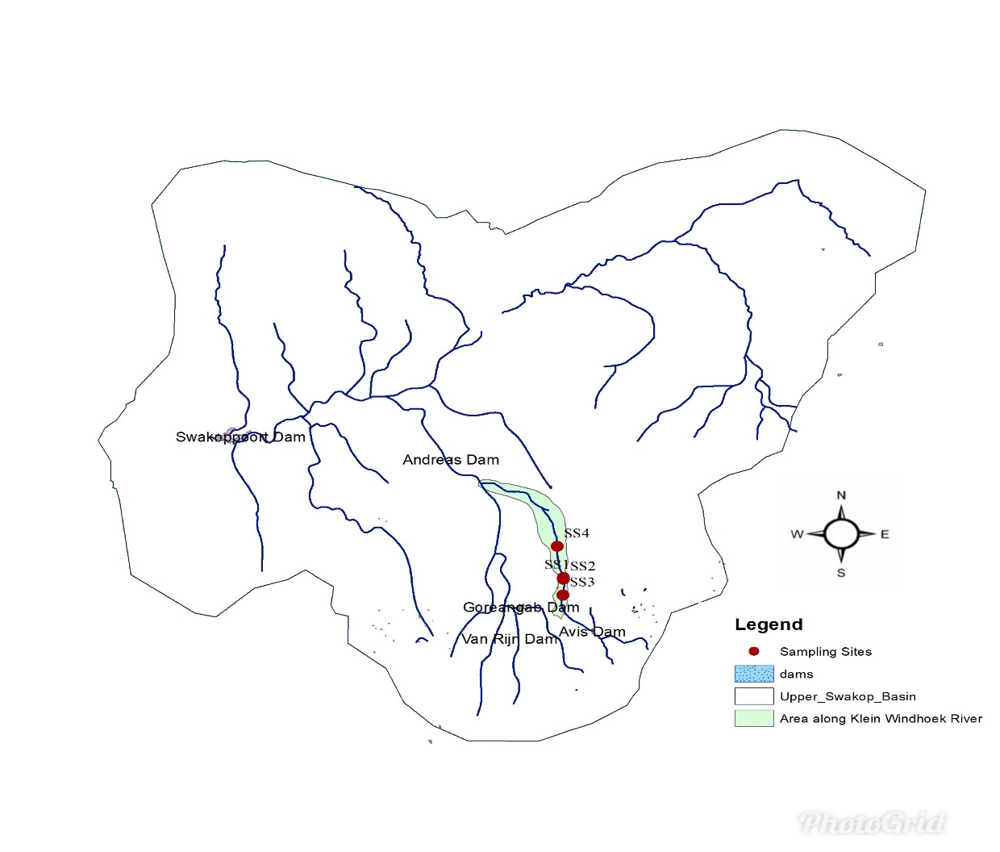

Figure 4: Sampling Site shown on Upper Swakop Basin map

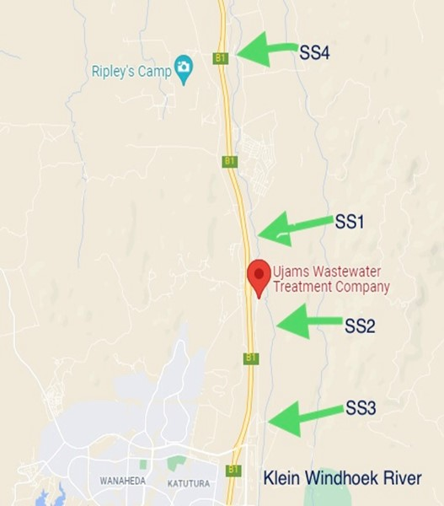
Figure 5: Sampling sites on google maps

The samples were tested at NamWater laboratory for physical and chemical water quality parameters. The water quality parameters tested included temperature, pH, Conductivity, Total Dissolved Solids (TDS), Dissolved Oxygen (DO), Chemical Oxygen Demand(COD), Chromium (Cr), Total Phosphate (TP).

3.5.4 Klein Windhoek River flow data

For this research flow estimates were used, typical flow data were collected from NamWater for Oanob River, a river that has a similar pattern as the researcher could not find historical flow data for Klein Windhoek River. Oanob River flow data is shown in Appendix D.

3.6 Modelling approach

In this study WEAP model was used to simulate and forecast the trend in the variation of water quality on Klein Windhoek River. The current accounts year used was 2014 the year Ujams Wastewater Treatment plant was commissioned with the last year of scenarios being 2021. Basic parameters used in the research are DO, COD, TDS, TP and Cr with referral to guidelines of discharging waste water into the environment. After modelling and calibration of water quality, water quality change trends were analysed by developing scenarios that might affect the water quality of the river. The WEAP21 model was used for this research because it is easier to understand, simple to use and was easily accessible at no cost.

3.7 Model calibration
Calibration is the iterative process of comparing the model with real system, revising the model if necessary, comparing again, until a model is validated (Aboud et al., 2009). Calibration is crucial when running models. It is important as it helps to assess the practicality of the model and also helps to give reliable results. Calibration process for this research included calibration of the flows, water quality of the river and the water treatment data. For this research, a model was produced for years 2014 to 2021. Year 2014 was used as the current accounts(base) year to show the difference in trend of water quality with 2015 onwards, which is when the Ujams Wastewater Treatment plant was now operational. This was based on the assumption that water quality changes in trends for water quality after commissioning of the new Ujams WWTP started to show a steady trend in January 2015.

Verification was done to compare how close the simulated results were close to the observed data and the model parameters for water quality. The researcher could however not do the same for flows as estimated flow values were used. Model verification results are assessed by Nash-Sutcliffe index for observed and simulated data:
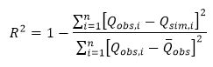
Where:
Q_{obs,i} is observed concentration of parameter at time i
Q_{sim,i} simulated concentration of parameter at time i
Q͞ _{obs} Average observed

The Nash-Sutcliffe Efficiency ranges from - ∞ to 1.The more Nash-Sutcliffe index is closer to 1, the closer the calculated results are with observed data and the model parameters are identified with high confidence level (Nguyen et al. 2013).

3.8 Scenarios for water quality analyses
In WEAP scenarios are meant to determine how trends might change in the future in a particular socio-economic setting or under a particular set of policy and technology conditions. Scenarios can be built and compared to assess their water requirements, costs and environmental impacts (Sieber, 2005).For instance with relevance to this research, what happens if wastewater treatment levels of parameters COD, DO, TP, and TDS were increased or decreased in the water treatment process. The following scenarios were formulated for this research:

- Scenario 1
The effluent before being discharge into Klein Windhoek River is processed but with a low level of treatment say 60 %. The purpose of this scenario is to assess the level of impact of wastewater treatment level on water quality in the Klein Windhoek River. This scenario enables us to see what could be the adverse impact of discharging poorly treated effluent on the water quality of the river.

- Scenario 2
In this scenario, effluent is treated to a higher level of 80 %. But there are additional point sources of pollution discharging into the river. This is to compare the difference compared to scenario one where water is treated below standard to see impact and change bought by illegal discharges. This will give a picture on how lack of monitoring who discharges illegally affects the water quality.

3.9 Data processing and analysis
Excel was used to show trends in observed data. Water quality data was also analysed using WEAP21 modelling software. Through the use of WEAP21 model, the researcher started by mapping the study area, then indicating the demand sites. Then a model was developed for water quality in the river. Assumptions were set afterwards and application of different possible scenarios helped with water quality forecasting.

3.10 Conclusion
In this chapter, the methods to be used for the research were discussed in detail. After the research study area was discussed and shown on a map, the research approach was explained. There was also an explanation on the input data required for the modelling software and how and where the data would be collected. The researcher also described the modelling approach including different scenarios to be applied. The next chapter has data presentation and the analysis of the data which was collected.

CHAPTER 4: RESEARCH RESULTS

4.1 Introduction
This chapter presents a summary of the data which was used for the research and the findings. The findings are presented in tables and also graphs extracted from WEAP modelling software which was used for data analysis.

The first specific objective of this research was to assess the various potential water pollutant sources and contributory elements to water pollution in Klein Windhoek River. The following input data and information was obtained and analysed.

4.2 Assessment of water quality along the Klein Windhoek River
Water quality sampling was done to assess the water quality levels at different sites along the Klein Windhoek River.

4.2.1 Water quality sampling results
The following results were recorded after the collected water samples were analysed.

Table 3: Klein Windhoek River water quality sampling results for May 2021
Date: 10/05/21  Parameter: | Units | Downstream of Ujams WWTP (SS1) | Upstream of Ujams WWTP (SS2) | Namibia Water Act No 11 of 2013-  Effluent Standards  (Max allowable) | US Environmental Protection Agency - Effluent standards  (Max allowable)
pH | - | 8.2 | 8.0 | 6.5-9.5 | 5.5-9
Electrical Conductivity | mS/m | 269.9 | 24.2 | <75 above intake potable water quality  (<103.5) | <75 above intake potable water quality
Chromium | mg/l | <0.01 | <0.01 | <0.05 | 0.05
DO | mg/l | 0.39 | 0.95 | >75 % saturation  (>6.75) | >75 % saturation
COD | mg/l | 36.2 | 20.9 | <100 | 120
TDS | mg/l | 1323 | 119 | <500 above intake potable water quality  (<694.5) | <500 above intake potable water quality
TP | mg/l | 0.60 | 0.30 | 1-2 | 1
Note. Water quality parameters outside the permissible range are highlighted in red.
Table 4: Klein Windhoek River water quality sampling results for May 2021
Date: 27/05/21  Parameter: | Units | Downstream of Ujams WWTP (SS1) | Upstream of Ujams WWTP (SS2) | Namibia Water Act No 11 of 2013-  Effluent Standards  (Max allowable) | US Environmental Protection Agency - Effluent standards  (Max allowable)
pH | - | 8.0 | 8.5 | 6.5-9.5 | 5-9
Electrical Conductivity | mS/m | 399.4 | 68.8 | <75 above intake potable water quality  (<103.5) | <75 above intake potable water quality
Chromium | mg/l | <0.01 | <0.01 | <0.05 | 0.05
DO | mg/l | 3.9 | 3.4 | >75 % saturation  (>6.75) | >75 % saturation
COD | mg/l | 136 | 116 | <100 | 120
TDS | mg/l | 2344 | 347 | <500 above intake potable water quality  (<694.5) | <500 above intake potable water quality
TP | mg/l | 0.4 | 0.30 | 1-2 | 1
Note. Water quality parameters outside the permissible range are highlighted in red.

Table 5: Klein Windhoek River water quality sampling results for June 2021
Date:14/06/21  Parameter | Units | Downstream of Ujams WWTP (SS1) | Upstream of Ujams WWTP (SS2) | Namibia Water Act No 11 of 2013-  Effluent Standards  (Max allowable) | US Environmental Protection Agency - Effluent standards  (Max allowable)
pH | - | 7.7 | 8.2 | 6.5-9.5 | 5-9
Electrical Conductivity | mS/m | 398.4 | 79.2 | <75 above intake potable water quality  (<103.5) | <75 above intake potable water quality
Chromium | mg/l | 0.13 | <0.01 | <0.05 | 0.05
DO | mg/l | 0.09 | 0.29 | >75 % saturation  (>6.75) | >75 % saturation
COD | mg/l | 986 | 12.1 | <100 | 120
TDS | mg/l | 2542 | 421 | <500 above intake potable water quality  (<694.5) | <500 above intake potable water quality
TP | mg/l | 6.1 | 0.20 | 1-2 | 1
Note. Water quality parameters outside the permissible range are highlighted in red.

Table 6: Klein Windhoek River water quality sampling results for June 2021
Date:28/06/21  Parameter | Units | Downstream of Ujams WWTP (SS1) | Upstream of Ujams WWTP (SS3) | Namibia Water Act No 11 of 2013-  Effluent Standards  (Max allowable) | US Environmental Protection Agency - Effluent standards  (Max allowable)
pH | - | 8.1 | 8.3 | 6.5-9.5 | 5-9
Electrical Conductivity | mS/m | 262.0 | 88.2 | <75 above intake potable water quality  (<103.5) | <75 above intake potable water quality
Chromium | mg/l | 0.01 | <0.01 | <0.05 | 0.05
DO | mg/l | 5.3 | 6.0 | >75 % saturation  (>6.75) | >75 % saturation
COD | mg/l | 23.7 | 13.1 | <100 | 120
TDS | mg/l | 1624 | 501 | <500 above intake potable water quality  (<694.5) | <500 above intake potable water quality
TP | mg/l | 0.27 | 0.13 | 1-2 | 1
Note. Water quality parameters outside the permissible range are highlighted in red.

Table 7: Klein Windhoek River water quality sampling results for July 2021
Date:13/07/21  Parameter: | Units | Downstream of Ujams WWTP (SS1) | Upstream of Ujams WWTP (SS3) | Namibia Water Act No 11 of 2013-  Effluent Standards  (Max allowable) | US Environmental Protection Agency - Effluent standards  (Max allowable)
pH | - | 7.7 | 8.2 | 6.5-9.5 | 5-9
Electrical Conductivity | mS/m | 296.3 | 104.6 | <75 above intake potable water quality  (<103.5) | <75 above intake potable water quality
Chromium | mg/l | 0.05 | <0.01 | <0.05 | 0.05
DO | mg/l | 0.18 | 0.77 | >75 % saturation  (>6.75) | >75 % saturation
COD | mg/l | 434 | 18.5 | <100 | 120
TDS | mg/l | 1468 | 510 | <500 above intake potable water quality  (<694.5) | <500 above intake potable water quality
TP | mg/l | 4.1 | 0.20 | 1-2 | 1
Note. Water quality parameters outside the permissible range are highlighted in red.
Table 8: Klein Windhoek River water quality sampling results for July 2021
Date: 27/07/21  Parameter: | Units | Downstream of Ujams WWTP (SS1) | Upstream of Ujams WWTP (SS3) | Namibia Water Act No 11 of 2013-  Effluent Standards  (Max allowable) | US Environmental Protection Agency - Effluent standards  (Max allowable)
pH | - | 7.0 | 8.2 | 6.5-9.5 | 5-9
Electrical Conductivity | mS/m | 390 | `70.1 | <75 above intake potable water quality  (<103.5) | <75 above intake potable water quality
Chromium | mg/l | <0.01 | <0.01 | <0.05 | 0.05
DO | mg/l | 0.08 | 0.65 | >75 % saturation  (>6.75) | >75 % saturation
COD | mg/l | 176 | 15.4 | <100 | 120
TDS | mg/l | 2355 | 523 | <500 above intake potable water quality  (<694.5) | <500 above intake potable water quality
TP | mg/l | 3.8 | 0.2 | 1-2 | 1
Note. Water quality parameters outside the permissible range are highlighted in red.

Table 9: Klein Windhoek River water quality sampling results for August 2021
Date: 05/08/21  Parameter: | Units | Downstream of Ujams WWTP (SS1) | Downstream of Ujams WWTP (SS4) | Namibia Water Act No 11 of 2013-  Effluent Standards  (Max allowable) | US Environmental Protection Agency - Effluent standards  (Max allowable)
pH | - | 6.6 | 7.2 | 6.5-9.5 | 5-9
Electrical Conductivity | mS/m | 314.9 | 360 | <75 above intake potable water quality  (<103.5) | <75 above intake potable water quality
Chromium | mg/l | 0.13 | <0.01 | <0.05 | 0.05
DO | mg/l | 0.14 | 4.8 | >75 % saturation  (>6.75) | >75 % saturation
COD | mg/l | 1690 | 380 | <100 | 120
TDS | mg/l | 1592 | 1761 | <500 above intake potable water quality  (<694.5) | <500 above intake potable water quality
TP | mg/l | 8.0 | 0.60 | 1-2 | 1
Note. Water quality parameters outside the permissible range are highlighted in red.

4.2.2 Analysis of water quality sampling results of Klein Windhoek River using graphs.

After sampling of water at various points along the Klein Windhoek River, the following graphs were also drawn to illustrate the water quality observed along the Klein Windhoek River at different sampling points against the stipulated standards for effluent discharge of wastewater effluent.

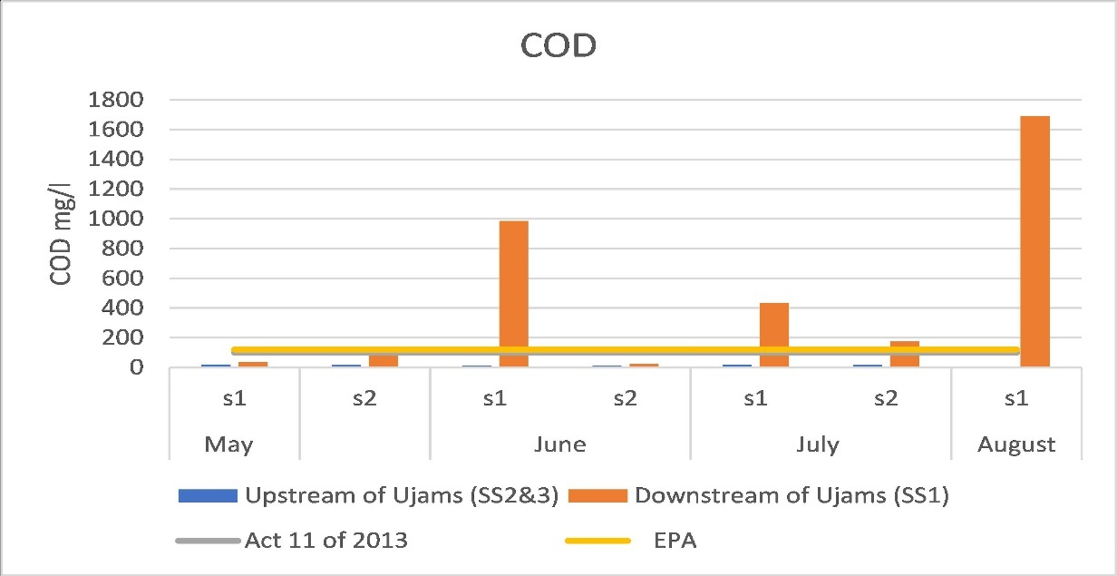
Figure 6: COD concentration values at sampling points

As illustrated above the COD values for grab samples taken downstream of the new biological nutrient removal plant, Ujams WWTP were at times exceeding the stipulated maximum standards according to Namibia Water Resources Management Act (Act No.11 of 2013) also the US Environmental Protection Agency (EPA) effluent discharge standards.

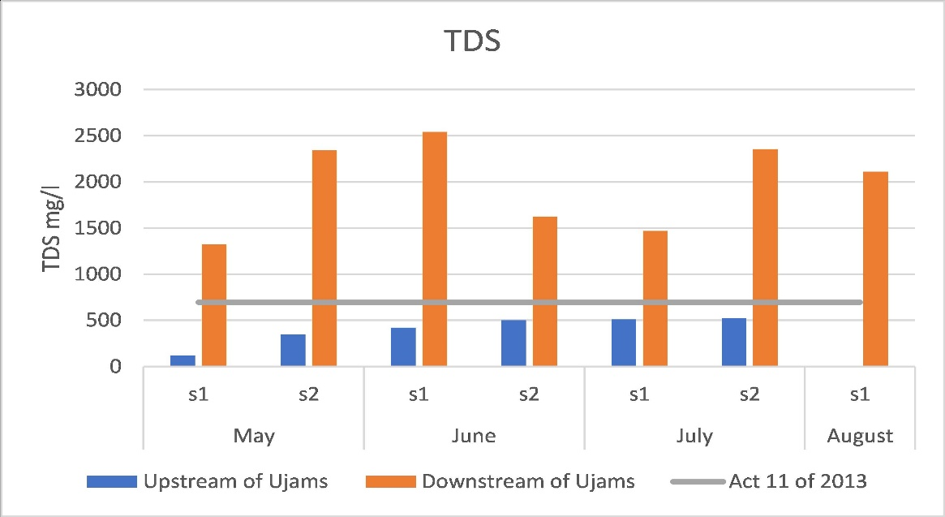
Figure 7: TDS concentration values at sampling points

According to Namibia Water Resources Management Act (Act No.11 of 2013) the maximum stipulated standards for wastewater effluent discharge TDS should be less than 500mg/l above the intake potable water quality value. Potable intake water for Windhoek had an average TDS value of 194.5 mg/l according to Namwater for the period the research was being done which means allowable value for effluent discharge should be less than 694.5 mg/l (500mg/l+194.5mg/l) but as shown in Figure 7, TDS in all the grab samples which were taken exceeded the maximum stipulated level of 694.5mg/l.

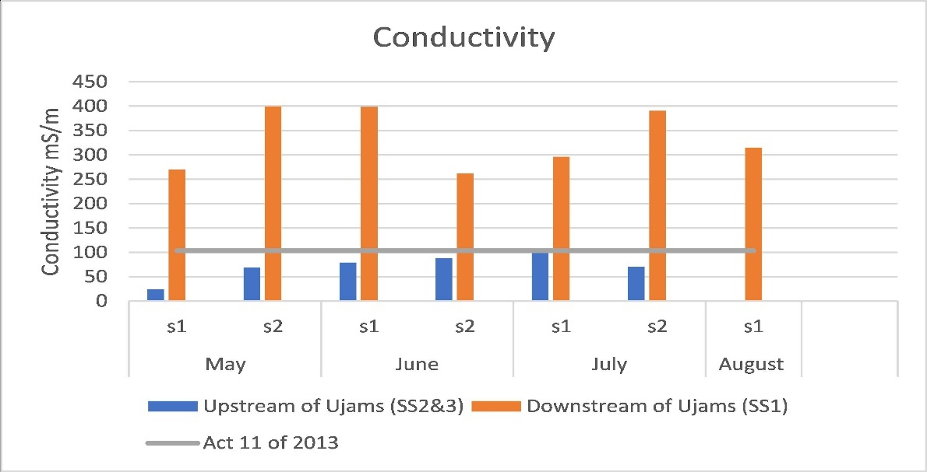
Figure 8: Conductivity concentration values at sampling points
According to Namibia Water Resources Management Act (Act No.11 of 2013), the maximum conductivity level of wastewater effluent discharged into the environment should be less than 75 mS/m above the intake potable water quality value. During the study period potable water intake conductivity in Windhoek averaged 28.5 mS/m which means the allowable conductivity value should be less than 103.5 mS/m. Figure 8 shows that conductivity values in all the grab samples exceeded the 103.5mg/l, the stipulated standard value according to the Act No.11 of 2013.

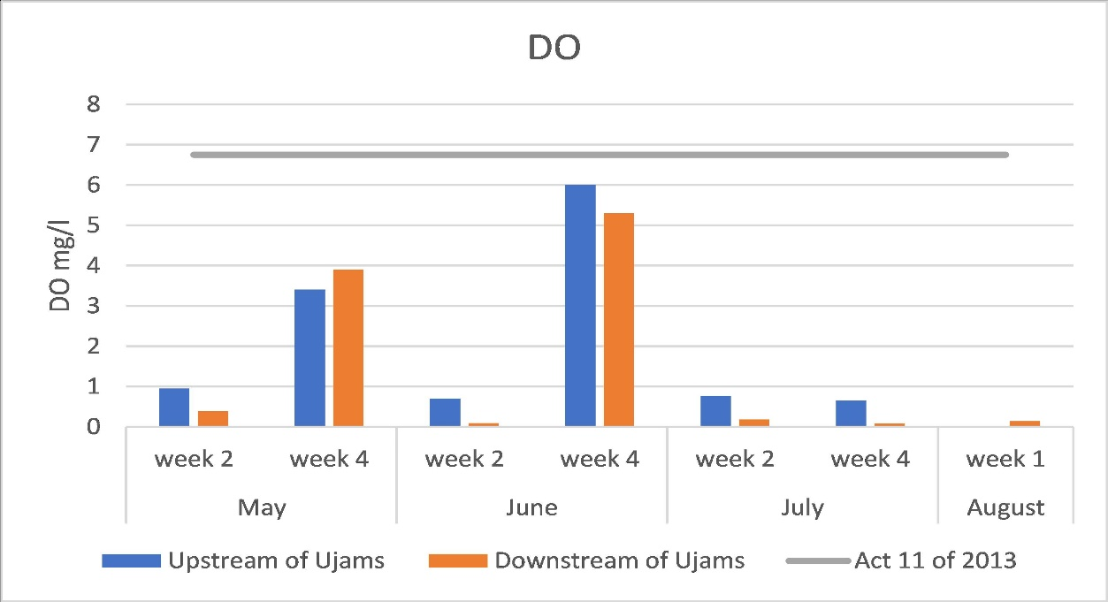
Figure 9: DO concentrations at sampling sites

According to Namibia Water Resources Management Act (Act No.11 of 2013) the stipulated standard level for DO should be more than 75 % above the saturation level. According to Kalumbu et al (2017) DO saturation level is 9mg/l in Windhoek hence the allowable limit becomes 6.75mg/l. From Figure 9 the DO values upstream and downstream were all less than the maximum allowable effluent discharge standard of 6.75mg/l. Upstream might be because the water was not flowing.

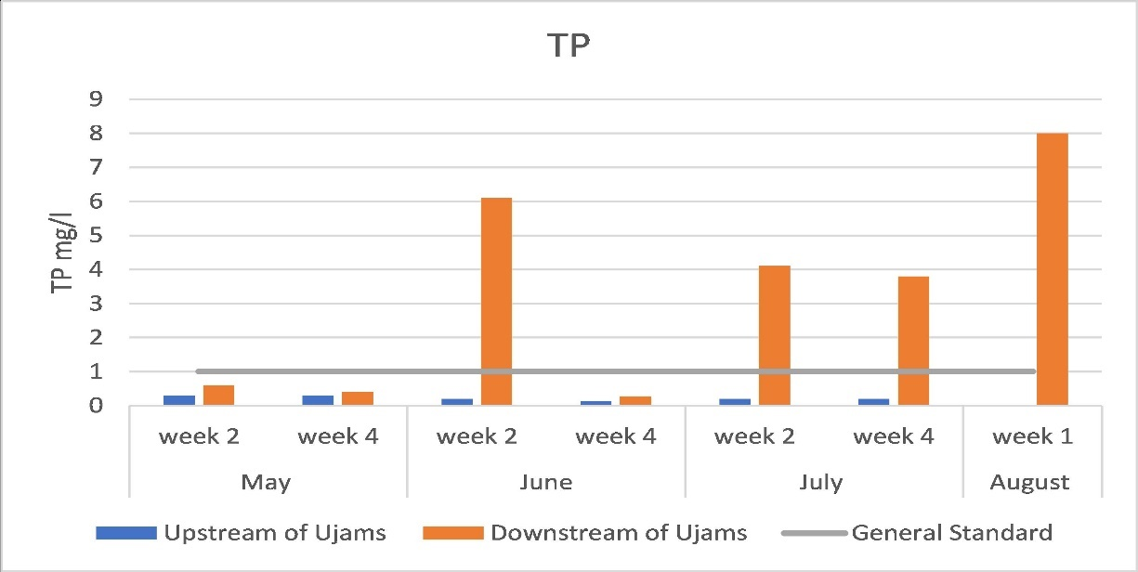
Figure 10: TP concentration values at sampling points

The US Environmental Protection Agency (EPA) for phosphate in wastewater effluent is between 1-2 mg/l. From the sampling results the total phosphate levels were at times above the permissible standard. The water quality sampling results are shown in Figure 10.

Figure 11 is a photograph of water flowing in the Klein Windhoek River just after the new Ujams WWTP discharge point. The photograph was taken from sampling site 1 (SS1) on the 27th of May 2021.
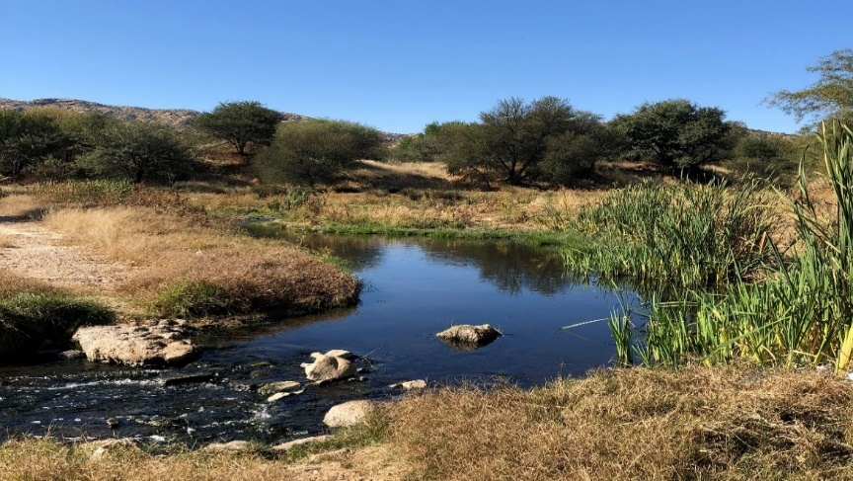
Figure 11: Effluent from Ujams WWTP (27/05/2021)

Figure 12 is a photograph of water in Klein Windhoek River at the same site sampling site 1 (SS1) on the 10th of June 2021. The photograph was taken when samples were being collected at a sampling site just after Ujams WWTP discharge point.
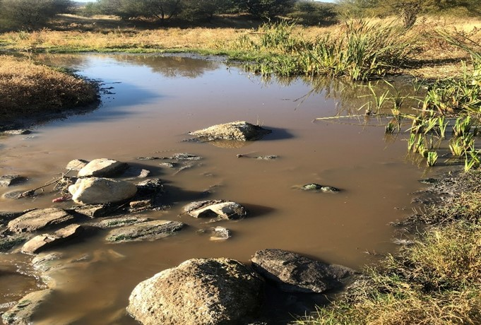
Figure 12: Effluent from Ujams WWTP (10/06/2021)

Comparing water flowing through SS1 on two different days, on the 10th of June water flowing through SS1 was mucky and had a pungent smell compared to on the 27th of May (Figure 11 and Figure 12). A comparison of the results from water quality testing for Figure 11 and Figure 12, showed that higher concentration levels of TDS and COD were recorded for Figure 12 though exceeding standards for both days. Total phosphate concentration levels were extremely high for Figure 12 while within range for Figure 11.

Figure 13 shows water flowing in Klein Windhoek River towards the brakewater area that had algae. The photograph was taken on the 5th of August 2021 less than two meters from SS4 when water quality samples were being collected. Water quality testing results from SS4 for the day the photograph was taken showed values exceeding standards for conductivity, COD, DO and turbidity.

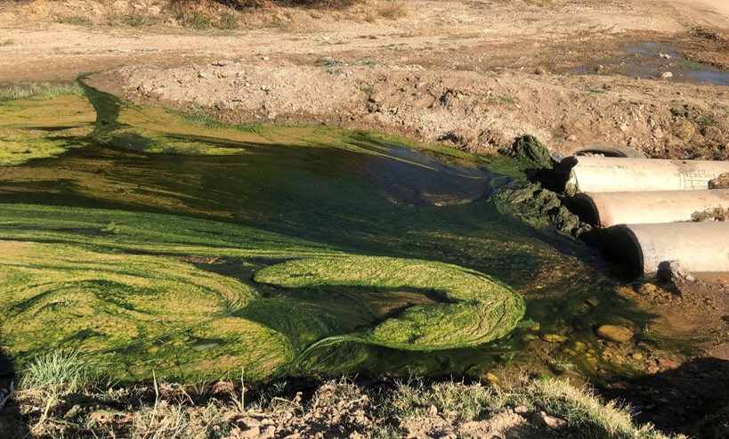
Figure 13: Klein Windhoek River flow towards Brakewater

For this research the data used for water quality modelling was water quality data from 2015 as historical data since the new biological nutrient removal plant Ujams was commissioned in November of 2014.

Historical secondary data from CoW for Ujams WWTP Effluent Water Quality Data (measured in 2015)
Table 10: Ujams WWTP Effluent water quality data (2015)
 | COD | TDS | Conductivity | TP
 | Av mg/l | Av mg/l | Av mS/m | Av mg/l
January | 68 | 1908 | 285 | 2.4
February | 52 | 2411 | 360 | 0.94
March | 62 | 2243 | 335 | 0.50
April | 46 | 1841 | 275 | 1.1
May | 46 | 2202 | 298 | 0.49
June | 65 | 2318 | 403 | 0.50
July | 49 | 2076 | 310 | 0.50
August | 48 | 2210 | 330 | 0.50
September | 49 | 2043 | 305 | 0.51
October | 57 | 1895 | 283 | 0.82
November | 57 | 2100 | 348 | 0.44
December | 61 | 2200 | 270 | 2.9

Historical secondary from CoW for water quality data of typical wastewater discharged into the CoW reticulation from industrial sites (measured in 2015)
Table 11: Water quality of typical wastewater discharge from industrial sites
 | COD | TDS | TP
 | Av mg/l | Av mg/l/d | Av mg/l/d
Meatco | 2614 | 1420 | 19.2
Namib Beverage | 1757 | 1091 | 15.5
Namib Breweries | 3484 | 2531 | 13.2

Average monthly temperatures in ⁰C for Windhoek

Table 12: Average monthly temperatures in Windhoek
Jan | Feb | March | April | May | June | July | Aug | Sept | Oct | Nov | Dec
22.3 | 21.2 | 20.1 | 18.1 | 15.6 | 12.5 | 12 | 15 | 18.7 | 21.4 | 22 | 22.7

4.3 WEAP21 Water Quality modelling

Using Weap21 modelling software the research area was defined and area boundaries were set. The schematic diagram of the research area is shown in Figure 14.

On the schematic diagram the green arrows represent water supply coming from Von Bach, it is further illustrated through a conceptual model in Figure 15. The red dots show the demand sites which are the various industries. Arrows from the demand sites represent the return flow of water from the different industries. For this research, return flow was mainly flowing to Ujams WWTP as wastewater discharged for treatment. An estimate of 95 % return flow to Ujams WWTP was used with 5 % being estimated as return flow to the river due to exfiltration. Fenz (2003) expressed exfiltration estimation as a percentage of dry-weather flow(dwf) between 1–5 % for well-maintained sewerage systems while Ellis et al. (2003) suggested exfiltration rates of 5–10 % dwf flow based on laboratory investigations.

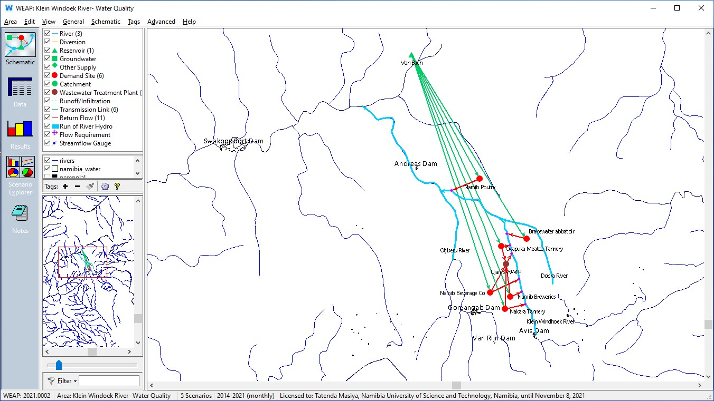
Figure 14: Study area schematic diagram

Parameters were set in WEAP modelling software starting in January 2015. The parameters for water quality included temperature, COD, DO, TDS and TP. Calibration was done using water quality data provided by City of Windhoek for Ujams WWTP for 2015. Some of the data used is shown in Table 10, Table 11 and Table 12. For head flows in Klein Windhoek River flow estimates were used with reference being given to Oanob River, a river that has a similar flow pattern.

A model was produced for years 2014 to 2021. Year 2014 was used as the current accounts(base) year to show the difference in trend comparing with 2015 onwards when the Ujams Wastewater Treatment plant was now operational, assuming changes in trends for water quality in January 2015 after Ujams Wastewater Treatment plant started operating.

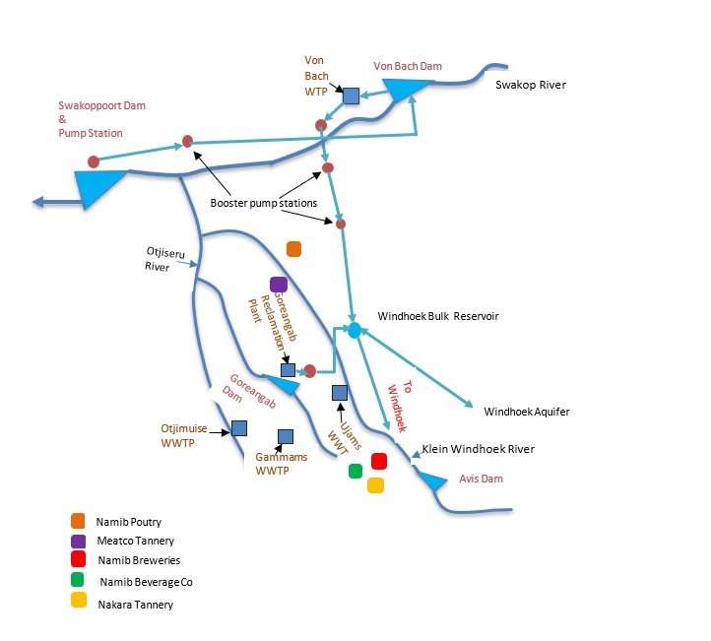
Figure 15: Conceptual model of the study area

After running the model, the results shown in Figure 16 shows comparative COD values before and after Ujams WWTP was operational. Two scenarios are compared, reference (without a wastewater Treatment plant) and after Ujams WWTP was added.

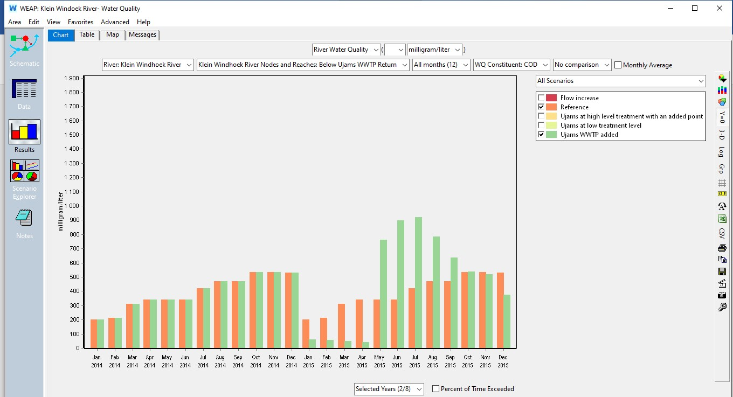
Figure 16: Comparative COD before and after Ujams WWTP was added

From the diagram it can be seen that introduction of a wastewater treatment plant would mean significant reduction in COD values below the return from Ujams in Klein Windhoek River for the first four months which represent the wet season.

Figure 17 also shows comparative results for TDS before Ujams WWTP was added and after Ujams WWTP was added. It also shows a significant reduction in TDS values after the introduction of Ujams WWTP for the first four months that represent the wet season.

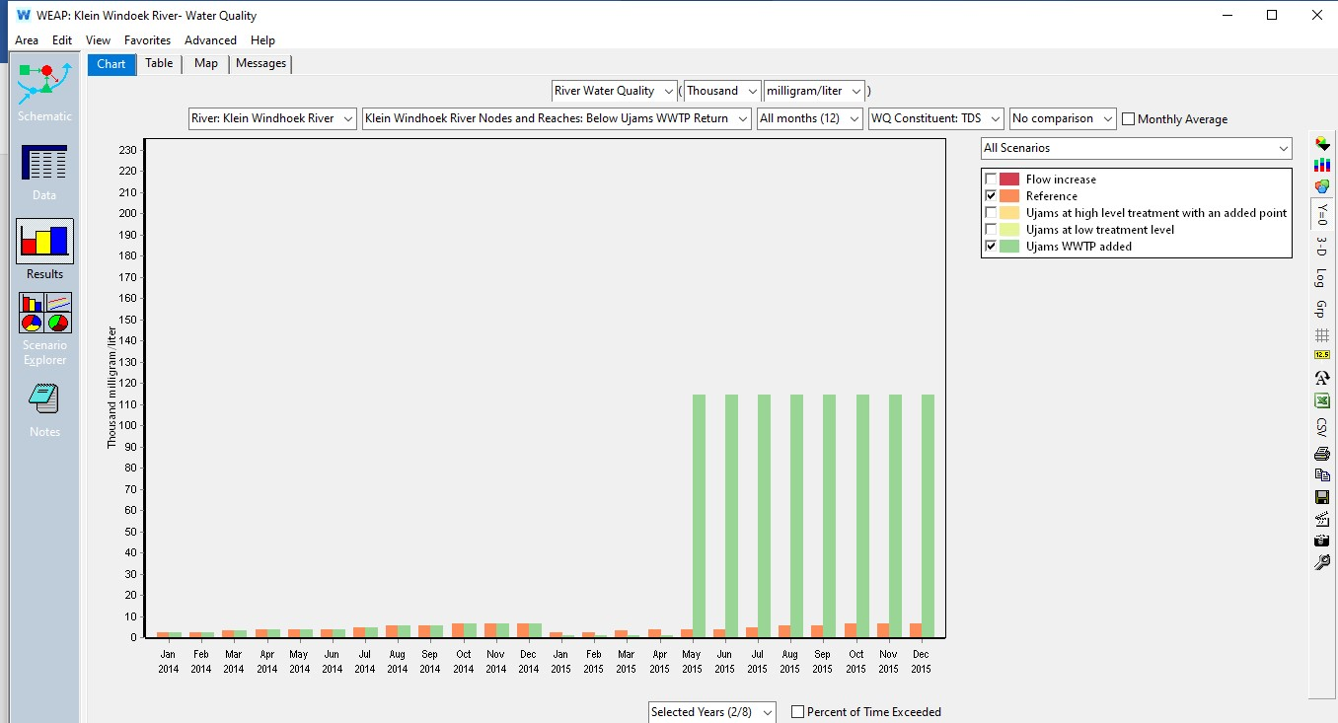
Figure 17: Comparative TDS values before and after Ujams WWTP was added.

Figure 18 shows results after running the model for comparative DO before and after Ujams WWTP was added selected years being 2014 and 2015. From Figure 18 a significant rise in DO can be seen for Klein Windhoek River after the Ujams WWTP is added in the first four months that represent the wet season.

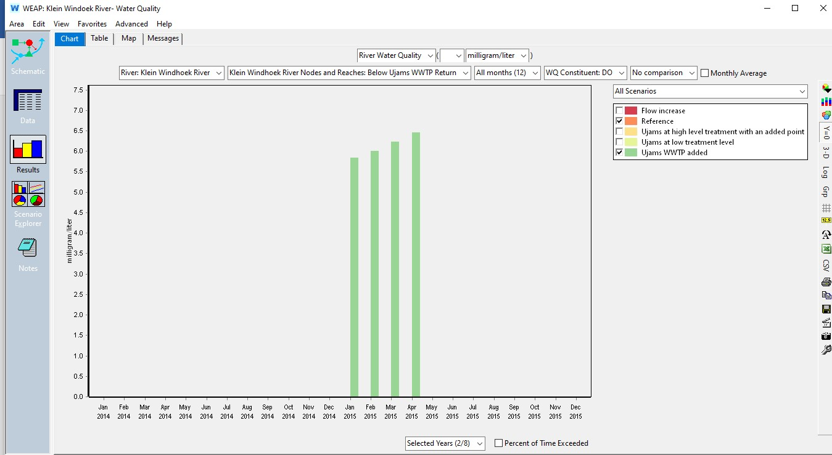
Figure 18: Comparative results for DO before and after Ujams WWTP

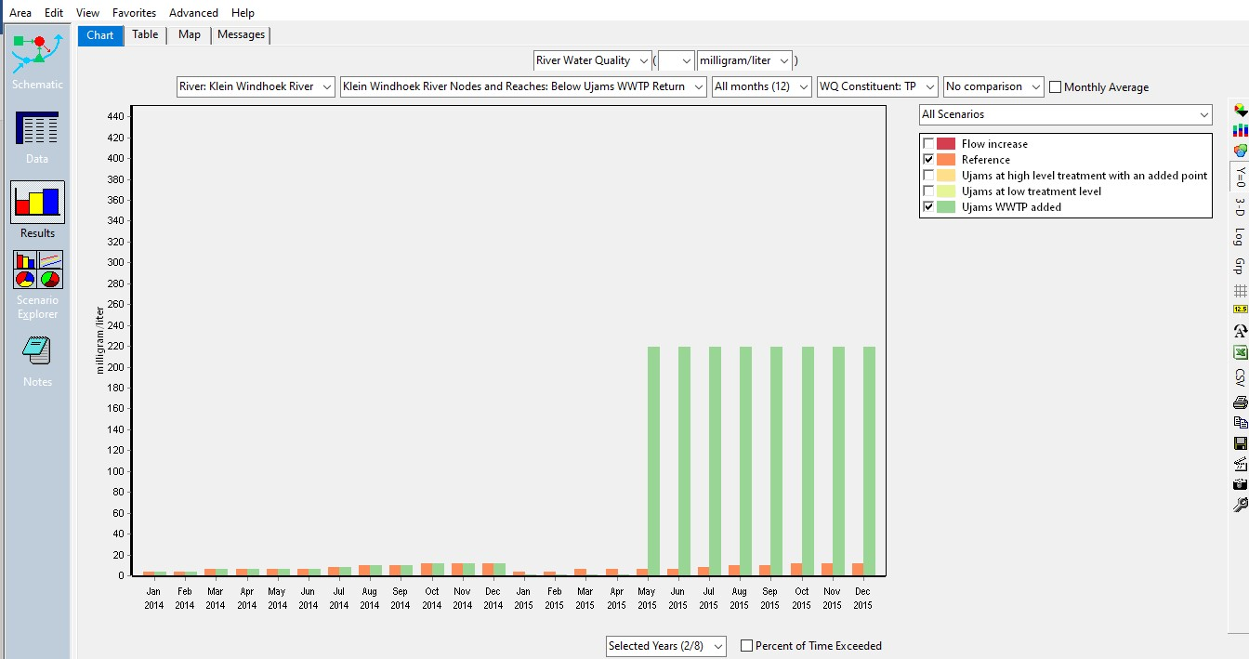
Figure 19: Comparative results for TP before and after Ujams WWTP
A significant reduction in TP values is also shown in Figure 19 for the months January to April.

4.3.1 Water Quality Verification
Verification of results for water quality after simulation was done by comparing water quality data City of Windhoek in 2015 and the model results for verification. The model parameters were then adjusted manually to try and achieve smaller absolute mean error between observed and simulated values for water quality parameters. The diagrams for comparison between simulated and observed values are shown in figure 20:

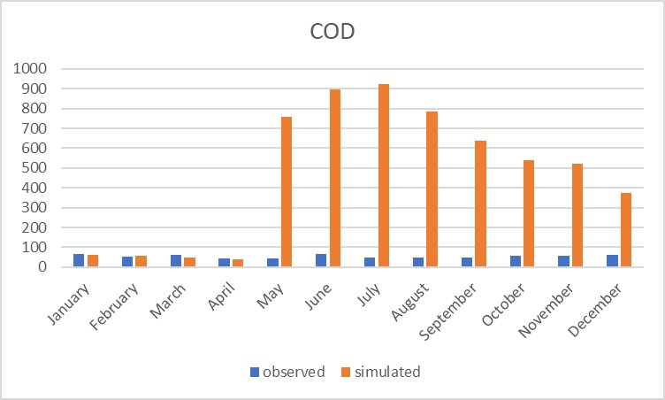 | 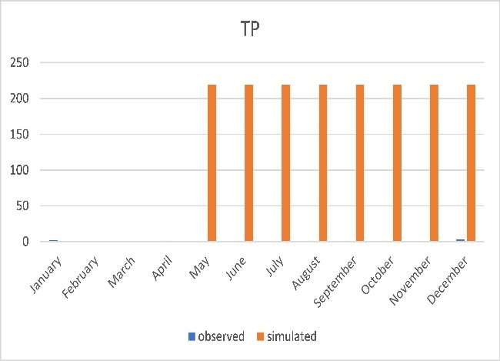
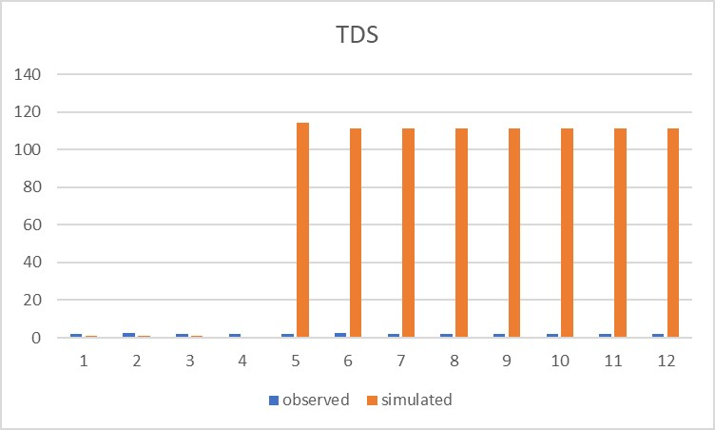

Figure 20: Comparison of simulated and observed data

Model verification of results was assessed using Nash-Sutcliffe efficiency for observed and simulated data and the following results were observed:
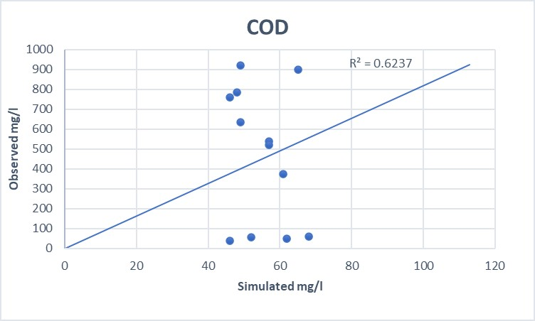
Figure 21: Correlation diagram showing NSE value for COD

The model showed NSE value of 0.62 for COD which is just above an average of 0.5 but below the satisfactory value of 0.7 as shown in Figure 21. The most deviation from trendline were shown during the dry season while it almost gave a perfect fit in the wet season. A RMSE value of 532.2mg/l was also calculated.

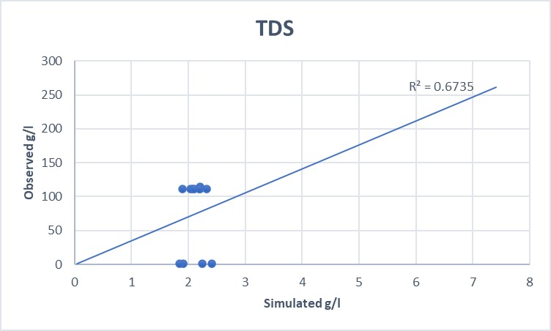
Figure 22: Correlation diagram showing NSE value for TDS

The model showed NSE value of 0.67 for TDS which is above the average of 0.5 but below a satisfactory value of 0.7 as shown in Figure 22. The most deviation from trendline were shown during the dry season while it almost gave a perfect fit in the wet season. A RMSE value of 89.55 was calculated.

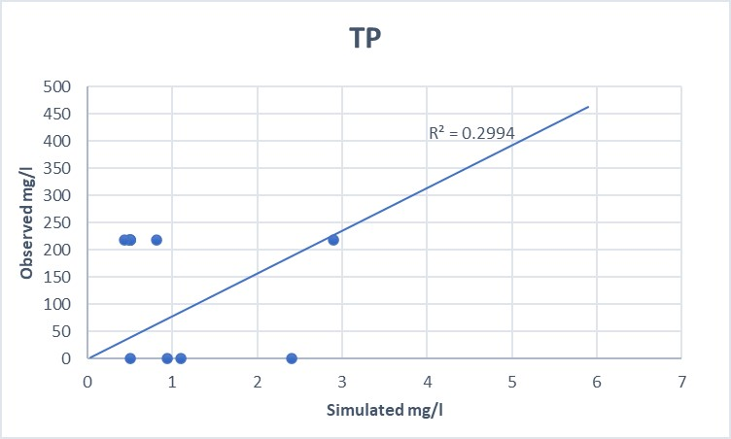
Figure 23: Correlation diagram showing NSE value for TP

The model gave NSE value of 0.30 for TP which is below the average of 0.5 and also below the satisfactory value of 0.7 as shown in Figure 23. A RMSE value of 178.12 was also shown.

4.3.2 Scenarios for Water Quality analysis in WEAP
Scenarios were applied for water quality analyses in order to see changes in trends for water quality in Klein Windhoek River for various changes.

Scenario 1:
Assuming the effluent from the industries before discharge into Klein Windhoek River is treated at Ujams WWTP but with a low level of treatment say 60 %, which helps to analyse the impact of wastewater treatment plant discharging effluent from Ujams WWTP which is below standard in to the Klein Windhoek River.

Scenario 2:
Assuming the effluent from industries is treated to a higher level of 80 % at Ujams WWTP, but then there is a point source discharging into the river at Brakewater industrial site. This will give a picture on how not monitoring who discharges illegally affects the water quality.
COD scenario analysis:
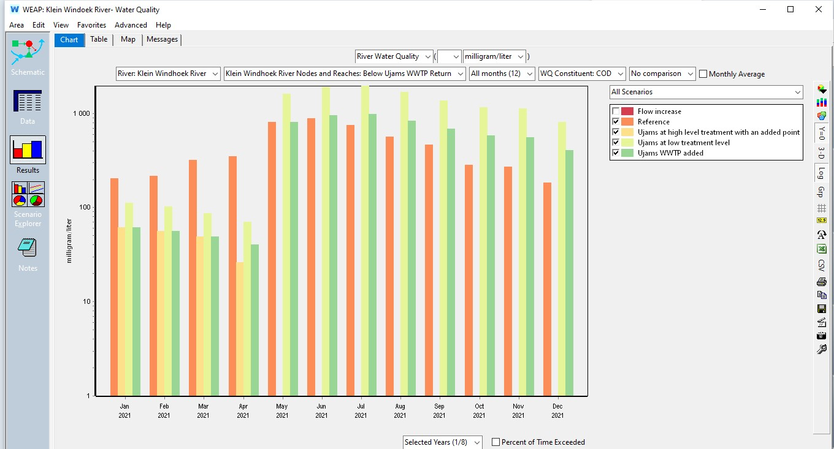
Figure 24: Bar chart for change in trend for COD concentration (scenario analysis)

COD levels below Ujams return point in the Klein Windhoek River shown in Figure 24 showed different results for the wet and dry season with some irregularities starting in the month of May to December which signify the dry season with minimal head flows. A line chart displaying the same trend results can also be seen in Figure 25.
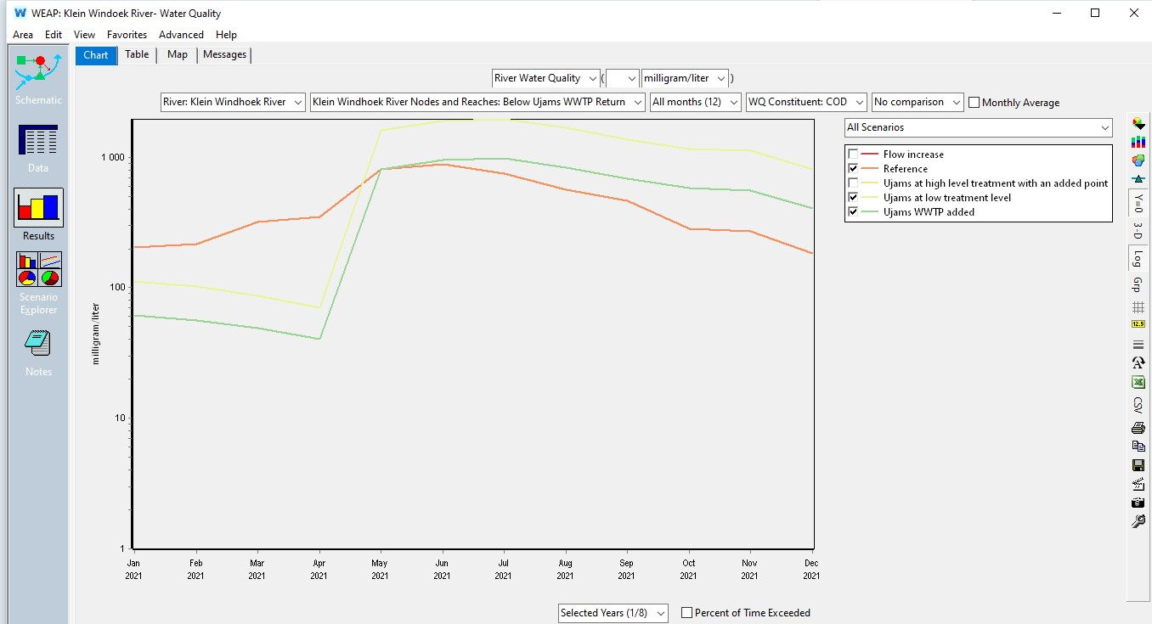
Figure 25: Line chart for change in COD trend (scenario analysis)

TDS scenario analysis:
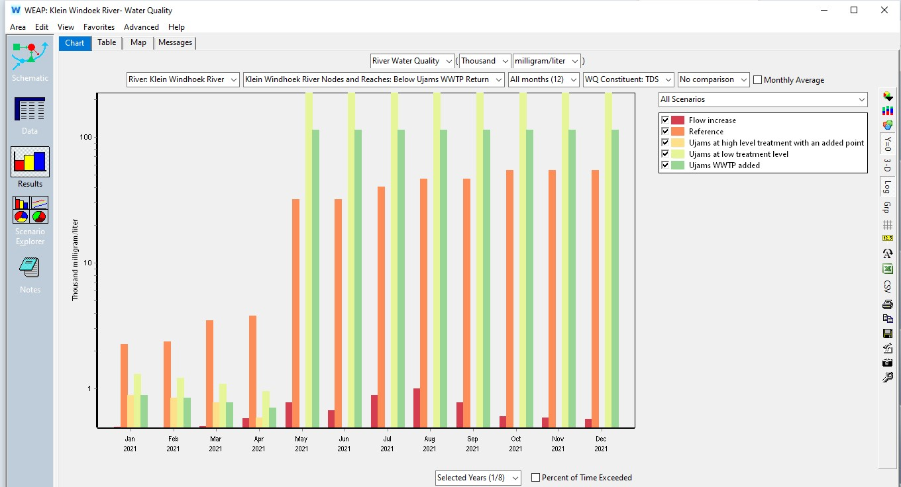
Figure 26: Bar chart for change in trend for TDS concentration (scenario analysis)
TDS levels below Ujams return point in the Klein Windhoek River shown in Figure 26 show different results for the wet and dry season with some irregularities starting in the month of May to December which signify the dry season with minimal head flows. A line chart displaying the same trend results can also be seen in Figure 27.

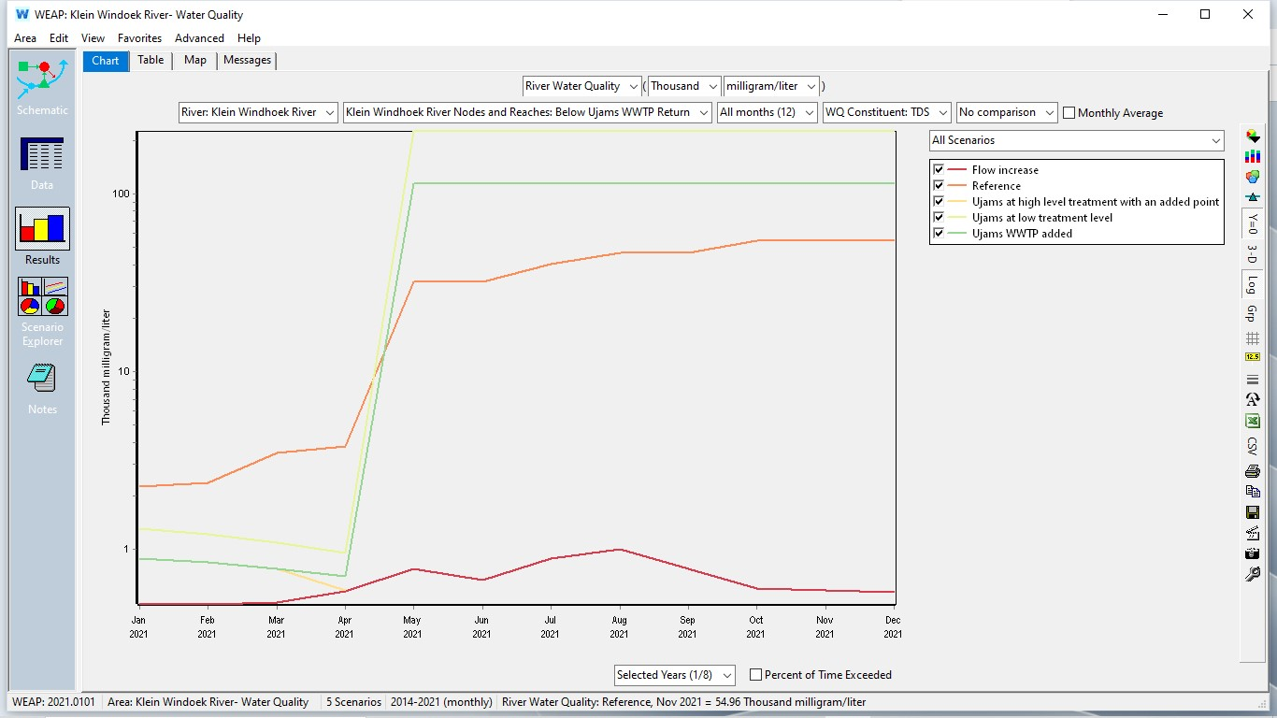
Figure 27: Line chart for change in trend for TDS (Scenario analysis)

4.4 Conclusion

In this chapter the researcher presented a summary of data used for the research and results of data analysis. The researcher starts by showing water quality sampling results for grab samples along the Klein Windhoek River. The researcher also presents results for data analysis which was done using the WEAP21 modelling software. The following chapter has a discussion, conclusions and recommendations.

CHAPTER 5: DISCUSSION, CONCLUSIONS AND RECOMMENDATIONS

5.1 Introduction
This chapter is presented in five sections. First the summary of the research is given followed by a discussion of the findings. The researcher then gives recommendations and a conclusion.

5.2 Summary
Water shortages have become a major problem in the Central Area of Namibia (CAN) where low rainfall is received like many parts of the country. Ground water recharge which is the main backup has also become very low in most seasons due to recurring dry-seasons. Water sources like the Goreangab reservoir have been abandoned due to high volumes of contaminants while Swakoppoort reservoir has been reported to be hypertrophic since 2008. Water pollution has become therefore a major drawback. This research demonstrates how water quality change trend forecasting could be useful for water quality management. The main objective of this research was to analyse the impact of industrial effluents on water quality of the Klein Windhoek River through the following research questions:

Q1. What are the contributory elements and main sources of water pollution in Klein Windhoek River?
Q2. What is the impact of industrial effluents on water quality of Klein Windhoek River?
Q3. What could be the impact of various possible scenarios with increase in pollution loads?

Computer modelling software have become very useful in recent years to help water managers in decision making, planning and managing water resources. WEAP21 model was used for modelling water quality in the Klein Windhoek River in this study as it is easy to use, available and easily accessible for developing countries. Data was collected through water quality sampling along the river and also from different websites. Some water quality data required for modelling was collected from the City of Windhoek. WEAP21 general parameters were set for water quality analysis for a period between 2015 to 2021.

5.3 Discussion

The findings from this study suggest that industrial effluents contribute significantly to contamination of water in the Klein Windhoek River even after the construction of a new biological nutrient removal wastewater treatment plant to treat the industrial effluents. A research by Kalumbu et al (2010) suggested that Klein Windhoek River was intermittently polluted by the Ujams waste water stabilisation ponds which were treating industrial waste waters. The researchers also highlighted the probability of water quality concerns in the Klein Windhoek River even after the replacing of stabilization ponds with a biological nutrient removal wastewater treatment plant in cases of ineffective treatment, this is considering Ujams WWTP would also discharge effluent into the river.

Klein Windhoek River water quality sampling results indicate that for parameters tested for this research COD levels, TP concentration levels, TDS concentration levels and DO were at times not within the stipulated standards after Ujams WWTP effluent discharge point. This is illustrated in Figure 6 to Figure 10. These findings show how water quality of the Klein Windhoek River depends on how effectively industrial waste waters are treated at Ujams Wastewater treatment plant not disregarding illegal industrial effluent discharges into the river. Water flowing in the river was mainly due to effluent discharge from Ujams WWTP during the dry season when the research was done. Trends from river water sampling results showed that on some days water samples taken downstream, close to Ujams discharge point could be classified as good water quality which falls within standards while some days sample results were exceeded the standards.

According to Pazvakavambwa (2018), extreme levels of DO, conductivity, TSS, TDS, COD and BOD were recorded close to Nakara Tannery, Okapuka Tannery and Namib Poultry in river reaches which might suggested illegal waste water discharges along the river. After sampling water flowing in the Klein Windhoek River, the researcher also noted extreme levels of conductivity, TDS and TP. For this research, water quality results for Klein Windhoek River also showed DO, COD, TDS and conductivity most times not being within the permissible range when water samples were collected. This is despite the change from waste stabilization ponds to a biological nutrient removal plant.

The more Nash-Sutcliffe efficiency is closer to 1 for the simulated results and observed data the more acceptable the model results are. If Nash-Sutcliffe efficiency is greater than 0.7, then the model parameters are considered as acceptable (Nguyen et al. 2013). Application of WEAP21 model in modelling water quality in the Klein Windhoek River for this research gave unsatisfactory results for COD, TDS and TP with NSE values below 0.7. NSE values obtained showed 0.62 for COD, 0.62 for TDS and 0.29 for TP. This is shown in Figure 21, Figure 22 and Figure 23.

Unsatisfactory modelling results could have been as a result of non-uniform flow in the ephemeral river stream that led to use of flow estimates for this research. WEAP21 model was able to model water in the Klein Windhoek River just below Ujams return point for the wet season with irregularities being shown for the dry season. Non-uniform flows representing the wet and dry seasons could not be modelled properly in WEAP as it indicated errors for minimal flows.

The absence of continuous recorded river flow data was a great hinderance for this research as Klein Windhoek River is an ephemeral river together with its tributary nodes. The river has minimal flows during the dry season. The flow in dry seasons is mainly effluent discharged by Ujams WWTP flowing downstream. The river flows after heavy rains thereby transporting contaminants downstream (Lehmann, 2010). Research by Pazvakavambwa (2018) highlights how WEAP assumes steady state flow in rivers and how WEAP was deficient in predicting water quality parameter values for ephemeral streams. Further research is needed in finding modelling software that works effectively for ephemeral streams.

5.4 Conclusions

- Temperature, pH and chromium levels were always within the stipulated standard stipulated in Namibia Act No.11 of 2013 downstream of Ujams WWTP discharge point. The COD levels in Klein Windhoek River were at times exceeding the stipulated standard of 100mg/l and TP concentration levels were also above the standard of 1-2mg/l at times at a sampling site in the river close to Ujams WWTP outlet point.

TDS concentration levels were always above the maximum stipulated standard downstream of Ujams outlet point. TDS in all the grab samples which were taken exceeded the maximum stipulated level of 694.5mg/l. DO levels were below stipulated standard of 6.75mg/l for both upstream and downstream of Ujams WWTP. These findings show how water quality of the Klein Windhoek River depends so much on the quality of effluent discharged from Ujams WWTP as the flow downstream of Ujams WWTP during dry seasons is mainly due to effluent from the biological nutrient removal plant.

- Application of WEAP21 model in modelling water quality in the Klein Windhoek River showed unsatisfactory results with NSE values of 0.62 for COD, 0.62 for TDS and 0.29 for TP. WEAP21 model was able to model water in the Klein Windhoek River just below Ujams return point for the wet season with irregularities being shown for the dry season. Non-uniform flows representing the wet and dry seasons could not be modelled properly in WEAP as it indicated errors for minimal flows.

- WEAP21 modelling software was deficient when used for water quality scenario analysis which included pollution loads modification as water quality for the dry season that had minimal flows could not be modelled properly in WEAP.

5.5 Recommendations

- There is need to maintain high treatment levels at Ujams WWTP to avoid poor quality effluent from being discharged into Klein Windhoek River. Probably pre-treatment of wastewater at industrial sites can help industries like Nakara Tannery, Okapuka Tannery and Namib Poultry discharge wastewater within standards at all times.

- There is need to have water pollution monitoring programs especially in this case where the industries are sited close to a river. i.e., there was no data on typical effluent concentrations received from Nakara tannery. Data obtained the other industries also had gaps and didn’t show there is frequent monitoring.

- There is need to closely monitor the quality of wastewater coming into Ujams WWTP from the various industries and to probably strictly issue penalties in case of wastewater exceeding limits being received at the water treatment plant.

- For future studies, using river flow data and subsurface flow data measured in the ephemeral streams and tributaries in the study area is recommended.

- WEAP21 model modification, which may include groundwater and subsurface flows can probably help Klein Windhoek ephemeral river system to be modelled more effectively.

The findings of this research show how proper wastewater treatment management techniques are essential in protecting water resources. To achieve this and continue protecting water resources, there is need to ensure that effluent discharged in to Klein Windhoek River is within the stipulated standards at all times.

APPENDICES

Appendix A : Effluent Standards- Water Act No.11 of 2013
Effluent to be discharged or disposed of in areas with potential for drinking water source contamination; international rivers and dams and in water management and other areas

 |  |  | Special  Standard | General Standard
DETERMINANTS | UNIT | FORMAT | 95 percentile requirements
PHYSICAL REQUIREMENTS
Temperature | ⁰C |  | Not more than 10 ⁰C higher than the recipient water body
Turbidity | NTU |  | <5 | <12
pH |  |  | 6.5-9.5 | 6.5-9.5
Colour | mg/litre Pt |  | <10 | <15
Smell |  |  | No offensive smell
Electric Conductivity 25⁰C | mS/m |  | <75 mS/m above the intake potable water quality
Total Dissolved Solids | mg/litre |  | <500 mg/l above the intake potable water quality
Total Suspended Solids | mg/litre |  | <40 | <100
Dissolved Oxygen | % Saturation |  | >75 | >75
Radioactivity | units |  | Below ambient water quality of the recipient water body
ORGANIC REQUIREMENTS

Biological Oxygen Demand | mg/litre | BOD | <10 | <30
Chemical Oxygen Demand | mg/litre | COD | <55 | <100
Detergents (soap) | mg/litre |  | <0.2 | <3
Fat, oil & grease | mg/litre | FOG | <0.1 | <3.0

Effluent to be discharged or disposed of in areas with potential for drinking water source contamination; international rivers and dams and in water management and other areas

 |  |  | Special  Standard | General Standard
DETERMINANT | UNIT | FORMAT | 95 percentile requirements
INORGANIC MACRO DETERMINANTS
Ammonia(NH₄-N) | mg/litre | N | <1 | <10
Nitrate (NO₃-N) | mg/litre | N | <15 | <20
Nitrite(NO₂-N) | mg/litre | N | <2 | <3
Total Kjeldahl Nitrate (TKN) | mg/litre | N | <5.0 | <33
Chloride | mg/litre | Cl | <40 mg/litre above the intake potable water quality | <70 mg/litre above the intake potable water quality
Sulphate | mg/litre | SO₄ | <20 mg/litre above the intake potable water quality | <40 mg/litre above the intake potable water quality
Fluoride | mg/litre | F | <0.05 | <0.5
Cyanide(Free) | ≤ g/litre | CN | <70 | <200
Soluble Orthophosphate | mg/litre | P | <1.0 | <15
Zinc* | Mg/litre | Zn | 1 | 5

Appendix B: Standard of Effluent Discharges from the US Environmental Protection Agency(EPA)

Parameter | Unit | Maximum permissible limit
 |  | Land/underground | Surface water courses
Free Chlorine | mg/l | - | 0.5
Total Suspended Solids(TSS) | mg/l | 45 | 35
Reactive Phosphorus | mg/l | 10 | 1
Colour |  | Not objectionable
pH |  | 5-9
Temperature | ⁰C | 40
Biological Oxygen Demand (BOD) | mg/l | 40
Chemical Oxygen Demand (COD) | mg/l | 120
Chloride | mg/l | 750
Aluminum | mg/l | 5
Arsenic | mg/l | 0.1
Beryllium | mg/l | 0.1
Cadmium | mg/l | 0.01
Total Chromium | mg/l | 0.05
Zinc | mg/l | 2
Copper | mg/l | 0.5
Cyanide | mg/l | 0.1

Appendix C: General Standards for Waste/Effluent Water Discharge into the Environment.

DETERMINANTS | MAXIMUM ALLOWABLE LEVELS
Biological Oxygen Demand (BOD)
Chemical Oxygen Demand (COD) | 75 mg/l as O
Oxygen dissolved (DO) | At least 75 % saturation
Total Dissolved Solids (TDS) | Not more than 500 mg/l more than intake water quality
Total Suspended Solids (TSS) | 25 mg/l
Phosphate | 1 mg/l as P
Temperature | 35 ⁰C
Zinc | 5.0 mg/l as Zn
pH | 5.5 – 9.5
Oxygen, Absorbed (OA) | 10 mg/l as O
Fluoride | 1.0 mg/l as F
Fats, Oil and Grease (FOG) | 2.5 mg/l (gravimetric method.)
Chlorine Residual | 0.1 mg/l as Cl₂
Chromium , total | 500 𝜇g/l as Cr
Copper | 1.0 mg/l as Cu
Sulphide | 1.0 mg/l as S

Appendix D: Oanob River flow data

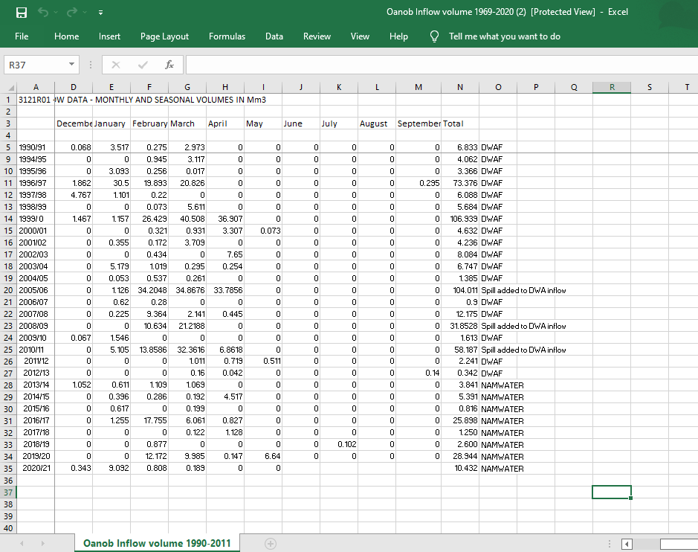

REFERENCES

Abdulla, H. J., Al-Quraeshi, N. K. B., & Al-Awadi, F. N. J. (2012). Study of Chemical Oxygen Demand ( COD ) in Relation to Biochemical Oxygen Demand ( BOD ). Journal of Kerbala University, 10(3), 8–11.
Aboud, S. J., Al Fayoumi, M., & Alnuaimi, M. (2009). Verification and validation of simulation models. Handbook of Research on Discrete Event Simulation Environments: Technologies and Applications, 58–74.
Agarwal, A., Patil, J., Goyal, V., & Kv, J. (2019). a Review on Weap21 Model for Managing Water Resources. November.
Arbabi, M., Hemati, S., & Amiri, M. (2015). Removal of lead ions from industrial wastewater: Removal methods review. Int J Epidemiol Res., 2(2), 105-109.
Arroyo Seco Foundation. (2010). The Five Basic Water Quality Parameters. 3–4.
Bartram, J., & Pedley, S. (1996). Water Quality Monitoring- A Practical Guide to the Design and Implementation of Freshwater Quality Studies and Monitoring Programmes. United Nations Environment Programme; World Health Organization.
Bashir, I., Lone, F. A., Bhat, R. A., Mir, S. A., Dar, Z. A., & Dar, S. A. (2020). Concerns and threats of contamination on aquatic ecosystems. Bioremediation and Biotechnology: Sustainable Approaches to Pollution Degradation, 1–26.
Biswas, A. K., & Tortajada, C. (2019). Water quality management: a globally neglected issue. International Journal of Water Resources Development, 35(6), 913–916.
Chapelle, F. . ., Bradley, P. M., McMahon, P. B., & Lindsey, B. (2019). Water Quality Information by Topic. What Is Water Quality?, https://www.usgs.gov/special-topic/water-science-school/science/water-quality-information-topic?qt-science_center_objects=0#qt-science_center_objects accessed 24 May 2020.
Chapman, D., Jackson, J., & Krebs, F. (1996). Biological monitoring. Occupational Medicine (Philadelphia, Pa.), 5(3), 491–498.
Clark, I. (2015). Sampling and Analysis. Groundwater Geochemistry and Isotopes, 381–402.
Corcoran, E., Nellemann, C., Baker, E., Bos, R., Osborn, D., & Savelli, H. (2010). Sick Water? The Central Role of Wastewater Management in Sustainable Development: A Rapid Response Assessment. In UN Habitat.
Department of Water Affairs. (1991). Water Act 54 of 1956. Ministry of Agriculture, Water and Rural Development. Republic of Namibia, 1969(September 1977), 1–69.
Dickens, C. W. S., & Graham, P. M. (2002). The south african scoring system (SASS) version 5 rapid bioassessment method for rivers. African Journal of Aquatic Science, 27(1), 1–10.
Doble, M., & Kumar, A. (2005). Biotreatment of industrial effluents. In Biotreatment of Industrial Effluents.
E, L., & Madhu, D. G. (2014). An Assessment of Water Quality in River Periyar, Kerala, South India Using Water Quality Index. IOSR Journal of Environmental Science, Toxicology and Food Technology, 8(8), 11–16.
Edokpayi, J. N., Odiyo, J. O., & Durowoju, O. S. (2017). Impact of Wastewater on Surface Water Quality in Developing Countries: A Case Study of South Africa. Water Quality.
Giupponi, C., & Sgobbi, A. (2013). Decision support systems for water resources management in developing countries: Learning from experiences in africa. Water (Switzerland), 5(2), 798–818.
Hahn, H. H., & Schreiner, H. (1978). Water quality modelling. Progress in Water Technology, 10(3–4), 185–201.
Halder, J. ., & Islam, M. . (2015). Water Pollution and its Impact on the Human Health. Journal of Environment and Human, 2(1), 36–46.
Kalumbu, G., Kgabi, N., & Reynders, C. (2017). The Impacts of Industrial Effluents on River Quality: A case of the Klein Windoek River, Namibia. LAP Lambert Academic Publishing.
Kanu, I., & Achie, O. K. (2011). Industrial Effluents and their Impact on Water Quality of receiving rivers in Nigeria. Journal of Applieal Technology in Environmental Sanitation, 1(1), 75–86.
Krenkel, P. ., & Novotny, V. (1980). Water Quality Management. In academic press (Vol. 26).
Kumara, P., Kumar, S., & Agarwal, A. (2010). Impact of industrial effluents on water quality of Behgul River at Bareilly. Advances in Bioresearch, 1(2), 127–130. http://soeagra.com/abr/vol2/18.pdf. Retrieved 20 June 2020.
Lazaridou-Dimitriadou, M. (1995). Water quality biomonitoring. 1–4.
Lehmann, F. L. (2010). Water quality of the Swakoppoort Dam, Namibia. December, 1–13, 80–83.
Lewis, E. W., Staddon, C., & Sirunda, J. (2019). Urban water management challenges and achievements in Windhoek, Namibia. Water Practice and Technology.
Li, L., Zheng, B., & Liu, L. (2010). Biomonitoring and bioindicators used for river ecosystems: Definitions, approaches and trends. Procedia Environmental Sciences, 2(July), 1510–1524.
Mishra, B. K., Regmi, R. K., Masago, Y., Fukushi, K., Kumar, P., & Saraswat, C. (2017). Assessment of Bagmati river pollution in Kathmandu Valley: Scenario-based modeling and analysis for sustainable urban development. Sustainability of Water Quality and Ecology, 9–10(June), 67–77.
Moyo, L. G., Vushe, A., January, M. A., & Mashauri, D. A. (2015). Evaluation of suitability of Windhoek’s wastewater effluent for re-use in vegetable irrigation: A case study of Gammams effluent. WIT Transactions on Ecology and the Environment, 199(1), 109–
Munir, H., & Gunderson, L. (2003). Computer model a useful tool in water quality research. 4194(651), 296–297.
NamWater. (2015). Management of the Upper Swakop Basin: Key Water Security to the Central Area of Namibia. Ministry of Agriculture , Water and Forestry.
Nguyen, T. (2005). Water Quality Monitoring in Rivers Water Quality Monitoring. Central Pollution Control Board, India.
Nguyen, T. D., DO, S. T., Hang, T. T., LE, A. T. T., & Bui, D. D. (2013). Application of weap model in forecasting water quality for water resources protection master plan with pilot study in application of weap model in forecasting waterquality for water resources protection master plan. 2–4.
Nosheen, G., Ullah, M., Khan, K. A., & Rehman, A. U. (2012). Impacts of Industrial Effluent on River Kabul. Hydro Nepal: Journal of Water, Energy and Environment, 44–47.
Pazvakawambwa, G. T. (2018). Water Resources Governance in the Upper Swakop Basin. 85–218.
Rusydi, A. F. (2018). Correlation between conductivity and total dissolved solid in various type of water: A review. IOP Conference Series: Earth and Environmental Science, 118(1).
Sieber, J. et al. (2005). Ser uide. Environment, August, 343. http://www.weap21.org/WebHelp/index.html accessed 19 August 2020.
Slaughter, A. R., & Mantel, S. K. (2018). Water quality modelling of an impacted semi-arid catchment using flow data from the WEAP model. Proceedings of the International Association of Hydrological Sciences, 377, 25–33.
U.S Environmental Protection Agency. (2001). Technical Guidance Manual For Estuarine and Coastal. October. https://www.epa.gov/sites/production/files/2018-10/documents/nutrient-criteria-manual-estuarine-coastal.pdf Retrieved 6 June 2021
U.S EPA. (2016). Online source water quality monitoring for water quality surveillance and response systems. U.S.Environmental Protection Agency, September, 114. https://www.epa.gov/sites/production/files/201609/documents/online_source_water_monitoring_guidance.pdf. downloaded 16 May 2021.
UNESCO. (2009). Water quality monitoring and wasterwater. Water Quality Monitoring and Wasterwater.
Wang, Q., Li, S., Jia, P., Qi, C., & Ding, F. (2013). A review of surface water quality models. The Scientific World Journal, 2013.
Water Science School. (2018). Water Quality Sampling Techniques . U.S. Geological Survey. https://www.usgs.gov/special-topics/water-science-school/science/water-quality-sampling-techniques
Whyte, R. G. (1986). What is a Decision Support System? Industrial Management & Data Systems, 86(7–8), 28.
World Bank Group. (1998). Water Quality Models. July, 101–107.
Wurbs, R. A. (1994).Computer Models for Water Resources Planning and Management.
Yates, D., Purkey, D., Sieber, J., Huber-Lee, A., & Galbraith, H. (2005). WEAP21 - A demand-, priority-, and preference-driven water planning model. Part 2: Aiding freshwater ecosystem service evaluation. Water International, 30(4), 501–512.

